[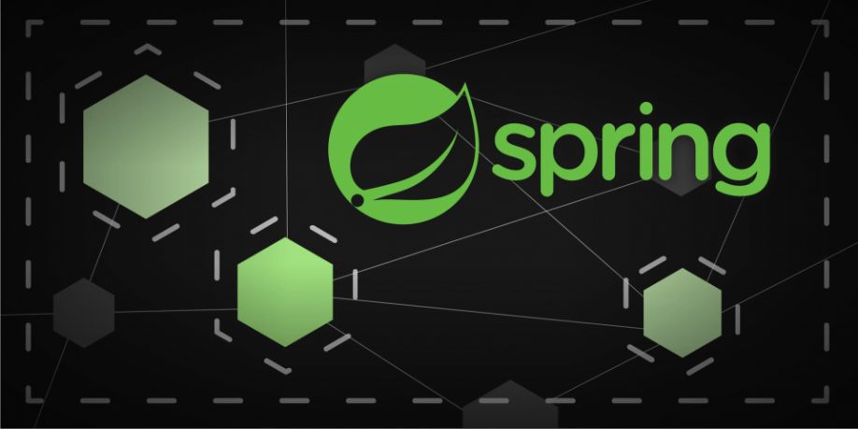](https://camo.githubusercontent.com/a3e5598db134838eeb384428095e1deea8e1fe98ff27034d58cdccb9a7bdeaad/68747470733a2f2f692e696d6775722e636f6d2f4c78666b3949452e706e67)

**Description**

Spring Security Keycloak Authentcation Example

**Keycloak**

Docker: <https://github.com/rodneyazev/docker-examples/tree/main/keycloak>

**Keycloack - Create realm**

[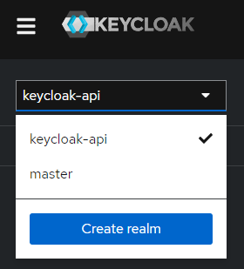](https://camo.githubusercontent.com/33f3bb59f5d93660df5edd2bb48c1455ce79554dcc4b6bc2597f15086c029272/68747470733a2f2f692e696d6775722e636f6d2f563952364c45652e706e67)

**Keycloack - Create client**

[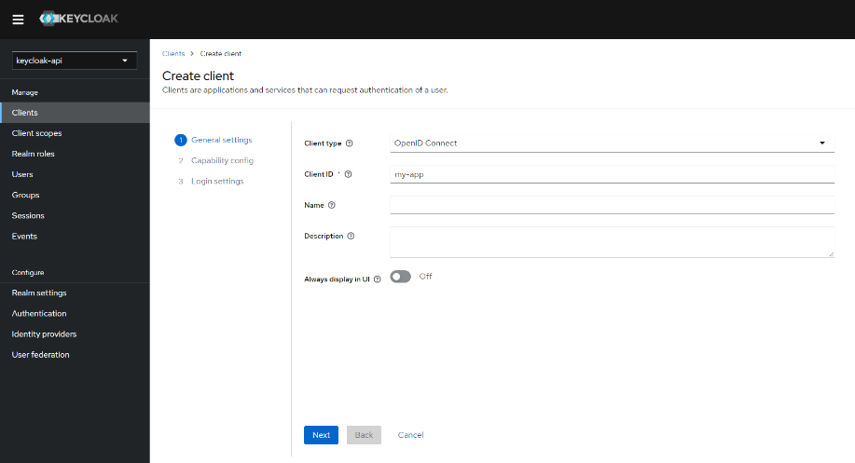](https://camo.githubusercontent.com/31b5a4a3caca620a896fa8d1c78ef0b5d997615ec1c6a07535075062f86d48a0/68747470733a2f2f692e696d6775722e636f6d2f4153696e4a51592e706e67)

[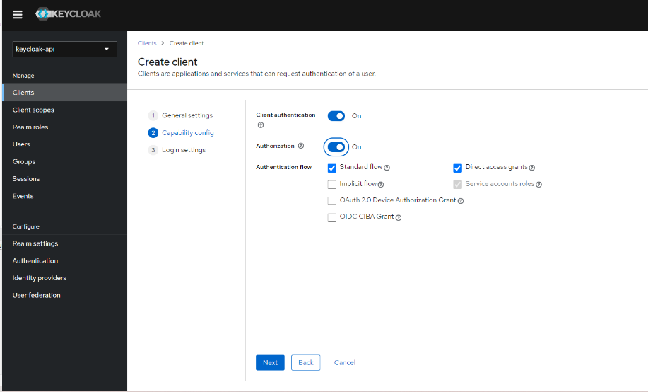](https://camo.githubusercontent.com/0641f10a548cad6c0a6579b0a50b445db68100fa3f2771ae29f7231090acba04/68747470733a2f2f692e696d6775722e636f6d2f496761464e55762e706e67)

[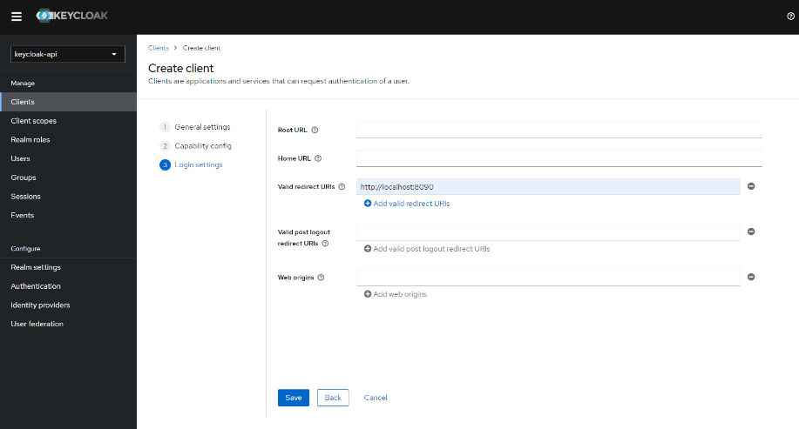](https://camo.githubusercontent.com/3d783093adce5fd31d334010c9ff294e4e4815179876d80a46eda8b498a30ab4/68747470733a2f2f692e696d6775722e636f6d2f6a7845796469482e706e67)

**Keycloack - Health check**

Link: <http://localhost:8080/realms/keycloak-api>

[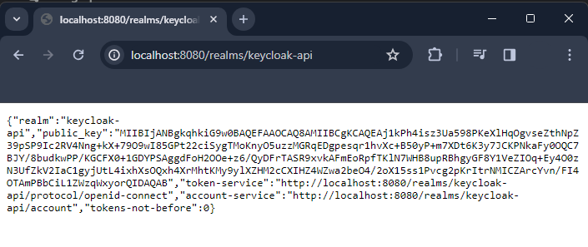](https://camo.githubusercontent.com/2cdce851d619fc6e4762ba42cdff82bce8a12a297223d5e2dffe17015e564dbe/68747470733a2f2f692e696d6775722e636f6d2f696f385751457a2e706e67)

**Keycloack - Client secret**

[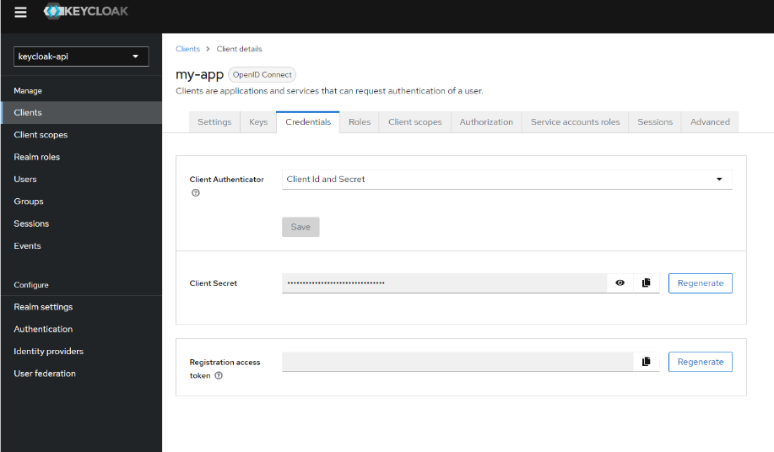](https://camo.githubusercontent.com/9ad9f76553d0918c34c2e8892c76d7d289a14fef11ac4881c136112ab6dc6226/68747470733a2f2f692e696d6775722e636f6d2f33674e643241632e706e67)

**API Validation**

* Unauthorized

[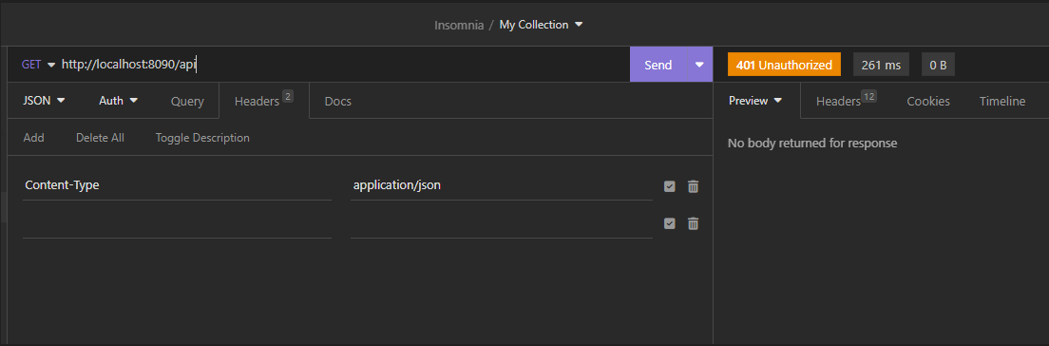](https://camo.githubusercontent.com/9150bb41df8063e72933af0b099c10ff84d165bf255ffc61d2e52de0bc69b34d/68747470733a2f2f692e696d6775722e636f6d2f536251687a70502e706e67)

* Token request

[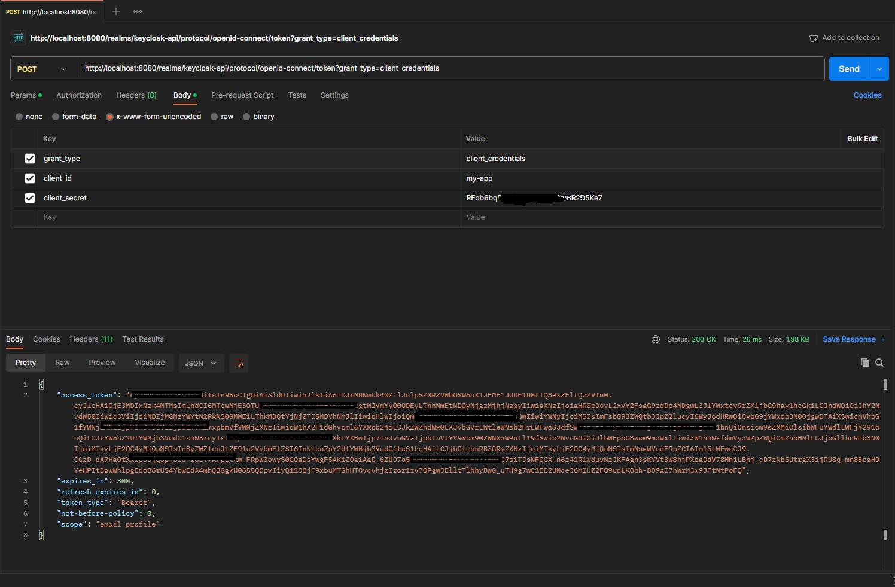](https://camo.githubusercontent.com/d7d3f77b907b79d82c0b2c97f5b009e91bb9248aea8c2198995b0a4a3b45c1b4/68747470733a2f2f692e696d6775722e636f6d2f51626b577075432e706e67)

* Authorization

[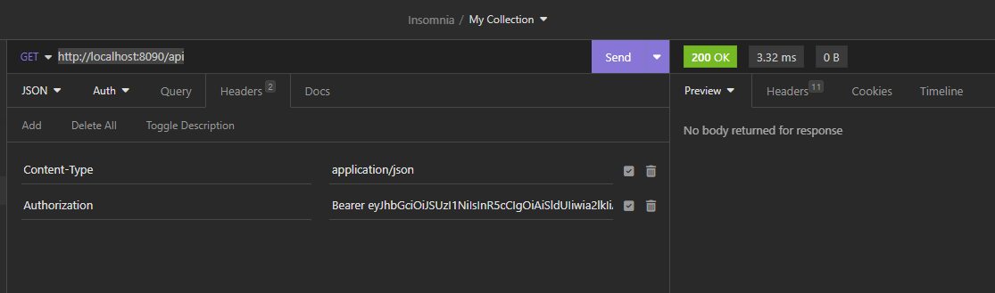](https://camo.githubusercontent.com/9997a583adcf8c3d7b4afca8cecb2488f61141c7708cb593d88eb8620b8fa1fc/68747470733a2f2f692e696d6775722e636f6d2f744268573557752e706e67)

**Source file / directory structure**

[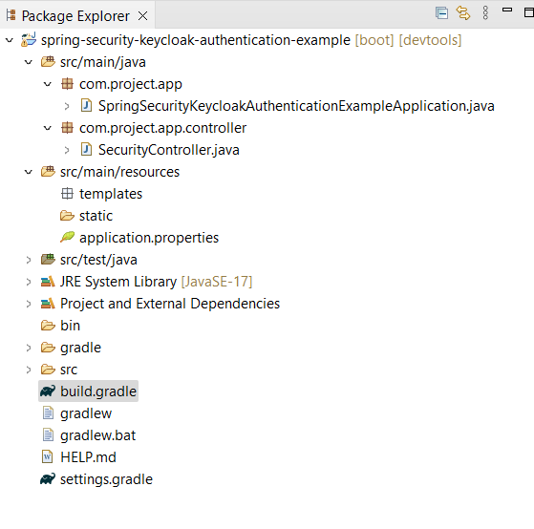](https://camo.githubusercontent.com/8bd38caffb2cd5f1c70c1570231d439aebf0774b81d410ba4346c1da5dab70b5/68747470733a2f2f692e696d6775722e636f6d2f4f3871694249652e706e67)

**Java Version Troubleshooting (if necessary)**

*Change to the most current version*

[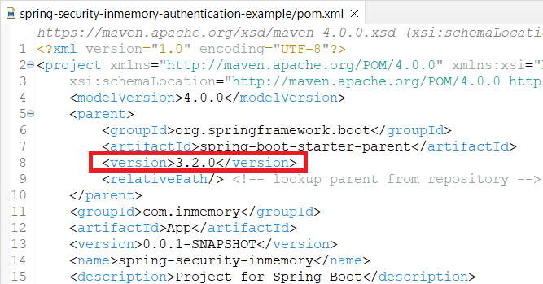](https://camo.githubusercontent.com/e2e82ad5129338c065b7c027150f847f8ae5717b33e516dd031a1477f2b57f74/68747470733a2f2f692e696d6775722e636f6d2f6d7067644461322e706e67)

*Uncheck****Enable project specific settings****option*

[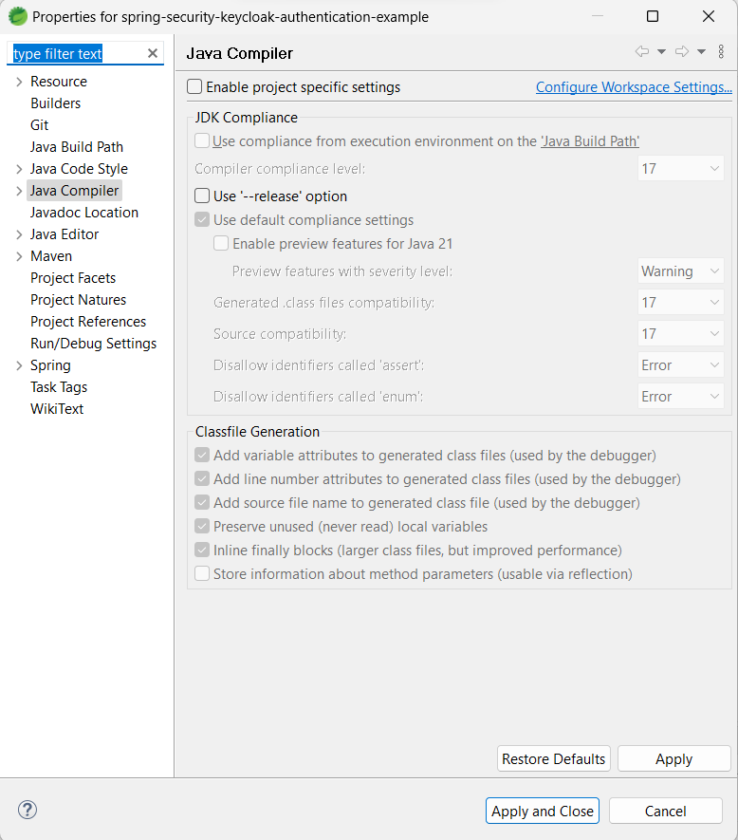](https://camo.githubusercontent.com/635255017474a6952e856d7940e1f76537f53176ec8d461805ec07a2489c278e/68747470733a2f2f692e696d6775722e636f6d2f4d35444155744d2e706e67)