[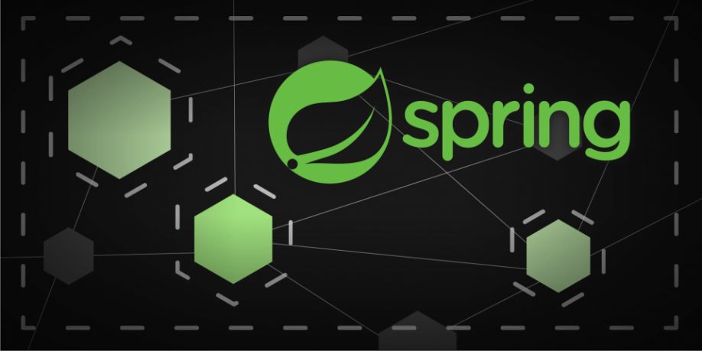](https://camo.githubusercontent.com/a3e5598db134838eeb384428095e1deea8e1fe98ff27034d58cdccb9a7bdeaad/68747470733a2f2f692e696d6775722e636f6d2f4c78666b3949452e706e67)

**Description**

Spring Security Oauth Resource Server RSA Token Example

**Swagger**

Swagger: <http://localhost:8080/swagger>

**RSA Key Generation**

openssl.exe genrsa -out keypair.pem 2048

openssl.exe rsa -in keypair.pem -pubout -out public.pem

openssl.exe pkcs8 -topk8 -inform PEM -outform PEM -nocrypt -in keypair.pem -out private.pem

**RSA project path**

Copy RSA .pem files to:

* */src/main/resources/certs*

**POST endpoint (token's request)**

<http://localhost:8080/token>

* Username: user
* Password: password

[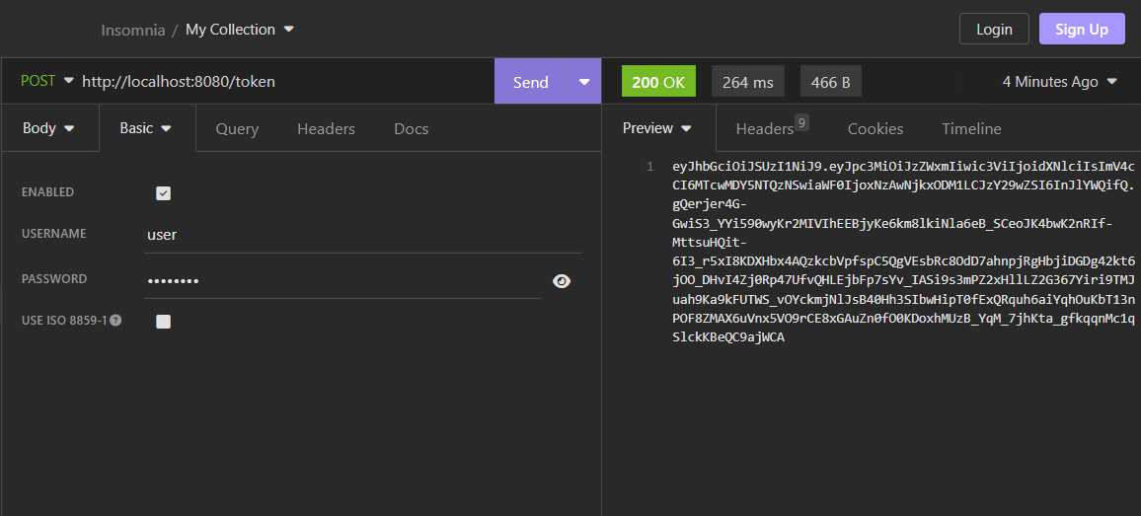](https://camo.githubusercontent.com/4d870fffd6d98ef4372e4ca5ed75e0b50082f3bb9b998d39fab2f074948030af/68747470733a2f2f692e696d6775722e636f6d2f6c7961326147362e706e67)

**GET endpoint (using token)**

[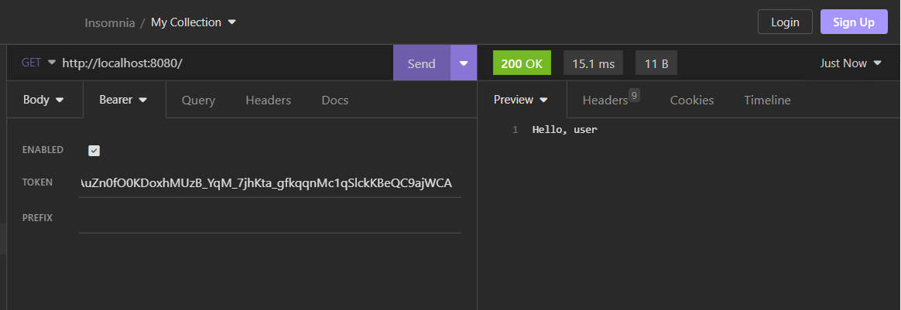](https://camo.githubusercontent.com/dba4835860c48ab4607e6eb7038d9d7f7c64967d34a54b338d21f1420b610de1/68747470733a2f2f692e696d6775722e636f6d2f616341334f72392e706e67)

**Test**

# unit test

$ mvn test -e

**Source file / directory structure**

[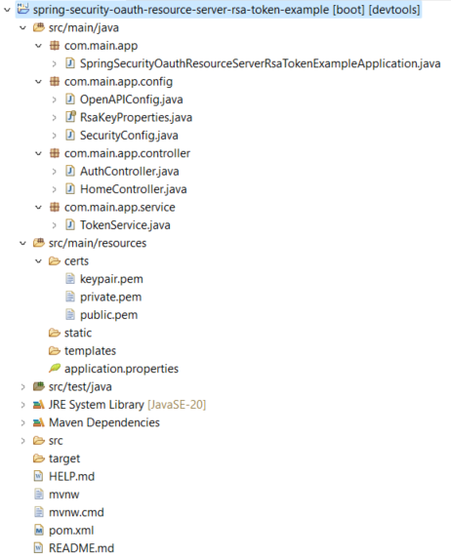](https://camo.githubusercontent.com/18406ebf71cea7d38ff93de191766b25aec1aaa10b8a39c5c0036a294d959a69/68747470733a2f2f692e696d6775722e636f6d2f414279316843362e706e67)

**Java Version Troubleshooting (if necessary)**

*Change to the most current version*

[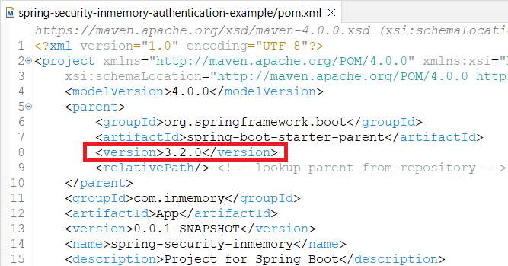](https://camo.githubusercontent.com/e2e82ad5129338c065b7c027150f847f8ae5717b33e516dd031a1477f2b57f74/68747470733a2f2f692e696d6775722e636f6d2f6d7067644461322e706e67)

*Uncheck****Enable project specific settings****option*

[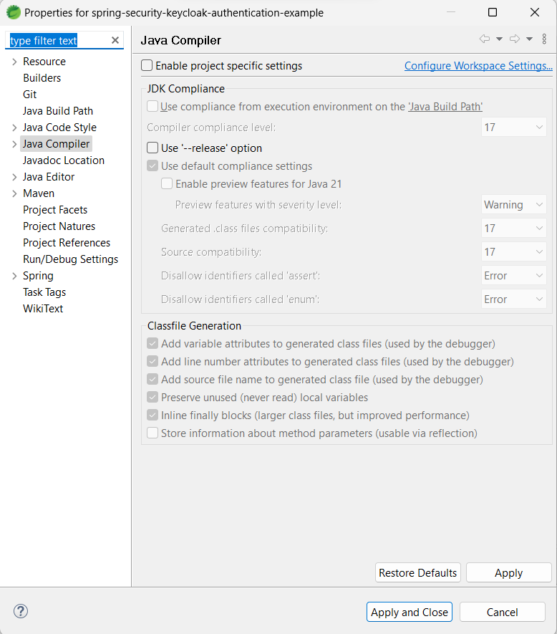](https://camo.githubusercontent.com/635255017474a6952e856d7940e1f76537f53176ec8d461805ec07a2489c278e/68747470733a2f2f692e696d6775722e636f6d2f4d35444155744d2e706e67)