[](https://camo.githubusercontent.com/a3e5598db134838eeb384428095e1deea8e1fe98ff27034d58cdccb9a7bdeaad/68747470733a2f2f692e696d6775722e636f6d2f4c78666b3949452e706e67)

**Description**

Spring Security Social Authentcation Example

**Google Cloud Platform - APIs Dashboard**

Link: <https://console.cloud.google.com/apis/dashboard>

**OAuth Consent Screen**

*User Type:****External***

[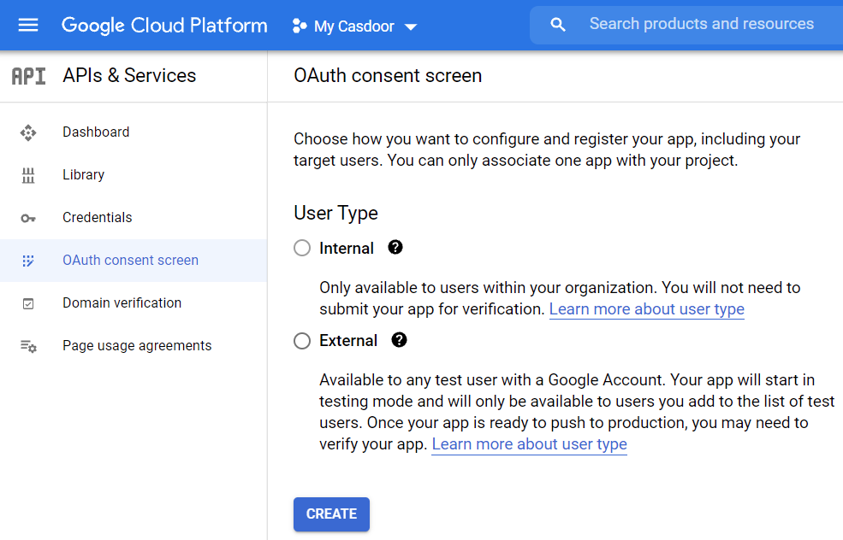](https://camo.githubusercontent.com/0456920e4fc89acf376e08d3e00ce27caa69c812aad36ebb809e74cec250fc42/68747470733a2f2f692e696d6775722e636f6d2f36563634517a432e706e67)

*Application name:****my-oauth-app***

[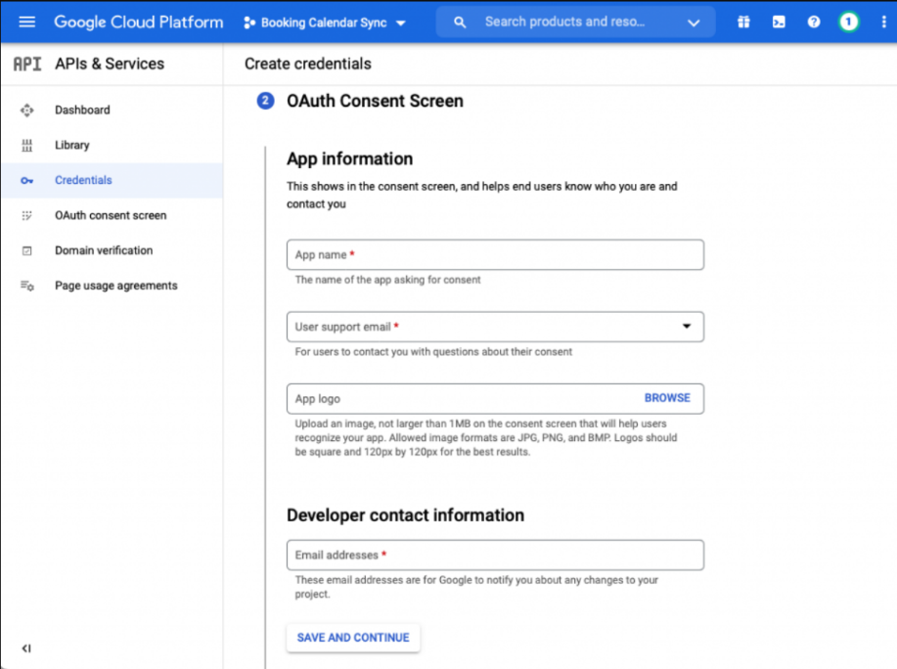](https://camo.githubusercontent.com/47fc6151ef3654c7a14200fb5ac68e507dc976731cc2a04702673b4f76667119/68747470733a2f2f692e696d6775722e636f6d2f436250564331732e706e67)

**Create Credentials**

*Name:****My Oauth App***

*Authorized JavaScript Sources:*[***http://localhost:8080***](http://localhost:8080/)

*Authorized redirect URIs:*[***http://localhost:8080/login/oauth2/code/google***](http://localhost:8080/login/oauth2/code/google)

[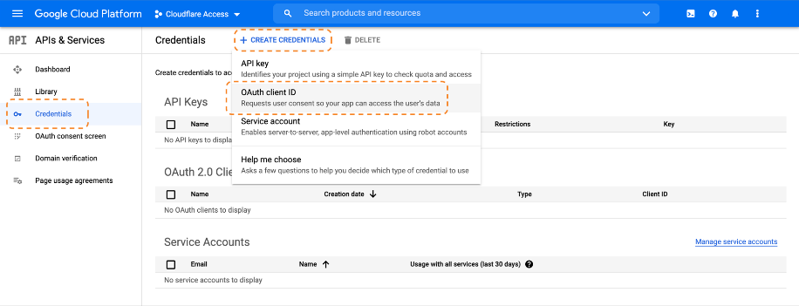](https://camo.githubusercontent.com/6e033661c79b724a7a9feececf326372414b084ce3d22cba14df158033ba7676/68747470733a2f2f692e696d6775722e636f6d2f6d7566313933792e706e67)

[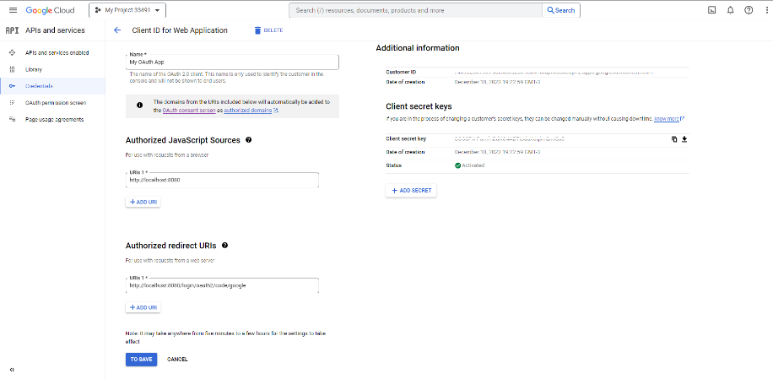](https://camo.githubusercontent.com/a0aed430fdc179575363164966e0842bc681cc241e9eef78ba588c721e44dc90/68747470733a2f2f692e696d6775722e636f6d2f4f74374b32666b2e706e67)

[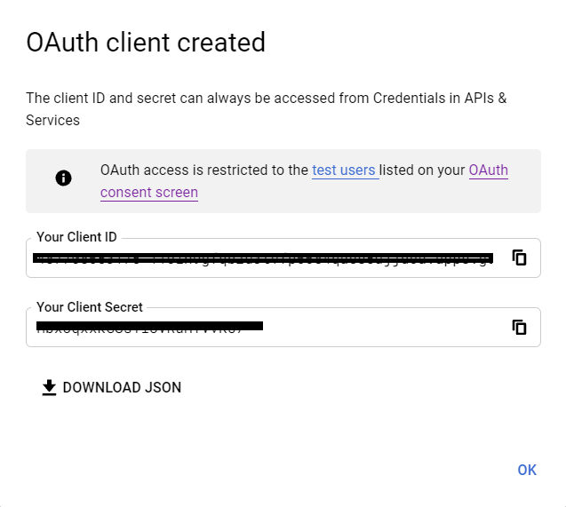](https://camo.githubusercontent.com/2438a5288eecebe15895ddc748d2b99bf2d80b78f6fc2cc60a06efdc07faaaaa/68747470733a2f2f692e696d6775722e636f6d2f795378676338782e706e67)

***Add your client id and client secret information.***

[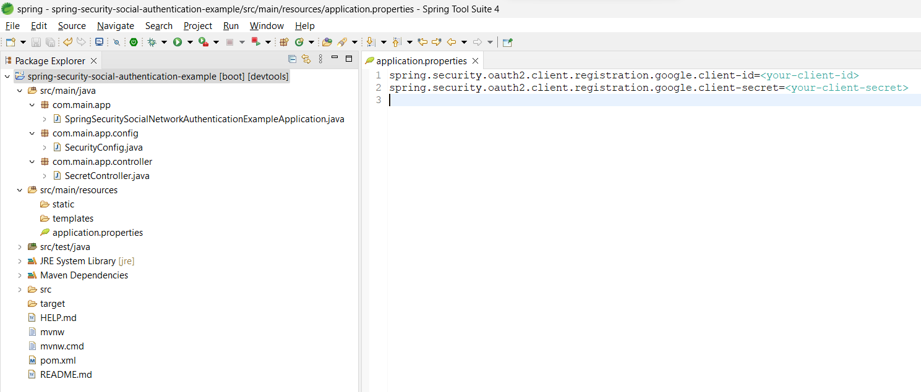](https://camo.githubusercontent.com/71645cfcdd723506822ddc69c22002bef7824e9fa11e188ded6f68e3cebe665b/68747470733a2f2f692e696d6775722e636f6d2f374a474b4d78342e706e67)

**Login**

Link: <http://localhost:8080/>

**Google Authentication Validation**

[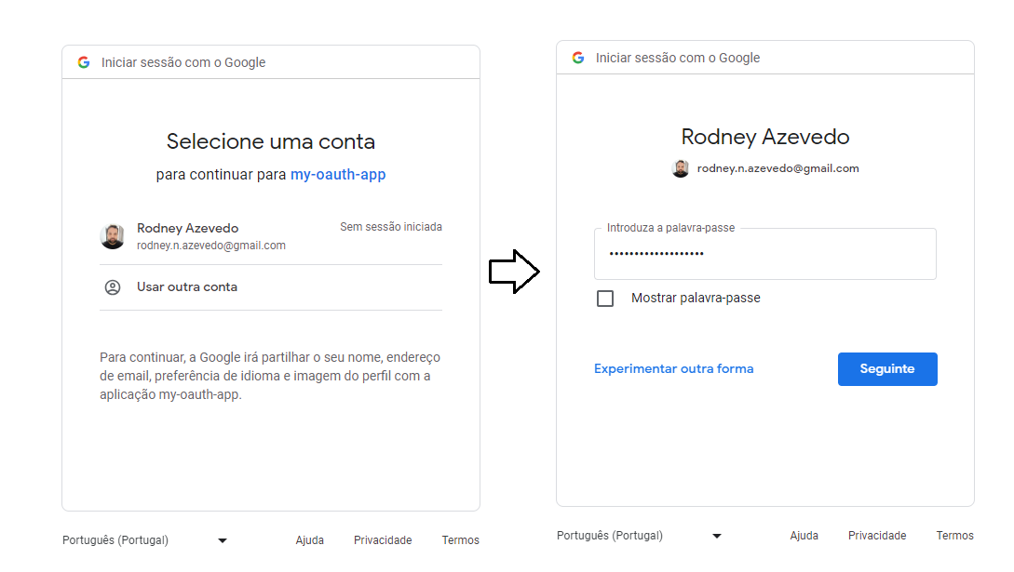](https://camo.githubusercontent.com/bf308a1ea63211bf1dcf8b3befe29e7a88a65a1658da58c030ca80e434c62a35/68747470733a2f2f692e696d6775722e636f6d2f6248795a68564f2e706e67)

[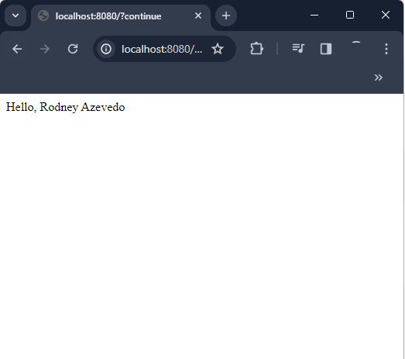](https://camo.githubusercontent.com/e7b04a7c8871503469ec67adb204f1c9a8df9e0a490bd53accc2ecbbb94f9b68/68747470733a2f2f692e696d6775722e636f6d2f366f7778336c5a2e706e67)

**Source file / directory structure**

[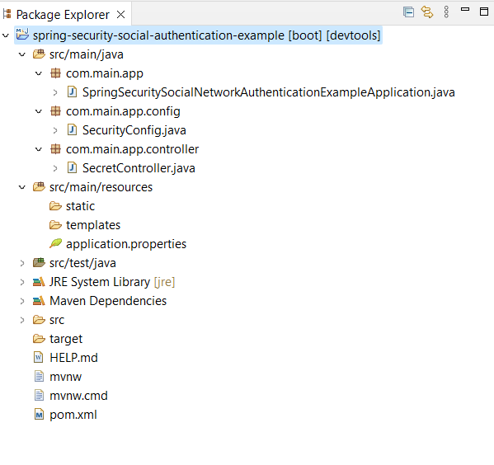](https://camo.githubusercontent.com/229aa797110229144d87f2488e566d1b7e275190c639c25e785e2ad52af1f8b4/68747470733a2f2f692e696d6775722e636f6d2f6e42524d79366b2e706e67)

**Java Version Troubleshooting (if necessary)**

*Change to the most current version*

[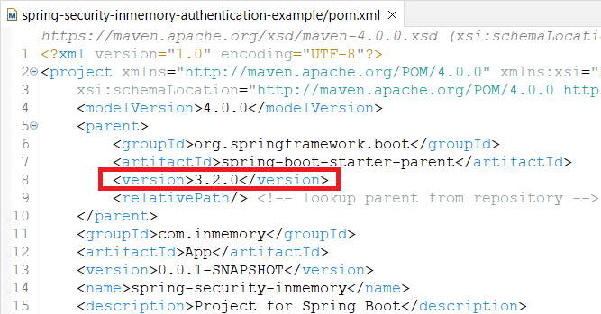](https://camo.githubusercontent.com/e2e82ad5129338c065b7c027150f847f8ae5717b33e516dd031a1477f2b57f74/68747470733a2f2f692e696d6775722e636f6d2f6d7067644461322e706e67)

*Uncheck****Enable project specific settings****option*

[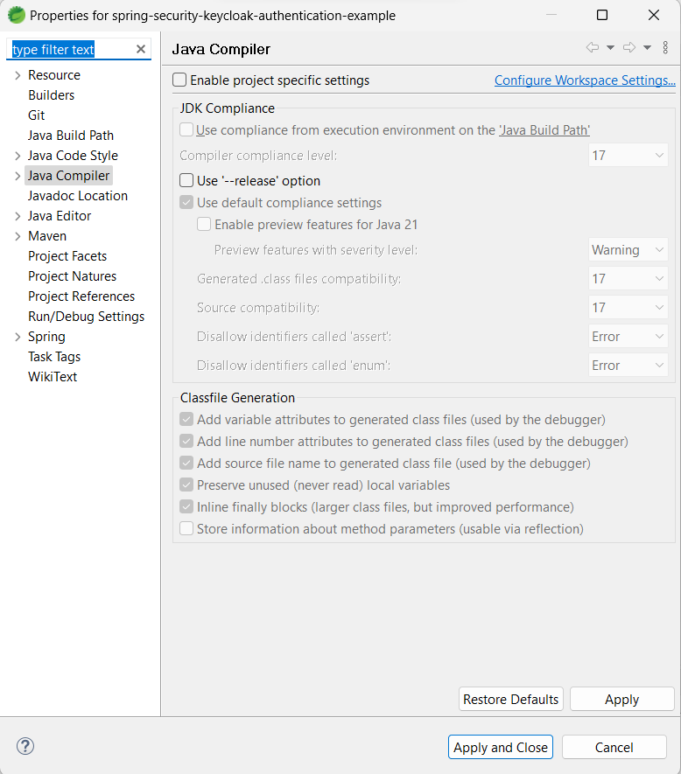](https://camo.githubusercontent.com/635255017474a6952e856d7940e1f76537f53176ec8d461805ec07a2489c278e/68747470733a2f2f692e696d6775722e636f6d2f4d35444155744d2e706e67)