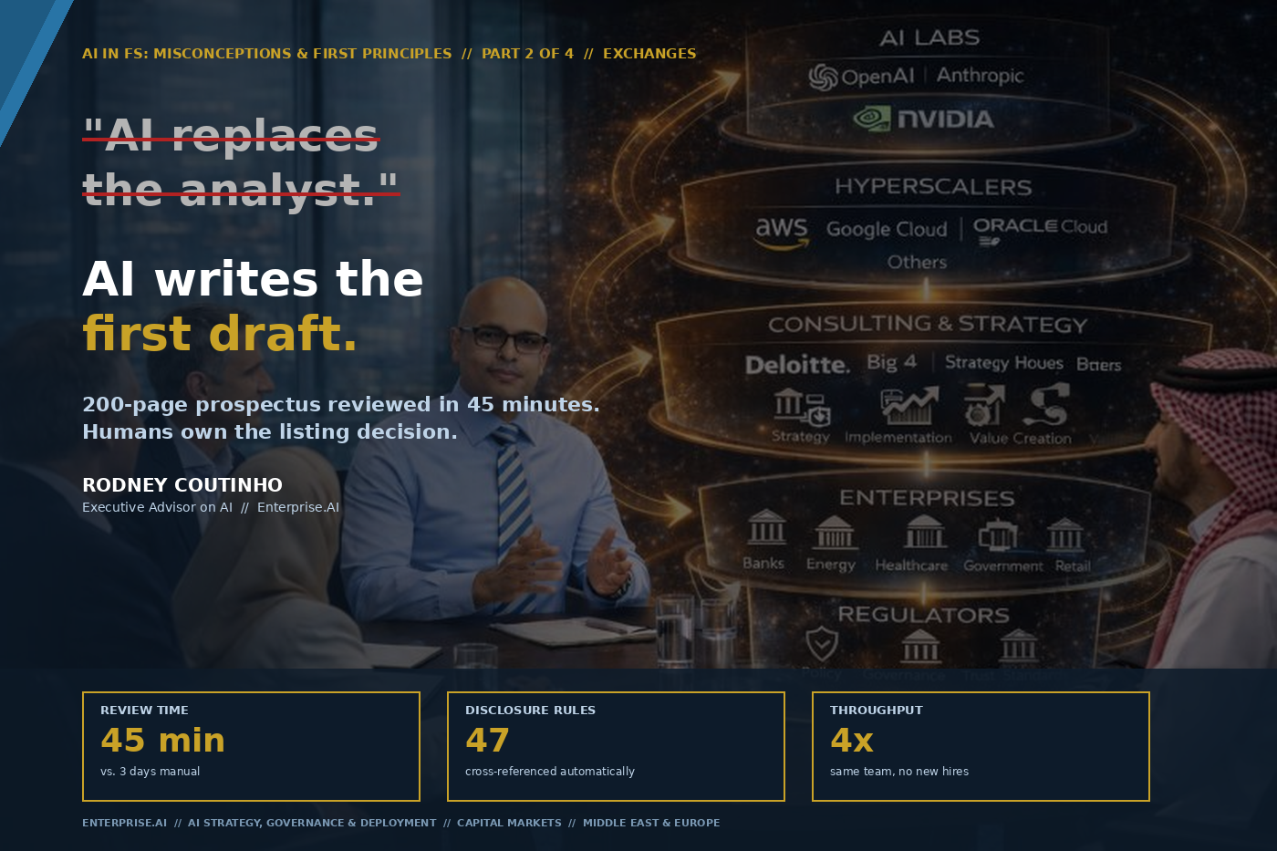

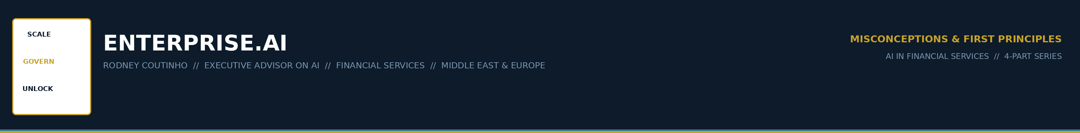
AI IN FINANCIAL SERVICES // MISCONCEPTIONS & FIRST PRINCIPLES
PART 2 OF 4 // EXCHANGES
Two versions of this misconception. Both wrong.
There are two versions of this misconception, and I hear both in every stock exchange and capital markets authority I advise.
Version A: "We can automate prospectus review. Deploy the model, reduce headcount by 60%, and clear the IPO backlog."

Version B: "AI can't be trusted with listing decisions. Too much liability. We'll wait."

The first misunderstands where the analyst's value lives. The second misunderstands what the technology does. In Part 1, I showed how banks burn AI budgets by asking models to do arithmetic. The fix was: code computes, AI judges. That principle extends here — from numbers to documents.
The result of getting this wrong: you either cut too aggressively and lose judgment — or you refuse to deploy and fall behind.

ENTERPRISE.AI // AI IN FS: MISCONCEPTIONS & FIRST PRINCIPLES // PART 2 OF 4 // 02

THE MISCONCEPTION
THE MISCONCEPTION
"AI replaces the analyst."
Automate the reading, cut the team. Or: too much liability — don't deploy at all.

A listing analyst receives a 200-page prospectus. They read it cover to cover. Cross-reference 47 disclosure requirements. Check financial statements against auditor opinions. Draft a completeness report.
Timeline: three days per prospectus. With twelve applications queued and four analysts, the backlog grows. IPO windows close. Issuers complain.
Neither the optimists nor the sceptics have asked the right question: where does the analyst's value actually live?
It does not live in reading 200 pages. It lives in the questions that come after.

ENTERPRISE.AI // AI IN FS: MISCONCEPTIONS & FIRST PRINCIPLES // PART 2 OF 4 // 03

THE FIRST PRINCIPLE
THE FIRST PRINCIPLE
AI writes the first draft.
Humans own the decision.
The analyst's role doesn't disappear. It elevates. From data extraction to judgment.
The listing decision is always human.

The questions the AI cannot ask:
"Is this management team credible?" • "Does this business model survive a rate cycle?" • "Is the market timing right for this sector?" • "What did we learn from the last IPO in this vertical?"

These are judgment calls that draw on experience, institutional memory, and market intuition. No model has them. No model should pretend to.
But the three days of reading, cross-referencing, and checklist completion? That is where the technology excels — and where the analyst's time is currently wasted.

ENTERPRISE.AI // AI IN FS: MISCONCEPTIONS & FIRST PRINCIPLES // PART 2 OF 4 // 04

WHAT THIS LOOKS LIKE IN PRACTICE
Prospectus Review Agent — designed for an exchange context.
45 min  REVIEW TIME | 47  DISCLOSURE RULES | 4x  THROUGHPUT

Phase 1 — Ontology-guided extraction.
Agent ingests the 200-page prospectus PDF. Extracts data against a defined ontology: section boundaries, financial tables, disclosure statements — each mapped to one of 47 regulatory requirements. Ontology-guided extraction, not free-form generation.
Phase 2 — Gap analysis and assessment.
The model assesses quality against the ontology. Flags gaps — some clear-cut, others borderline:
"Section 8.3 (Related Party Transactions) — no disclosure of board member interests in supplier contracts. Rule 42(b) requires explicit disclosure."

Human gate.
The analyst receives a structured output — not 200 pages, but a prioritised gap analysis. They review in 45 minutes. Focus shifts to judgment calls. The listing decision is always human.

ENTERPRISE.AI // AI IN FS: MISCONCEPTIONS & FIRST PRINCIPLES // PART 2 OF 4 // 05

THE THROUGHPUT REFRAME
The argument that changes the conversation: AI is a capacity multiplier, not a headcount reduction tool.
1 | 200-page prospectus → 45-minute analyst review.  The reading is automated. The judgment is elevated. The analyst focuses on management credibility, market timing, and sector risk — not checklist completion.

2 | 3 days → same-day turnaround.  Twelve queued applications cleared in one week instead of one month. IPO windows no longer close because the listings team can't keep up.

3 | Analyst headcount doesn't decrease. Throughput increases 4x.  The same team handles four times the volume. No redundancies. No recruitment crisis. The exchange becomes the venue where issuers want to list.

4 | Better audit trail than the manual process.  Every extraction logged. Every flag traceable to source page and rule number. The AI-assisted review is more auditable than the one done by hand.

Cost per review: ~$2.50 at the AI layer. Trivially cheap compared to three analyst-days.

ENTERPRISE.AI // AI IN FS: MISCONCEPTIONS & FIRST PRINCIPLES // PART 2 OF 4 // 06

THE ADVISORY CONVERSATION
When I sit with a Head of Listings or a Chief Regulatory Officer at an exchange, the questions are always the same:
"Won't this replace our analysts?"
No. It replaces the reading. The analyst's value isn't in reading 200 pages — it's in the questions they ask after.
"How do we handle liability?"
The AI flags. The analyst decides. The listing decision is always human. The audit trail is better than the manual process.
"What about edge cases — unusual structures, dual-class shares, SPACs?"
The ontology defines what the agent looks for. Edge cases surface as anomalies, not missed items. The agent says "I don't recognise this structure" rather than silently skipping it.
"Our prospectuses are in Arabic and English."
Language is where AI excels. Bilingual extraction is a strength, not a limitation.

ENTERPRISE.AI // AI IN FS: MISCONCEPTIONS & FIRST PRINCIPLES // PART 2 OF 4 // 07

THE BOTTOM LINE

The misconception — that AI replaces the analyst — leads to two dead ends. The principle — that AI writes the first draft and humans own the decision — unlocks a third path: the analyst's role elevates, the exchange's capacity multiplies, and the listing decision remains exactly where it should.

In Part 1, I showed how code computes and AI judges in a credit memo. Here, the same separation applies — extending from numbers to documents. The architecture principle doesn't change when the input is a 200-page PDF.
Next week — Part 3: We've established that code computes and humans decide. But who governs the AI itself? In investment management, the answer is usually a PDF in the compliance folder. That's the misconception.

ENTERPRISE.AI // AI IN FS: MISCONCEPTIONS & FIRST PRINCIPLES // PART 2 OF 4 // 08

THE SERIES
Four parts. Four verticals. Four misconceptions. Four first principles. Each with a working example.
01 | Banks | "AI should do everything." — Part 1
02 | Exchanges | "AI replaces the analyst." — This article
03 | Investment Mgmt | "AI governance is a compliance exercise." — Next week
04 | Insurance | "You need perfect data before you start."

RODNEY COUTINHO
Founder, Enterprise.AI // Executive Advisor on AI
AI Strategy, Governance & Deployment // Financial Services

ENTERPRISE.AI // AI IN FS: MISCONCEPTIONS & FIRST PRINCIPLES // PART 2 OF 4 // 09

ENTERPRISE.AI
SCALE · GOVERN · UNLOCK

Executive Advisor on AI
Banking · Capital Markets · Insurance · Investment Management
Middle East · Europe

theenterpriseai.co.uk
linkedin.com/in/rodneycoutinho

AI IN FINANCIAL SERVICES // MISCONCEPTIONS & FIRST PRINCIPLES
PART 2 OF 4 // EXCHANGES

