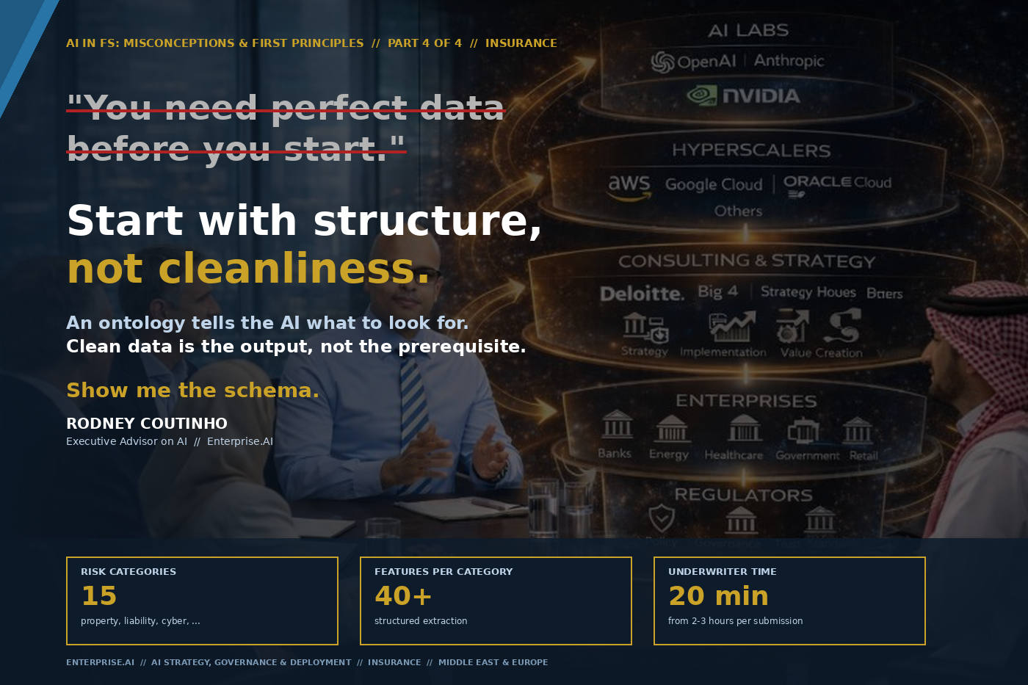

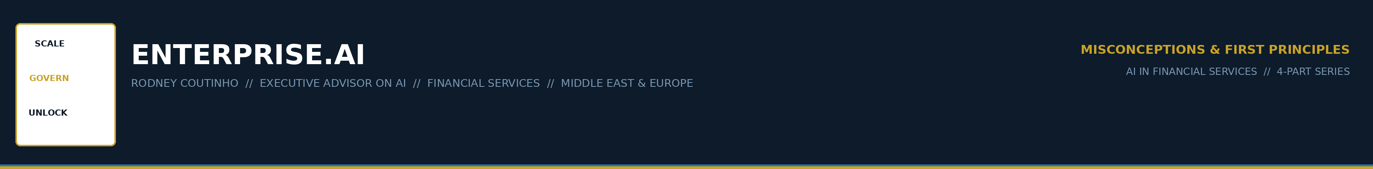
AI IN FINANCIAL SERVICES // MISCONCEPTIONS & FIRST PRINCIPLES
PART 4 OF 4 // INSURANCE
The most expensive mistake in insurance AI today.
An insurer sits on fifteen years of claims data in three systems. Different formats. Different codes. Medical reports scanned as PDFs in 2012. Loss adjuster notes buried in emails.
So the firm launches a data lake project. Eighteen months later, it is not finished.
Research shows approximately 80% of data lake initiatives fail to deliver their promised value. The data lake becomes the prerequisite for everything and the deliverable of nothing.

Meanwhile, underwriters still read forty-page broker submissions manually. Two to three hours per submission. Seventy percent of their time on data extraction.

ENTERPRISE.AI // AI IN FS: MISCONCEPTIONS & FIRST PRINCIPLES // PART 4 OF 4 // 02

THE MISCONCEPTION
THE MISCONCEPTION
"You need perfect data before you start."
Clean the data. Standardise the formats. Build the lake. Then deploy.

This sounds reasonable. It is the most expensive mistake in insurance AI today.
1 | Data cleaning is not a finite project  Claims data from 2012 coded differently from 2018. Medical reports are unstructured PDFs. Broker submissions arrive as a bundle of formats — no two the same.

2 | 74% extract, only 14% deploy  74% of Lloyd’s firms use AI for data extraction. Only 14% have deployed agents inside the underwriting workflow. The gap is where the advantage is being built.

3 | 80% of data lake projects fail  The data lake becomes the prerequisite for everything and the deliverable of nothing. Average implementation: 18+ months.

The firms waiting for clean data are not building the advantage. The competitive landscape is moving without them.

ENTERPRISE.AI // AI IN FS: MISCONCEPTIONS & FIRST PRINCIPLES // PART 4 OF 4 // 03

THE FIRST PRINCIPLE
THE FIRST PRINCIPLE
Start with structure, not cleanliness.
An ontology tells the AI what to look for. Clean data is the output, not the prerequisite.
Show me the schema.

CLEAN-DATA-FIRST | ONTOLOGY-FIRST AI
Clean 15 years of historical data | Define the schema, extract against it
18-month data lake project | Agent producing structured data from day one
Data quality as prerequisite | Data quality as byproduct of productive work
Separate cleanup before AI | Every extraction is a validation
Project that never finishes | Incremental improvement with every submission

ENTERPRISE.AI // AI IN FS: MISCONCEPTIONS & FIRST PRINCIPLES // PART 4 OF 4 // 04

WHAT THIS LOOKS LIKE IN PRACTICE
I designed an underwriting triage agent — it ingests broker submissions and extracts risk features against a defined ontology.
15  RISK CATEGORIES | 40+  FEATURES PER CATEGORY | 20 min  UNDERWRITER REVIEW

1 | Define the ontology  15 risk categories — property, liability, workers comp, auto, umbrella, cyber. 40+ features per category. Acceptable ranges. Required documentation.

2 | Extract against the schema  Agent ingests the submission package — PDFs, emails, spreadsheets — and extracts structured data against the ontology. Not freeform. Structured.

3 | Validate and flag  "Declared revenue ($12M) inconsistent with employee count (3). Expected range: $2M–$8M." The agent surfaces the anomaly. The human resolves it.

4 | Data quality improves  Every extraction populates the structured dataset. Anomalies surface. Patterns emerge. The data lake fills as a byproduct — not a prerequisite.

ENTERPRISE.AI // AI IN FS: MISCONCEPTIONS & FIRST PRINCIPLES // PART 4 OF 4 // 05

REGULATORY ALIGNMENT
Ontology-first extraction maps directly to what regulators are now requiring.
✓ | EU AI Act (August 2026)  Requires auditable documentation, bias testing, decision explainability. Ontology-defined extraction produces a structured, auditable record of what was extracted.

✓ | SDAIA Responsible AI Policy (April 2026)  Risk-tiering framework with proportionate obligations. An underwriting triage agent is high-tier. The ontology provides the documentation the regulator needs.

✓ | IFRS 17  Fundamentally changed how insurers measure and report contracts. Ontology-first extraction produces data in the shape that IFRS 17 measurement models require.

✓ | LMA AI Adoption Toolkit (April 2026)  Practical guidance on risk tiering, data protection, accountability. Encourages exactly the structured approach: define, govern, deploy incrementally.

The firms that build structure first are not just better governed. They are the ones that will pass the audits that are coming.

ENTERPRISE.AI // AI IN FS: MISCONCEPTIONS & FIRST PRINCIPLES // PART 4 OF 4 // 06

THE ADVISORY CONVERSATION
When I sit with a Chief Underwriting Officer or Head of Claims, the questions are always the same:
"Our data is too messy for AI."
That is exactly why you need AI. The agent extracts structure from mess. Every extraction improves the data. Waiting for clean data is waiting forever.
"We tried an AI project and it failed because of data quality."
Did you define the ontology first? Or did you point the model at raw data and hope? Structure is the prerequisite, not cleanliness.
"What about Solvency II and IFRS 17?"
The ontology is your regulatory map. Define features that align with risk categories and measurement models. The extraction produces data in the shape the regulator needs.
"How do we handle medical data?"
PII guardrails from Part 3. Medical data never leaves the environment. Extraction produces structured risk features, not raw medical text.
"What about legacy systems?"
The agent reads what your systems produce — PDFs, emails, spreadsheets. It requires document access, not system integration. That is a much simpler problem.

ENTERPRISE.AI // AI IN FS: MISCONCEPTIONS & FIRST PRINCIPLES // PART 4 OF 4 // 07

THE SERIES
Four parts. Four verticals. Four misconceptions. Four first principles. Each with a working example.
01 | Banks | "AI should do everything." — Published
02 | Exchanges | "AI replaces the analyst." — Published
03 | Investment Mgmt | "AI governance is a compliance exercise." — Published
04 | Insurance | "You need perfect data before you start." — This article

Four industries. One pattern.
Code computes. Humans decide. Governance is architecture. Structure before cleanliness.
The misconception changes. The first principles do not.

RODNEY COUTINHO
Founder, Enterprise.AI // Executive Advisor on AI
AI Strategy, Governance & Deployment // Financial Services

ENTERPRISE.AI // AI IN FS: MISCONCEPTIONS & FIRST PRINCIPLES // PART 4 OF 4 // 08

ENTERPRISE.AI
SCALE · GOVERN · UNLOCK

Executive Advisor on AI
Banking · Capital Markets · Insurance · Investment Management
Middle East · Europe

theenterpriseai.co.uk
linkedin.com/in/rodneycoutinho

AI IN FINANCIAL SERVICES // MISCONCEPTIONS & FIRST PRINCIPLES
PART 4 OF 4 // INSURANCE

