Build New Virtual Machine Web Server in Live Environment

REVISION HISTORY

|  |  |  |
| --- | --- | --- |
| **Author** | **Comments** | **Date** |
| Tracy Hartzler | Initial Draft derived from SOP_SCM-0605-14_Build_Install_Web_Server | 9.22.2015 |
|  | SOP Validation Review on new web server SJPRWEB40 |  |
|  |  |  |
|  |  |  |
|  |  |  |
|  |  |  |
|  |  |  |
|  |  |  |
|  |  |  |
|  |  |  |

**TABLE OF CONTENTS**

PURPOSE 3

1.0 PROCEDURE 3

1.1 Scope and Applicability 3

1.2 Summary of Method 3

1.3 Risks and Definitions 5

1.4 Cautions 6

1.5 Roles & Responsibilities 6

PHASE I 7

1.8 Procedure: Pre-Maintenance Tasks 7

PHASE II 14

1.9 Procedure: Pre-Maintenance Tasks 14

PHASE III 38

1.10 Procedure: Maintenance Tasks 38

PHASE IV 43

1.11 Procedure: Processing Live IMS Data Tasks 43

PHASE V 44

1.12 Procedure: Start Processing Web Traffic 44

2.0. VALIDATION 44

IMPORTANT NOTE: 45

3.0 REFERENCES 46

3.1 Change Management Policy 46

Infrastructure_Change_Management_Policy_v2.docx 46

3.2 Web Server Certification Project Wiki page 46

3.3 CCR for Adding a new Web Server in Live Environment 46

3.5 Checklist for SOP SCM-0508-14 46

3.7 How to Run the BVT Test Wiki Page 46

3.8 Documents in Wiki relating to building new server in the data center 46

4.0 Appendix 47

4.1 (1.8.3 Pre-Maintenance Task 3) Certificates Table 47

4.2 Manual Deployment Instructions 48

# PURPOSE

The purpose of adding a new Web server is to add more IMS instances to improve messaging throughput and to enable additional web traffic capacity for the production environment. ***The main requirement of this task is to create and put the new server into service safely and with very high confidence that there are zero (0) impacting issues.***

The procedure listed below ensures that the outcome stated above is consistently reproducible for every Web server built using the procedure.

Each of the tasks in the following procedure require an SME. Anyone with the requisite knowledge in the task area should be able to complete these tasks with the information provided.

Each participant in the server buildout must be familiar with the following procedure and should review the procedure prior to beginning any of the tasks. A checklist has been created that maps to the numbered tasks. Print out or open the checklist and check off tasks that have been completed. If you discover a discrepancy or a new detail or new task that needs to be added to this document, please make notes in your copy of the SOP and send to the appropriate team for review and acceptance into the document.

# 1.0 PROCEDURE

## 1.1 Scope and Applicability

The purpose for this SOP is to authorize and guide the building and installing of a new Web server in the RelayHealth SV5 data center Production environment. The Web server is to be built with 3 build phases and 2 monitoring phases to ensure that it complies with all baseline expectations following Phases I, II and III prior to processing live IMS messages in Phases IV and starts handling Web traffic in Phase V.

## 1.2 Summary of Method

1.2.1 Prerequisites – before beginning procedure

1.2.1.1 All participants must review and be familiar with this SOP

1.2.1.2 All participants must be familiar with the Infrastructure Change Management Policy regarding submitting a CCR and maintenance windows. See the reference section at the end of this document for a link to the Change Management Policy and a sample CCR.

1.2.1.3 Release manager (the manager of the team that is building the server) must complete a new CCR for each buildout.

1.2.1.4 Read and understand the tasks in the checklist associated with this SOP.

1.2.1.5 Need to obtain access to PAC Secrets via PAC request.

Login to the following:

<https://pac.mckesson.com>

Select OU=PAC Managed …. RHC PAC Secrets access.

Login to SV5 PAC with your PAC Secrets account (not regular McKesson account) to see the secrets

-NAMCK\username password

-First OTP token

-Second OTP token

-Click on HOSTS tab

-Enter “SJPRWEB” into 2nd field at top

-Should display list of all the servers

1.2.1.6 Need to obtain administrator access (PAC) for the following servers:

SV5-SJMGDEP01

SV5-SJMGDPP01

SV5-SJPRFAB01

SV5-SJPRETL01

SV5-SJPRWEB’s

RHC-HSQADEP01

1.2.2 Build Phases

The following summaries describe at a high level the phased building of a new Web server. Each of these phases has a static baseline that is the referred to as the “truth”. There is one Web Server Certification (WSC) test that when run, determines which phase the buildout is in and runs the appropriate tests for Phase I, Phase II and Phase III. The test compares the baseline with what is found on the target server (testserver) and performs evaluations and then creates output files for each component tested.

For more detail regarding the WSC test methodology see the REFERENCES section Web Server Certification Project.

**Phase I**

This phase contains the "base image" and some manual installations. There is no RelayHealth code or services installed at this time. This is the first gate and the validation must pass in order to advance to Phase II of the build out.

**Phase II**

When the Phase II steps are completed the RelayHealth code or services are installed, but the server is in a "safe" state and can be left in that state until the maintenance window is available to perform Phase III. At this point all the interop and Web services exist but are in a safe state and cannot process messages. "Safe" state means that all the Interop and RelayHealth services are disabled and stopped. The GPO cannot automatically restart these services. This phase includes deploying all Core, InteropApplications, HydroPlatform and Verification code, RelayHealth and Interop services and to finalize all configurations.

**Phase III**

This is the phase that enables all of the services on the server, without allowing the server to process live data. In this phase we essentially turn everything on and validate that all is in an expected state.

**Phase IV**

This is the phase where the server begins to process live IMS data and includes monitoring steps.

**Phase V**

This is the web traffic processing and monitoring phase.

## 1.3 Risks and Definitions

1.3.1 Risk assessment explaining what will happen if the procedure is not followed or is followed incorrectly; listed here and at the critical steps in the procedure),

If the web server is not built following the approved methodology and this procedure there is:

* a risk of not having the correct image containing the correct components as expected in Phase I
* a risk of not having the correct components in the correct state as expected in Phase II
* a risk of incorrectly setting up the servers, and failing to process messages and web requests successfully, causing production downtime
* a risk of going fully live unexpectedly and receiving web traffic

1.3.2 Definitions (identifying any acronyms, abbreviations, or specialized terms used),

|  |  |
| --- | --- |
| **Term** | **Definition** |
| Maintenance | The work that is being performed by this procedure in the maintenance window. |
| Maintenance Window | The designated time frame for performing the maintenance |
| Pre-Maintenance Window | The designated time frame for doing the prep work that has to be completed prior to the maintenance work, outside the maintenance window |
| Network Maintenance Window | Weekly on Tuesday/Wednesday/Thursday, 2:00PM – 4:00PM |
| Production | Some people refer to any environment that is customer facing to be a production environment. While true, for purposes of this SOP, this definition means specifically the Production environment versus the Demo, Integration or Staging environments. |
| Base Image | The Phase I configuration of the server. Includes all items required prior to starting Phase II. The SA team is responsible for the tasks involved. |
| WSC | Web Server Certification – A rigorous process was performed to certify that the WSC Test is a valid verification of the intended correct state of a new production web server as it is put into service. |
| SCE | Software Configuration Engineer. |
| Target Server | The new Web server being built. |
| SME | Subject Matter Expert. The person fulfilling a specific role has the requisite knowledge and expertise to start and complete the task. |
| BVT | Build Verification Test |
| GPO | Group Policy Object |

## 1.4 Cautions

Cautions (indicating activities that could result in equipment damage, degradation of service, or possible invalidation of results; listed here and at the critical steps in the procedure),

* Phase I must be completed and fully validated prior to beginning Phase II.
* There must be a manual stop at the end of Phase II to validate that the server is in the expected configuration prior to performing Phase III.
* There must be live monitoring in place for Phases IV and V to ensure that the new server is not causing new unique errors
* Server will be processing live IMS data after completion of task **1.11.1 Processing Live IMS Data Task**
* Server will be accepting Web traffic after completion of task **1.12.1 Processing Web Traffic Task 1**

## 1.5 Roles & Responsibilities

1.5.1 SOP owner (Automation Team DevOPS Engineer)

Role responsible for creating and maintaining this SOP.

1.5.2 Software Configuration Engineer (SCE)

Role responsible for the following areas of the buildout:

1.5.2.1 Coordinating the buildout with all participants

1.5.2.2 Creating test file folders on the server

1.5.2.3 Validating that Phase I meets baseline expectations before starting Phase II

1.5.2.4 All Phase II and III build and configuration tasks

1.5.2.5 All Procedure tasks with Role = SCE

1.5.3 Network Administrator (NA)

The role responsible for adding the node to the F5 and the following:

1.5.3.1 All Procedure tasks with Role = NA – Adminstrator

1.5.3.2 All Procedure tasks with Role = NA – Security

1.5.3.3 All Procedure tasks with Role = NA – Monitoring

1.5.4 System Administrator (SA)

The role responsible for the initial build phase (Phase I) of the new Web server and the following:

1.5.4.1 All Procedure tasks with Role = SA

1.5.5 Network Operations Center (NOC)

The role responsible for monitoring the system for errors during the “go live” Phases IV and V and the following:

1.5.6.1 All Procedure tasks with Role = NOC

1.5.6.2 Accepting the server into the environment after passing Phase V.

Steps 1.6 and 1.7 were intentionally removed.

## PHASE I

## 1.8 Procedure: Pre-Maintenance Tasks

Identify all pertinent steps, in order, and any other information needed to accomplish the procedure task prior to the prescribed maintenance window. Phase ensures that the base image and all the system administrative tasks are completed correctly and consistently for each new server being built. To that end they have put together a task list with screenshots which is available as a link in the REFERENCES section at the end of this document.

**1.8.0 Pre-Maintenance Task 0 - Remote**

*Role: System Configuration Engineer (SCE)*

***Task Description:* Phase I – Create test folder structure and copy test files** from remote server to the target server.

*Task Details:* *Create the DevOpsScripts folders on the target server.*

* Log onto SJMGDEP01 in SV5 using rhb.ad credentials
* Launch an Administrator session of PowerShell
* Navigate to *F:\ServerVerification\Infrastructure\RelayHealth*\*RunRemoteScripts*\
* Open file RH_WebServerNames_Deploy.config in Notepad ++
* Remove any other server from the “NewWeb” environment list.
* Add the target server to the “NewWeb” environment.
* Run command:

.\Setup_DevOpsScripts_Folders.ps1 -username -password -environment NewWeb

* This will create all the required folders in C:\Setup\DevOpsScripts and copy all the required baseline and test script files.
* Run command:

.\RH_CopyAllFiles_Web.ps1 -environment NewWeb

* This will copy all the required baseline and test script files to the new server.

*Validation:* When you log into the server in 1.8.6 to run the test you can visually inspect for the folders and tests etc. If you run the test and the folders/files don’t exist you will get failure messages in PowerShell instance.

**===============================================================================**

**Documents in Wiki relating to building new server in the data center.**

<https://wiki.relayhealth.com/standard-operating-procedure/new_server_build_in_data_center>

Link: 4 OS deployment using PXE Boot.doc

Link: 5 Installing Windows SCOM Agent.docx

**===============================================================================**

**1.8.1 Pre-Maintenance Task 1**

*Role:* SA

***Task Description:* Phase I - Run AD_Framework script**

*Task Details:* Must be done before creation of the new server

See document: 4 OS deployment using PXE Boot.doc

* + Login to **SJMGNET01** (or any management server that this can be done from)
  + Must be domain administrator to run the following script.
  + Login to **SJMGDEP01**
  + Open PowerShell in Admin Mode
  + Browse to: C:\Scripts\ AD_Framework \AD_Framework_Non_Management_GP_10132014
  + Run: DeployMaster.ps1

*Validation:* WSC Phase I Test

*Notes:*

* Has to be done by SAT because we (Automation team) don’t have permissions to run.
* Script runs but displays errors on host. Completes successfully.

**1.8.2 Pre-Maintenance Task 2**

*Role:* SA

***Task Description:* Phase I – Install the Base Web Server Image**

*Task Details:*

See document: 4 OS deployment using PXE Boot.doc

* + Done via System Center
* OS Installation using SCCM. (We have a dedicated image for Relay Health Web Server Build and I have used that image).

*Validation:* The SCCM console will show as completed.

And the WSC Phase I Test will show missing components.

**1.8.3 Pre-Maintenance Task 3**

*Role:* SA

***Task Description:* Phase I – Manual steps to execute after executing the Web Server Base Image**

*Task Details:*

**1.8.3.1 Assign static IP on the target server.**

* Launch a command window
* Enter ipconfig /all

*Validation:* Expected result: DHCP Enabled = No

**1.8.3.2 Add server to domain**

See document: 4 OS deployment using PXE Boot.doc

* Log onto the target server
* Go to System properties
* Verify that Domain = domain name (rhf.ad)

*Validation:* Log on with domain account.

**1.8.3.3 Push SCOM agent from Operations Manager**

See document: 5 Installing Windows SCOM Agent.docx

* From SCCM console, locate target server and install agent.
* Installs Microsoft Monitoring Agent application.

*Validation:* WSC Phase 1 applications test

*Notes:* After joining domain SCCM will automatically push agent to target server.

**1.8.3.4 Patch server**

* Launch WUAPP via Run window.

*Validation:* There should be no important updates available to download

**1.8.3.5 Run WebEpermissions.ps1**

* Target server script location: C:\Setup\SCM\Tools
* Run command ./WebEpermissions.ps1

*Validation:*

* Launch Windows Explorer.
* Right-click on Data (E:) folder to display properties.
* Click on Security tab.
* Click on PRWEB_DL-E$(RHF\PRWEB_DL-E$)

Verify that the “Modify” permission been set.

* Close the properties window.
* Right-click on OSDisk (C:\InetPub\logs) folder to display properties.
* Click on PRWEB_DL-InetpubLogs$(RHF\ PRWEB_DL-InetpubLogs$)

Verify that the “Modify” permission been set.

*Notes:* Script runs but displays errors on host. Completes successfully.

**1.8.3.6 Ensure that 1 server certificate (SJPRWEBXX.RHF.AD) exists in MMC console.**

* This certificate gets put on by group policy (GPO)

*Validation:*

* Launch MMC from Run window.
* In Console1 File menu: Click “Add/Remove Snap-in” item.
* Click on “Certificates”
* Click on “Add”
* Next window, select “Computer Account” and then click “Next”.
* Next window, select “Local computer” and then click “Finish”.
* In the Add or Remove Snap-ins window, click “OK”.
* In the Console 1 window, expand the “Console Root\Certificates” folder.
* Expand the “Personal” folder.
* Click on “Certificates”

Result: The SJPRWEBXX.RHF.AD certificate should be displayed.

*Notes:* [thartzler] I have checked the current baseline and all the online PRWEB servers and they only have 1 of these certificates.

**1.8.3.7 If found, remove all other certificates in the “Personal” folder (except for those found in 1.8.3.6 step)**

*Note:* This is here because it was believed that the current base image has other server named certificates and they must be removed.

*Validation:* Only 1 certificate remaining the “Personal” folder.

**1.8.3.8** **Manually add all certifica**tes – See Certificates Table in the Appendix

Current production certificate list:

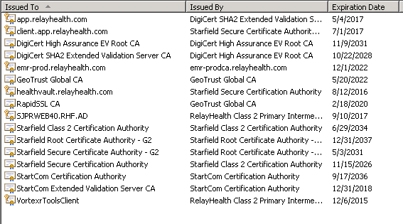

All the certificate authorities above except for GeoTrust Global CA will be installed as each certificate is installed.

The GeoTrust Global CA can be copied from another server as in the steps below for copying certificate authorities.

* Find the certificate in the following Share site.

<http://share.relayhealth.com/security/Lists/Encryption%20Certificates/Censored%20View.aspx>

1. Download certificate from Share
2. Copy to desktop on target server.
3. From the MMC console:
4. Right-click on the \Personal\Certificates folder
5. Right-click on All Tasks
6. Select Import to launch the Welcome to the Certificate Import Wizard.
7. Click Next
8. Enter file name by browsing to file location and selecting the file.
9. Click Next
10. Enter Passphrase from the Share page for the certificate to the Password field in the wizard.
11. Click Next
12. Keep default Certificate Store (Personal) unless the certificate needs to go to the (Trusted People) store.
13. Click Next
14. Click Finish

*Validation:* WSC Phase 1 compareCertificates_Phase1 test passes.

**1.8.3.9** **Copy certificate authorities to target server.**

* + Log on to Source web server
  + Log on to Target web server
  + Open trusted certificateauthorities for Source and Target web server.
* Launch MMC from Run window.
* In Console1 File menu: Click “Add/Remove Snap-in” item.
* Click on “Certificates”
* Click on “Add”
* Next window, select “Computer Account” and then click “Next”.
* Next window, select “Local computer” and then click “Finish”.
* In the Add or Remove Snap-ins window, click “OK”.
* In the Console 1 window, expand the “Console Root\Certificates” folder.
* Expand the “Trusted Root Certification Authorities” folder.
* Click on “Certificates”
* In Console1 File menu: Click “Add/Remove Snap-in” item.
* Click on “Certificates”
* Click on “Add”
* Next window, select “Computer Account” and then click “Next”.
* Next window, select “Another computer” and then click “Finish”.
* Enter the computer name for the computer you want to copy from. Example: SJPRWEB15
* Click “Finish”
* In the Add or Remove Snap-ins window, click “OK”.
* The just added computer name, Certificates will display.
  + Copy all the certificateauthorities from Source to Target server certificateauthorities’ folder.
* Expand the “\\SJPRWEB15\Trusted Root Certification Authorities” folder.
* Click on “Certificates”
* Select all the certificate authorities
* Right-click and select “Copy”
* Select the Local Computer \Personal\Trusted Root Certification Authorities and paste into that list.
* Right-click and select “Paste” into this list.
* Click “Yes” to replace each existing certificate.

*Validation:* WSC Phase I Test

**1.8.4 Pre-Maintenance Task 4**

*Role: System Configuration Engineer (SCE)*

***Task Description:* Phase I - Create WinRM listener.**

*Task Details:*

* + Log onto the target server
  + Copy the file *WinRM.ps1* from the *\\SJMGDEP01\F$\SCM\BuildOut\hwebsource\scripts* to Target server C:\Setup
  + Launch an Administrator session of PowerShell
  + Run commands *Set-Location* C:\Setup and *.\WinRM.ps1*
  + Run "gpupdate /force" on the target server and reboot if necessary

*Validation 1: Host will display “The following listener is created on this SJPRWEBXX.RHF.AD”*

*Validation 2:* Run the WinRM_Test_Remote.ps1 script

* Login to SJMGDEP01
* Launch an Administrator session of PowerShell
* Navigate to *F:\ServerVerification\Infrastructure\RelayHealth*\*RunRemoteScripts*\
* Run command:

.\WinRM_Test_Remote.ps1 -username -password -environment NewWeb

Expected result:

SJPRWEB30.RHF.AD

Connecting to SJPRWEB30.RHF.AD on port 5986 with the ssl flag turned on

Testing WinRM

Remote session successfully opened.

**1.8.5 Pre-Maintenance Task 5**

*Role: System Configuration Engineer (SCE)*

***Task Description:* Phase I - Additional installations and known exceptions.**

*Task Details:*

**1.8.5.1 Install Active Directory Management Pack Helper Object application.**

* Need steps for this task.
* Installed from System Center Operations Manager?
* Is this an Orchestrator step?

*Validation:* WSC Phase 1 applications test

*Notes:* Need installation information

**1.8.5.2 Remove NetWorker application.**

* Launch Control Panel
* Click on Programs
* Click on Programs and Features
* Right-click on the NetWorker program and select “Uninstall”

*Validation:* WSC Phase 1 applications test

**1.8.5.3 Install Riverbed AppInternals application.**

* Installation steps documented in https://wiki.relayhealth.com/rh-dev-doc/riverbed_appinternals_windows_agent_installation

Wiki page covers:

* Riverbed AppInternals application install
* BlackBox Monitoring Agent install
* DotNet Monitoring Agent Configuration
* Validations

*Validation:* WSC Phase 1 applications and services test

**1.8.5.4 OPNET AppInternals Xpert Managed Node application.**

* Should be removed when Riverbed is installed above.

*Validation:* WSC Phase 1 applications test

**1.8.5.5 McAfee Solidifier 32 bit version.**

* New McAfee package does not include this.

*Validation:* WSC Phase 1 applications test, will be a known exception.

*Notes:* Put in the production known exceptions list.

**1.8.5.6 McAfee VirusScan Enterprise.**

* Has to be the same version as what is currently in production.

*Validation:* WSC Phase 1 applications test

**1.8.5.7 Intel(R) Network Connections 18.7.28.0**

* Not all Web servers have the same NIC.

*Validation:* WSC Phase 1 applications test. Will be a known exception until application baselines are changed.

*Notes:* That will happen when some other NIC becomes the predominant NIC in production.

**1.8.5.8 Intel(R) Network Connections 19.6.171.0.**

* Matching exception for 1.8.5.8

*Validation:* WSC Phase 1 applications test

*Notes:* Will be a known exception until this NIC becomes the predominant NIC in production.

**1.8.6 Setup routing.**

* Need steps for this task.

*Validation:* WSC Phase 1 applications test

*Notes:*

**1.8.7 Pre-Maintenance Task 6**

*Role: System Configuration Engineer (SCE)*

***Task Description:* Phase I - Run the Web Server Certification (WSC) Test and archive the Test Data**

*Task Details:* The master test script should detect that this server is in Phase I by determining that

* Did not find folder E:\RelayHealth\Deployhelp, code has not been deployed.
* This is a WEB server, running the Web Server Certification PHASE I test scripts.

*Task Details:* perform the following:

* + Log onto the target server
  + Launch PowerShell as Administrator
  + CD to C:\setup
  + Run Command.\Next_Test_Cleanup.ps1 – server SERVERNAME Removes and archives any test artifacts from the necessary folders so that each test ends up with only the artifacts from the current test.
  + CD to C:\setup\Scripts_Local_SVMaster
  + Run Command .\RH_WebServerCertification_Master_PROD.ps1

*Validation:* All tests should pass, cannot advance to Phase II until all issues are resolved. PASS means no FAILED tests,

* + if you get a FAILED result then it will have to be investigated and determined whether to fix the problem and get a PASSED result or make a baseline change that will affect ALL WEB SERVERS in the environment, not just the new server
  + If you get a WARNING then it will have to be investigated and determine how to proceed. If you make a baseline change it will affect ALL WEB SERVERS in the environment, not just the new server

*Task Details: After the FINAL Phase I test passes, archive the folder,* and perform the following:

* + Log onto the target server
  + Open Windows explorer and navigate to C:\setup
  + Select the \DevOpsScripts folder and copy using the copy command.
  + During iterative testing, after running test, copy C:\setup\DevopsScript folder and RENAME as “DevOpsScript_Phase1_2” etc. for each iteration of the test.
  + After last test, Rename the copied folder DevOpsScripts_Phase1_Final

*Notes:* The Phase I, II and III archives will be used for baseline analysis by the automation team. Do not ignore this step.

See 2.0 Validation section for more details regarding the tests.

## PHASE II

## 1.9 Procedure: Pre-Maintenance Tasks

Identify all pertinent steps, in order, and any other information needed to accomplish the procedure task prior to the prescribed maintenance window.

**1.9.1 Pre-Maintenance Task 7**

*Role: System Configuration Engineer (SCE)*

***Task Description:* Phase II - Identify the Build Version and Release Name.**

*Task Details:*

* Go to <https://app.relayhealth.com/info.aspx> . Note the Version number.

To get the correct production release build number,

* Log onto a current live Web server in production
* Open a command window and get directory, dir E:\RelayHealth.
* This will show the <Junction> which contains the build number.
* Record the build number in the checklist

*Validation:* None

**1.9.2 Pre-Maintenance Task 8**

*Role:* NA - Security

***Task Description:* Phase II - Add the New Server to the Windows firewall rules in the Group Policy (GPO).**

*Task Details:*

* + Increase the range of the web server IP’s in the firewall rules for connectivity between the web servers, mongo/SQL servers, PCA servers etc.

*Notes: Someone will need to make the request to the network team and determine when this gets done.*

*Validation:* WSC Phase II Test

***Task Description:* Phase II –Update the Group Policy for the Windows Firewalls on the Production SQL Server databases**.

Permissions required: Domain Administrator of RHB.AD domain

**Steps:**

* Log onto the Domain Controller SJMGDCB01/02
* Start -> Control Panel -> Administrative Tool -> Group Policy Management
* Open the RHB.AD forest and the RHB.AD domain
* Group Policy Objects -> PRDBA-Group-Policy
* Select Settings tab
* Open Computer Configuration -> Policies -> Windows Settings -> Security Settings -> Windows Firewall and SCW
* Add the web server(s) IPs to the IP Range of the Firewall Rules that specify web server IP ranges.

**Task Description: Phase II –Update description of Mongo IPTables firewall (Puppet) changes.**

Chidam added the IPtables Rules on the puppet server:

Steps:

* The Modules are located on the Puppet Server:
* /etc/puppetlabs/puppet/modules/rh-prmgo/manifests/init.pp
* Verification: On the MongoDB server you can check the iptables:

ACCEPT tcp – 0.0.0.0/0 0.0.0.0/0 source IP range 10.100.105.220-10.100.105.223 multiport ports 9001 /* 112 accept SJPRWEB30-33 server connections to Mongo DB */

**Task Description: Phase II – AppFabric Windows Firewall Group Policy Update**

* Log onto the Domain Controller SJMGDCB01/02
* Start -> Control Panel -> Administrative Tool -> Group Policy Management
* Navigate to Servers\Environments\PRODUCTION
* Right-click on \PRFAB folder
* Click on PRFAB SCW and Firewall Policy object
* Navigate to Computer Configuration\Policies\Windows Settings\ Name Resolution\Windows Firewall
* Select Inbound rule
* Select “Allow inbound connections for service: AppFabricCachingService for protocol: TCP”
* Add target server IP address

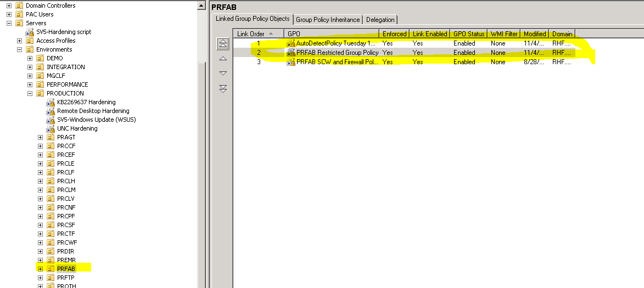

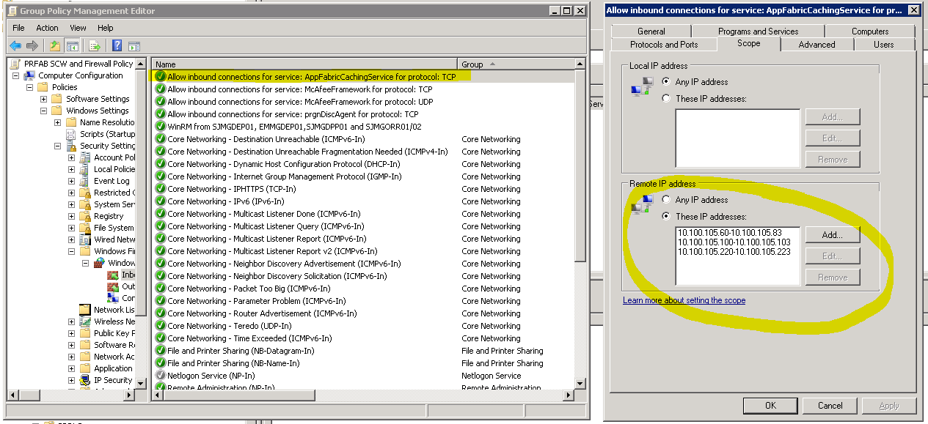

**1.9.3 Pre-Maintenance Task 9**

*Role:* NA - Adminstrator

***Task Description:* Phase II - Add the node in F5.**

*Task Details:* Request NA to add a node with the following information

Create a Jira ticket, assign to NAT team.

Sample ticket:

Infrastructure IX-968

Add nodes SJPRWEB's 30,31,32,33 to F5

SJPRWEB30 IPv4 10.100.105.220

SJPRWEB31 IPv4 10.100.105.221

SJPRWEB32 IPv4 10.100.105.222

SJPRWEB33 IPv4 10.100.105.223

App pool Names =

PROD_APP_POOL_443, PROD_APP_POOL_9200,

PROD_NIMCL_1199, PROD_NIMCL_16000,

PROD_NIMCL_16001, PROD_APP_POOL_8443

State = Disabled

The steps would be:

1. Add node to the appropriate partition (stage, production, integration, common, etc.)
2. Disable the node (if desired)
3. Configure node to be in all web pools (NIM_CL, rTools, API, API_CL, APP443/8443)
4. Add node to Member switch F5 iRule and test it.

*Validation:* None

*Notes:* In Phase IV member switch for the node should work. In Phase V the node should be green in the live Prod Pool.

**1.9.4 Pre-Maintenance Task 10**

*Role: System Configuration Engineer (SCE)*

***Task Description:* Phase II - Copy the Core code archive into SJMGDEP01 \RelayHealth\Releases folder.**

*Task Details:*

* + Log Onto SJMGDEP01 on SV5 using rhb credentials (destination)
  + Open the destination folder on SJMGDEP01 *F:\SCM\Buildout\hwebsource\dirstruct\RelayHealth\Releases*
  + Open the source folder on SJMGDPP01
  + Launch new Windows Explorer and enter the following: \\sjmgdpp01\codetemp$\Core (E:\CodeTemp\Core)
  + Copy the *Buildversion.zip* file of the version in step 1.9.1 from SJMGDPP01 share to the destination folder
  + Sample file name <ci5.8.1.122743.zip>

*Validation:* Verify that the Core code archive is copied.

To get the correct production release build number, open command window and get directory E:\RelayHealth. This will show the <Junction> which contains the build number.

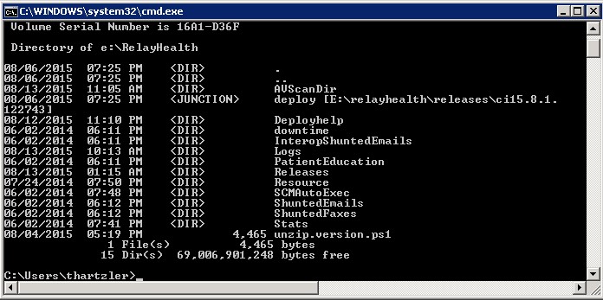

Corresponding zip file for the current released build on SJMGDPP01:

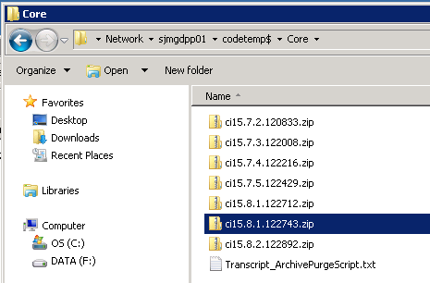

**1.9.5 Pre-Maintenance Task 11**

*Role: System Configuration Engineer (SCE)*

***Task Description:* Phase II - Copy the Interop code archive into SJMGDEP01 \interopApplications\Releases folder.**

*Task Details:*

* + Log Onto SJMGDEP01 on SV5 using rhb credentials (destination)
  + Open the destination folder on SJMGDEP01 *F:\SCM\Buildout\hwebsource\dirstruct\interopApplications\Releases*
  + Open the source folder on SJMGDPP01
  + Launch new Windows Explorer and enter the following: \\sjmgdpp01\codetemp$\Interop
  + Copy the *Buildversion.zip* file from SJMGDPP01 share to the destination folder

*Validation:* Verify that the build is copied.

**1.9.6 Pre-Maintenance Task 12**

*Role: System Configuration Engineer (SCE)*

***Task Description:* Phase II - Copy the HydroPlatform code archive into SJMGDEP01 \HydroPlatform\Releases folder.**

*Task Details:*

* + Log Onto SJMGDEP01 on SV5 using rhb credentials (destination)
  + Open the destination folder *F:\SCM\Buildout\hwebsource\dirstruct*HydroPlatform *\Releases*
  + Open the source folder on SJMGDPP01
  + Launch new Windows Explorer and enter the following: \\sjmgdpp01\codetemp$\HydroPlatform
  + Copy the *Buildversion.zip* file from SJMGDPP01 share to the destination folder

*Validation:* Verify that the build is copied.

*Notes:*Use the same method to find the release number as you did for Core, except do Dir E:\HydroPlatform

**1.9.7 Pre-Maintenance Task 13**

*Role: System Configuration Engineer (SCE)*

***Task Description:* Phase II - Copy the Verification code archive into SJMGDEP01 \Verification\Releases folder.**

*Task Details:*

* + Log Onto SJMGDEP01 on SV5 using rhb credentials (destination)
  + Open the destination folder on SJMGDEP01 *F:\SCM\Buildout\hwebsource\dirstruct\Verification\Releases*
  + Open the source folder on SJMGDPP01
  + Launch new Windows Explorer and enter the following: \\sjmgdpp01\codetemp$\Verification
  + Copy the *Buildversion.zip* file from SJMGDPP01 share to the destination folder

*Validation:* Verify that the build is copied.

**1.9.8 Pre-Maintenance Task 14**

*Role: System Configuration Engineer (SCE)*

***Task Description:* Phase II – New Server DTD**

***Task Details 1 (New DTD Exists):***

*The latest versions of the DTD files are stored in OneCloud on RHC-HSQADEP01.*

* Log onto RHC-HSQADEP01
* CD E:\DTD\Latest
* Check for recent version of DTD for the target server (SJPRWEB_XX_environment.dtd)
* Check for recent version of the encrypt\decrypt config file: RelayHealth.EncryptDecryptConfig.exe.config

**On SJMGDEP01**

Verify F:\SCM\Buildout\MachineSpecifics\SERVERNAME folder for the target server exists.

Copy the latest DTD to the \dirstruct\config folder and rename it “environment.dtd”.

Copy the latest RelayHealth.EncryptDecryptConfig.exe.config file to the MachineSpecifics\SERVERNAME\dirstruct\config\tools_encryption folder

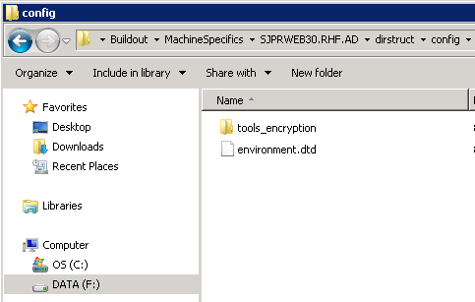

***Task Details 2 (Creating New DTD):***

* Log onto RHC-HSQADEP01
* CD E:\DTD\Scripts
* Edit CreateDTDs.ps1
* Add new server to:

.\DTDFromBaton.ps1 -environmentName SV5_Production -dtdFilePath "E:\DTD\Latest\SJPRWEB_30_environment.dtd" -pacOUName PRWEB -serverNameAtDomain "[SJPRWEB30@RHF.AD](mailto:SJPRWEB30@RHF.AD)"

* Edit CopyDtdToTargetServers.ps1
* Add new server(s) to:

$destServer="sjprweb30$destSV5FrontDomain"   # SJPRWEB

$srcDtdFile="SJPRWEB_30_environment.dtd"

Set-LocationtdToServer -srcPath "$srcPath" -srcUser "$credNAMCK.UserName" -srcPass (Decrypt-SecureString($credNAMCK.Password)) -srcDtdFile

"$srcDtdFile" -destServer "$destServer" -destPortRM "$destPortRM" -destUser "$($credSV5.UserName)" -destPass (Decrypt-SecureString($credSV5.Password))

* Execute .\CreateDTDs.ps1
* On desktop right-click and RunAsAdmin the file "RunAsPowerShell.bat"
* (In order to run PowerShell session as a user that can access PAC Secrets %windir%\system32\runas.exe /netonly /user:NAMCK\thartzler PowerShell)
* At prompt, enter NAMCK PAC Managed Password
* (You now have a PowerShell session running as your PPAC-Managed NAMCK user)

- Enter

   Set-location e:\dtd\scripts

   .\CreateDTDs.ps1

(You will be prompted for NAMCK e-id to access Sharepoint)

DTDs and config file created in folder E:\DTD\Latest

*Validation:* Several scripts following will need to parse the DTD. If they succeed without parsing error then this is verified.

**1.9.9 Pre-Maintenance Task 15**

*Role: System Configuration Engineer (SCE)*

***Task Description:* Phase II - Update Patient Education folder on SJMGDEP01**.

*Task Details:* Copy patient education folder from a server already in production

* + Log Onto SJMGDEP01 on SV5 using rhb credentials (destination)
  + Open the destination folder F:\SCM\Buildout\hwebsource\dirstruct\RelayHealth
  + Open the source folder on current live server
  + Launch new Windows Explorer and enter the following: \\SJPRWEB24\E$\RelayHealth
  + Copy the *PatientEducation folder* from the source folder share to the destination folder

*Validation:*

* Compare folder properties to verify number of folders and files match.
* WSC Phase II Test

**1.9.10 Pre-Maintenance Task 16**

*Role: System Configuration Engineer (SCE)*

***Task Description:* Phase II - Populate the BuildOutConfig.config**

*Task Details:*

* + Launch NotePad++ as Administrator
  + Populate the buildoutsetup.config file in \\SJMGDEP01\F:\SCM\Buildout with server- and environment-specific values.
  + Update the build version number in the config
  + For a new machine in an existing environment,

1. Add the machine settings to the machines tag of that particular environment XML. Pay attention to account names and passwords. Passwords come from PAC secrets.
2. Set the CodeDeployed flag of the new server to False to deploy the RelayHealth application to the new server.
3. Ensure that the CodeDeployed flag of the all existing servers in the environment is set to True.

**1.9.11. A Pre-Maintenance Task 17.A**

*Role: System Configuration Engineer (SCE)*

***Task Description:* Phase II – Check if a reboot is needed before proceeding to 1.9.11.B.**

*Task Details:*

* Target server: Launch Server Manager
* Click on Roles
* Look for message at bottom of screen that says “Console cannot refresh until computer is restarted.”
* If the message is displayed, restart server and check for message again.

*Validation:* None

*Notes:* Had to restart server 2 times before clearing message.

**1.9.11.B Pre-Maintenance Task 17.B (new step)**

*Role: System Configuration Engineer (SCE)*

***Task Description:* Phase II - Run the MachineKey script before running buildout scripts.**

*Task Details:*

Changing the process to Run the MachineKey.ps1 script before running the buildout scripts.

From any current live Web server:

* Copy E:\config\tools_encryption folder to new target server E:\config
* Copy web.config file to new target server

Filename C:\Windows\Microsoft.NET Framework64\v2.0.50727\CONFIG\web.config

* Copy the E:\RelayHealth\Deployhelp folder to the target server E:\.
* DeployHelp contains the parseDTD file and the MachineKey.ps1 file.

SJMGDEP01 server:

* Copy the latest DTD from F:\SCM\Buildout\MachineSpecifics\SERVERNAME \dirstruct\config folder to the target server E:\config folder and rename it “environment.dtd”.
* Copy the latest RelayHealth.EncryptDecryptConfig.exe.config file to the target server E:\config\tools_encryption folder
* Encrypt the environment.dtd file.

Target server:

* Launch PowerShell as Administrator
* Set-Location E:\RelayHealth\DeployHelp
* Run the machinekey.ps1 script ./machinekey.ps1

**Script should complete with no visible errors.**

C:\Windows\Microsoft.NET Framework64\v2.0.50727\CONFIG\web.config file **was modified at a time** which coincides with running the script.

**If successful, remove the \Config folder and E:\Relayhealth folder.**

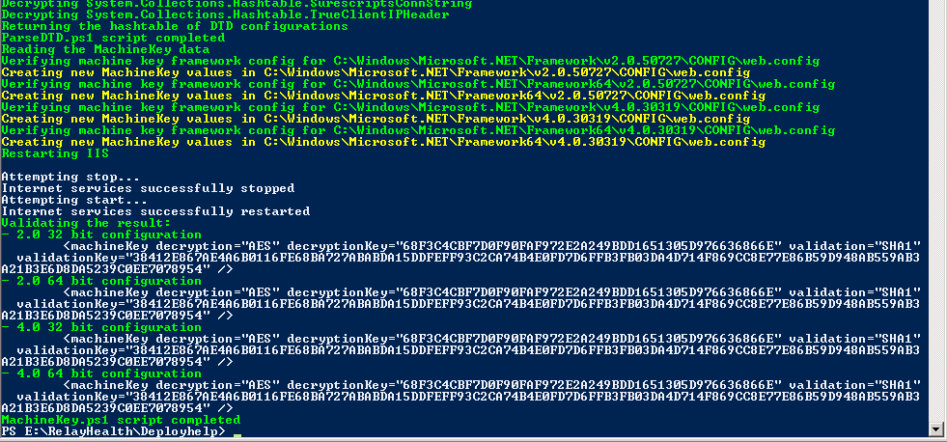

**1.9.11.C Pre-Maintenance Task 17.C**

*Role: System Configuration Engineer (SCE)*

***Task Description:* Phase II - Kick off Automated buildout scripts.**

*Task Details:*

* + Make sure to execute step 1.9.11.A above before proceeding
  + Log onto SJMGDEP01 on SV5 using rhb credentials
  + Launch an Administrator session of PowerShell
  + Run the following commands *set-location F:\SCM\Buildout*
  + Run script *.\BuildoutPackageExecuter.ps1 -EnvironmentPrefix Prod -noDatabase*

*Validation:* None

*Notes:* Use the 4 letter prefix of the environment as per buildoutsetup.config

**Known Errors from running this script.**

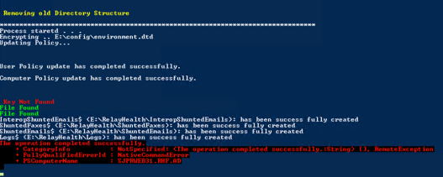

**Wintertree**

The Key Not Found error is expected. Couldn’t find the registry key it was looking for because it doesn’t exist. Look at the Wintertree.ps1 script to see what key it looks for.

Looking for HKLM:\software\Wow6432Node\Wintertree

$tmpKey = "SpellingServer"

File Not Found messages are from the Wintertree.ps1 script also.

This is what I got on PRWEB30 buildout. It means the following files were not found:

$tmpFile ="WintertreeSpellingServer.dll"

$tmpFile1 ="WSpellingServer.dll"

Having to run the buildout scripts a second time on PRWEB31 resulted in:

**File Found** messages in the screen shot above.

The Key Not Found error and the “operation completed successfully” messages are not related.

**Reg Import**

The “operation completed successfully” message is a result of scriptbooter.ps1 line 61 command: reg import c:\hwebsource\scripts\RelayHealthEventLog.reg

Open the c:\hwebsource\scripts\RelayHealthEventLog.reg file to see what it is trying to set.

Run regedit and navigate to the following.

One of the entries is not in HEX

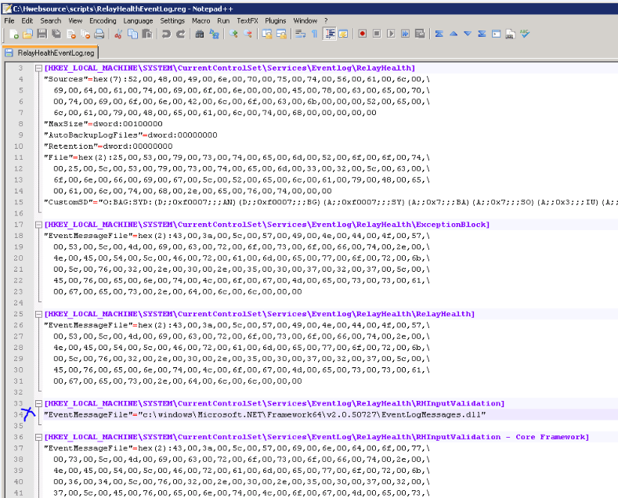

**1.9.12 Pre-Maintenance Task 18**

*Role: System Configuration Engineer (SCE)*

***Task Description:* Phase II – Manual Step - Set Services as Disabled**

*Task Details:*

* + Log onto target server
  + Launch an Administrator session of PowerShell, importing all system modules
  + Run the following commands
  + *Set-Location E:\RelayHealth\Deployhelp*
  + Run script *./ControlServicesScheduleds.ps1 -StopAllMode*

*-DisableServices*

*Validation:* All RelayHealth named services are disabled.

*Notes:*

* + Expect the test to fail for initiate services. As they have not created yet (see additional notes for full details)
  + While trying to understand why the INITIATE tasks were split up in the original SOP, we discovered the following:
* Got errors that lead us to investigate the initiate.properties file on the server. That file had the old database instance and an incorrect “mad.db.port” number. (1433 versus 49102)
* We discovered that the reason that some of the Initiate steps were run later in the SOP is because the script in step 1.9.22 Point to Multi-node database; sets the database instance and the correct port number.
* Another method to make sure that all RH services are disabled if the script above does not disable the hydro services use the following in PowerShell:

get-service rhc* | stop-service -passthru | set-service -StartupType disabled

**1.9.13 Pre-Maintenance Task 19**

*Role: System Configuration Engineer (SCE)*

***Task Description:* Phase II – Manual Step - Verify log folder permissions.**

*Task Details:*

* On target server, browse to https://api.relayhealth.com (creates W3SV504 log folder)

*Validation:*

* Make sure permissions on the following folder are applied to children folders
* In Windows Explorer, navigate to: C:\inetpub\logs
* Right-click on \LogFiles
* Click on the Security tab
* Verify that the following user name exists with the permissions listed below.

User: PRWEB_DL-InetpubLogs$(RHF\ PRWEB_DL-InetpubLogs$)

Permissions: Modify, Read & execute, List folder contents, Read, Write

* + Check Permission on folder W3SVC504

Note: This verification will always fail until a change is made in script. See remediation steps following.

* + Verify it has same permission’s as its parent folder.
  + Navigate to: C:\inetpub\logs\LogFiles
* Right-click on \W3SV504
* Click on the Security tab
* Verify that the following user name exists with the permissions listed below

User: PRWEB_DL-InetpubLogs$(RHF\ PRWEB_DL-InetpubLogs$)

Permissions: Modify, Read & execute, List folder contents, Read, Write

**Steps to remediate:**

* Open Windows Explorer
* Go to C:\inetpub
* Right-click Logs folder, select "Properties"
* Click "Security" tab
* Click "Advanced" button
* Click "Change Permissions" button. Approve UAC override
* Check the "Replace all child object permissions with inheritable permissions form this object".
* Click "Apply"

**Expected result:**

* Browse to C:\inetpub\logs\LogFiles
* Right-click on the folder to verify, e.g. W3SVC504, select "Properties"
* Click "Security" tab
* Inspect the PRWEB - InetPub$ and IIS_USRS properties
* Expect "Modify" permissions to be checked

*Note:* After configuring AppFabric, browse to the following sites to create the rTools (503) and core.services (510) and SureScripts(Interop) (508) folders and set the permissions on them as well as the above.

*Now that the Page Load test works, all of these should be created when that test script is run.*

**1.9.14 Pre-Maintenance Task 20**

*Role: System Configuration Engineer (SCE)*

***Task Description:* Phase II – Manual Step - Configure MSDTC.**

*Task Details:*

* + Log on to target server
  + Go to Start/Administrative Tools/Component Services/Computers/My Computer/Distributed Transaction Coordinator
  + Select Local DTC, Right Click and select Properties, Go to Security Tab
  + Set the following values as per existing live production server:
  + Network DTC Access
  + Allow Remote Administration
  + Allow Inbound
  + Allow Outbound
  + No Authentication Required
  + Enable XA Transactions
  + Enable SNA LU 6.2 Transactions
  + Account = NT AUTHORITY\NetworkService

*Validation:*

Run MSDTC test located in C:\Hwebsource\scripts\dtctest.ps1

* + Launch PowerShell as Administrator
  + cd C:\Hwebsource\scripts
  + Get the database instance, username and password from SQL database connection string in the DTD
  + Run command: .\dtctest.ps1 -Instance “database instance” -Username -Password

How to decrypt\encrypt the DTD file:

* + Launch PowerShell as Administrator
  + Set-location E:\config
  + Run this command to decrypt .\tools_encryption\RelayHealth.EncryptDecryptConfig.exe d
  + Run this command to encrypt .\tools_encryption\RelayHealth.EncryptDecryptConfig.exe e

Previous Successful DTC test:

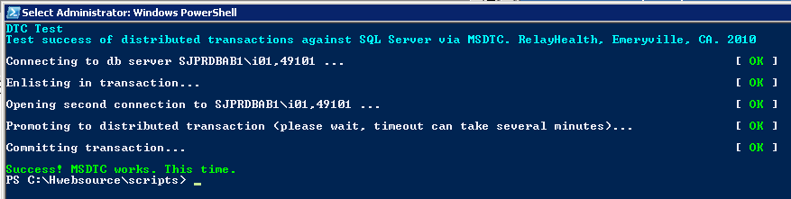

Current production DTC settings [7/29/15] from PRWEB24:

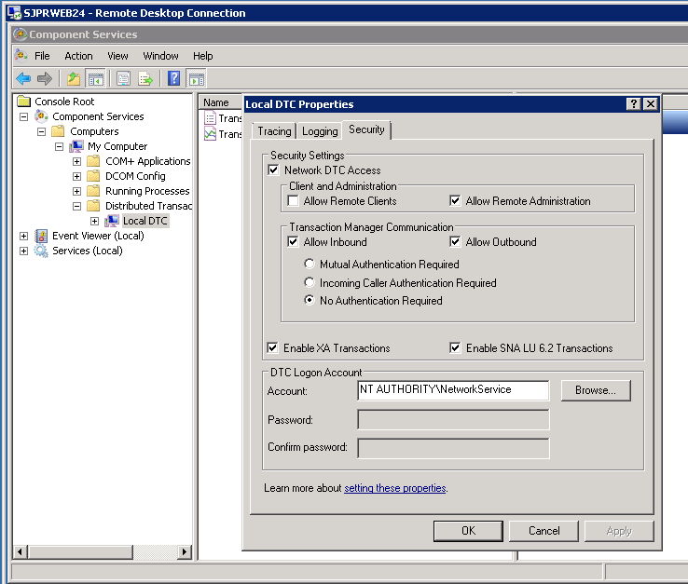

**1.9.15 Pre-Maintenance Task 21**

*Role: System Configuration Engineer (SCE)*

***Task Description:* Phase II – Manual Step - Simulator Site.**

*Task Details:*

* + Create c:\temp folder for simulator site
  + Is only used if Simulator is actually deployed so IIS won’t fail during deployment.

*Validation:* None

**1.9.16 Pre-Maintenance Task 22**

*Role: System Configuration Engineer (SCE)*

*Task Description:* **Phase II – Manual Step – Certificate Permissions**.

*Task Notes:*

*During Phase I buildout step 1.9.11 the hv.ps1 script generates the 2 .bat files below.*

*registercert_generated1.bat*

@SET WC_CERTNAME= healthvault.relayhealth.com

@"E:\healthvault\winhttpcertcfg.exe" -g -a "Network Service" -c LOCAL_MACHINE\My -s %WC_CERTNAME%

@SET WC_CERTNAME=

registercert_generated2.bat

@SET WC_CERTNAME= healthvault.relayhealth.com

@"E:\healthvault\winhttpcertcfg.exe" -g -a "SJPRWEB30SERV@RHF.AD" -c LOCAL_MACHINE\My -s %WC_CERTNAME%

@SET WC_CERTNAME=

I made multiple copies of the 2 files and renamed them as listed in the task details below. Then I put in the correct certificate for each and saved them to the SJMGDEP01 server; F:\SCM\Buildout\hwebsource\dirstruct\healthvault

The files created will be copied to the target server during the buildout step and 3 will need to be modified for the target server. See details below. The former SOP steps were overly complicated and prone to error.

*Task Details:*

* + Log onto target server
  + Open PowerShell as administrator and run following commands:
    - cd e:\healthvault
    - Run batch file ./NetworkService_HealthVault.bat
    - Expected result

Matching certificate:

CN=healthvault.relayhealth.com

Private key access has already been granted for account:

NT AUTHORITY\NETWORK SERVICE

* + - Run batch file ./NetworkService_EMR.bat
    - Expected result

Matching certificate:

CN=emr-prod.relayhealth.com

Granting private key access for account: NT AUTHORITY\NETWORK SERVICE

* + - Run batch file ./NetworkService_VortexrTools.bat
    - Expected result

Matching certificate:

CN=VortexrToolsClient

Granting private key access for account: NT AUTHORITY\NETWORK SERVICE

* + - Edit batch file: ServerName_HealthVault.bat
* Open file from NotePad++ as administrator
* Modify the server name to be that of the target server
* Run batch file ./ServerName_HealthVault.bat
* Expected result:

Matching certificate:

CN=healthvault.relayhealth.com

Granting private key access for account: RHF\SJPRWEB**XX**SERV

* + - Edit batch file ServerName_EMR.bat
* Open file from NotePad++ as administrator
* Modify the server name to be that of the target server
* Run batch file ./ServerName_EMR.bat
* Expected result:

Matching certificate:

CN=emr-prod.relayhealth.com

Granting private key access for account: RHF\SJPRWEB**XX**SERV

* + - Edit batch file ServerName_VortexrTools.bat
* Open file from NotePad++ as administrator
* Modify the server name to be that of the target server
* Run batch file ./ServerName_VortexrTools.bat
* Expected result:

Matching certificate:

CN=VortexrToolsClient

Granting private key access for account: RHF\SJPRWEB**XX**SERV

*Validation:* Included in details above as expected result.

**1.9.17 Pre-Maintenance Task 23**

*Role: System Configuration Engineer (SCE)*

***Task Description:* Phase II – Manual Step – Install 2 MS patches**

*Task Details:*

* + On Target server: Navigate to C:\hwebsource\MSPatch. You will find a patch which has to be installed.
  + Right-click on NDP45-KB2828841 –x64.exe and select run as administrator option.
  + In update window, click “Next”
  + Select “I have read and accept the license terms”
  + Click “Next” to begin installation
  + Click “Finish”
* Also install the Direct Messaging patch KB2480994

to address the “ASN1 Out Of Memory” error

* Patch can be found on existing live server in C:\setup\Hotfix folder.

*Validation:* Use WUAPP to find patch. Check Installed updates link.

* In a Run window, open WUAPP
* In the Windows Update window, click on “View update history”
* Click on the “Installed Updates” link near top of page.
* Search for KB2828841
* Search for KB2480994

**1.9.18 Pre-Maintenance Task 24**

*Role: System Configuration Engineer (SCE)*

***Task Description:* Phase II – Manual Step – SSL Renegotiation Key Patch.**

*Task Details:*

* + Log onto target server
  + Launch “regedit” from Windows Start\Run search field.
  + Under HKLM\SYSTEM\CurrentControlSet\services\HTTP\Parameters\SslBindingInfo\”new serverip”:8443
  + There is a DefaultFlags key for the default value which is set to “**0**”. Change it to”**2**”.

Shown in binary.

Change by right-clicking on item and selecting “Modify”

*Validation:* Log onto server and search for key

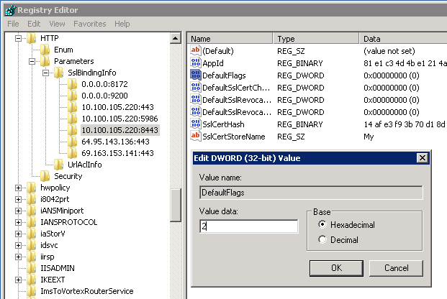

**1.9.19 Pre-Maintenance Task 25**

*Role: System Configuration Engineer (SCE)*

***Task Description:* Phase II – Manual Step - Add Metascan License to the Registry**

*Task Details:*

* + Target server, Launch PowerShell as administrator
  + Run the following commands *Set-Location c:\hwebsource\scripts*
  + Run script reg import c:\hwebsource\scripts\License_32bit_Relay Health_2-26-2016_ALL.reg. Click OK, if prompted.
  + Run script *reg import c:\hwebsource\scripts\License_64bit_Relay Health_2-26-2016_ALL.reg.* Click OK, if prompted.

*Validation:* You will get a message “The operation completed successfully.”

To verify the license was properly installed:

1. Open cmd.exe (or PowerShell) on target server.
2. Change directory to the installation location C:\Program Files (x86)\OPSWAT\Metascan Core
3. Run omsLicMgrCLI.exe checklicense
4. Verify the license status says "Activated” and the expiration date is in the future.

*Notes:*

Current license located on Share: <http://share.relayhealth.com/clinical/operations/infrastructure/Infrastrucutre%20Operations%20Home%20Page/2014%20Licenses.aspx>

Search on “Metascan”, select the check-box in the Metascan row displayed, click “View Item” at top of the Licenses page.

Download the new license to the DEP01 server: F:\SCM\Buildout\hwebsource\scripts\

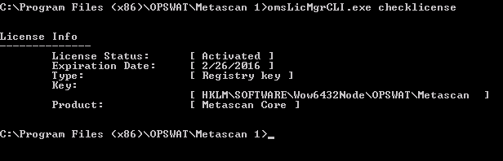

**1.9.20 Pre-Maintenance Task 26**

*Role: System Configuration Engineer (SCE)*

***Task Description:* Phase II – Manual Step - Install App Fabric Client**

*Task Details:*

* + Launch PowerShell as administrator
  + Run the following commands *Set-Location c:\hwebsource\scripts*
  + Run script *./AppFabricSetup.ps1*

*Validation:* Script completes successfully, no errors. Be aware that it may take several minutes to import the modules.

**1.9.21 Maintenance Task 27**

*Role: System Configuration Engineer (SCE)*

***Task Description:* Phase III – Add the new server to existing AppFabric Cluster**

*Task Details:*

* + Log on to **SJPRFAB01**.
  + Launch PowerShell as Administrator, run the following commands:

Import-Module DistributedCacheAdministration

Use-CacheCluster

Grant-CacheAllowedClientAccount SJPRWEB30$

*Validation on SJPRFAB01:*

Import-Module DistributedCacheAdministration

Use-CacheCluster

Get-CacheAllowedClientAccounts

Expected result: Target server listed at bottom of displayed list.

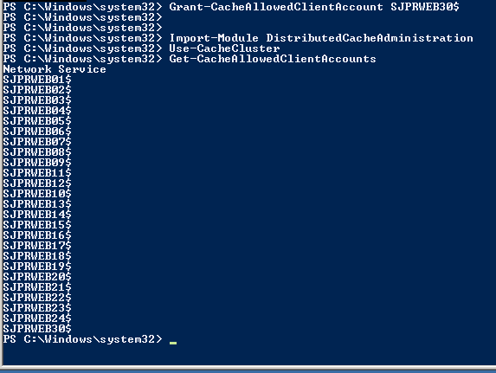

**1.9.22 Maintenance Task 28**

*Role: System Configuration Engineer (SCE)*

***Task Description:* Phase III – AppFabric Test**.

*Task Details:* Verify that AppFabric is correctly configured before running BVT.

* + **Via computer other than the new server**
  + Browse to https:\\app.relayhealth.com\memberX*\info.aspx*

*Validation:* Expecting the info page to display Server Name: SJPRWEBXX for the target server, if it does then AppFabric is working.

***Run the Page Load test****.*

* Cd c:\setup\DevOpsScripts
* Run script: ./chk_LoadWebPages_LIMITED.ps1
* If the pages keep spinning, click on tab for app.relayhealth and rTools and uncheck the “Continue to prompt when website content is blocked” check box.
* Click “Close”
* This will open a browser section and launch the following pages:
* app.relayhealth.com
* rTools.relayhealth.com
* api.relayhealth.com – with expected 403 error.

**1.9.23 Pre-Maintenance Task 29**

*Role: System Configuration Engineer (SCE)*

***Task Description:* Phase II – Manual Step - Install and Configure the Initiate Service**

*Task Details:* Installation

* + From target server, launch PowerShell as Administrator
  + Run the following commands *Set-Location C:\hwebsource\initiate*
  + Run script *./unattended.cmd*

*Validation:* Expected result as shown below.

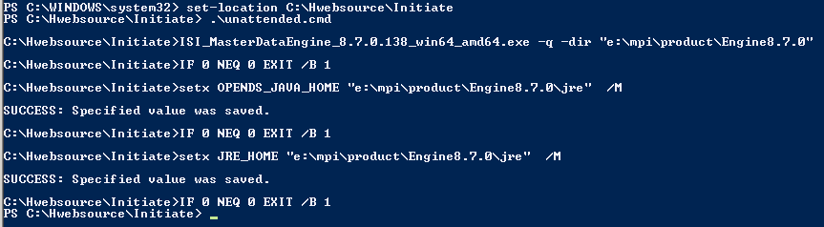

*Task Details:* Configuration

* + Run the following commands *Set-Location E:\mpi\project\initiate\scripts*
  + Run script: *./initiatesetup.ps1*

*Validation:* Expected result as shown below.

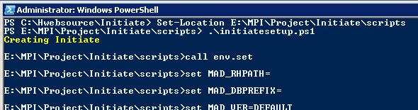

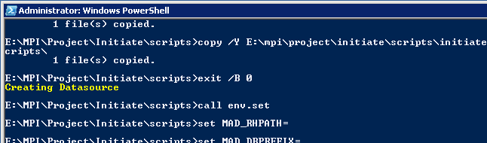

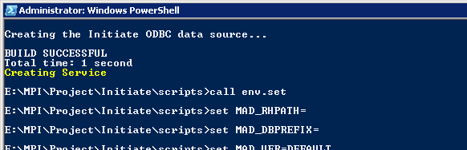

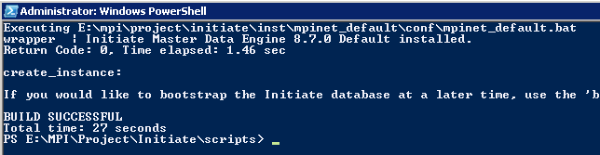

* + Run script: *./installpassive.bat*

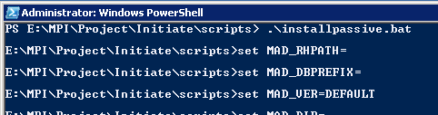

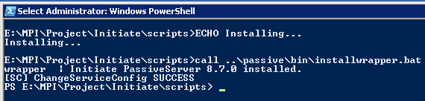

* + Launch Server Manager
  + Stop and Disable the following Initiate services
  + Initiate Master Data Engine 8.7.0 Default (MPINETDEFAULT)
  + Initiate PassiveServer 8.7.0

**1.9.24 Pre-Maintenance Task 30**

*Role: System Configuration Engineer (SCE)*

***Task Description:* Phase II – Manual Step – Point to Multi-node database.**

*Task Details:*

* + Log on to SJMGDEP01
  + Open NotePad++ as administrator
  + Update F:\DevOps\Scripts\SQLMultiNode\SQLmultinode.config

PROD section: <Environment name="PROD">

Update the build number to the appropriate value. Example:<BuildNumber value="13.9.2.112415"/>

Add target server name and IP in a new xml tag to PROD section:

<Server Name="SJPRWEBXX" IP="10.100.105.223" Deploy="True" />

Make sure all other servers have deploy flag set to “False“

* + Open PowerShell as Administrator.
  + Run following command

cd F:\DevOps\Scripts\SQLMultiNode

Run command .\SQLMultiNode_WEB2.ps1 -Env prod

-Type multi -Flip_Initiate

*Validation:*

**SJMGDEP01 server:**

End of script result:

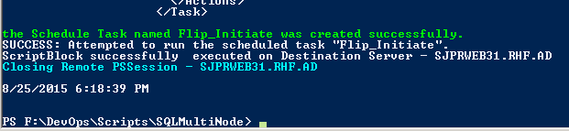

* + Update F:\DevOps\Scripts\SQLMultiNode\SQLmultinode.config

Set the deploy flag to “False“

* Check “F: \DevOps\ Scripts\ SQLMultiNode\logs\Flip_Initiate” for log from target server with time stamp close to when script was run.

**Target server: Inspect the following logs:**

E:\MPI\Project\Initiate\log\mpinet_default-20150819-102607.mlg

INFO  Java: com.initiatesystems.hub.socket.SocketServer: Socket listener (16000) started

E:\MPI\Project\Initiate\passive\logs\PassiveServer.log

INFO  | Wrap perSimpleAppMain | 2015-08-19 10:27:09 | Socket is Accepting Connections on port 16001

If the logs have not been created, it will be because the Initiate services didn’t start. Restart the services and then look for the logs again.

**Target server: Next steps:**

* Log on to the web server delete the flip-initiate scheduled task.
* Set initiate services “Initiate Master Data Engine 8.7.0 Default” and “Initiate PassiveServer 8.7.0” to be disabled and stopped.
* Make sure IIS Admin Service and Metacan service is set to Automatic and Started.
* Make sure service “SMTPSVC” is set to manual start mode and stopped.

WSC Phase II Tests “compareDBConnectivity_Phase2.ps1” and “compareServices_Phase2.ps1, plus the following:

**1.9.25 Pre-Maintenance Task 31**

*Role: System Configuration Engineer (SCE)*

***Task Description:* Phase II – Manual Step – Deploy the Core, Interop, Hydro and Verification code.**

*Task Details: See* ***4.2******Manual Deployment Instructions*** *in Appendix.*

**1.9.26 Pre-Maintenance Task 32**

*Role: System Configuration Engineer (SCE)*

***Task Description:* Phase II – Manual Step – Add Server to the Auto Deployment Process.**

*Task Details: See* ***4.3*****Add Server to the Auto Deployment Process** *in Appendix.*

**1.9.27 Pre-Maintenance Task 33**

*Role: System Configuration Engineer (???)*

***Task Description:* Phase II - Enable Riverbed AppInternals Monitoring**

*Task Details:*

* Monitoring agent configuration steps documented in https://wiki.relayhealth.com/rh-dev-doc/riverbed_appinternals_windows_agent_installation

**1.9.28 Pre-Maintenance Task 34**

*Role: System Configuration Engineer (SCE)*

***Task Description:* Phase II - Run WSC Test and Archive Folders**

*Task Details:* The master test script should detect that this server is in Phase II by determining that variable $testSwitch = 2

* Found folder E:\RelayHealth\Deployhelp, code has been deployed. `n"
* Scheduled Task file is blank .... have not installed Scheduled Tasks"
* This is a WEB server, running the Web Server Certification PHASE II test scripts.

*Task Details:* perform the following:

* + Log onto the target server
  + Launch PowerShell as Administrator
  + CD to C:\setup
  + Run Command .\Next_Test_Cleanup.ps1 – server SERVERNAME Removes and archives any test artifacts from the necessary folders so that each test ends up with only the artifacts from the current test.
  + CD to C:\setup\Scripts_Local_SVMaster
  + Run Command .\RH_WebServerCertification_Master_PROD.ps1

*Validation:* All tests should pass, cannot advance to Phase II until all issues are resolved. PASS means no FAILED tests,

* + if you get a FAILED result then it will have to be investigated and determined whether to fix the problem and get a PASSED result or make a baseline change that will affect ALL WEB SERVERS in the environment, not just the new server
  + If you get a WARNING then it will have to be investigated and determine how to proceed. If you make a baseline change it will affect ALL WEB SERVERS in the environment, not just the new server

*Task Details: After the FINAL Phase I test passes, archive the folder,* and perform the following:

* + Log onto the target server
  + Open Windows explorer and navigate to C:\setup
  + Select the \DevOpsScripts folder and copy using the copy command.
  + Rename the copied folder DevOpsScripts_Phase2_Final

*Notes:* The Phase I, II and III archives will be used for baseline analysis by the automation team. Do not ignore this step.

See 2.0 Validation section for more details regarding the tests.

**1.9.29 Pre-Maintenance Task 35**

*Role: System Configuration Engineer (SCE)*

***Task Description:* Phase II - Modify Metascan Configuration**

*Task Details:*

Need to set:

Temp folder

# Threads

* Start->OPSWAT->Metascan Console
* Open Metascan\ServerName\Scan\Scan Configuration
* Ensure that the Active Malware Scanning Engine(s) is set to scan engine (customer licensed) McAfee VirusScan Enterprise
* Thread Pool Size = 30 (rather than the default 20)
* Temporary Directory – Primary change to E:\RelyHealth\AVScanDir
* Cache Scan Results = TRUE
* Clean Action = Delete
* Click Apply Changes until the button turns gray

## PHASE III

## 1.10 Procedure: Maintenance Tasks

Identify all pertinent steps, in order, and any other information needed to accomplish the procedure task during the prescribed maintenance window

For the following tasks you will need PAC access to SJPRFAB01 and SJPRETL01 servers.

**1.10.1 Maintenance Task 1**

*Role: NOC*

***Task Description:* Phase III – Add new server as a Test Host for IMS.**

*Task Details:* Via rTools, add the new server as a Test Host.

* From your local machine, via browser, navigate to https://rtools.relayhealth.com
* Login and navigate to Tools 🡺 IMS Administration 🡺 IMS Test Hosts Name page.
* Enter the target Web server’s name in the Add new: text box.
* Click the Add button

*Validation:* The server name should be displayed in the IMS Test Hosts list.

**1.10.2 Maintenance Task 2**

*Role: System Configuration Engineer (SCE)*

***Task Description:* Phase III – Creating Scheduled Tasks.**

*Task Details:*

* + Log onto Target server
  + Launch PowerShell via Import system modules
  + Run the following commands *Set-Location E:\RelayHealth\DeployHelp*
  + Run script *.\CreateScheduledTasks.ps1 -username "User" -password "Password" –useProductionPaths*

*Validation:* WSC Phase III Test

*Notes:* Get password from Pac or Buildout.config

**1.10.3 Maintenance Task 3**

*Role: System Configuration Engineer (SCE)*

***Task Description:* Phase III - Switch on Windows services.**

*Task Details:*

* + Log onto Target server
  + Launch PowerShell, Import system modules
  + Run the following commands *Set-Location E:\RelayHealth\DeployHelp*
  + Run script *.\Start-Services.ps1 (.\Get-WindowsServicesConfigurations.ps1)*

*Validation:* Visually inspect the services

* IISAdmin
* Metascan
* SMTP
* W3SVC

*Notes:* The services affected are listed in script *Get-WindowsServicesConfigurations.ps1*

**1.10.4 Maintenance Task 4**

*Role: System Configuration Engineer (SCE)*

***Task Description:* Phase III – Switch on Initiate services.**

*Task Details:*

* + Log onto Target server
  + Launch Server Manager, navigate to Configuration > Services
  + In the Services window do the following:
  + If either Initiate services (Initiate Master Data Engine, Initiate Passive Server) Startmode is Disabled change them to Automatic (Delayed Start)and then Start them.
  + Launch PowerShell, Import system modules
  + Run the following commands *Set-Location E:\RelayHealth\DeployHelp*
  + Run script *.\Start-Services.ps1 (.\Get-InitiateServicesConfigurations.ps1 -useProductionPaths)*

*Validation:* WSC Phase III Test

**1.10.5 Maintenance Task 5**

*Role: System Configuration Engineer (SCE)*

***Task Description:* Phase III – Create Initiate LDAP users.**

System (this one will be there just change the password s/match PAC)

RHInitiateUser

RHWorkbenchUser

*Task Details:*

* + Log on ETL Server (**SJPRETL01**).
  + Open Initiate Workbench as Administrator
  + In User Management, click on the green/orange plug icon. Connect (Host Name and Port) to the new web server (TARGET SERVER NAME) using System user with default password
  + In the Users list panel, click “New”
  + Create RHInitiateUser (using the password from PAC secrets for SJPRWEB OU)
  + Select “Administrator” in group membership panel and save
  + In the Users list panel, click “New”
  + Create RHWorkbenchUser (using the password from PAC secrets for SJPRWEB OU)
  + Select “Administrator” in group membership panel and save
  + Before changing the system user, verify that you can connect to the ones just created.
  + Change the System user password as per the PAC.
  + No edit button, just overwrite the current password in the User Information panel

*Validation:* Using initiate workbench connect to the new server using RHInitiateUser, System and RHWorkbenchUser

**1.10.6 Maintenance Task 6**

*Role: System Configuration Engineer (SCE)*

***Task Description:* Phase III – Switch on Interop, HydroPlatform and RelayHealth Services.**

*Task Details:*

* + Launch PowerShell as administrator
  + Command: Set-Location E:\RelayHealth\DeployHelp
  + Run script ./ControlServicesScheduleds.ps1

*Validation: Via Server Manager, visually verify that each RelayHealth service has been started.*

**1.10.7 Maintenance Task 7**

*Role: System Configuration Engineer (SCE)*

***Task Description:* Phase III – Enable the SMTP service.**

*Task Details:*

* + Log onto Target server
  + Launch Server Manager, navigate to Configuration > Services
  + In the Services window do the following:
  + Set start mode for SMTP svc to Automatic
  + Start SMTPSVC to be running

*Validation:* WSC Phase III Test

**1.10.8 Maintenance Task 8**

*Role:* NA – Monitoring

***Task Description:* Phase III - Verify SCOM has discovered all the expected monitors**

*Task Details:*

* + Take the new servers out of maintenance window.  Wait for 15-20 minutes before going to next step.
  + In Windows Computers, find the new server.  Open Health Explorer for the server.
  + Verify logical disks are listed.
  + Verify all RelayHealth services are listed.

*Validation:*

* + Group membership verification: Verify the new server is included in the correct base group.  For example, a new production server should be in SJPRWEB group.

*Notes: What server is this task being performed on?*

**1.10.9 Maintenance Task 9**

*Role: System Configuration Engineer (SCE)*

***Task Description:* Phase III - Run the Web Server Certification (WSC) Test and Archive Folders**

*Task Details:* The master test script should detect that this server is in Phase III by determining that the variable $testSwitch = 3

* Found deployed code folder and Scheduled Task"
* This is a WEB server, running the Web Server Certification PHASE III test scripts.

*Task Details:* perform the following:

* + Log onto the target server
  + Launch PowerShell as Administrator
  + CD to C:\setup
  + Run Command .\Next_Test_Cleanup.ps1 SERVERNAME
  + Removes and archives any test artifacts from the C:\setup\DevOps\Exceptions, \Exports, and \Results folders so that the \DevOps folders are populated with the test files from the current test only.
  + CD to C:\setup\Scripts_Local_SVMaster
  + Run Command .\RH_WebServerCertification_Master_PROD.ps1

*Validation:* All tests should pass, cannot advance to Phase IV until all issues are resolved. PASS means no FAILED tests,

* + If you get a FAILED result then it will have to be investigated and determined whether to fix the problem and get a PASSED result or make a baseline change that will affect ALL WEB SERVERS in the environment, not just the new server
  + If you get a WARNING then it will have to be investigated and determine how to proceed. If you make a baseline change it will affect ALL WEB SERVERS in the environment, not just the new server
  + There are Failed and Warning results that cannot be resolved for a variety of reasons. These exceptions will need to be put in the known exceptions file so that when the server is in service, post deployment tests will ignore these results.
  + The production known exception file is located on the SJMGDEP01 server, F:\ServerVerification\KnownExceptions\Prod\Exceptions_Prod_Web_Known.csv

*Task Details: After the FINAL Phase III test passes, archive the folder,* and perform the following:

* + Log onto the target server
  + Open Windows explorer and navigate to C:\setup
  + Select the \DevOpsScripts folder and copy the folder.
  + Rename the copied folder DevOpsScripts_Phase3_Final

*Note:* The Phase I, II and III archives will be used for baseline analysis by the automation team. Do not ignore this step.

*Note:* See 2.0 Validation section for more details regarding the tests

* + Server is now hosting Relay Health application with required services running.
  + It is not processing any production IMS data.
  + It is part of the F5 pool but is disabled and not allowing live traffic.

**1.10.10 Maintenance Task 10**

*Role: System Configuration Engineer (SCE)*

***Task Description:* Phase III - Run BVT with the Member Switch**

*Task Details:*

1. Launch Remote Desktop
2. Login to automation server <qaematm01> using < IP 10.12.42.105> or < IP 10.12.42.106>
3. Enter user name & password
4. Click on the appropriate test icon to bring up the test dialog window. The icon must include the current build version. If no icon exists with the current build version, contact someone from the QA team to either create one or give you instructions on how to proceed.
5. Enter Environment select <production>
6. If using member switch: modify environment URL by adding member switch – example <relayhealth.com/member24>
7. Enter Test Suite <BVT>
8. Enter Nunit Run Mode <select GUI>
9. Enter rTools credentials <production rTools account>
10. For production server request 24 hour tokenless account from the DBA team
11. Click Run the Build Verification Test dialog window is displayed.
12. Click on BuildVerificationTest
13. Right-click to display menu
14. Click on Run All

*Validation:* N/A

*Notes:* See REFERENCES section:How to Run the BVT Test Wiki Page

**1.10.11 Maintenance Task 11**

*Role:* NOC

*Task Description:* Phase III - Monitor Elmah log

*Task Details:*

* + Once notified the new system has been deployed, a NOC member will monitor the elmah log for errors via the rTools administrative interface.
  + Specifically noting any abnormal increase in errors from the new system, in relation to those from existing systems.

*Validation:*

* + If atypical errors from the new system are found, the NOC member will troubleshoot.
  + If the troubleshooting is unsuccessful, will contact the SCE team.
  + The server will not be allowed to enter the next phase of deployment, until such items are remediated.

## PHASE IV

## 1.11 Procedure: Processing Live IMS Data Tasks

Identify all pertinent steps, in order, and any other information needed to accomplish the procedure task during the prescribed maintenance window.

**1.11.1 Processing Live IMS Data Task 1**

*Role: System Configuration Engineer (SCE)*

***Task Description:* Phase IV - rTools -Take server out of IMS TEST HOST**

*Task Details:* Via rTools, remove the new server as a Test Host.

* Requires RelayHealth rTools account for the Production Environment
* From your local machine, via browser, navigate to https://rtools.relayhealth.com
* Login and navigate to Tools 🡺 IMS Administration 🡺 IMS Test Hosts Name page.
* Find the server name and click the Delete button

*Validation:* The server name should be removed from the IMS Test Hosts list and the text “No record found.” displayed.

*Notes:* ***Server will be processing live IMS data after completion of this task.***

**1.11.2 Processing Live IMS Data Task 2**

*Role:* NOC

*T****ask Description:* Phase III - Monitor Elmah log**

*Task Details:*

* + Once notified the new system has been deployed, a NOC member will monitor the elmah log for errors via the rTools administrative interface.
  + Specifically noting any abnormal increase in errors from the new system, in relation to those from existing systems.

*Validation:*

* + If atypical errors from the new system are found, the NOC member will troubleshoot.
  + If the troubleshooting is unsuccessful, will contact the SCE team.
  + The server will not be allowed to enter the next phase of deployment, until such items are remediated.

## PHASE V

## 1.12 Procedure: Start Processing Web Traffic

Identify all pertinent steps, in order, and any other information needed to accomplish the procedure task during the prescribed maintenance window

**1.12.1 Processing Web Traffic Task 1**

*Role:* NA - Administrator

***Task Description:* Phase V - Enable server in the F5 load balancer.**

*Task Details:*

The node was added in a disabled state (see **Phase II** **Task 1.93**). Enabling is a couple of clicks and it will automatically be activated in all pools (assuming the health check for the pool succeeds).  Generally speaking, enabling or disabling a node can be done outside of a change window.

*Validation:* Monitoring by the NOC team

**1.12.2 Processing Web Traffic Task 2**

*Role:* NOC

*Task Details:*

* + Once notified the new system has been deployed, a NOC member will monitor the elmah log for errors via the rTools administrative interface.
  + Specifically noting any abnormal increase in errors from the new system, in relation to those from existing systems.

*Validation:*

* + If atypical errors from the new system are found, the NOC member will troubleshoot.
  + If the troubleshooting is unsuccessful, will contact the SCE team.
  + The server will not be allowed to remain in service until such items are remediated.

# 2.0. VALIDATION

2.1 Validation activities are designed to allow self-verification of the quality and completeness of the work.

1. Describe the validation plan regarding what the validation is intended to verify and the validation methodology.

* The WSC master test script will be run after each of the first 3 phases.
* The master script detects the state (phase) of the server and calls a set of tests for the Phase that is detected.
* Each of the tests called uses the same methodology and creates the same output.
* The methodology and output files are fully described in the WSC project Wiki page. See the REFERENCE section for the link to the Wiki page

1. Describe the preparation of appropriate validation procedures that are required to demonstrate successful completion of the procedure(s).

The WSC project was a rigorous exercise to determine the baseline value of each phase of building a new Web server. The result of that project is that it determined that the methodology employed is valid and that the resulting Web server needs no further validation regarding it’s suitability for full service in the Production environment.

1. List or describe specific success criteria for each validation procedure should be included.

Each tests compares a static baseline value with an observed tested server value.

Each comparison returns one of three possible results:

* Passed – means that the baseline matches the value observed on the tested server
* Failed – means that the observed value does not match the baseline value
* Warning – means that the baseline does not contain the value observed on the tested server

The final test results for each phase must return “PASSED” in order to proceed or it is agreed on a case-to-case basis to accept a “WARNING” and go to the next phase. The final Phase III tests must return “Passed” in order for the server to be left in service for final monitoring and acceptance.

IMPORTANT NOTE: Due to several factors that are not important to the acceptance and implementation of this document, there are “known” exceptions to the baseline values. A WSC test is considered as “PASSED” if it matches the current baseline value OR it is a “known” exception. An example of a known exception is that some servers use model_x NIC card and other servers have model_y installed. Both are valid values. One is in the baseline and the other is treated as a “known” exception.

A known exception list will be available for each new server buildout.

1. List or describe specific roles (not people’s names) that are required for each validation step.

* Anyone from the SCE or DevOps team who has the appropriate access is able to run any of the WSC server verification tests.

# 3.0 REFERENCES

Documents or procedures that interface with the SOP should be fully referenced (including version), such as related SOPs or vendor instructions, etc. methods manuals. Attach or provide a link to referenced documents or related SOPs.

a) Criteria, checklists, or other standards that are to be applied during the procedure such as citing this document as guidance for reviewing SOPs)

b) Records Management (specifically, e.g., as forms to be used and locations of files).

* Include on-line request forms
* Include on-line documentation

3.1 Change Management Policy

Infrastructure_Change_Management_Policy_v2.docx

<https://wiki.relayhealth.com/standard-operating-procedure/Change%20Management%20Policy>

3.2 Web Server Certification Project Wiki page

RelayHealth Wiki page that describes the original Web Server Certification project and how the validations work.

<https://wiki.relayhealth.com/rh-dev-doc/web_server_certification_project#phase_i_teams_sat_qa>

## 3.3 CCR for Adding a new Web Server in Live Environment

See “*Copy of CCR 2015-09-04 Build SJPRWEB32-33 production web server.xlsx”* in the Attachments section of the following link:

[https://wiki.relayhealth.com/standard-operating-procedure/SCE%20Standard%20Operating%20Procedures](https://wiki.relayhealth.com/standard-operating-procedure/SCM%20Standard%20Operating%20Procedures)

## 3.5 Checklist for SOP SCM-0508-14

See “*Checklist*_SCM-0508-14_Build_Web_Server.docx” in the Attachments section of the following link:

[https://wiki.relayhealth.com/standard-operating-procedure/SCE%20Standard%20Operating%20Procedures](https://wiki.relayhealth.com/standard-operating-procedure/SCM%20Standard%20Operating%20Procedures)

## 3.7 How to Run the BVT Test Wiki Page

[*https://wiki.relayhealth.com/standard-operating-procedure/how_to_run_bvt*](https://wiki.relayhealth.com/standard-operating-procedure/how_to_run_bvt)

3.8 Documents in Wiki relating to building new server in the data center**.**

<https://wiki.relayhealth.com/standard-operating-procedure/new_server_build_in_data_center>

Link: 4 OS deployment using PXE Boot.doc

Link: 5 Installing Windows SCOM Agent.docx

# 4.0 Appendix

4.1 (1.8.3 Pre-Maintenance Task 3) Certificates Table**:**

Request from InfoSec through Sharepoint: [SSL/TLS Certificate Request](http://share.relayhealth.com/clinical/Security/processes/Lists/Certificate%20Request/NewForm.aspx)

InfoSec installs the certificates on the server – order the certificates three weeks before starting the server buildout.

New Certificate Data

|  |  |
| --- | --- |
| **Subject** | **Issuer** |
| CN=SJPRWEBXX.RHF.AD | CN=RelayHealth Class 2 Primary Intermediate Server CA, OU=Secure Digital Certificate Signing, OU=http://ca.relayhealth.com/repository, O=RelayHealth (McKesson Technologies Inc.), C=US |
| CN=client.app.relayhealth.com | CN=Starfield Secure Certificate Authority - G2, OU=http://certs.starfieldtech.com/repository/, O="Starfield Technologies, Inc.", L=Scottsdale, S=Arizona, C=US |
| CN=healthvault.relayhealth.com | SERIALNUMBER=10688435, CN=Starfield Secure Certification Authority, OU=http://certificates.starfieldtech.com/repository, O="Starfield Technologies, Inc.", L=Scottsdale, S=Arizona, C=US |
| CN=RapidSSL CA | CN=GeoTrust Global CA, O=GeoTrust Inc., C=US |
| CN=emr-prod.relayhealth.com | CN=emr-prodca.relayhealth.com, OU=WOS RelayHealth, O=McKesson Corp, L=Atlanta, S=Georgia, C=US |
| CN=StartCom Extended Validation Server CA | CN=StartCom Certification Authority, OU=Secure Digital Certificate Signing, O=StartCom Ltd., C=IL |
| CN=VortexrToolsClient | CN=RelayHealth Class 2 Primary Intermediate Server CA, OU=Secure Digital Certificate Signing, OU=http://ca.relayhealth.com/repository, O=RelayHealth (McKesson Technologies Inc.), C=US |
| CN=Starfield Secure Certification Authority | OU=Starfield Class 2 Certification Authority, O="Starfield Technologies, Inc.", C=US |
| CN=StartCom Certification Authority | CN=StartCom Certification Authority, OU=Secure Digital Certificate Signing, O=StartCom Ltd., C=IL |
| CN=app.relayhealth.com | CN=DigiCert SHA2 Extended Validation Server CA, OU=www.digicert.com, O=DigiCert Inc, C=US |

## 4.2 Manual Deployment Instructions

**Copy archives from SJMGDPP01\e$\CodeTemp folders**

Note:

Do not remove the current archive from any of the \Releases folders. Causes a problem with the “soft” link “Deploy”

If it is necessary to remove the Deploy link;

Open a command window as **ADMINISTRATOR**

Use command: rd E:\InteropApplications\Deploy

Similar command for \RelayHealth, \HydroPlatform and \Verification.

1. Copy the Core code archive into target server E:\RelayHealth\Releases folder.
   1. Manually extract the \Releases folder's zipped file.
   2. Copy everything from E:\RelayHealth\Releases\RelayHealthDeployHelp into the E:\RelayHealth\DeployHelp folders.
2. Copy the Interop code archive into target server E:\interopApplications\Releases folder.
   1. Manually extract the \Releases folder's zipped file.
   2. Copy everything from E:\interopApplications\Releases\InteropApplicationsDeployHelp folder into the E:\InteropApplications\DeployHelp folders.
3. Copy the HydroPlatform code archive into target server E:\HydroPlatform\Releases folder.
   1. Manually extract the E:\HydroPlatform\Releases folder's zipped file.
   2. Copy everything from E:\HydroPlatform\Releases\HydroPlatformDeployHelp into the E:\HydroPlatform\HydroPlatformDeployHelp folders.
4. Copy the Verification code archive into target server E:\Verification\Releases folder.
   1. Manually extract the E:\Verification\Releases folder's zipped file.
   2. Copy everything from E:\Verification\Releases\VerificationDeployHelp into the E:\Verification\VerificationDeployHelp folders.

**Deploy new code to target server.**

Make sure you have the latest DTD on the target server before running the following:

1. New Admin PowerShell session: **Deploy RelayHealth Core and Interop**

Set-Location E:\RelayHealth\Deployhelp

.\deploy.ps1 -release "15.8.2.123109" -serviceUser SJPRWEB30SERV@RHF.AD -servicePassword "password" -domainHostName "relayhealth.com" -scheduledUser SJPRWEB30TASK@RHF.AD -scheduledPassword "password" -isProduction -NoDatabase

1. New Admin PowerShell session: **Deploy Verification**

Set-Location E:\Verification\VerificationDeployHelp

.\DeployVerification.ps1 -release "15.8.2.123109" -isProduction

1. New Admin PowerShell session: **Deploy HydroPlatform**

Verify on a current running live server that Hydroplatform has the same build number as those above. Sometimes it is different.

Set-Location E:\HydroPlatform\HydroPlatformDeployhelp

.\DeployHydroPlatform.ps1 -release "15.8.2.122892" -serviceUser SJPRWEB30SERV@RHF.AD -servicePassword "password" -isProduction

1. After deploying Hydro, **STOP and DISABLE all RH services**.

get-service rhc* | stop-service -passthru | set-service -StartupType disabled

**4.3 Add Server to Auto Deployment Process**

**4.3.1 Add server to DeployConfig.config**

Log onto SJMGDPP01

* + Open NotePad++ as Administrator
  + Open file E:\Autodeployment\Scripts\DeployConfig.config
  + In **Production** section:
  + Copy last WebServer row
  + Change Name, UrlMember, and MemberName to that of the new server and save.
  + Open file E:\Autodeployment\Scripts\PushCenter.config
  + In **Production** section:
  + Copy last WebServer row
  + Change Name, UrlMember, and MemberName to that of the new server and save.

Note:

**4.3.2 Create PushCenterAgent scheduled task**

Log onto the target server:

Export scheduled task from existing server and save to desktop.

Open Server Manager

Click on Task Scheduler in Configuration section

Right-click on “Task Scheduler library”

Click on “Import Task”

Find “PushCenterAgent” XML document and double-click.

The “Create Task” window will display:

* Check for “Run whether user is logged in or not”
* Check for “Run with Highest Privileges”
* Click on “Change User or Group” button.
* Enter scheduled task user RHF\SJPRWEBXX
* Click “Check Names”
* Click “OK”
* Enter scheduled task user password (from PAC Secrets)

Validation:

* Verify that the PushCenterAgent scheduled task exists.

See screen shots below:

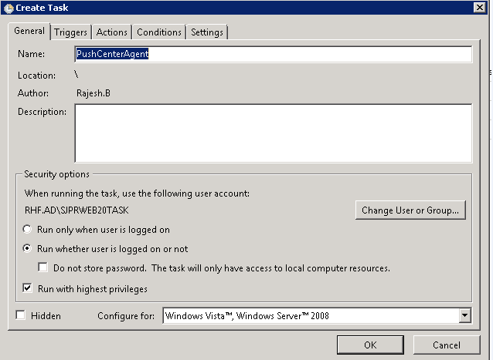

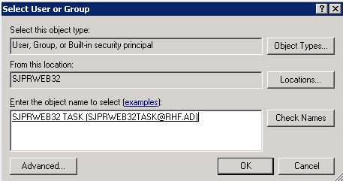

**4.3.3 Add missing files**

E:\RelayHealth\DeployHelp

DeployParallel.ps1

PushCenterAgent.ps1

**4.3.4 Edit the server name in the PushCenterAgent.ps1 script**

**4.3.5 Create the E:\Verification\VerificationDeployHelp\ReleaseInfo folder**

**4.3.6 E:\RelayHealth\unzip.version.ps1** (copy, run ?)

4.3.7 Update (what is being updated? Where do you run these commands?)

UPDATE [Pushcenter].[dbo].[DeployQueue]

SET [deploystatus] = 1

Where timecreated > ‘2015-09-10 12:00:00’

AND [ServerName] in (‘SJPRWEBXX’, ‘SJPRWEBXX’)

Found this in PushCenterAgent.ps1 script which doesn’t quite match what was in Martin’s steps.

[string] $dbquery = "Update [PushCenter].[dbo].[DeployQueue] SET [deploystatus]=`'2`' Where [ServerName]=`'SJPRWEB32`' and [deploystatus]=`'1`' and [deploytype]=`'unzip`' and [buildnumber]=`'$release`'"