Certificate
You worked hard on the AI Agents Email Crash-Course for 7 days. You completed all the homework, created an impressive README, and even recorded a demo.
Now it's time to earn a certificate for your effort!

Evaluating your Project
I created an evaluation agent that reviews your repository against different criteria:
- Dataset: FAQ dataset (0), original dataset (2)
- Data Pipeline: None (0), basic (1), structured (2)
- Agent Implementation: None/notebooks only (0), partial (1), modular scripts (2)
- Agent Evaluation: None (0), basic (1), comprehensive (2)
- User Interface: None (0), basic script (1), interactive app (2)
- Code Organization: Unorganized (0), split files (1), well-structured (2)
- Reproducibility: No instructions (0), basic (1), clear/easy (2)
- Documentation: Goal, setup, usage, visuals (1 point each)
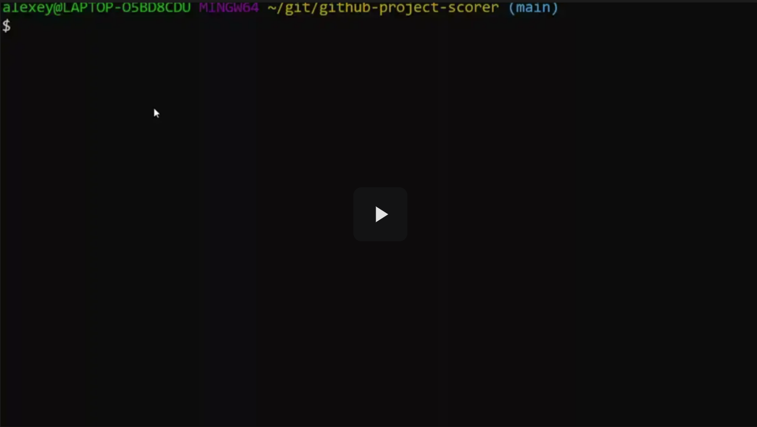
Watch a demo here.
Here's how to use it to evaluate your project:
git clone https://github.com/alexeygrigorev/github-project-scorer.git
cd github-project-scorer
uv sync

export OPENAI_API_KEY="your key"
uv run python main.py
# or make run

Provide your GitHub project URL and select the ai-crash-course.yaml criteria template.
This will help you identify areas for improvement. It costs approximately $0.05 to $0.10 per evaluation. For me, in the video above, it was ~$0.06.
This step is optional, but it will help you identify what to work on.

Getting a Certificate
Is your project ready? Let's get a certificate!

Cohort mode
If you’re taking part in this course inside a cohort, you can submit your project for peer review. If you pass the review and review 3 submissions of other course participants, you get a signed verifiable certificate.
- Go to https://courses.datatalks.club/ai-hero-2026/
- Select the project attempt that is not closed yet
- Add the link to your project
- After the submission deadline, review 3 submissions from other students
- Get a certificate!
- You can see a video about it here: https://www.loom.com/share/647233992ab44b0e94d756ab74dc1bb5
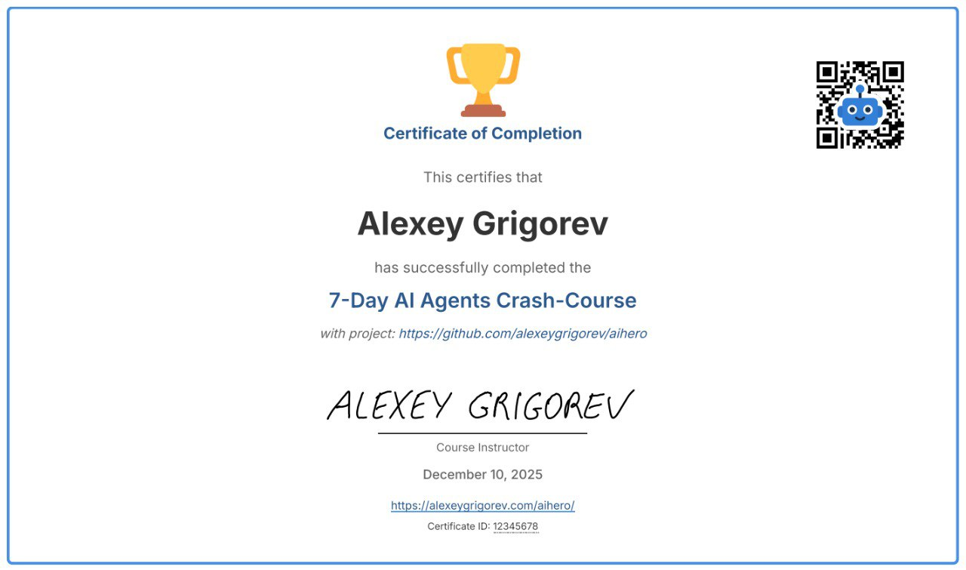

Self-paced Mode
If you’re taking the course in a self-paced mode, you can also get a certificate. It will be different: it won’t have my signature, and it’s not downloadable and verifiable by others.
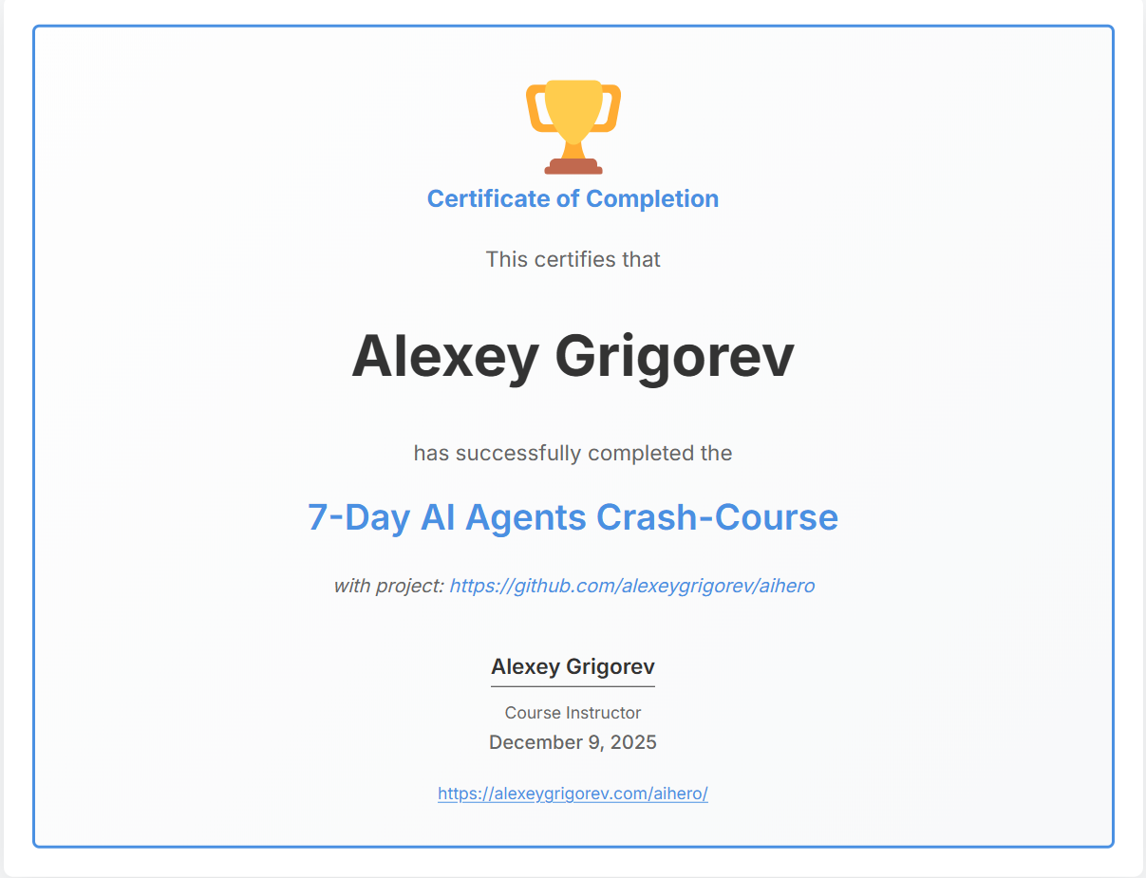
- Go to http://alexeygrigorev.com/aihero/certificate.html
- Enter your name and project URL
- Click "Generate"
- Save the result as a PDF
- Share it on LinkedIn

Project Evaluator
Want to learn how I built the evaluator? The code is open-source, allowing you to review the implementation details.
I also cover it in my course AI Bootcamp: from RAG to Agents. Join me if you want to learn how to create similar agents step by step.
Remember: you receive a 15% discount with the code "AIHERO" for completing this course.

Share the Results

Example post for LinkedIn
🚀 Just completed the AI Hero course and built my first AI agent!

Over 7 days, I learned how to:

• Create a data pipeline for processing GitHub repos
• Index the data into a search engine
• Create a conversational AI agent
• Evaluate my agent
• Deploy my agent to Streamlit Cloud
• Create a polished repo with the code

My project helps users [DESCRIBE YOUR PROJECT]. The agent answers questions and provides relevant information from [YOUR DATA SOURCE].

My code: [YOUR_REPO_LINK]

Thanks to @Alexey Grigorev for this incredible free course. Perfect for anyone wanting to learn practical AI development!

Course link: https://aishippinglabs.com/courses/aihero

Example post for Twitter/X
Just finished building my first AI agent in 7 days! 🤖

For my project, I built:

✅ Data pipeline
✅ Search engine
✅ Agent
✅ Evals
✅ UI

Code: [YOUR_REPO_LINK]

Thanks @Al_Grigor for your free course! Perfect intro to AI Agents!

Join here: https://aishippinglabs.com/courses/aihero

Community
Do you have questions about this lesson, or would you like to suggest improvements? Find me and other learners in DataTalks.Club Slack:
- Join DataTalks.Club
- Find us in the #course-ai-hero channel
In the community channel, you can:
- Ask questions about course content
- Share your work and get feedback
- Show off your deployed applications
- Get help with deployment issues
- Connect with other participants
Don't hesitate to reach out. The community is here to help each other succeed!

