Rodny Joseph

10/19/16

PlayMySong

**Unit Test Plan**

**Homepage & Navigation Bar**

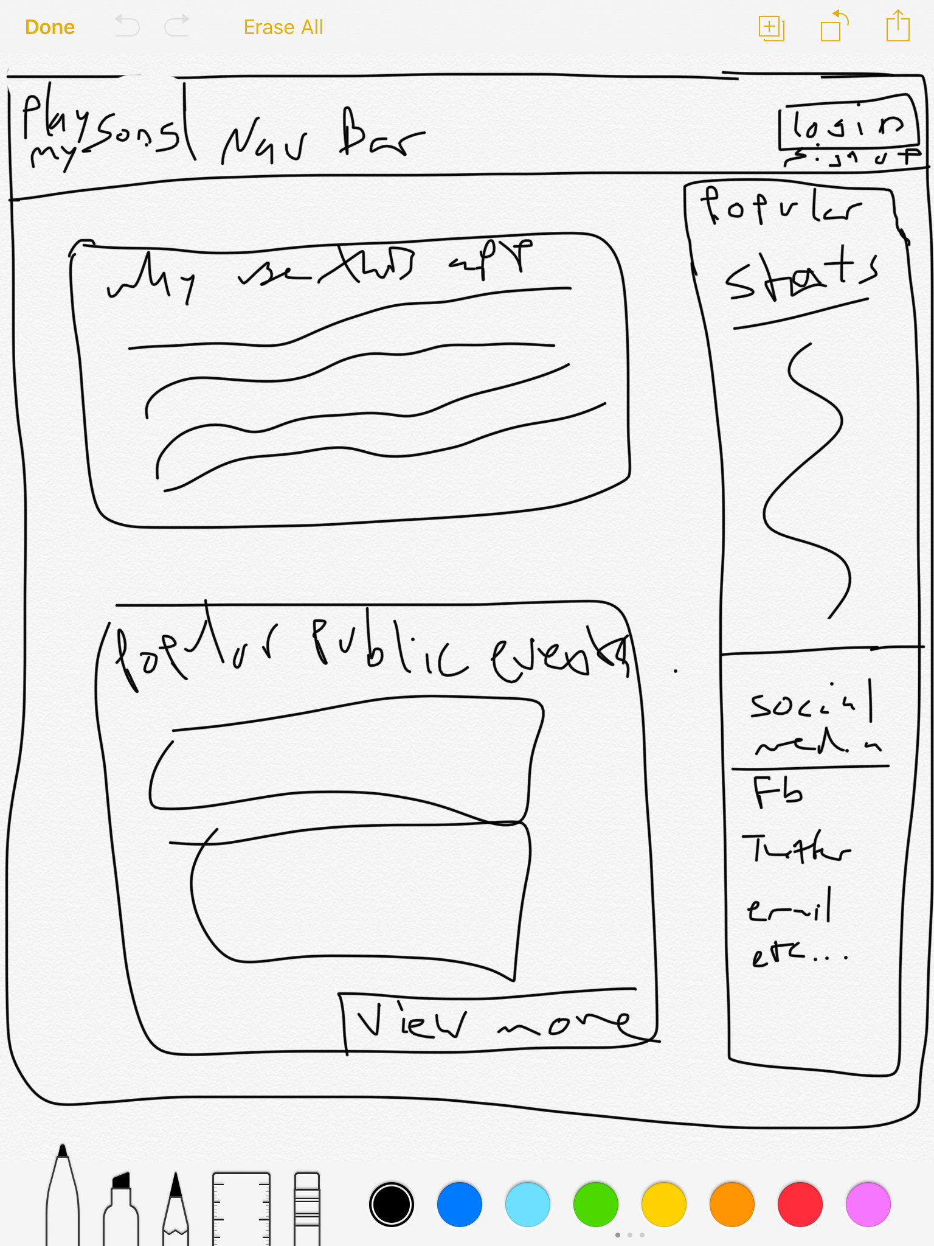

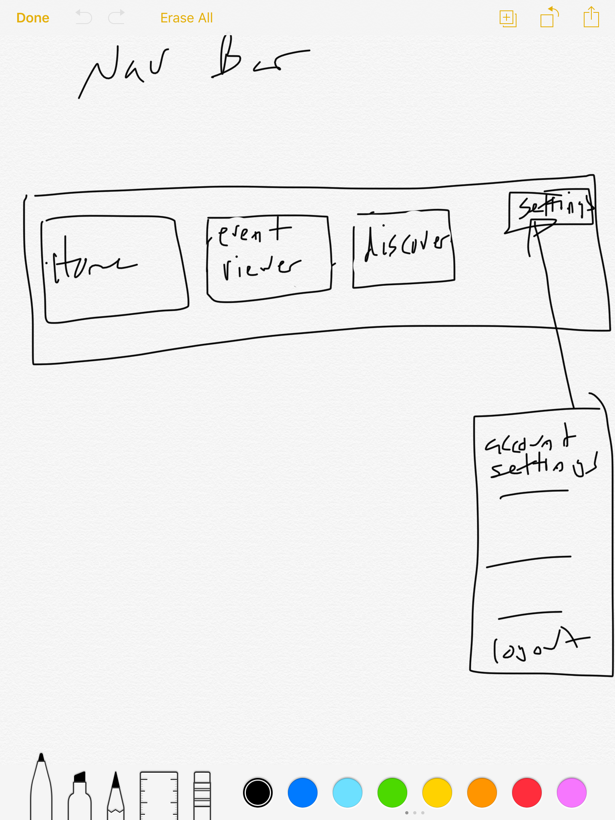

1. Navigation Bar
   1. Home
      1. When clicked: direct user to home-screen page
   2. Event Viewer
      1. When clicked: direct user to event viewer page
   3. Discover
      1. When clicked: direct user to Discover page
   4. Login/settings
      1. When clicked: Open a side panel showing user settings (login, log-out)
2. Social Media (optional but possible implementation in current site version)
   1. When clicked: user will get option to like us on facebook/twitter, or share to facebook/twitter
3. Home-Page
   1. Generate popular public events
   2. View more option. When Clicked: In-page displayed events, and option to go to discover page for more.

Test Plan

1. Click individual tabs to got to respected pages
2. Click on social media to see if the option to like or share appears on facebook/twitter

Signup Page

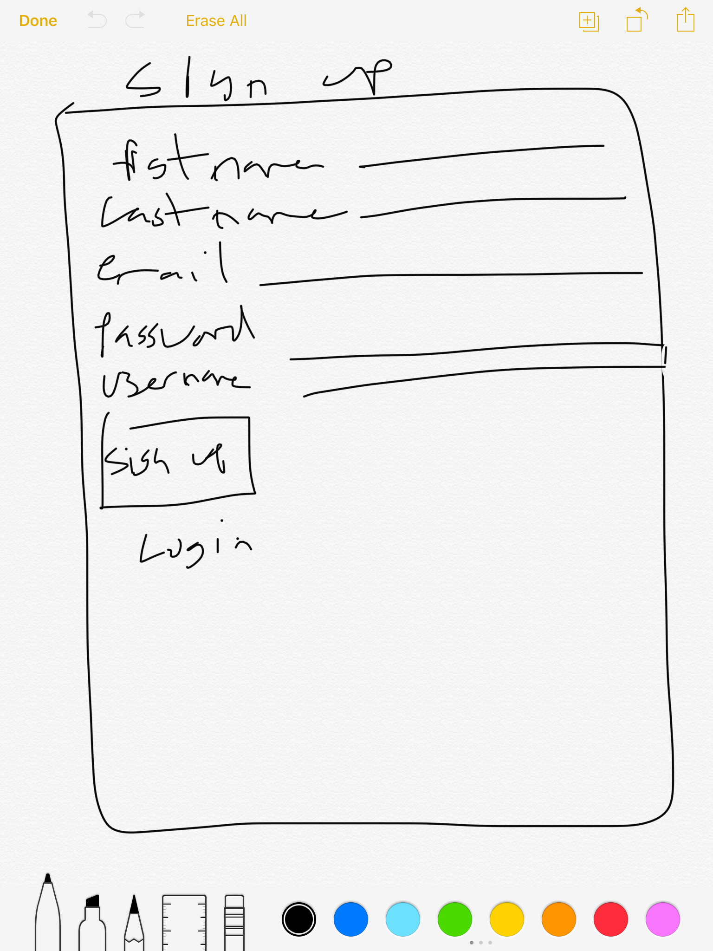

1. Form data entry: (ignoring spaces, and htmlspecialchars (malicious code/ javasript))
   1. Firstname required, error message when form is submitted without firstname entry
   2. Lastname required, error message when form is submitted without Lastname entry
   3. email required, error message when form is submitted without email entry
   4. username required, error message when form is submitted without username entry
   5. password required, error message when form is submitted without password entry
   6. Username must be unique, doesn’t already exist in database
2. Test plan
   1. Enter in data in form using spaces and htmlspecialchar for required fields
   2. Leaving a text field blank and submitting the form
   3. Try to use an existing username in form submission

Login Page

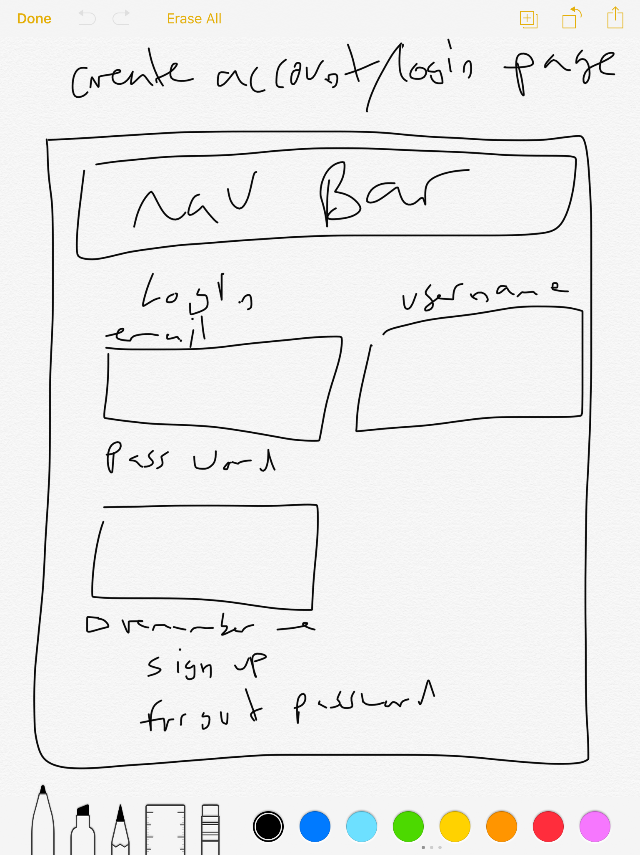

1. Form data entry: (ignoring spaces, and htmlspecialchars (malicious code/ javasript))
2. Firstname and password must match with whats in the database. If not, then error message displays that username or password is incorrect
3. Username and password required to login

Test plan

1. Enter in data in form using spaces and htmlspecialchar (malicious code/ javasript))
2. Leaving a text field blank and submitting the form
3. Using incorrect username or password

* “Remember Me” and “Forgot Password” features are optional for this version and likely will not be implemented until later versions