Meridian Data Operations Manual
Providers, backfills, data-source routing, and storage
Author: Codex | Version: 0.1 | Date: 2026-04-07

This manual covers the main data-operations workflow in Meridian: configure providers, validate feed posture, plan backfills, choose routing defaults, and confirm storage behavior.
Screenshots were captured from the Windows WPF shell in fixture mode on April 7, 2026. Live provider counts and operational metrics will vary in a connected environment.

Open The Workspace
Start from the landing surface that groups the core data-management actions.

Step 1. Begin in Data Operations
Open the Data Operations workspace to reach the main controls for providers, backfills, symbols, storage, and collection sessions. This workspace is the fastest way to orient around data-ingestion responsibilities.
- Use the quick actions row to jump directly into the page you need.
- The operational focus cards are useful when you want to review provider posture or storage before making changes.
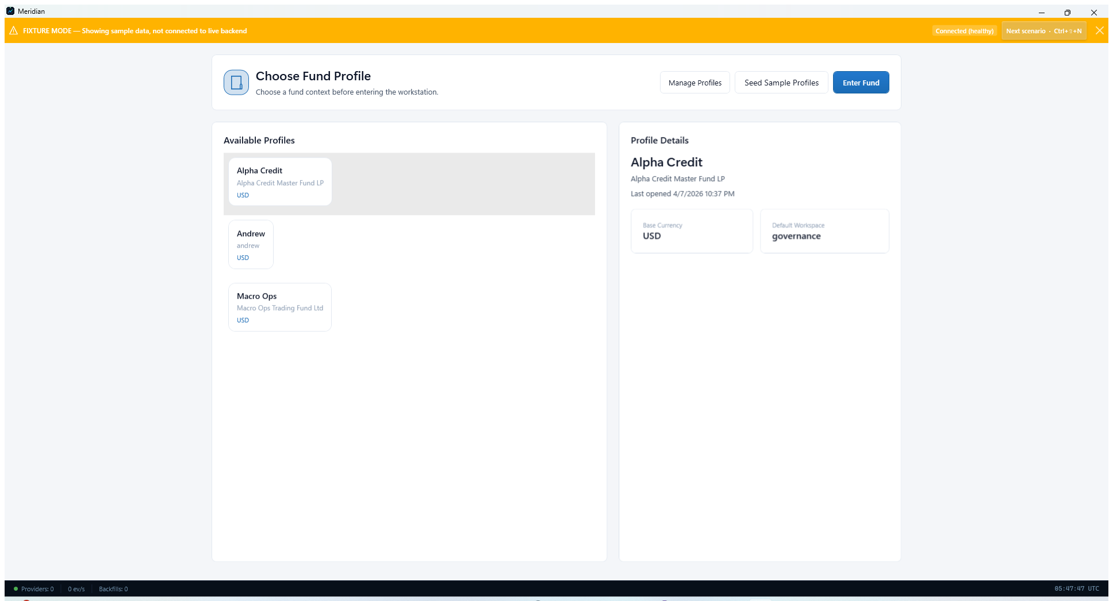
Data Operations workspace with its main quick actions.

Configure Providers
Set up the upstream market-data providers and confirm that Meridian can reach them cleanly.

Step 2. Configure and validate providers
Open Data Providers to review the configured streaming and backfill sources. Use Configure for provider-specific settings, then use Validate or Test Connections to confirm that credentials, routing, and network posture are usable before data collection begins.
- Typical operator-managed providers shown here include Interactive Brokers, Alpaca, Polygon, StockSharp, and NYSE.
- Validate provider setup before you schedule backfills or expand symbol coverage.
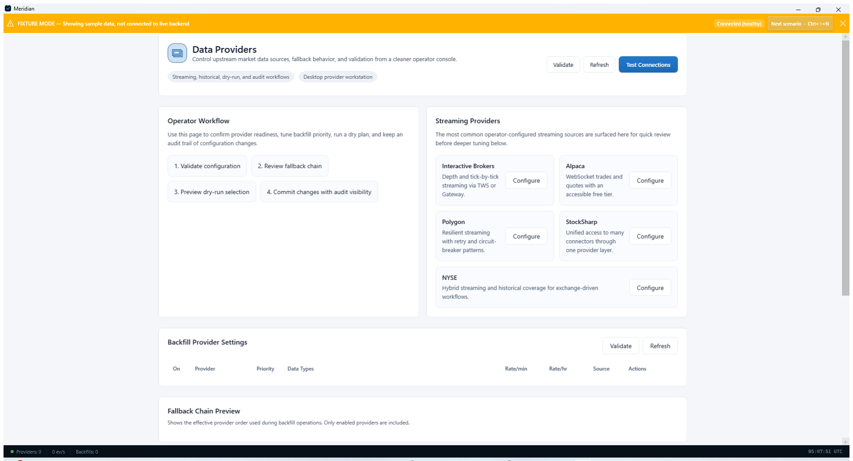
Data Providers page used to configure and test market-data integrations.

Step 3. Review provider health and recent connection history
Open Provider Health after configuration changes or before market open. This page summarizes connected and disconnected providers, latency, and recent connection activity so you can catch degraded posture early.
- Refresh the page after changing credentials or restarting a backend service.
- Connection History helps explain recent disconnects or retries.
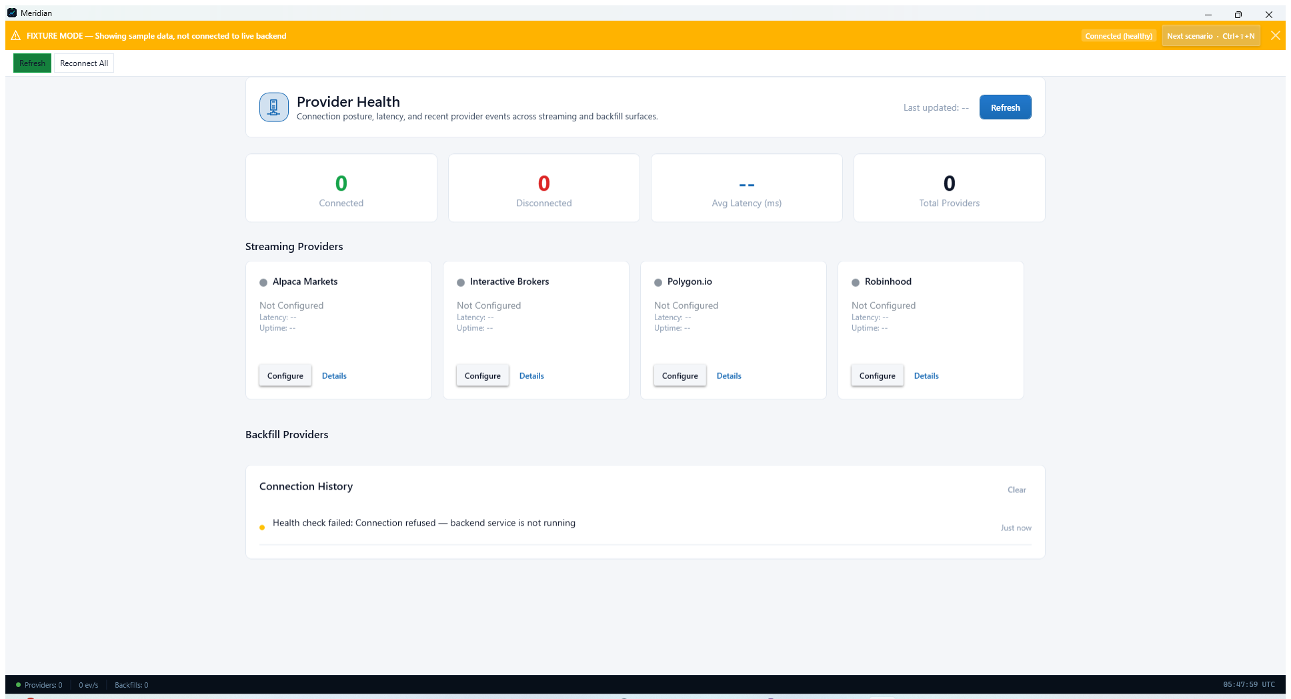
Provider Health page with connectivity and latency summary tiles.

Manage Historical Collection
Use backfill and routing controls to decide how Meridian should catch up and recover missing history.

Step 4. Plan and launch historical backfills
Open Historical Data Backfill when you need to repair gaps, update a symbol set, or build an archive from scratch. Choose the provider, symbol list, provider-priority fallback order, and granularity before launching a job.
- Backfill Wizard is a good starting point for first-time operators.
- Use Fill All Gaps or Update to Latest after the initial archive is established.
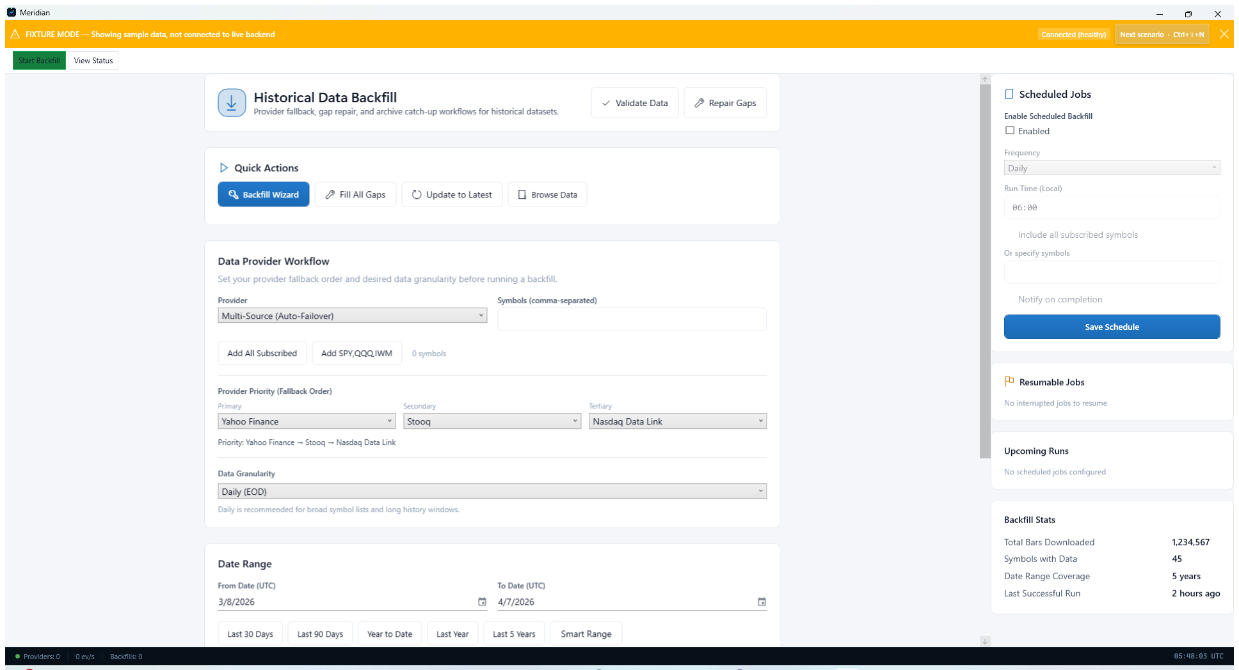
Historical Data Backfill page with workflow and scheduling controls.

Step 5. Set the default real-time and historical sources
Open Data Sources Configuration to choose the default real-time and historical providers Meridian should prefer. Enable automatic failover if you want Meridian to switch to the next source when the primary source becomes unavailable.
- Finish basic provider configuration before expecting the drop-downs to populate.
- Keep failover settings modest until you understand provider stability and entitlement limits.
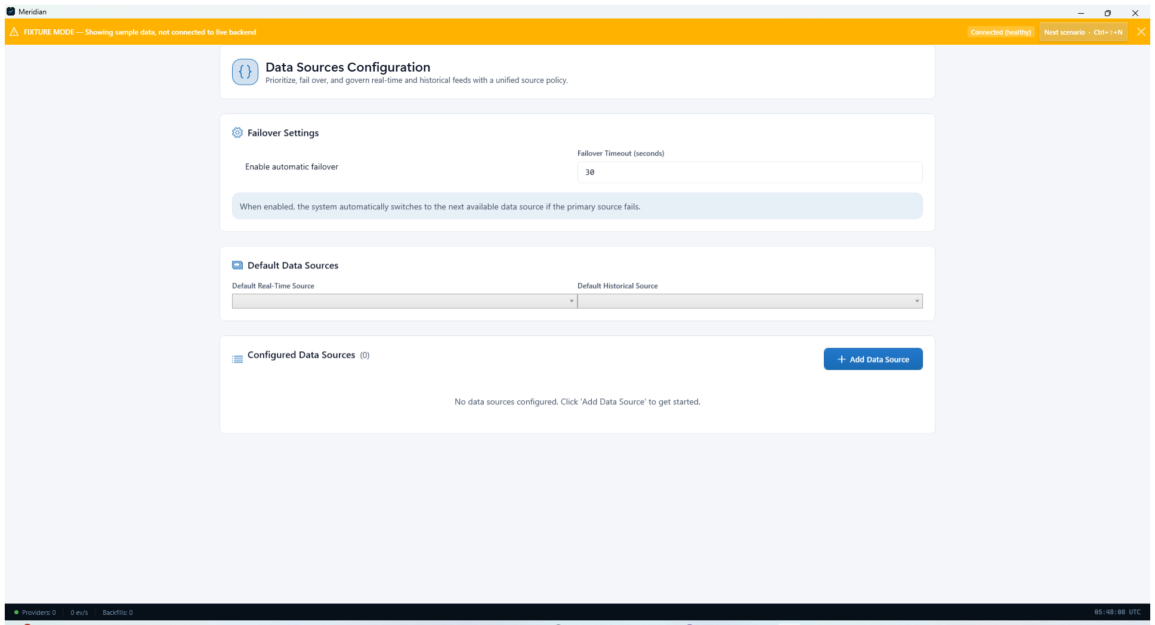
Data Sources Configuration page for default routing and automatic failover.

Confirm Storage
Verify how the archive will be laid out on disk before data volume grows.

Step 6. Review storage directory, layout, and compression
Open Storage Management to confirm where Meridian writes data, how files are organized, and which compression format is active. The file-structure preview helps operators understand exactly what the archive will look like on disk.
- Symbol-based layout and gzip are the default posture shown in the fixture screenshot.
- If you need a different disk or mount point, change the data directory before large backfills.
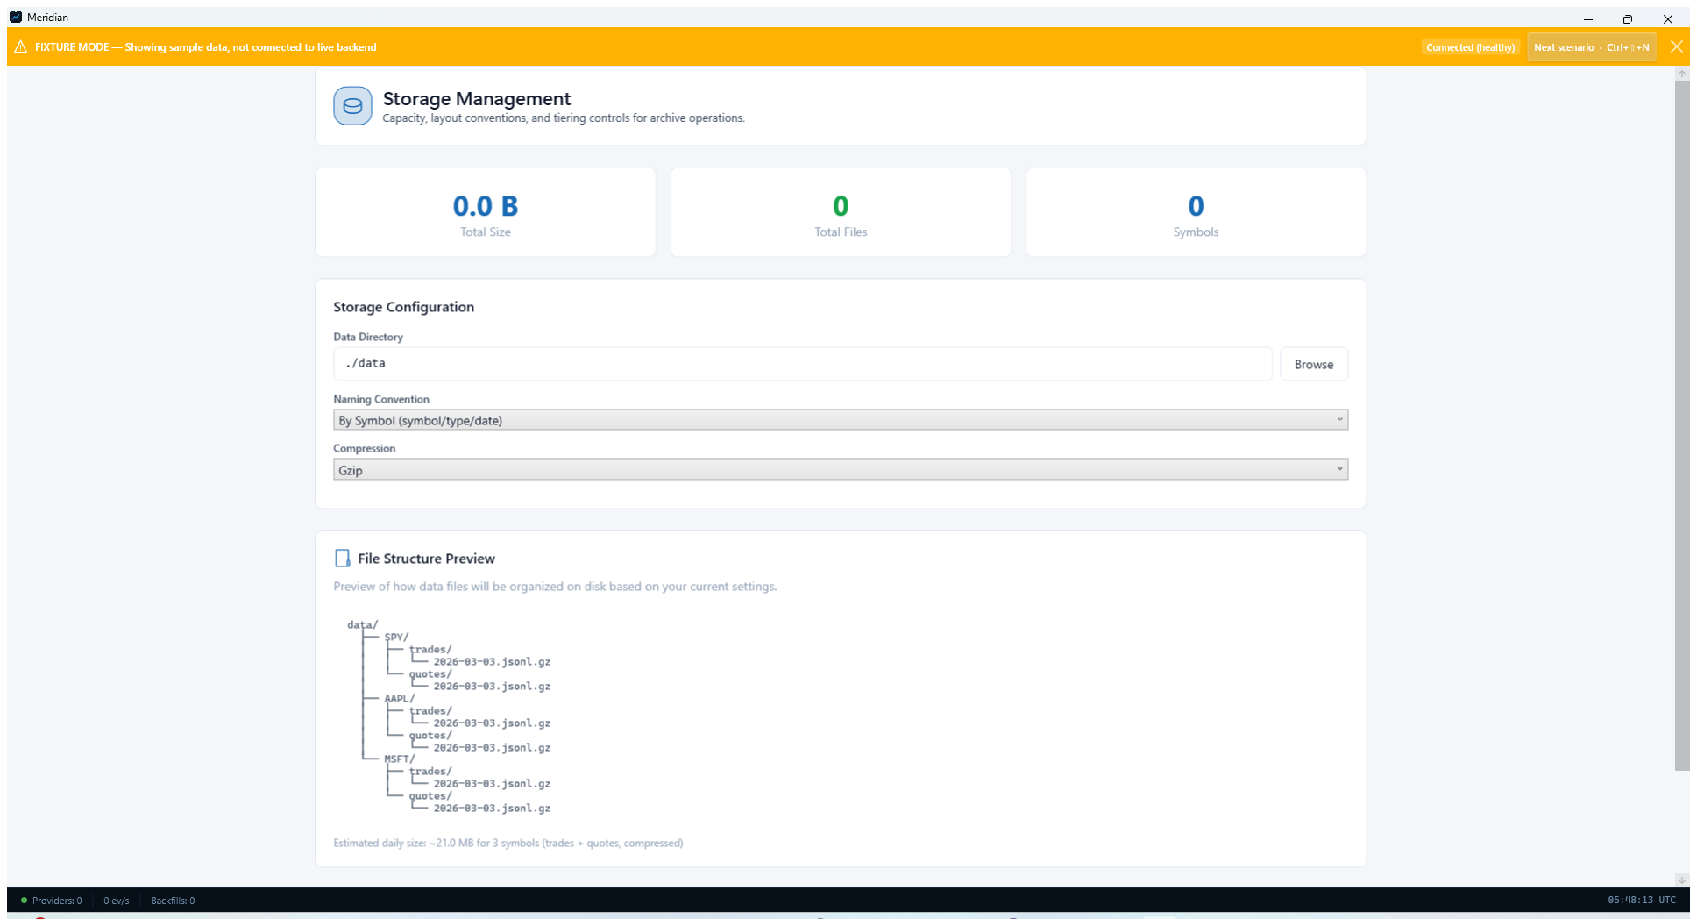
Storage Management page showing archive path, naming convention, and compression.

