Meridian Platform Overview Manual
A guided tour of the desktop shell and main workspaces
Author: Codex | Version: 0.1 | Date: 2026-04-07

This manual introduces the Meridian desktop shell and the main workspaces a new operator will use day to day.
Screenshots were captured from the Windows WPF shell in fixture mode on April 7, 2026. The layout matches the desktop product, but live counts and status values may differ in a connected environment.

Shell Orientation
Start with the shell surfaces that tell you where you are, what is running, and how to move between workspaces.

Step 1. Start on the dashboard
Open Meridian to land on the Dashboard. This is the main monitoring surface for collector status, event throughput, integrity signals, and quick actions such as Start Collector, Stop Collector, View Logs, and Backfill.
- Use the top banner and bottom status bar to confirm whether you are in fixture mode or connected to a live backend.
- This is the fastest place to confirm whether the desktop shell is healthy after launch.
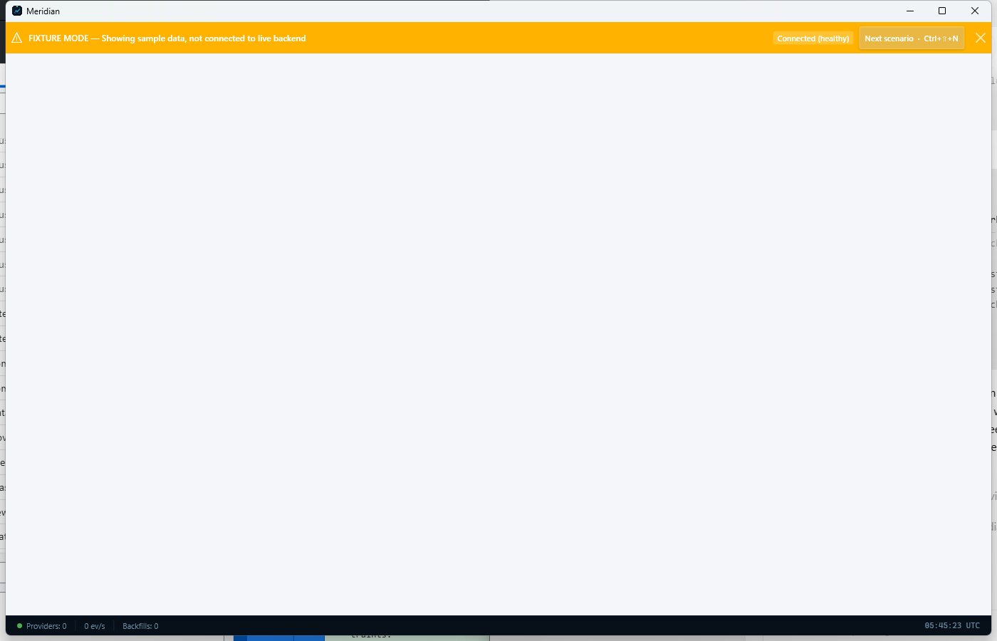
Dashboard with collector controls, summary cards, and quick actions.

Step 2. Use the Workspaces page to switch contexts
Open Workspaces when you want to move between functional operating modes. Meridian uses workspace templates to group related pages, layouts, and navigation paths for research, trading, data operations, and governance.
- Use Activate to switch into a workspace.
- Use Capture Current to save the current session layout if you want to preserve a working setup.
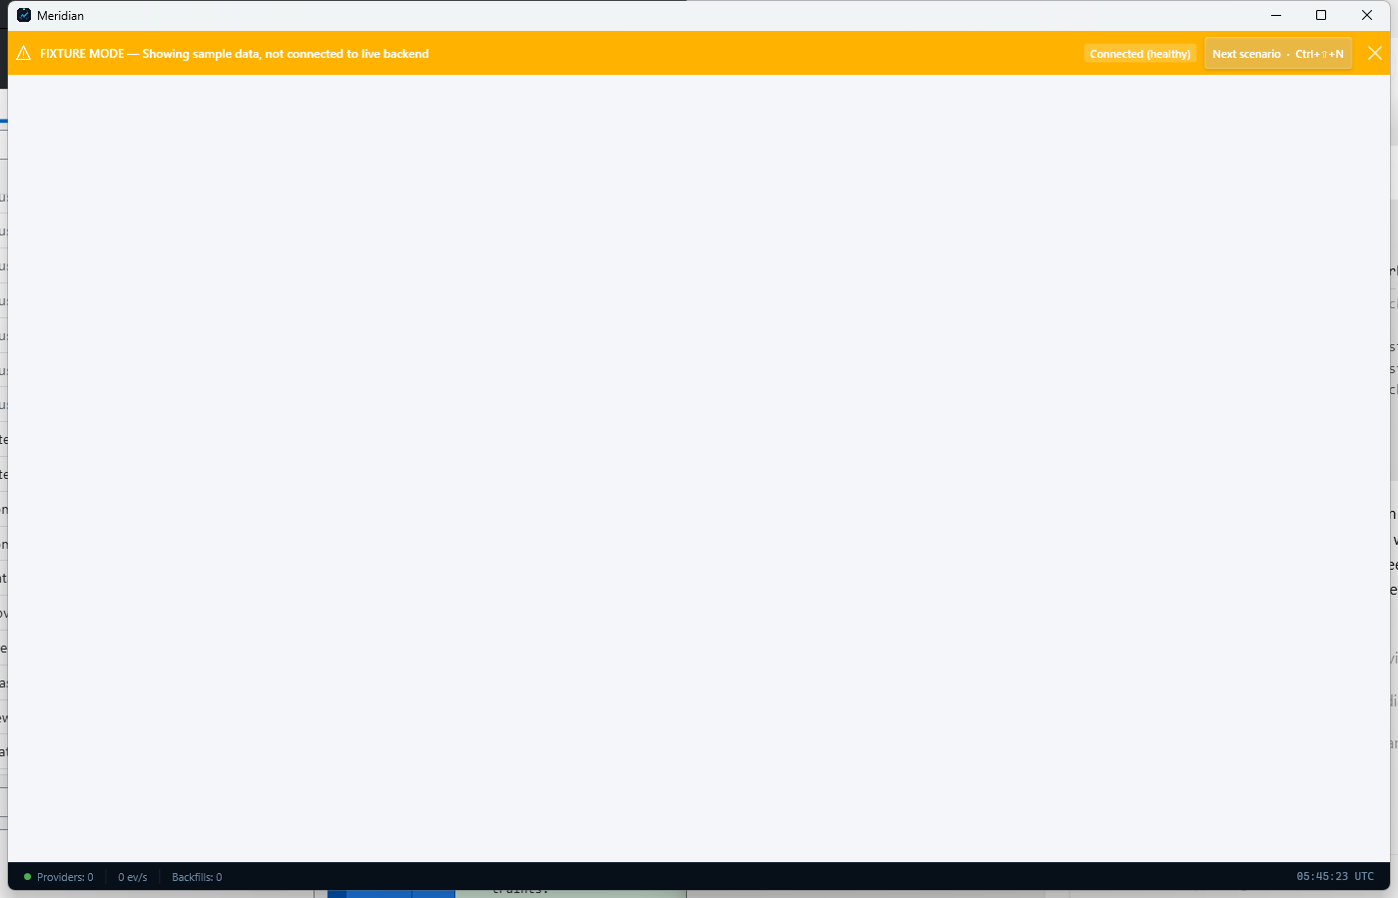
Workspaces page used to activate or capture workstation layouts.

Main Workspaces
Each workspace groups a different operating responsibility inside the same shell.

Step 3. Open the Research workspace
Use the Research workspace for idea generation, backtests, strategy comparison, and exploratory analysis. It is the right starting point when you are testing hypotheses or reviewing model behavior before deployment.
- Expect links to backtesting, strategy runs, and QuantScript-style exploratory tools.
- Research work is usually upstream of the Trading workspace.
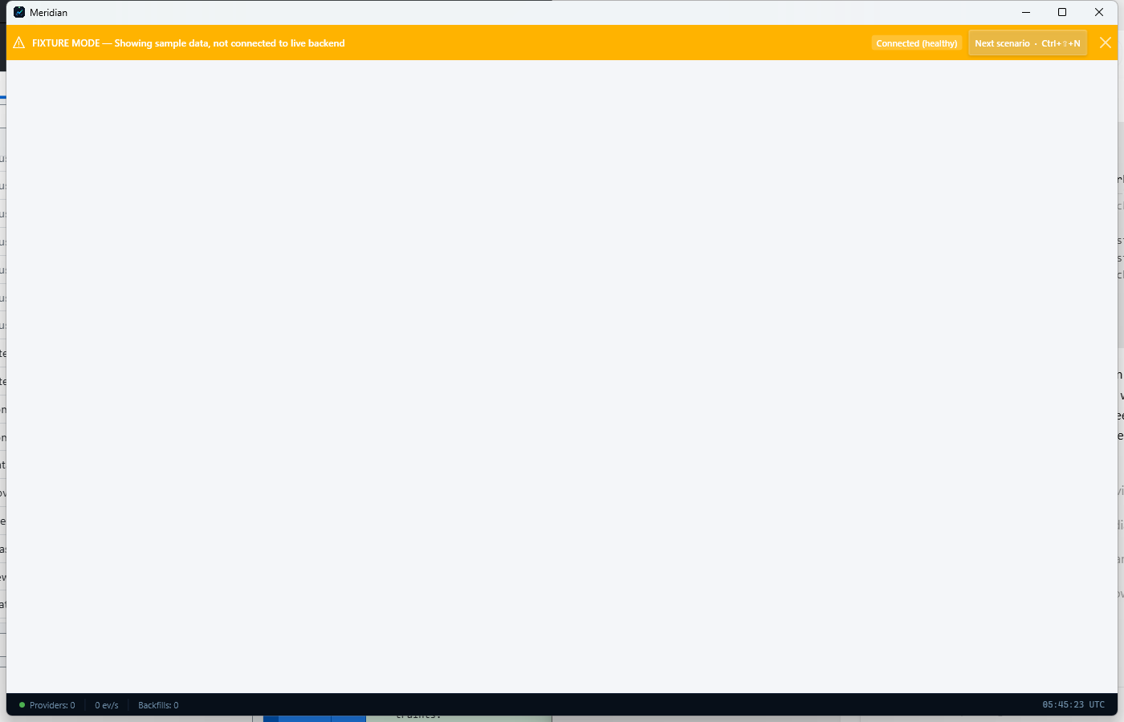
Research workspace overview.

Step 4. Open the Trading workspace
Use the Trading workspace for live operational views such as blotters, position monitoring, and risk checks. This is where operators move once a strategy, run, or portfolio needs hands-on supervision.
- Trading surfaces emphasize current state and controls instead of configuration.
- Use this workspace after research outputs are ready for operational review.
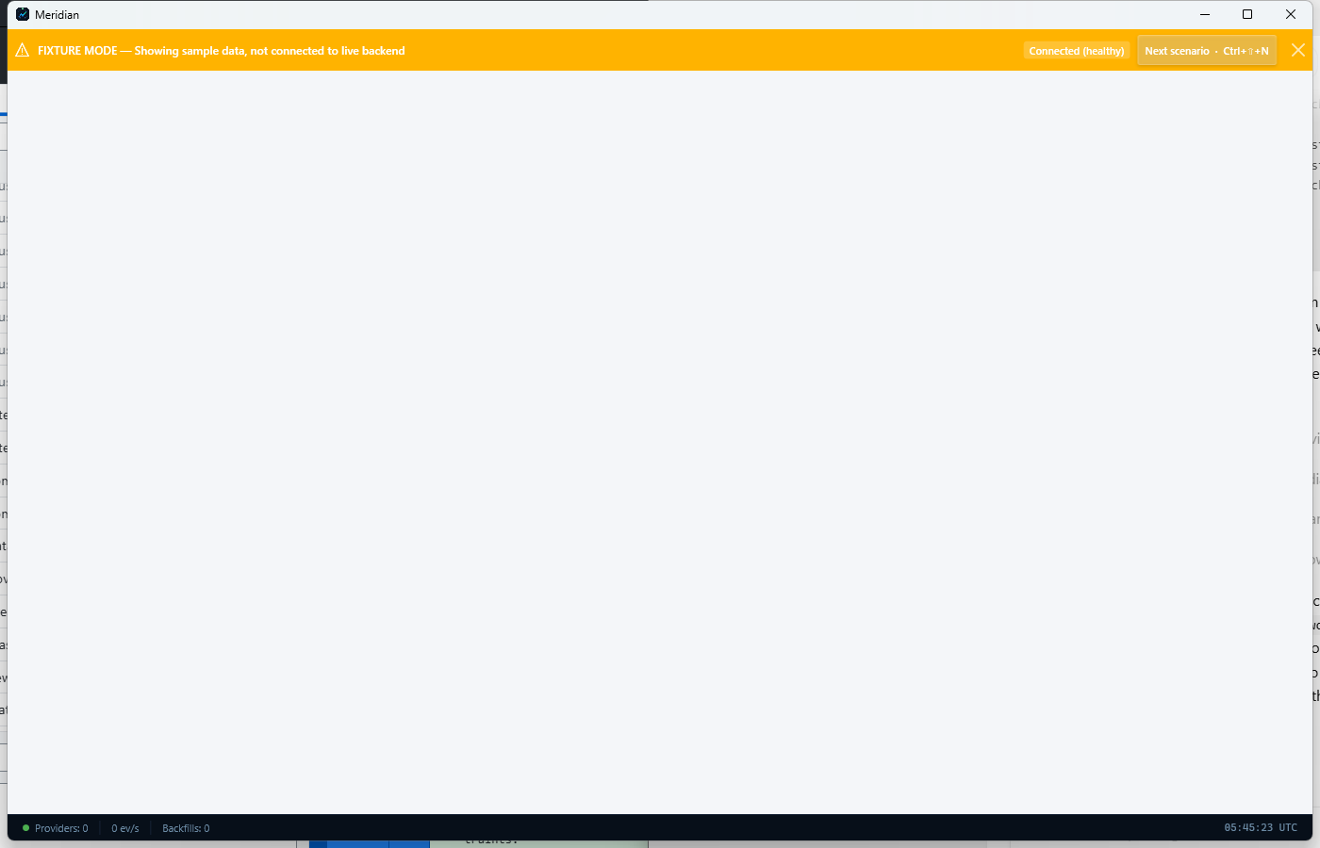
Trading workspace overview.

Step 5. Open the Data Operations workspace
Use Data Operations for provider setup, backfill, symbol coverage, and storage posture. This workspace is the operational control center for market-data ingestion and archive maintenance.
- If a feed is missing or an archive job needs review, start here.
- This workspace complements the quick-start setup manual.
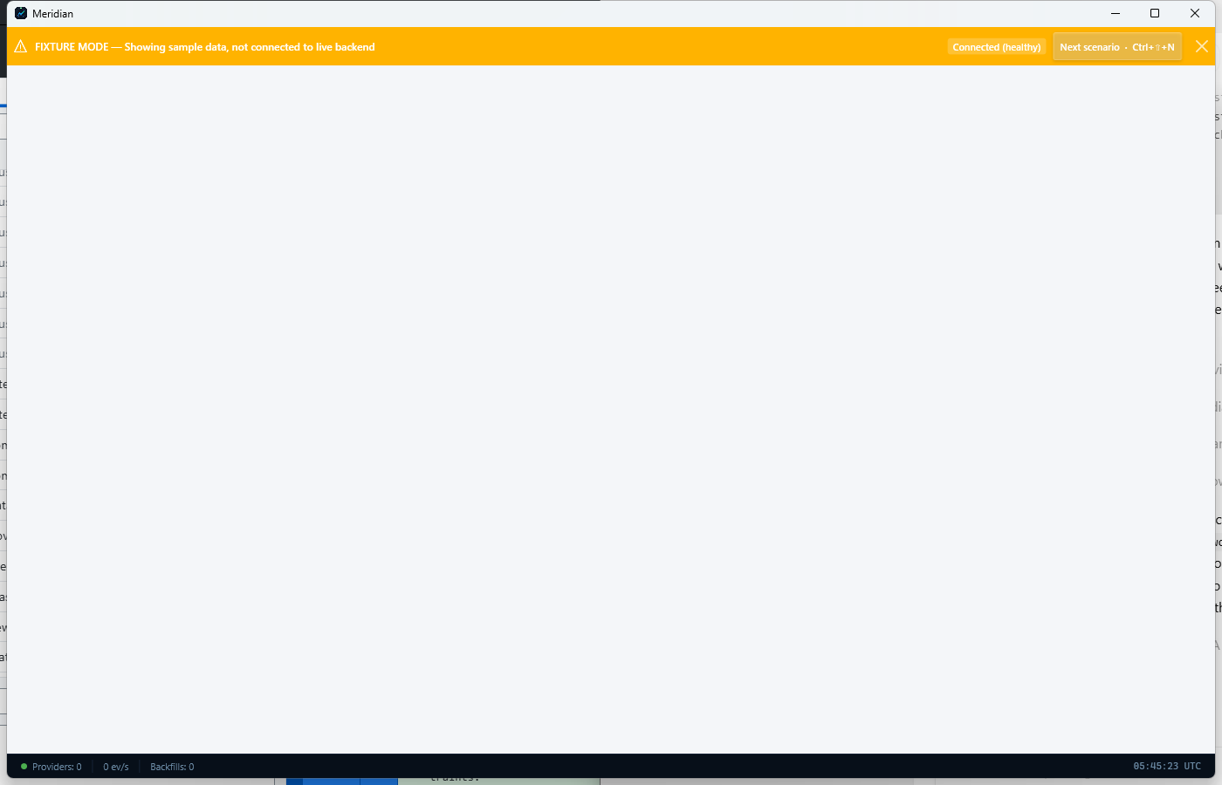
Data Operations workspace overview.

Step 6. Open the Governance workspace
Use Governance for oversight, diagnostics, audit posture, notifications, and fund-operations support screens. It helps centralize trust and control tasks that cut across the rest of the platform.
- Governance surfaces are useful when you need an operator-wide control view rather than a single workflow view.
- Use it alongside Settings when controls or credentials change.
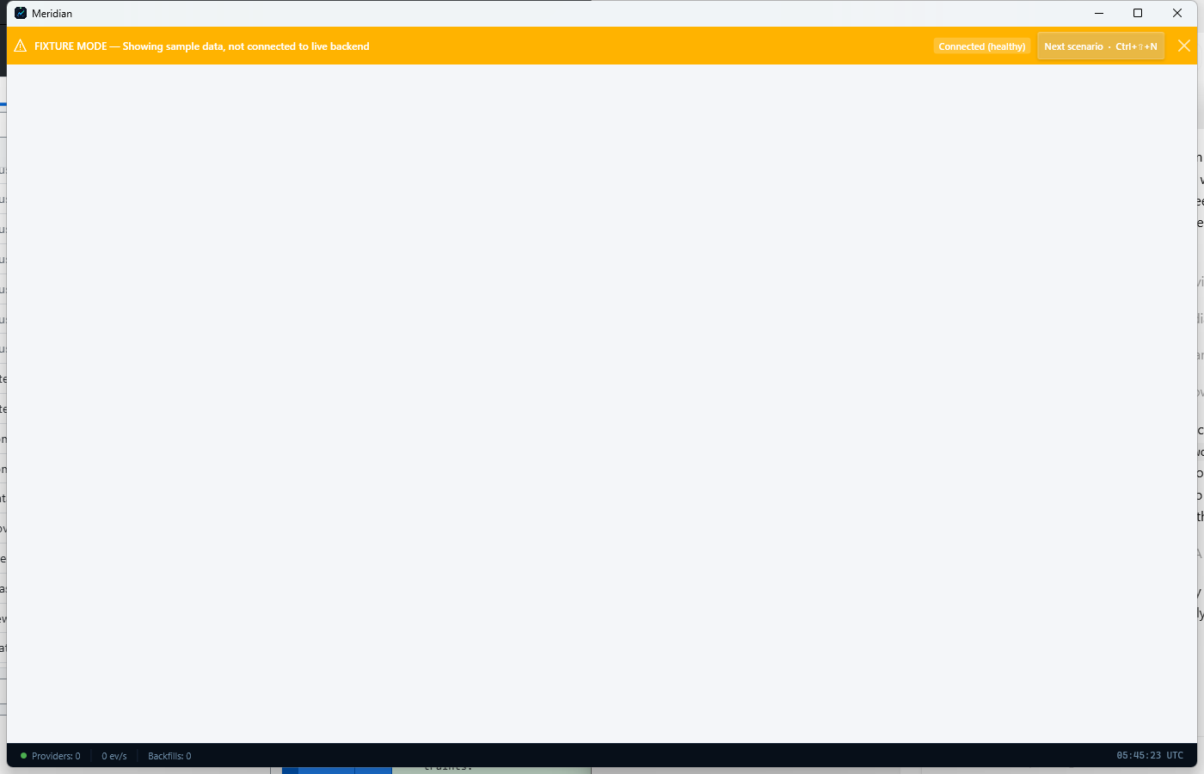
Governance workspace overview.

Built-In Help
Meridian includes in-product guidance so operators can self-serve common setup and navigation questions.

Step 7. Use Help when you need onboarding or shortcuts
Open Help & Getting Started when you need a refresher on setup order, keyboard shortcuts, or documentation links. It is the quickest built-in reference for onboarding and daily-use reminders.
- Press F1 to open Help.
- The help page includes the quick-start sequence for Provider, Credentials, Symbols, Storage, and Start.
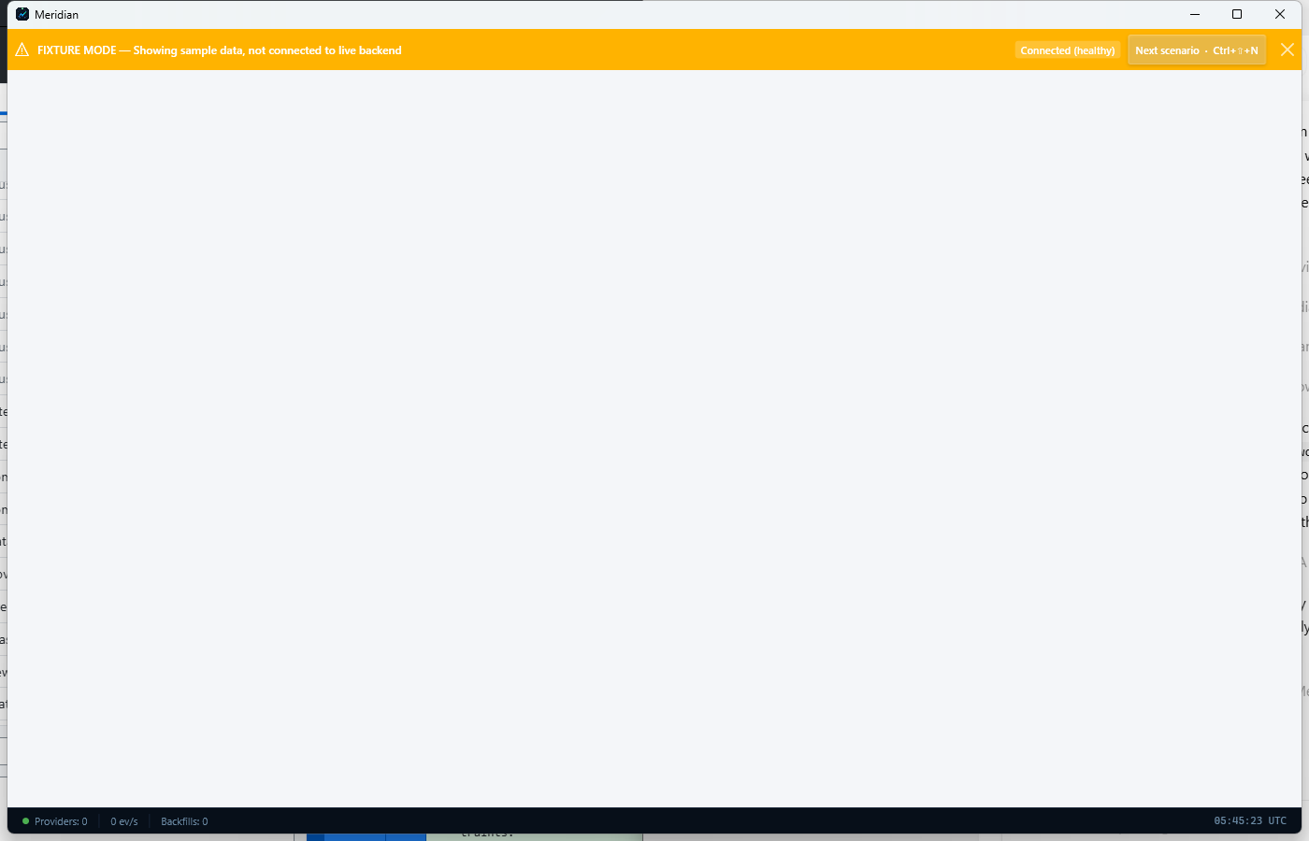
Help & Getting Started page with tutorials, shortcuts, and documentation links.

