Self-Development Plan

Chapter 1 – Who am I?

Rodolfo Fava

Table of Contents

Chapter 1.1 Self Analysis 2

Chapter 1.2 Personality Test Results 3

Chapter 1.3 Personality Test Analysis 4

Feedback from my girlfriend Andressa: 4

Feedback from my classmate Ben: 4

Feedback from my cousin Filippo: 5

Feedback from myself: 5

Chapter 1 – Who am I?

## Chapter 1.1 Self Analysis

My name is Rodolfo. I am 21 years old and Brazil is my home country, but I am also half-Italian.

I came to NHTV to study game development because it is a highly regarded educational institution as well as an industry partner. For instance, the PlayStation First Academic Partnership Programme shows a strong connection with major companies in the video games field. For me, video games are really appealing due to the creative as well as the logic part of their development and consequently, the experience they provide. I consider myself as a creative person; I have taken drawing, piano, singing, and even guitar lessons in my free time. It is also worth mentioning that I have a background in programming and problem-solving as well, due to my previous unfinished higher education in Network Engineering. Despite having earned valuable skills from my last degree, it hardly gave me the chance to explore my creative side. That is the reason I interrupted my studies there and decided to go for a game bachelor in NHTV.

My family was really skeptical at the beginning when I said I wanted to quit university, they believed I was only doing it because I was not resilient enough in my studies, when in fact, I was taking my education quite seriously. I recall helping my colleagues understand some topics on advanced subjects, so that proves I was not simply avoiding work.

Anyhow, at this point, I am not too sure of what kind of job I would like to have in the game industry. However, I am considering the idea of working as an indie game developer in my own company, in a position that I could have a say on every aspect of the game, from the functionality to the music and the visual art. Nevertheless, I hope the following years in NHTV will provide me with enough information to make a reasonable decision.

Right now I must say it is being difficult to adapt to the new routine, the heavy workload of NHTV and balancing my time with studies, house chores, and social activities. In order to be more efficient in my school work, I have started using planning tools like Trello, and I have also become more aware of what is excepted from me. For example, I am learning to use Perforce (which I struggled with in the last weeks) and I can now send a link from swarm and directly paste it on my Straight Jacket Objectives separately. Fortunately, I have my friends and colleagues to thank for helping me.

Now that I have learned the basics on documenting my progress as a student, I have set goals for the following weeks. For instance, on this link <https://trello.com/b/MYoraoN7/galaxian> it can be seen that I am taking my first steps in terms of getting my work done. By clicking on each card, a set of checklists and objectives pop-up on the screen, so I can keep track of what I have done and what still needs improvement.

## Chapter 1.2 Personality Test Results

Permanent link to the results:

<https://www.123test.com/personality-test/id=ffc3a4e7aa20f9c0198f>

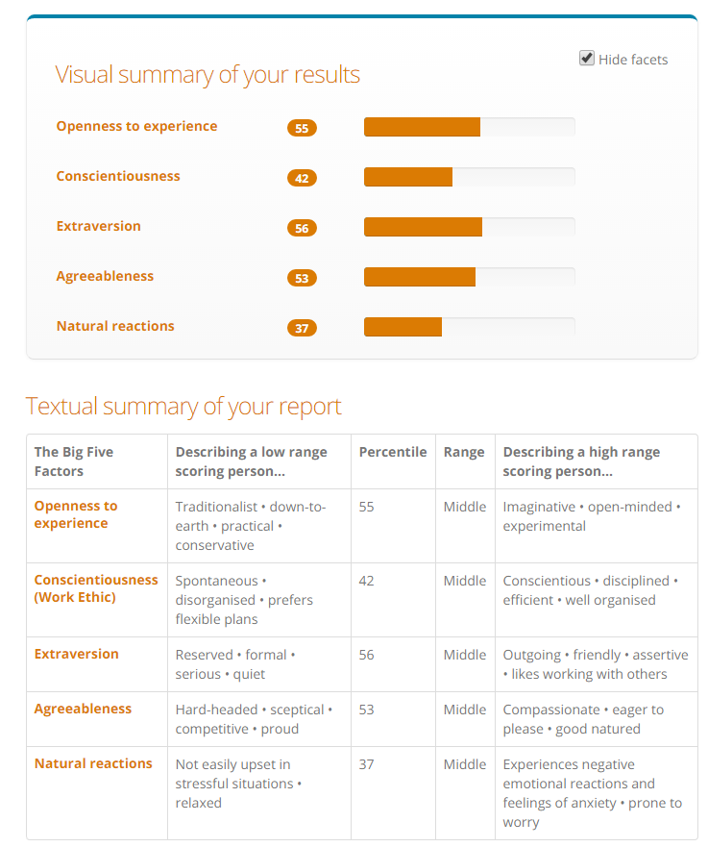

Figure 1 Personality Test Results

## Chapter 1.3 Personality Test Analysis

### Feedback from my girlfriend Andressa:

* Openness to experience:
  + At the same time Rodolfo is open to new experiences, like visiting new places or doing different activities, he is also aware of what he likes and dislikes.
* Conscientiousness:
  + Rodolfo is spontaneous, and may prefer flexible plans, but he is more productive in a consistent work routine. He realizes he can be very disorganized, so he tries hard to overcome it.
* Extraversion:
  + Rodolfo is very respectful towards people he is not familiar with but is really outgoing with everyone.
* Agreeableness:
  + Rodolfo can be really stubborn in some discussion topics like politics, on the other hand, he is really easy to talk to when it comes to deciding what we are going to do. We always discuss what we are doing next, so no one is imposing any decisions on the other.
* Natural reactions:
  + Rodolfo can cope well with pressure in a work environment, however, he can be short-tempered towards people who are unwilling to cooperate in the team.

### Feedback from my classmate Ben:

* Openness to experience:
  + I think Rodolfo is very open to new experiences, he is very active in exploring Breda and the Netherlands. I think his score in this should be higher.
* Conscientiousness:
  + Rodolfo has a good work ethic though I am not sure how organised he is. I believe his score should be higher for this too, though.
* Extraversion:
  + He is very outgoing and seems to make friends easily. As before, a higher score is more appropriate!
* Agreeableness:
  + Rodolfo is very compassionate and willing to help his friends.
* Natural reactions:
  + Rodolfo seems very calm and unaffected by stressful situations. I believe his score in this should be lower.

### Feedback from my cousin Filippo:

* Openness to experience:
  + I think Rodolfo is a person eager to live a variety of different experiences but he's enough mature to avoid the dangerous ones. He's confident and he knows what he wants from his life.
* Conscientiousness:
  + Rodolfo is undoubtedly a spontaneous person who could sometimes be disorganized. However, his discipline and will are always so strong to allow him to accomplish the majority of his works.
* Extroversion:
  + Rodolfo spontaneity and vivacity are extremely contagious and stay close to him it's really a pleasure. He's able to make you laugh whenever he want.
* Agreeableness:
  + Rodolfo has a genuinely open mind able to argue and accept the opinions and the feedback of the others making himself a real listener and an interesting person.
* Natural reactions:
  + Even when the pressure is extremely high, Rodolfo can always manage properly his reactions proving to be a very good colleague and friend.

### Feedback from myself:

I believe the results of the text did not represent precisely my personality in its nature, despite its range in areas and exaggerated extent. For instance, I picture myself more as compassionate than skeptical. I also can not see myself as a practical person, despite my background in logic subjects like mathematics and physics. For that reason, I disagree with some of the scores, but I can accept some of the others, for I have been told to be a sensible person, and not extremely logical or passionate.