The Diamond Method

Rationale
The diamond method is a natural scale grids visualization method for guitar in standard tuning. The diamond method helps finding the right notes for any common western tonality based on the natural scale. It is based on the visualization of figures on the guitar fretboard. Grid figures visualized on guitar fretboard indicate which are the natural scale notes that can be used to form chords, arpeggios or even to improvise.
This method only covers the use of the natural scale and all its relative forms, which includes major degrees and chords (e.g. FMaj7), minors (Dm7), the dominant (F7), and the half-diminished (Em7b5).
In order to use the diamond method, knowledge of the natural scale and all its grades is required (that is: what is the natural scale (for example, C, D, E, F, G, A, B), what are its grades (e.g. the fourth degree is known as the Lydian mode, and differs from the first degree on its augmented fourth; the reader is required to know what are the alterations that make each scale), and what is a modulation. Those are not difficult topics. Some basics are introduced in this text.
Much of popular and classical Western music is based on the structure of the major and minor scales —a pattern of seven notes (like C, D, E, F, G, A, B)— regardless of the starting note (key). By mastering the diamond method, the user can improvise (including jazz) and have most of the theoretics solved. Of course, the user needs the playing technique, which is out of the scope of this text (knowing how to make a shoe is not the same as using your hands to make a shoe, that is, you still need to learn how to use your fingers; I will show you how to make a shoe, but it is you that should practice and apply the theory to produce the actual shoe).

Basics
When the tone of a song is CMaj, the white keys on the piano are used to form chords, arpeggios or develop improvisations. However, if the tonality is DMaj, some black keys are required and some white keys are unused. Learning the right scales on the piano has some difficulty due to the structure of the notes on the instrument, in this case, the piano.
However, in the guitar, there are no white and black positions. In order to learn fingerings on the piano, many people emulate the idea of the black and white keys on the guitar:
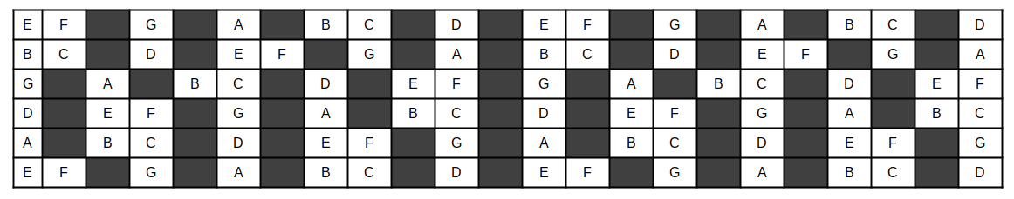
The problem of such idea is that, again, like on the piano, this fingering allows only to play songs in the CMaj tonality.
But the guitar has an advantage that the piano has not: shifting any amount of semi-tones implies just sliding the hand for the same amount of frets.
With the previous method, just shifting the markings does not work. Of course, we can try to shift the black and white markings, but that is very difficult to memorize.
Here’s the key to this method: what if we can find a permanent structure that describes such white and black markings, and we use such structure in any position?
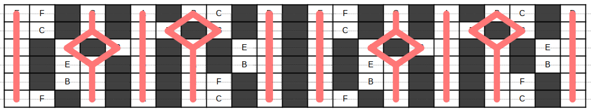
Notice that some notes are still missing, and we’ll deal with them later.
However, this structure is easy to memorize, allowing playing in most tonalities on western music, just by shifting the shape to the right or to the left.
So, that’s the basic idea. Now, let’s address it in a formal way.

The Diamonds
We’ll call this structure «the diamonds» simply because it reminds of such shapes.
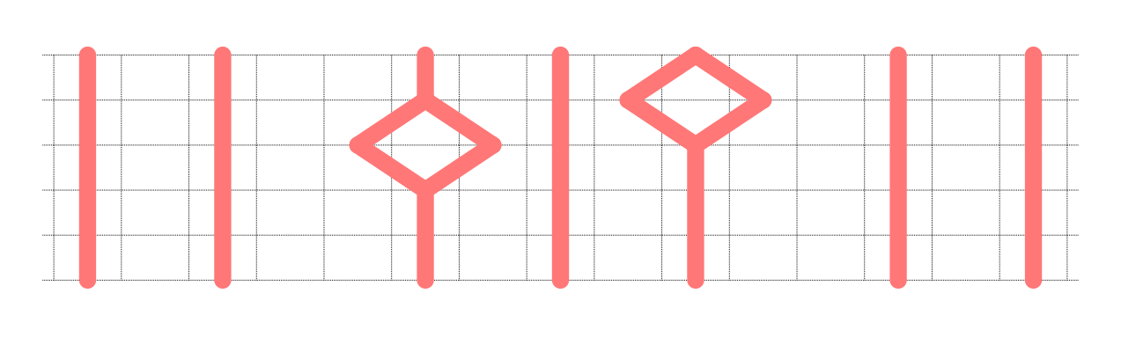
Let’s examine the structure
- The diamonds are to be shifted to the right or to the left of the fretboard, as needed (to the left? to the right? how many frets? we’ll explain that later). A 12 frets shift (which is the same as 12 semitones shift or 6 whole tones shift) makes the pattern repeat, infinitely.
- There are two parallel lines that repeat every 12 semitones. We’ll call this lines the mixolydian lines: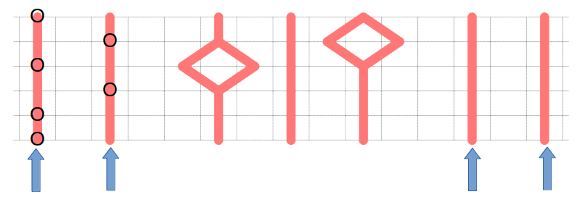
- Notice that a V7 chord (with the tonal note on the 5st string) is drawn on the image; that is a dominant chord, which is the fifth degree on the natural scale, that is, the chord built on notes 1st, 3rd, 5th and 7th of the Mixolydian mode. That’s why the lines that contain such chord are called the mixolydian lines.
- There is a single line, the dorian line, to the left and/or to the right of the mixolydian lines, which is always at a distance of 5 semitones (five frets):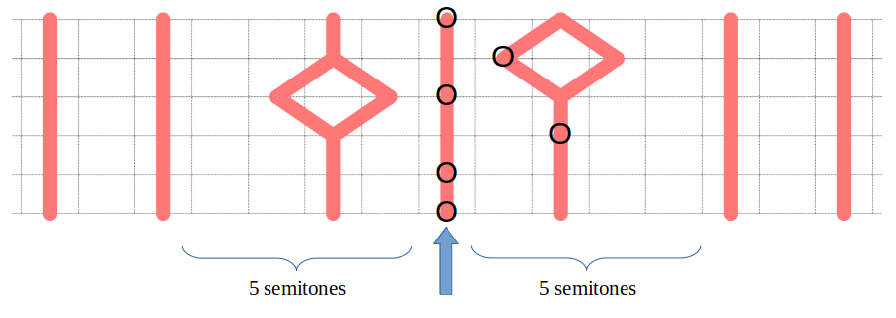
- That is, the mixolydian lines are five frets to the left or to the right of the dorian line.
- In addition, a iim7 chord (with the tonal note on the 5st string) is drawn on the image; that is a minor chord, which is the second degree on the natural scale, that is, the chord built on notes 1st, 3rd, 5th and 7th of the Dorian mode. That’s why the line that contain such chord is called the dorian line.
- The diamonds are two frets (one tone) to the left and to the right of the dorian line: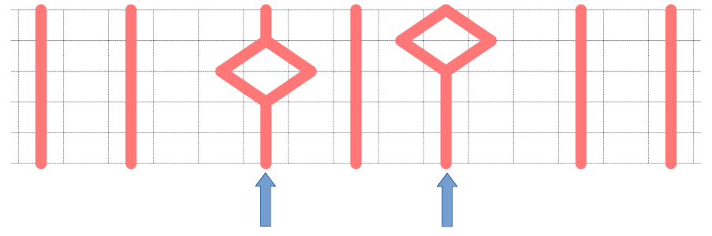
- The left diamond would be a line if it wouldn’t miss the note on the third string. That is, the left diamond is centered on the third string.
- The right diamond would be a line if it wouldn’t miss the note on the third string. That is, the left diamond is centered on the second string.
- As said, some notes are missing. This is because I recommend to memorize the diamonds in two stages; first, the structure above. Then, when you master that, learn the missing shapes:
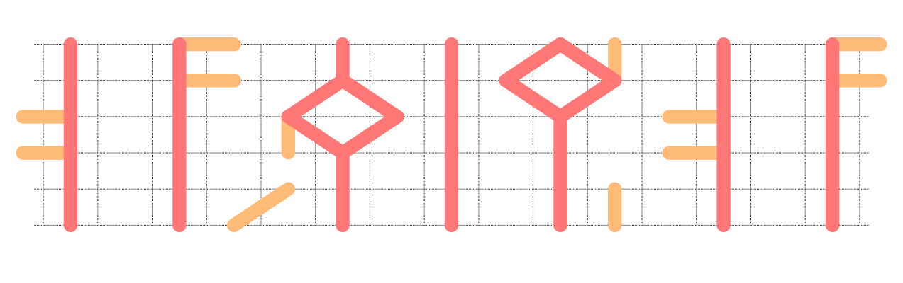
As you see, the missing shapes are very easy to learn:
- The mixolydian right line has two notes to the right, on strings 1 and 2.
- The mixolydian left line has two notes to the left, on strings 3 and 4.
- The right diamond has an upwards queue, far from the dorian line.
- The left diamond has a downwards queue, far from the dorian line.
- There are two weird lines on strings 5 and 6. Use whatever notion to learn them. Or just don’t. A couple of missing notes will not harm your playing.
Now, we’ve learned where are the white keys on the guitar, and, better yet, how to transpose (just shift the structure to the right or to the left by the number of semi-tones you want to transpose).

