3rd Nov

Note:ADD Actual start date in the BI department

1)in the admin (completed)

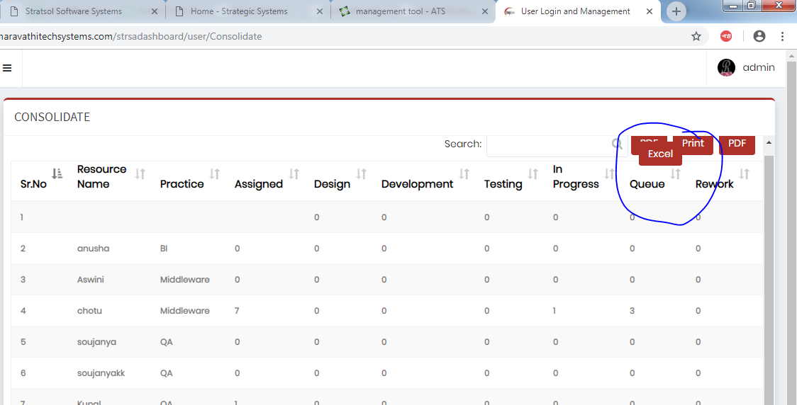

2)still pdf download is pending (what is the pending)(Only for consolidate it is coming for others its not cmng)

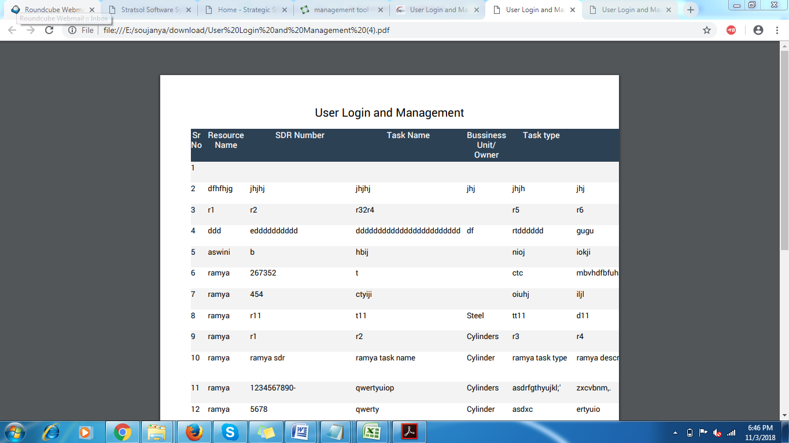

3)When admin / user close the side bar then place the mouse over the “my account “ then the departrment is displaying in White/ Black .

4)in the JDE fuctional form we have two practiice filed

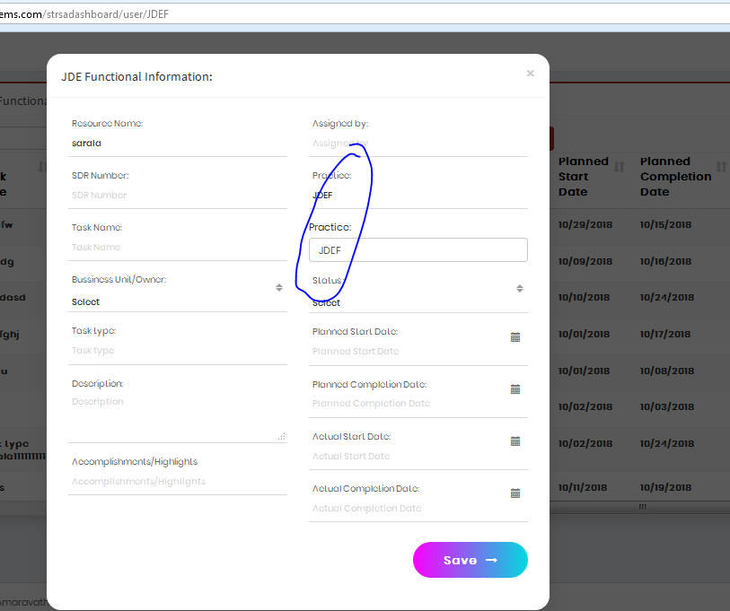

5)in the JDE technical form insert form actual completion is text filed because of that i am not able to enter the new data

6)in the middelware form

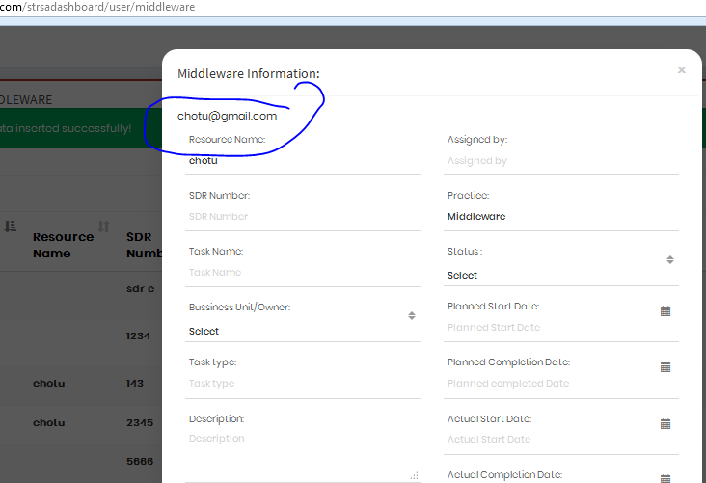

7)in the middelware edit form description is not displaying

8)in the QA display record Manual spelling wrong

9)in the QA comment text is not display in the edit form

10)In the QA insert form

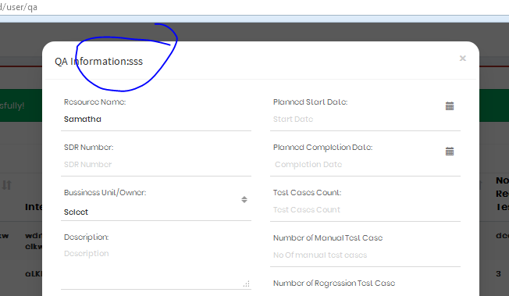

16th Oct

3)In the admin while adding the user the Status Active and Delete are the option , But previous it was deactive ? (previous also same , active and delete not inactive) (But make Inactive )(delete-> option is already there by side , so can you make it Inactive) and for users dashboard not need active and delet in there profile

1)in bi edit form

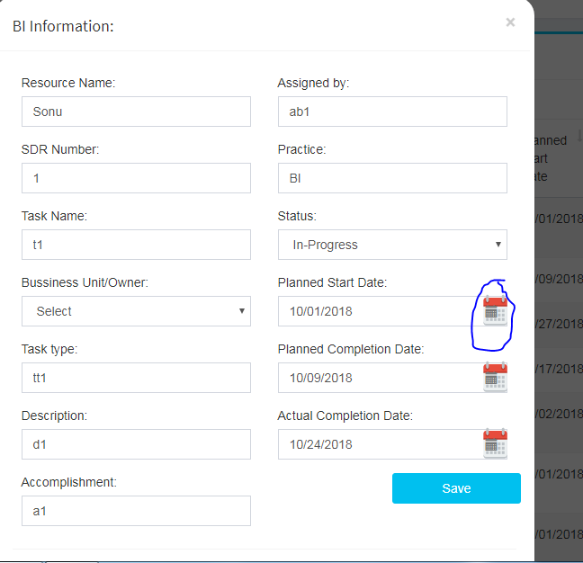

2)JDEF form design which you have added in that drop down is not working

3)

15th Oct

1)In BI edit Replace the date picker symbol ,which you kept for others (COMPLETED)

2)In the admin while adding users , remove the consolidate in the Depart drop down (COMPLETED)

3)In the admin while adding the user the Status Active and Delete are the option , But previous it was deactive ? (previous also same , active and delete not inactive) (But make Inactive )(delete-> option is already there by side , so can you make it Inactive) and for users dashboard not need active and delet in there profile

4)BI Date picker field in edit form became text field

5)Design of the form

14th oct  
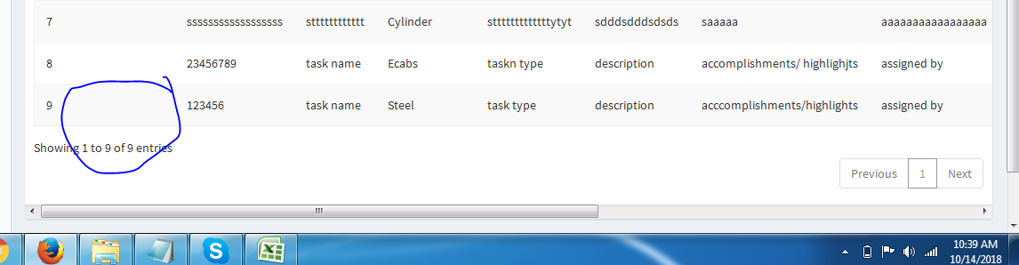1)In BI resource name is not saving (COMPLETED)

2)place holder in the edi (COMPLETED)

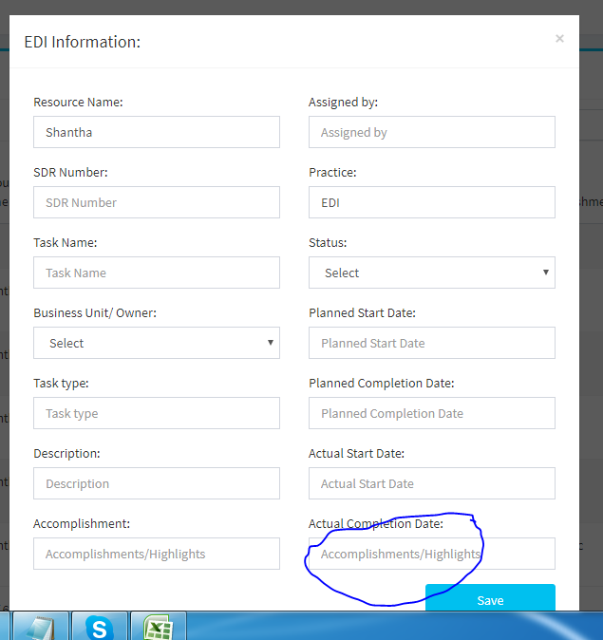

3)in edi task name is not displaying in (COMPLETED)

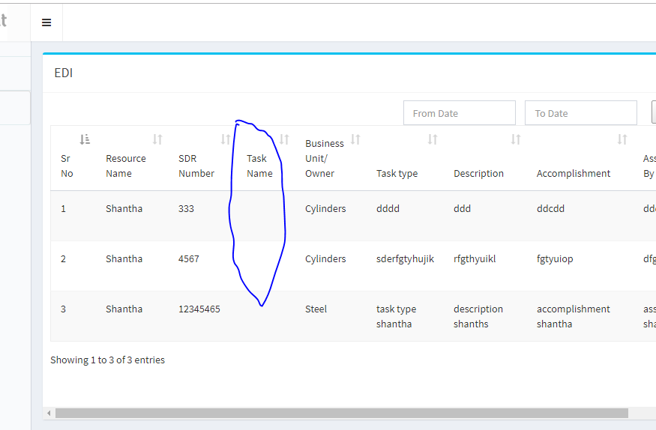

4) Want the date picker symbol for the date picker (COMPLETED)

5)In consolidate

i) User Id is not needed (COMPLETED)

ii) Resource name -> should not be email id it should be name in the field (COMPLETED)

iii)admin should not be in the list (COMPLETED

6)In the admin the user account adding form contain the status field drop down option Active and delete-------> before it was inactive

7)Admin---> remove the consolidate option form the drop down in the user add account form (so no user will be created under consolidate only admin will have ) (COMPLETED)

10/13/2018 (ASWINI SIDE PENDING WORKS)

1)in jdef plan startdate edit is not working.(COMPLETED)

2)in bi form edit is not working (COMPLETED)

3)Consolidate automated form (COMPLETED AFTER CHECK INTIMATE ME IF U WANT ANY CHNAGES)

4)EBS(done), QA(done) , middelware(done) form planed start and completion filed is text , it should be a date picker (NEED EXPLENATION ) Done by sir

5)QA still ia m not able to add the data (COMPLETED)

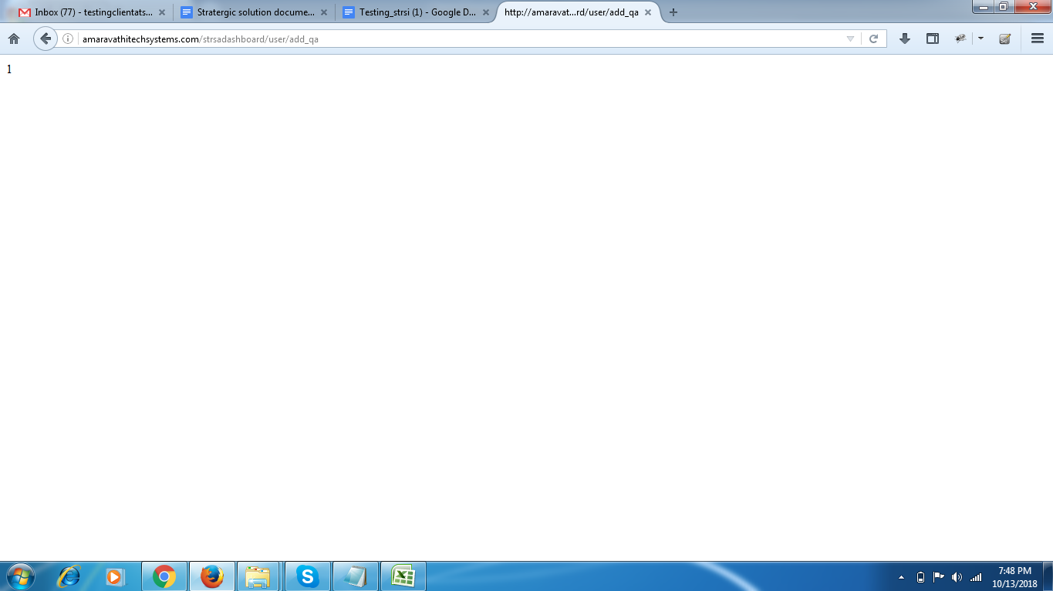

6)in this date is not able to select (COMPLETED)

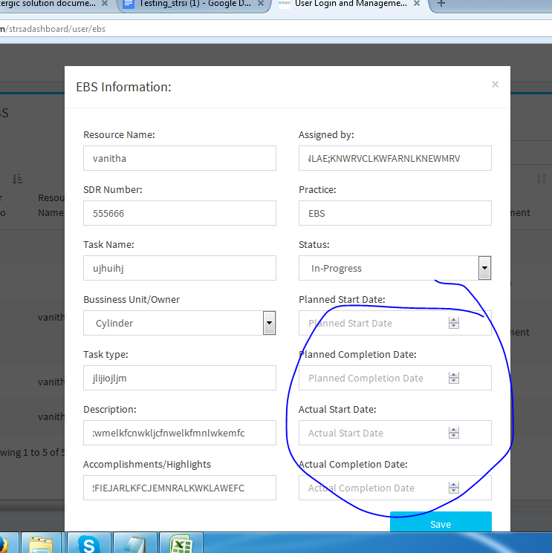

9th oct

1)keep all full names of the fields (COMPLETED)

2)Filter of the date picker is still not working(11)Filter should on the Plan start date Field (From and To)) (its taking plan start date and end date only am I need to mention place holder for that?)

(Only take plan start date to filter) if i select from 3rd oct to 5th oct ->its showing 10th oct ? (completed ) working

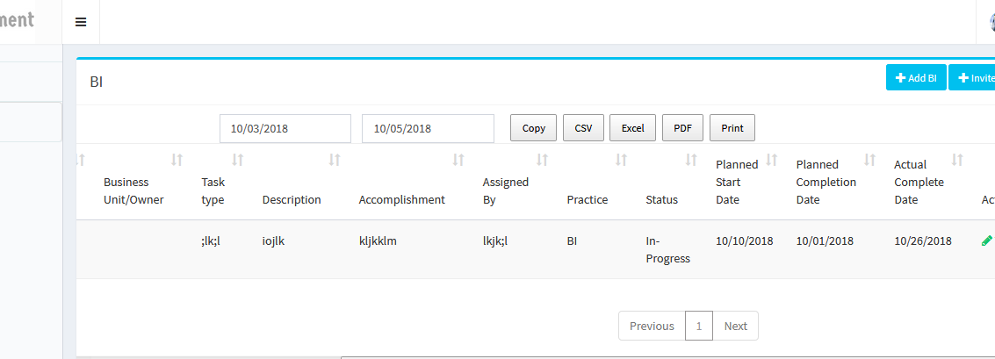

3) 10)In individual department User names should be unique-> this should be only for the individual department check with the email unique

(COMPLETED)

4)User->click on the ADD BI(in all dep)-> click on save-> its showing” Data updated successfully “ but the data is not displayed

5)in the BI form the place holder , not only BI even in other forms.(completed )

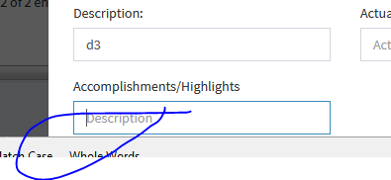

6)While editing the forms the date picker field is becoming text field and the Business Unit/Owner drop down is not showing what we selected previously (COMPLETED) (not working still some issue)

7) this is Business Unit/Owner in all forms even in some display (completed)

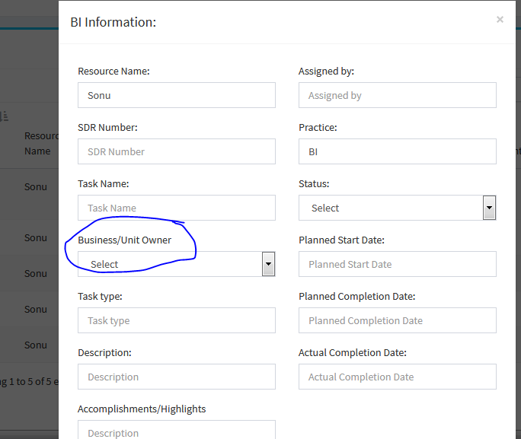

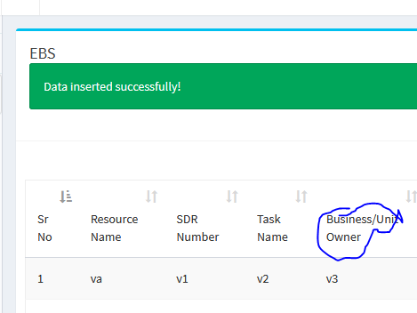

8)in th EDI form (completed)

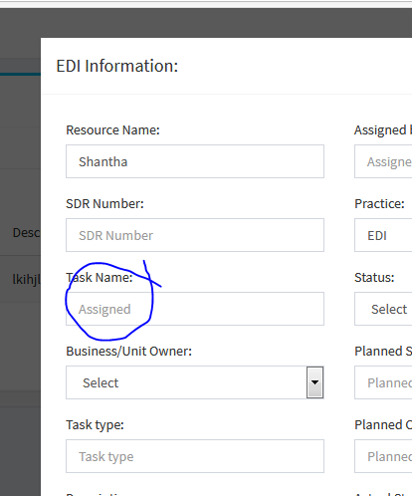

9)place holder (completed)

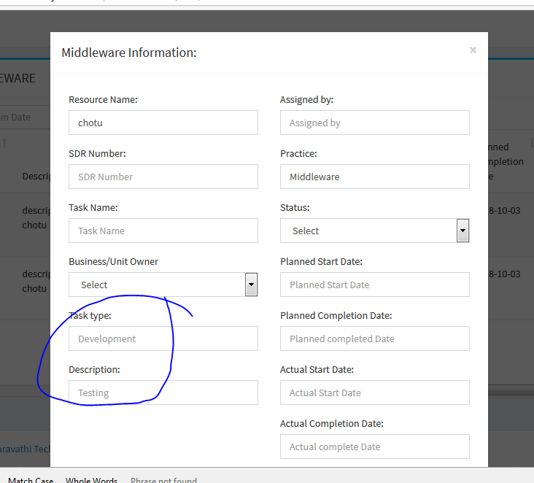

10)in the middleware user form Accomplishments/Highlights filed is missing (completed)

11)in DBA admin and even in user(display and form) ->in EBS user display and the form->in JDE technical admin and user (display and form also) 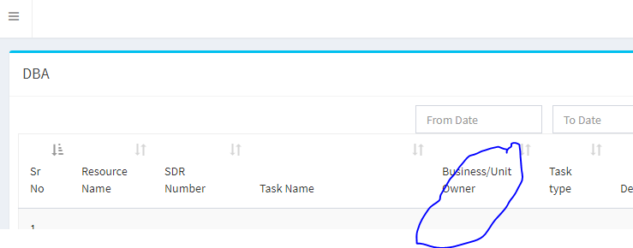

COMPLETED

12)in BI edit is not working ,

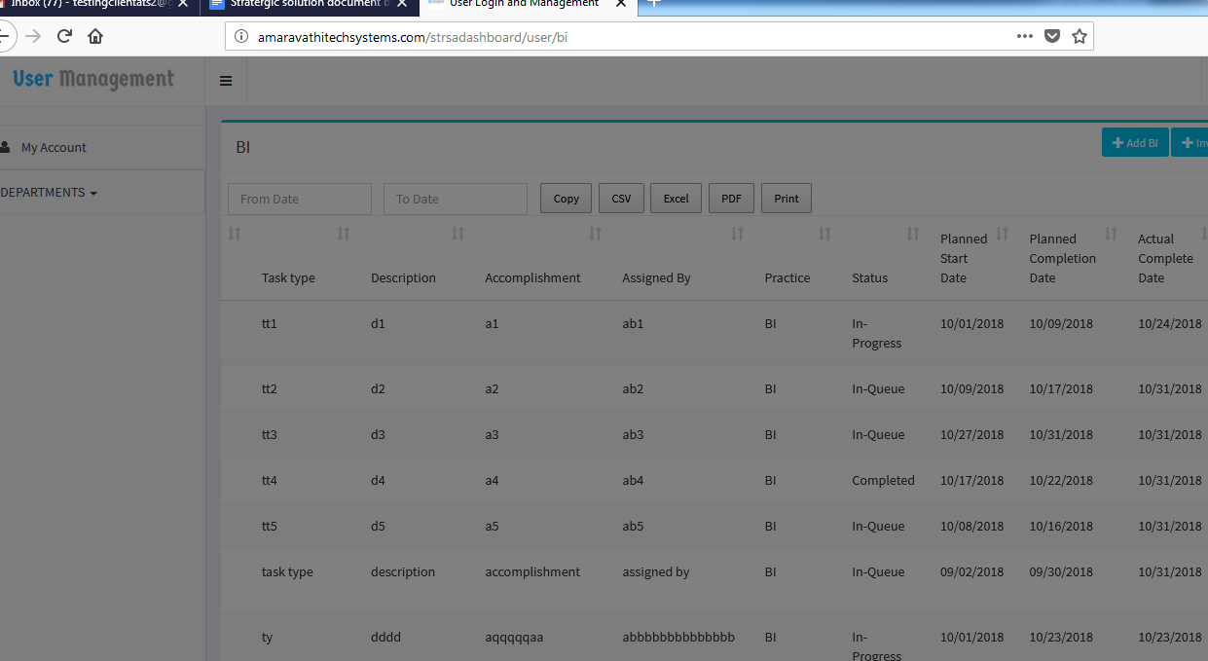

in EBS edit resources name is not displaying (COMPLETED)

In middelware , QA , EBS , JDE Functional (resource and status not showing ) , JDE Technical , EDI (Resource and busniess unit)edit resource name not displaying (COMPLETED)

13)in the middelware when i click on the edit that form contain (COMPLETED)

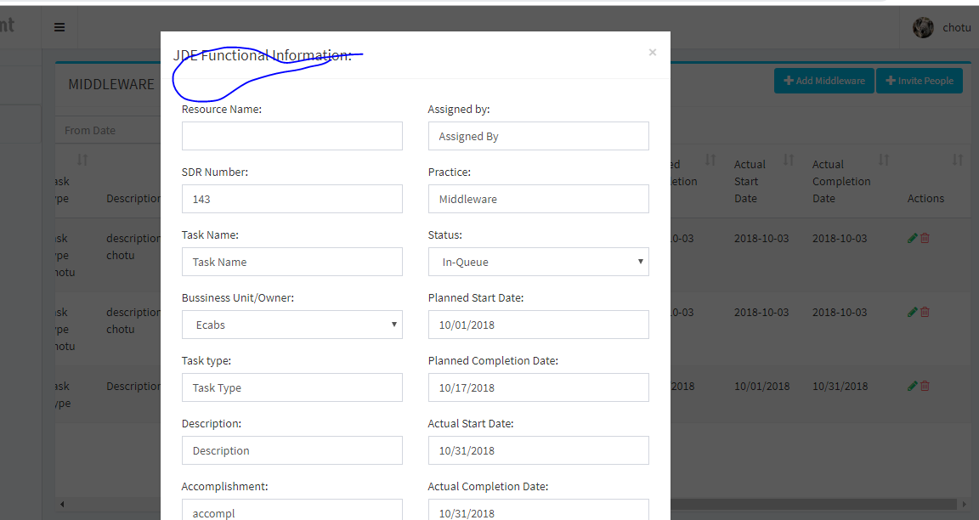14)Date picker in the form need side arrow symbol

15)Consolidate automated form

16)EBS(done), QA(done) , middelware(done) form planed start and completion filed is text , it should be a date picker (NEED EXPLENATION)

17)QA user is not able to add new form (completed)

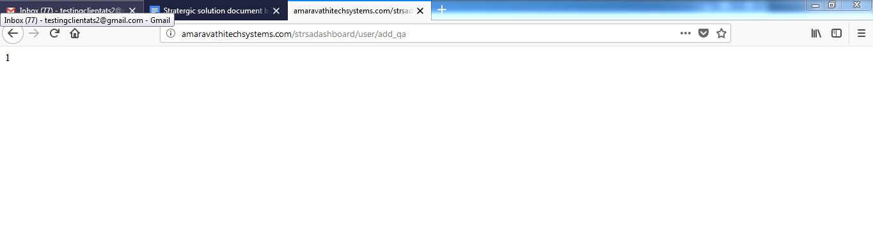

18)EDI filter is not there in admin and in user (COMPLETED)

19)EDI user i am not getting the form to add new data (COMPLETED)

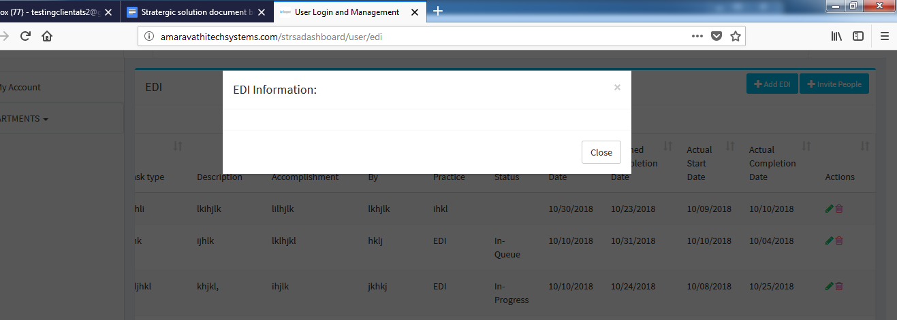

3rd oct

1)in the department keep full name for the JDE Functional and JDE Technical (completed)

2)admin-> department->consolidate is navigating to the 404 page (completed)

3)Admin ->for ever department page it is showing user , change this to the related department name which we are opening (completed)

4)admin-> in the department for QA I am not able to see(completed)

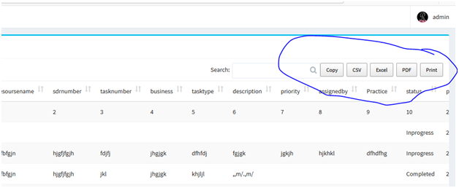

5)Users QA-> check with the form of the place holder its not related to the fields (completed)

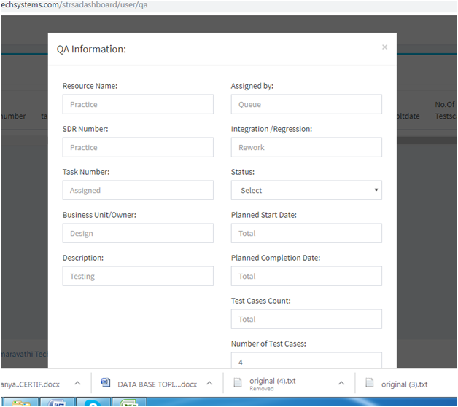

6)in the QA department there is no task number filed(removed)

7)in the QA form of the user

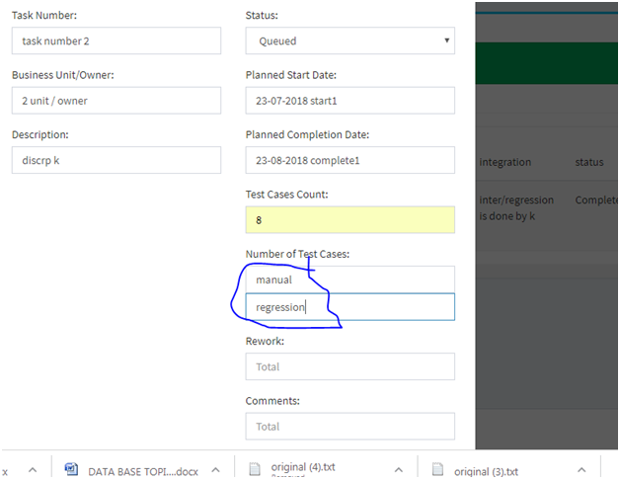

the place holder is begin  
getting the default name manual and regression(completed)

8)in the QA display of the department in the user(completed)

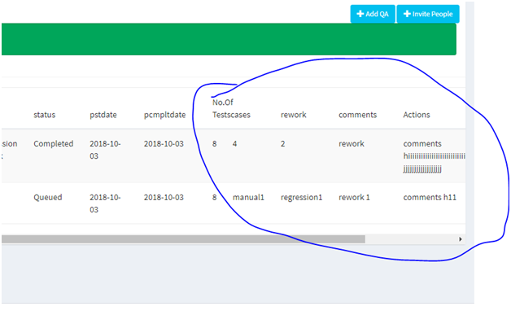

Test Case Count filed is missing and that field value is going to other fields (what is this action)c(completed)

9)QA-display in the user and the admin both

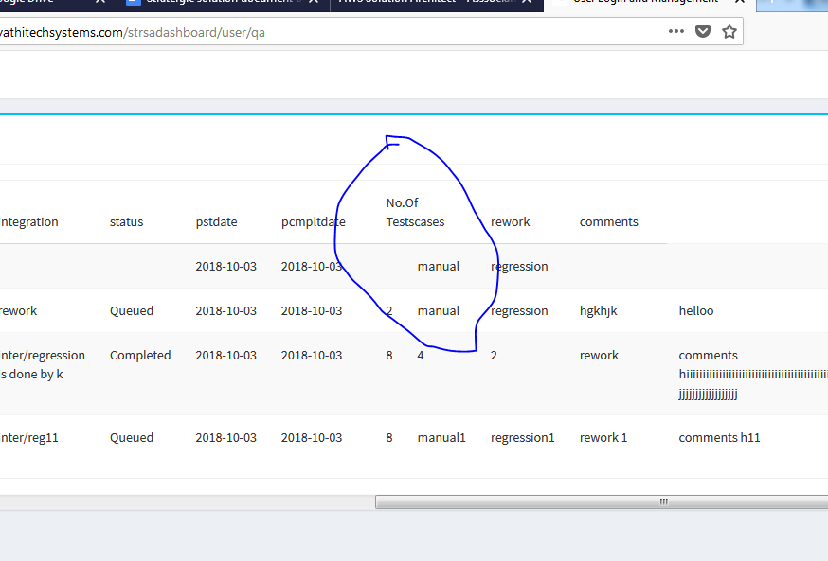

this filed No of teste case should be have two sub column that is Manual and Regression

10)QA display in user and admin this fileds getting todays date defaultly (completed)

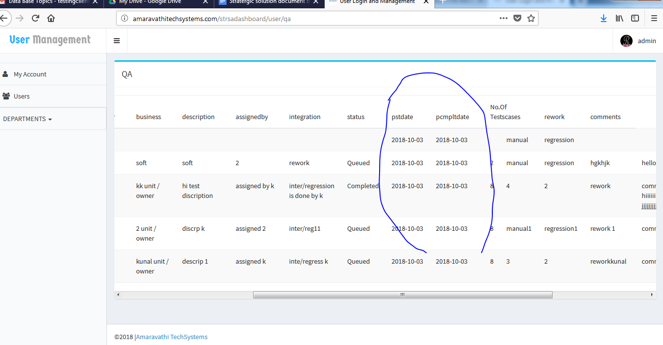

11)all the department form placeholder names is not related to fileds

12) All the department filed name , in all the display should be in the Full form and Starting should be in the capital and even check with the spelling mistake (leaving consolidate)

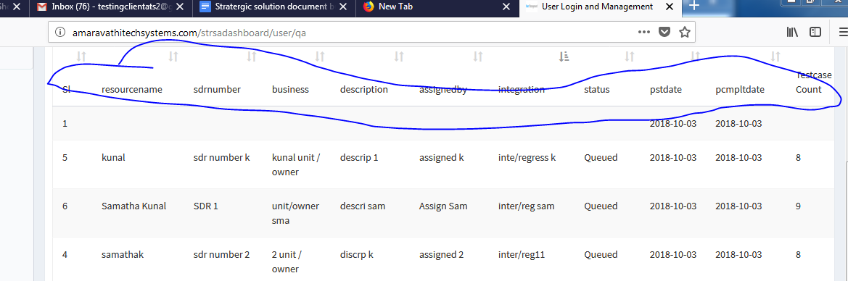

13)In all the departemnt the No of Test case -> Manual and Regression having the probelm in the display check it out(same as the bug 9th)

14)10th bug is same in all other departments also even for the actual start date and actual completion date is also taking default todays date and displaying . (in all the department same problem)

(completed chk afetr insert new values))

15)When admin add the new user under the consolidate ->the user is not gettng the depatment as consolidate (completed)

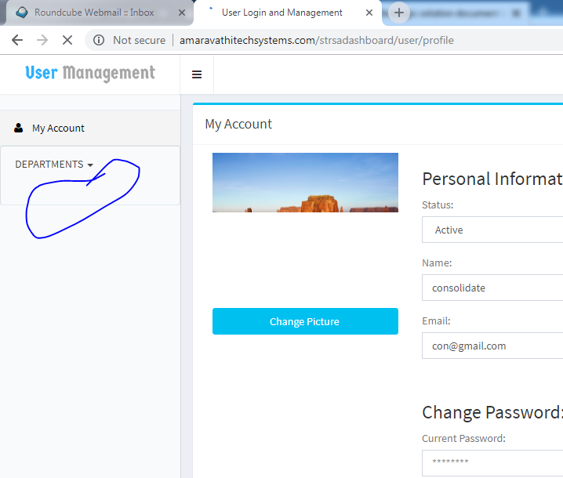

16)The user profile is taking more time to load not stopping the loading symbol

17)User for the department which as the automation(yes/no )option (example BI) when user try to edit the y/no defaultly its going the previous values of Y/N

18)