**GENERAL INFORMATION**

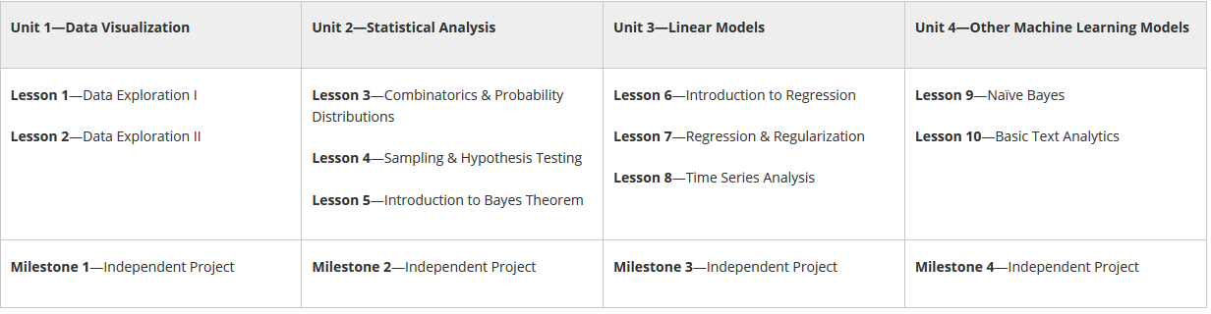

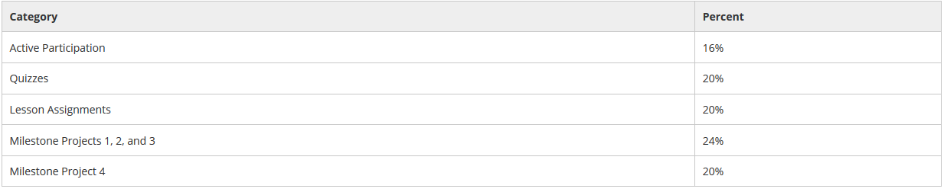

**UNIT 1 DATA VISUALIZATION**

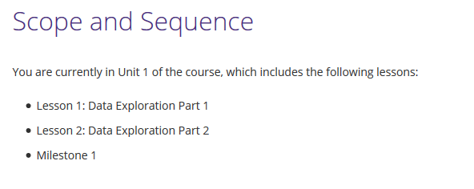

***LESSON 1 DATA EXPLORATION***

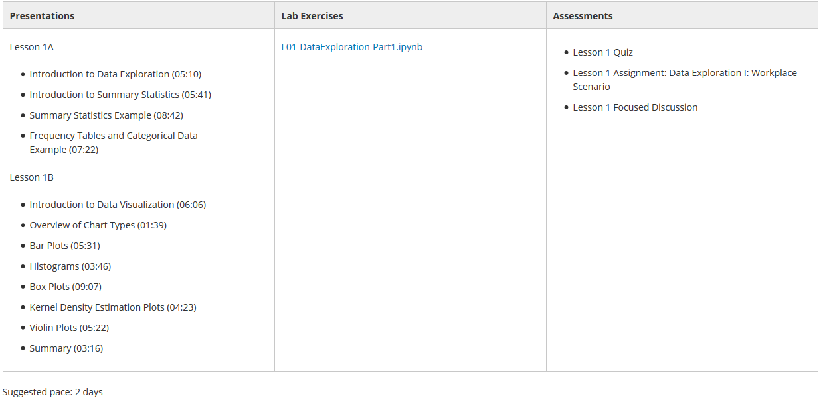

***LESSON 2 DATA EXPLORATION***

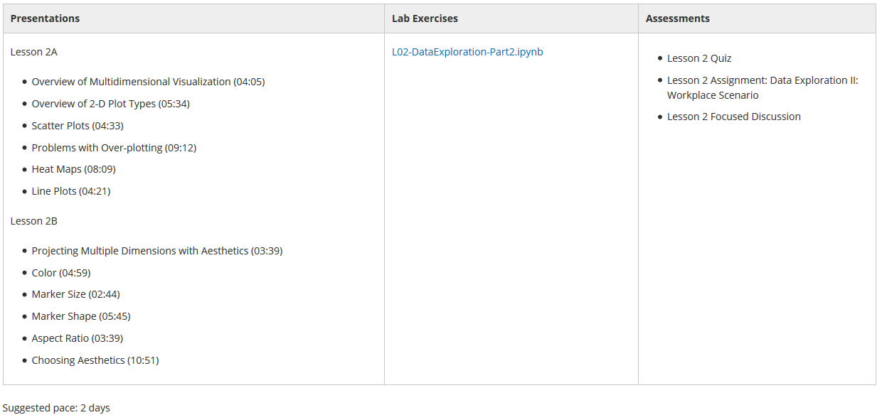

*MILESTONE 1 (1 DAY)*

**UNIT 2 STATISTICAL ANALYSIS**

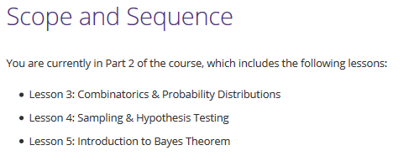

***LESSON 3 COMBINATORICS & PROBABILITY DISTRIBUTIONS***

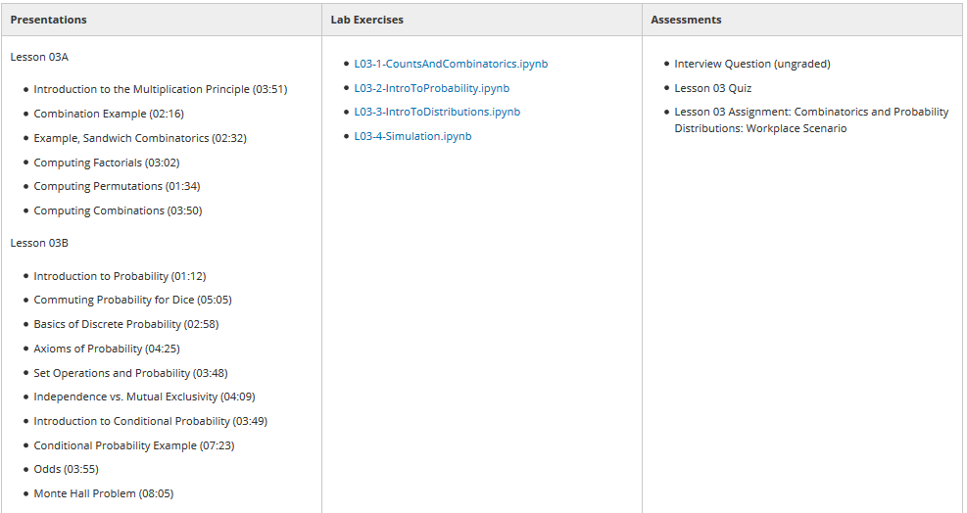

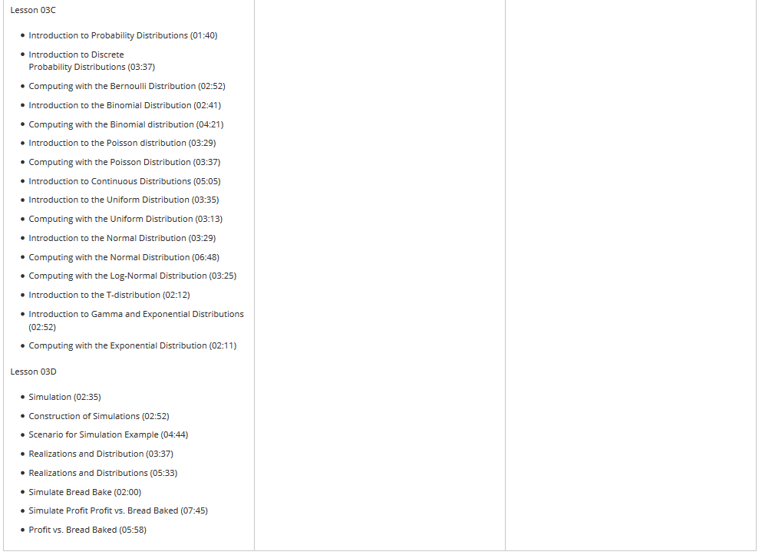

***LESSON 4 SAMPLING & HYPOTHESIS TESTING***

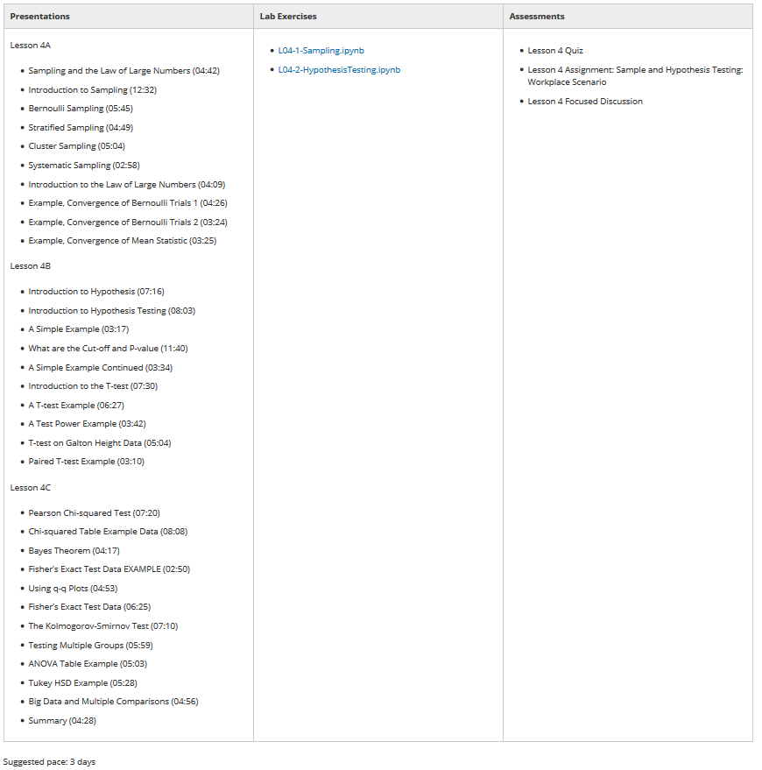

***LESSON 5 INSTRODUCTION BAYES THEOREM***

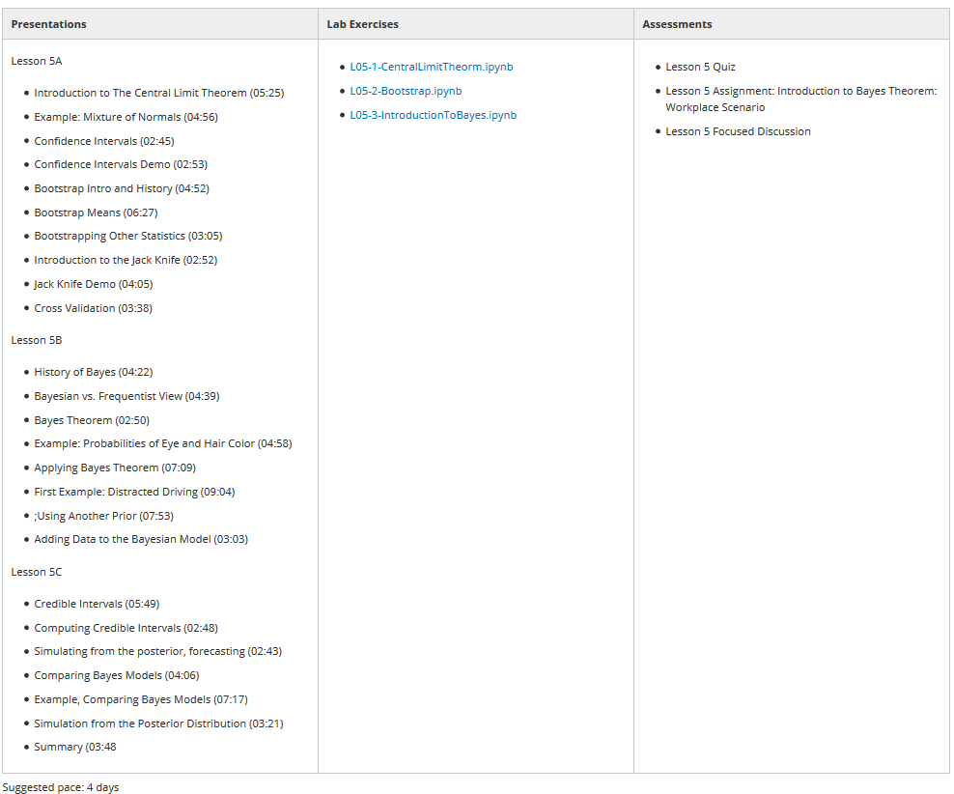

*MILESTONE 2 (2 DAY)*

**UNIT 3 LINEAL MODELS**

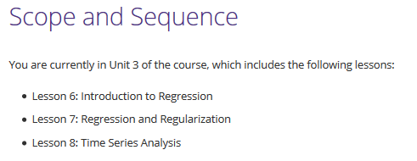

***LESSON 6 INTRODUCTION TO REGRESSION***

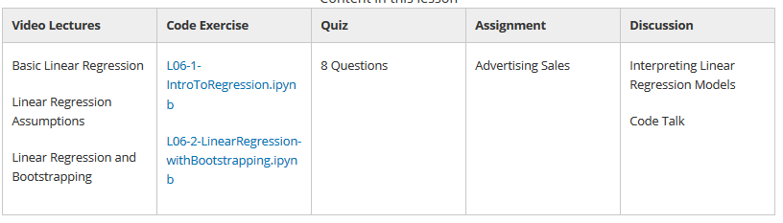

***LESSON 7 REGRESSION AND REGULARIZATION***

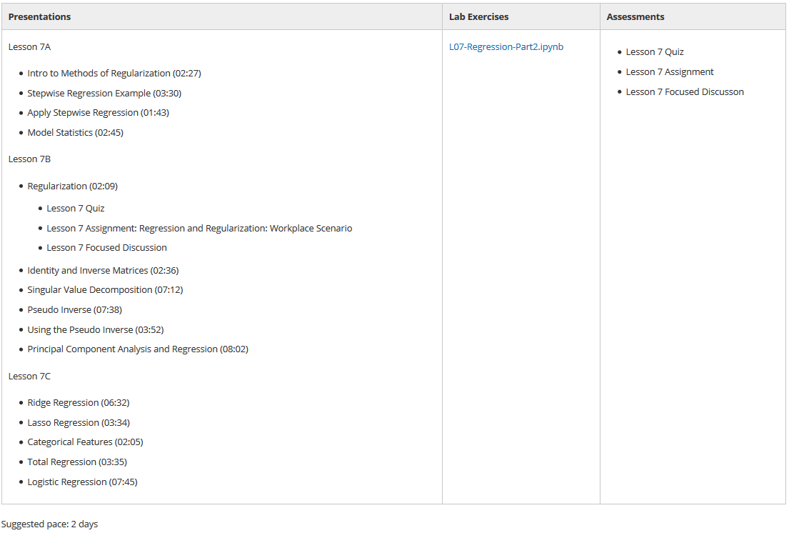

***LESSON 8 TIME SERIES ANALYSIS***

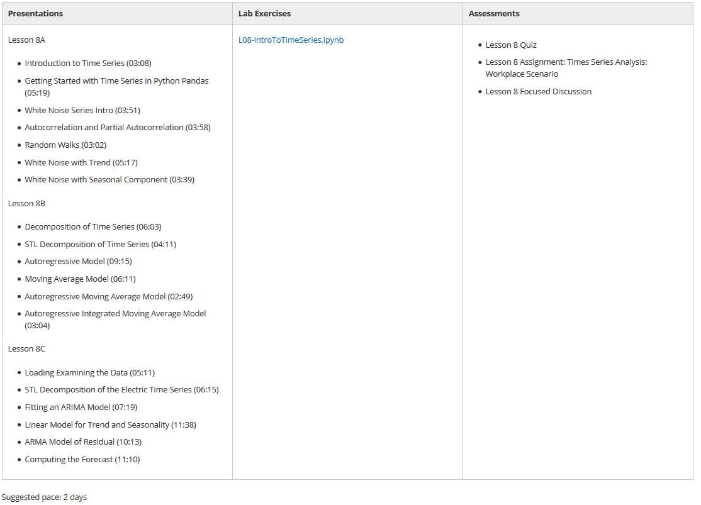

*MILESTONE 3 (2 DAY)*

**UNIT 4 OTHER MACHINE LEARNING MODELS**

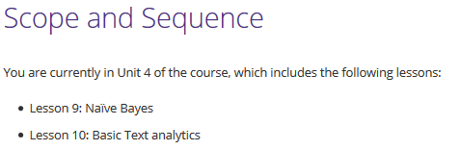

***LESSON 9 NAÏVE BAYES***

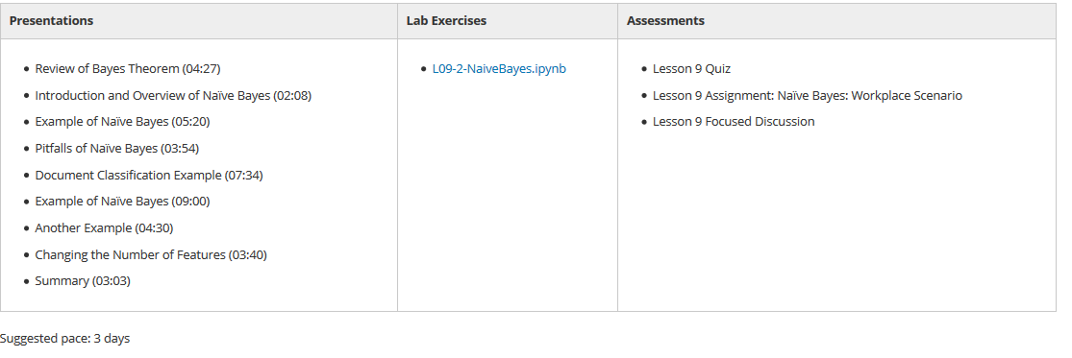

***LESSON 10 BASIC TEXT ANALYTICS***

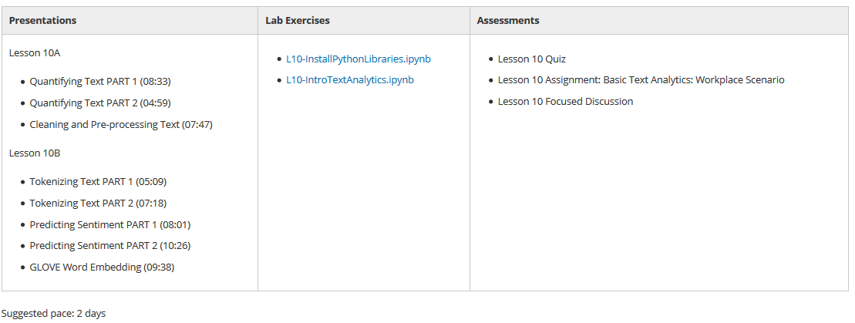

*MILESTONE 4 (5 DAY)*

*CONCLUSIONS*