**VM Instructions**

1. Download PuTTY if you haven’t already done so - https://www.puttygen.com/
2. Log into your VM Instance - [My virtual machines - Azure Lab Services](https://labs.azure.com/virtualmachines)

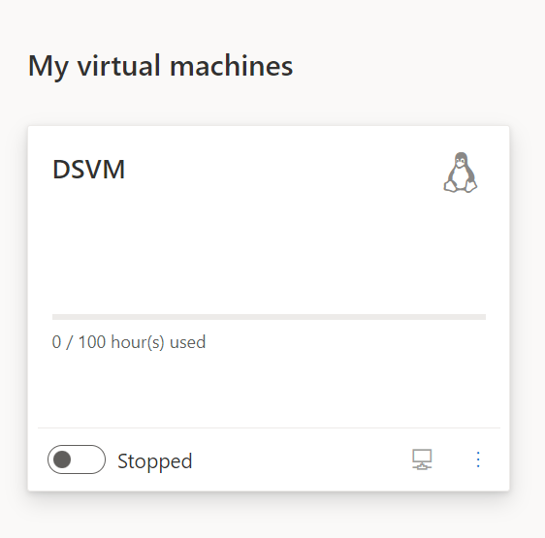

1. On the bottom left move it from Stopped to Starting. You want it to change to Running

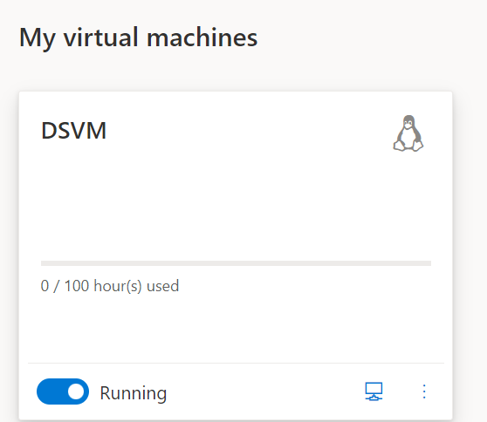

1. Connect via SSH and set a password if you haven’t already done so

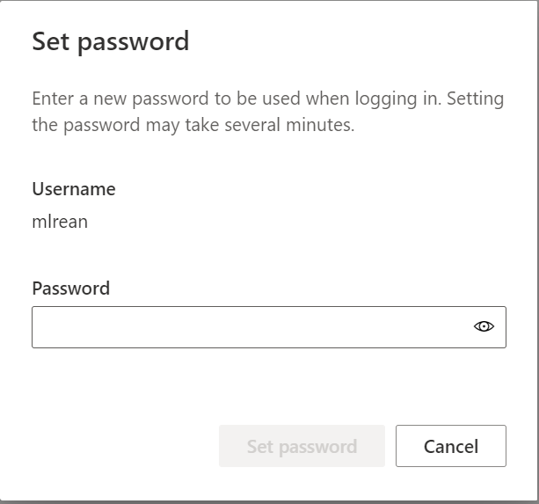

1. After you set a password you are going to want to connect again. You should get this message

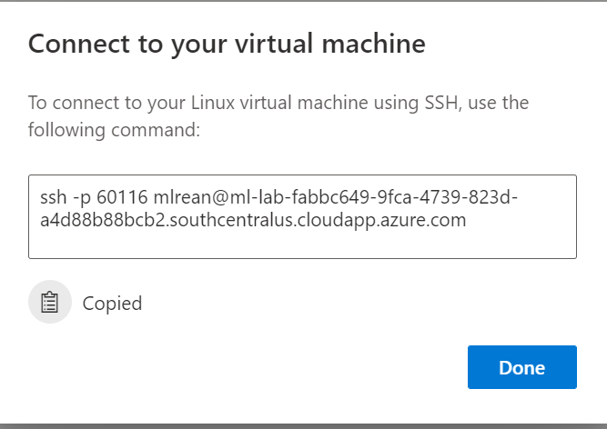

1. Open PuTTY
2. In Putty go to Connections – SSH – Auth – Tunnels

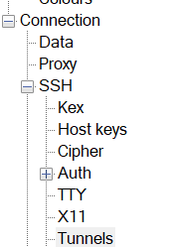

1. In Source port type in L888 and in Destination type in localhost:8888

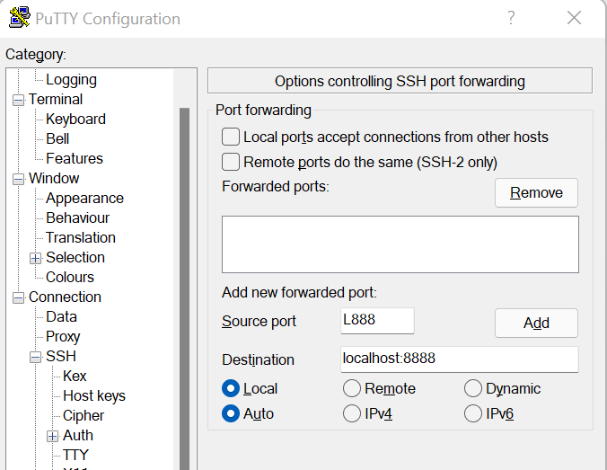

1. Click Add

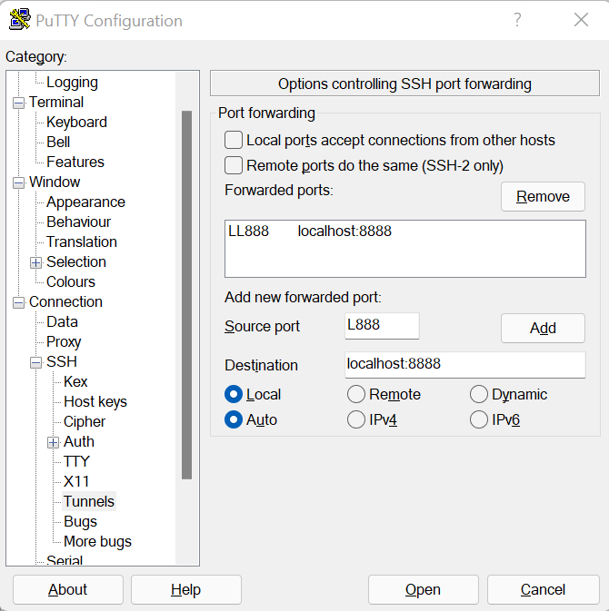

1. Go back to session and type in the path for the vm as well as the port. You can find this in the Connect to your virtual machine popup in the Azure Lab Services.
   1. Host Name [mlrean@ml-lab-fabbc649-9fca-4739-823d-a4d88b88bcb2.southcentralus.cloudapp.azure.com](mailto:mlrean@ml-lab-fabbc649-9fca-4739-823d-a4d88b88bcb2.southcentralus.cloudapp.azure.com)
   2. Port – 60116

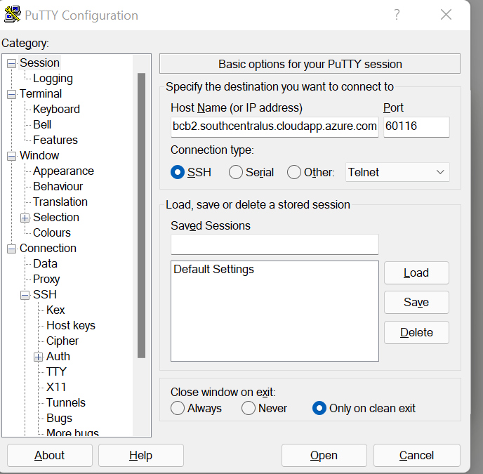

1. Click Open and you should see this

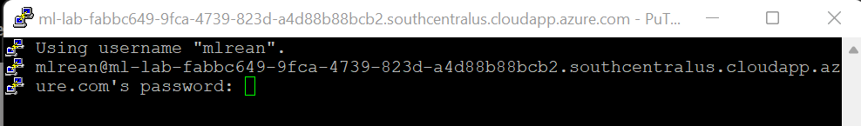

1. Type in your password
2. You should now see

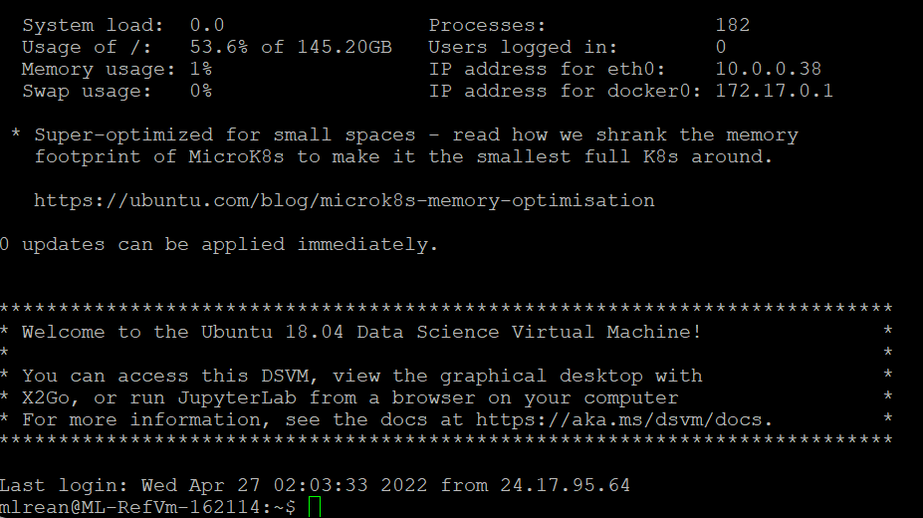

1. After typing in your password you want to type this command “jupyter notebook --no-browser” (no “ “)
2. It will then tell you

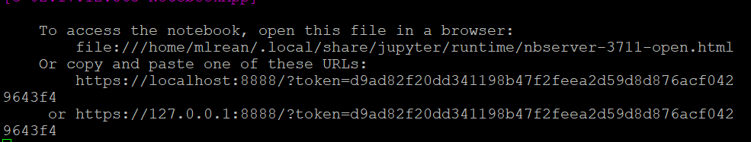

1. Go to that link
2. After that this might be helpful - [Data Science Virtual Machine documentation - Azure | Microsoft Docs](https://docs.microsoft.com/en-us/azure/machine-learning/data-science-virtual-machine/) as well as [Explore Linux - Azure Data Science Virtual Machine | Microsoft Docs](https://docs.microsoft.com/en-us/azure/machine-learning/data-science-virtual-machine/linux-dsvm-walkthrough)