EXAM OPTIMIZE YOUR AUTOMATION SKILLS

# GENERAL

The System Under Test (SUT) is <http://automationpractice.com/index.php>. This is really a nice fake e-commerce site to practice test automation. If you have a project where you need to practice different flows for online stores, this is the website you want. All exercises must be executed within Katalon Studio and of course you should create test cases, test suites and so on.

# PREPARATION

1. Follow the instructions in [Prepare exam optimize your automation skills.docx](https://teams.microsoft.com/_#/docx/viewer/teams/https%3A~2F~2Fcapgemini.sharepoint.com~2Fsites~2FPizzasessionsimproveyourautomationskillsclass1~2FShared%20Documents~2FGeneral~2FPrepare%20exam%20optimize%20your%20automation%20skills.docx?threadId=19%3A29eaab7e020f42fc80c62fac954902df%).
2. Open a web browser and go to <http://automationpractice.com/index.php?controller=authentication&back=my-account>
   1. Create an account (if necessary) and use a simple password like **abc** because later on this password may be stored on the public site Github.com:  
        
      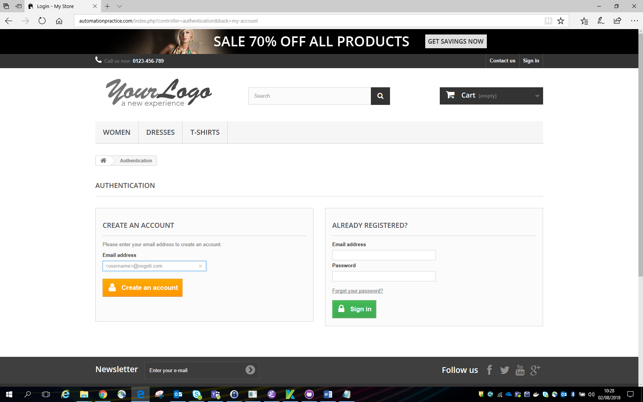
3. Open Katalon Studio 5.5 or higher
   1. Enable Git, if necessary:  
        
      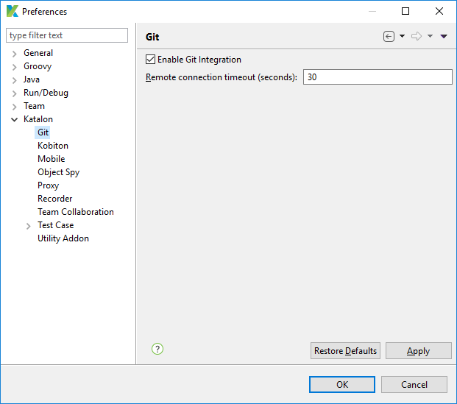
   2. Checkout the GitHub project katalon-exam (replace <username> by your GitHub username in both the Repository URL and User):  
        
      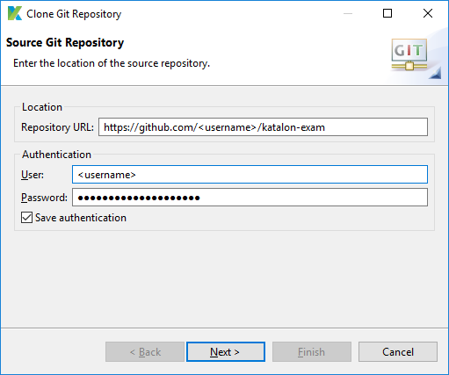
   3. Go to Profiles and choose the default profile. Change there the loginUsername and loginPassword to the email address and password you have used in Create an account in the previous step (step 2):  
        
      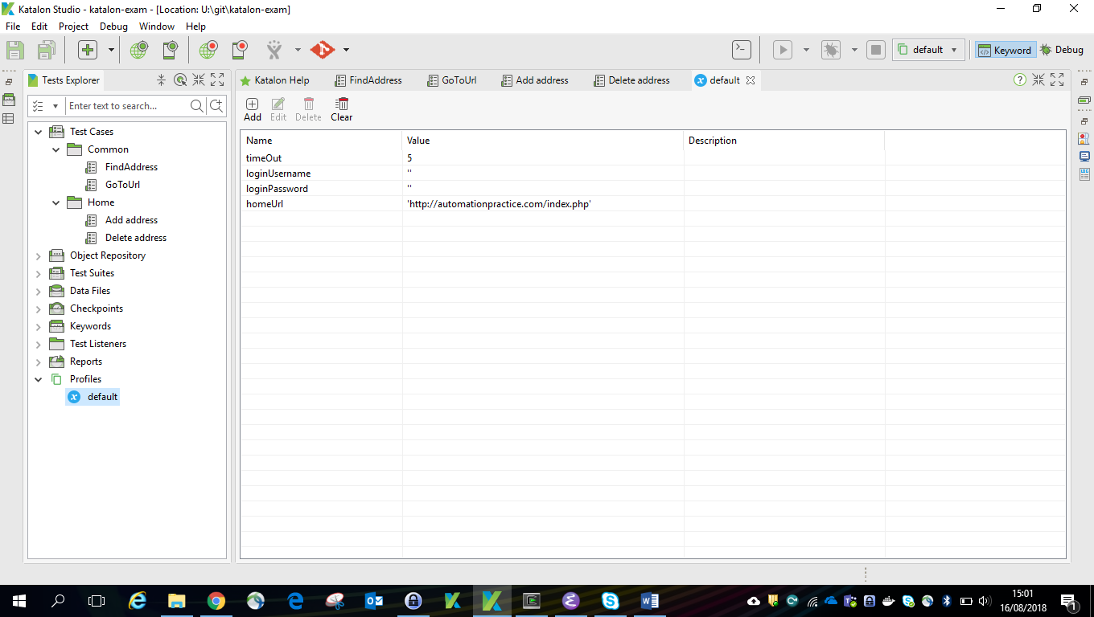
   4. Run the test case **Add address** (Test Cases -> Home) just to check whether everything works fine. At the end you should be signed in.

# EXERCISE 1 - Add an address

Detailed steps:

1. Select the **Add address** test case and start the Record Web. You should see this:  
     
   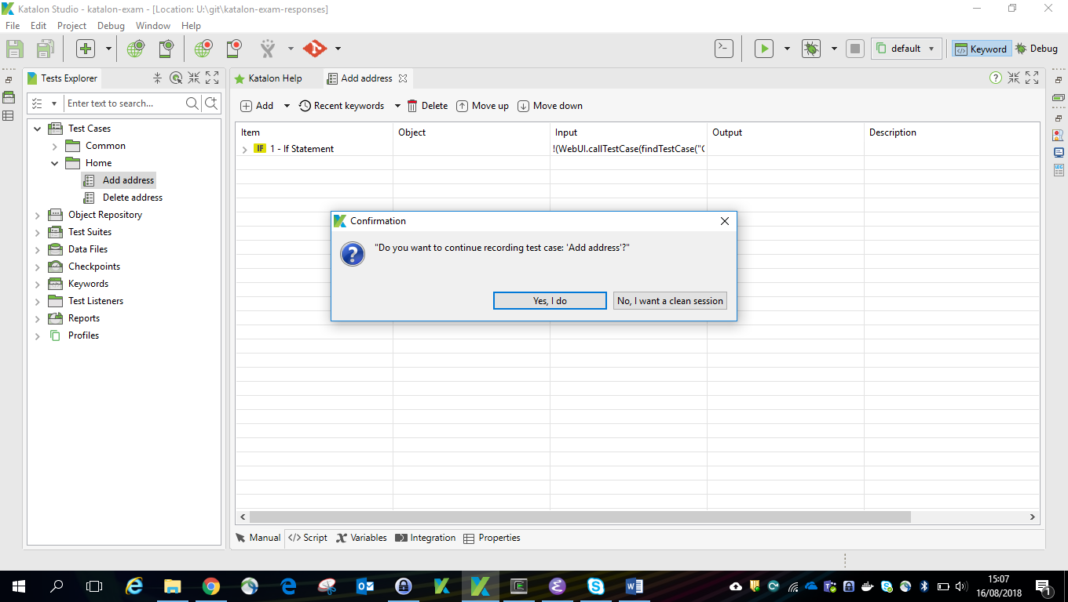  
   1. Accept the dialog (Yes, I do) to start the recorder.
   2. In the recorder empty the URL and click Run (all steps) and wait till he is ready.
   3. In the browser (the SUT) go to the bottom and click the button **Add a new address**.
   4. The last line shown in the recorder will now look something like this:  
        
      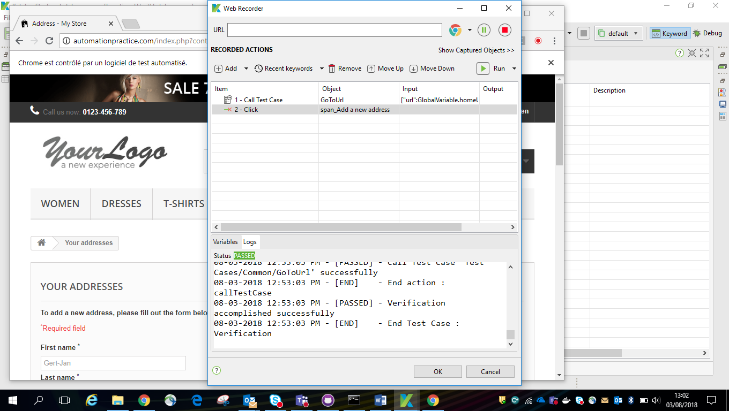
   5. Click OK and once more OK here:  
        
      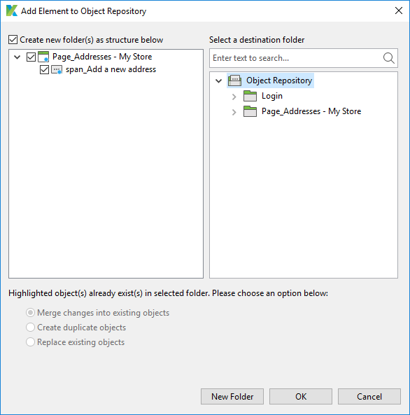
2. Repeat the previous step but now you have to enter an address in the last page (after the button Add a new address has been pressed by the recorder). Replace the values you have entered by variables and save the **Add address** test case.
3. Create an internal spreadsheet **Addresses** in the Data Files directory with one column for each variable defined in the test case. Create one Home and one Work address.
4. Create a Test Suite **Add addresses** and use the data driven approach to combine the spreadsheet and the test case.

# EXERCISE 2 - Delete an address

Detailed steps:

1. Create a Test Suite **Delete addresses** using the test case **Delete address** and use the data driven approach to combine the spreadsheet **Addresses** and the test case.

# EXERCISE 3 – Improve Add and address

The **Add address** test case should also handle the case when the address is already there. The alias created in the Add new address Web page is the key for checking this information. Look at the **Delete address** test case and change the **Add address** test case in a similar fashion.

You can check your solution by running test suite **Delete addresses** first and then twice **Add addresses**. There should be no error in the logs.

# EXERCISE 4 - Best practices

The answers to the questions below can be found in the Word document [Improve your automation skills](https://teams.microsoft.com/_#/docx/viewer/teams/https%3A~2F~2Fcapgemini.sharepoint.com~2Fsites~2FPizzasessionsimproveyourautomationskillsclass1~2FShared%20Documents~2FGeneral~2FImprove%20your%20automation%20skills.docx?threadId=19%3A29eaab7e020f42fc80c62fac954902df%40thread.skype&bas) in Microsoft Teams.

Which best practices have you used? Describe them in the table below (please note that the number of lines is arbitrary):

|  |  |
| --- | --- |
| Best practice | Example |
| Green test runs | Even when testing apparition of error messages (like when adding twice the same address alias), a successful test should be flagged Passed / Green.  Therefore we should check that capture of expected error messages always return “Pass” |
| Never use Thread.sleep() | Use of keywords such as “Wait for Element …” |
| Do not run ALL test across ALL targeted browser | Well in this exercises I supposed Chrome and Firefox where targeted browser. So I tested Add addresses on Firefox, Add same Alias on Chrome and Delete addresses onChrome. With more test cases or data spreadsheet we could ventilate on both browsers. |
| Name wisely | By looking at the variable and object name we easily understand what they refer to |
| Make simple test instead of adding comments | Using a modular approach here with specific methods in the common directory makes it easier to understand the whole test cases |
| Take screenshots for analysis in case of failure | Screenshot function is activated in the project setting from Katalon |
| Use DDT | We have set up an internal database spreadsheet to run multiple tests. We used this same spreadsheet for both tested functions |
| Test case independancy | We have built different test cases for different functions (add address and delete address). Both can be run independently, as long as the premises are correctly set. |
| Detailed reporting | By chance Katalon is providing a very detailed console log, with screenshots when failure occurs. Nevertheless I guess we will learn to make also more explicit / business oriented reports. |

# EXERCISE 5 - Cleanup / efficiency

Ensure that in all test cases the browser is only opened when necessary and never closed by you. Remove all unnecessary objects.

*** THE END ***