Do we need to import a sample code base to github?

Why don’t we use bitbucket?

**Linking a Bitbucket or GitHub repository with JIRA**

<https://confluence.atlassian.com/adminjiraserver073/linking-a-bitbucket-or-github-repository-with-jira-867028213.html>

Will we be allowed to do this?

## Make sure you understand how JIRA Software connects to your DVCS account

The JIRA DVCS connector links JIRA Software Server to an account on a DVCS hosting service (Bitbucket Cloud, GitHub, or GitHub Enterprise). For this reason, the connector needs permission from your DVCS account to access your account data. The connector does this through an [OAuth](http://oauth.net/) access token.

Do we want a fully functioning model / test env?

Examples in DD project:

Development changes are tracked through the development field:

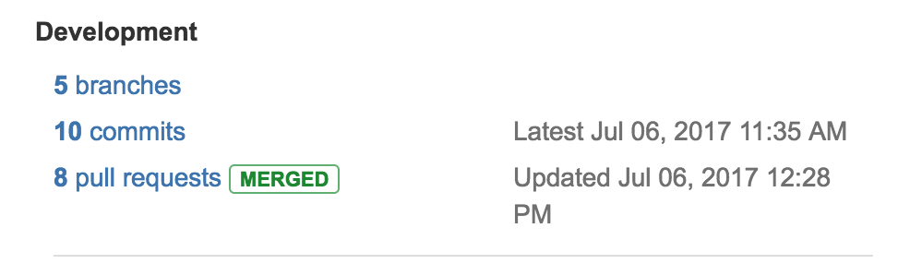

Click on commits or pull requests to see what was checked in:

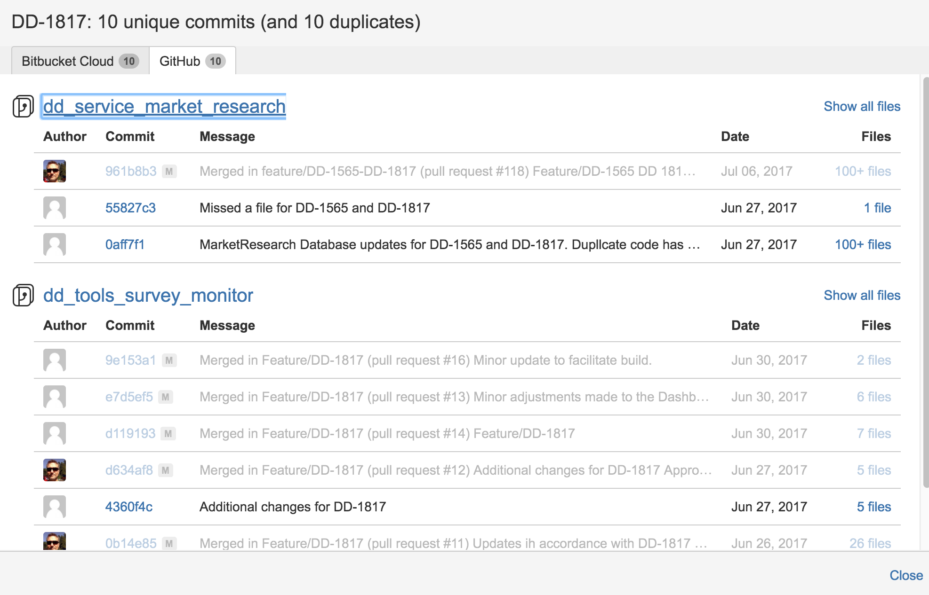

With DD, here is the disconnect… Jenkins is separate entity from Jira, so we can’t see if a build ran or was successful based on the changes.

Enter… Jenkins Integration for Jira

<https://marketplace.atlassian.com/plugins/com.marvelution.jira.plugins.jenkins/server/overview>

The add-on had to uploaded manually for some reason. I could not find it in the search.

Ran into a problem:

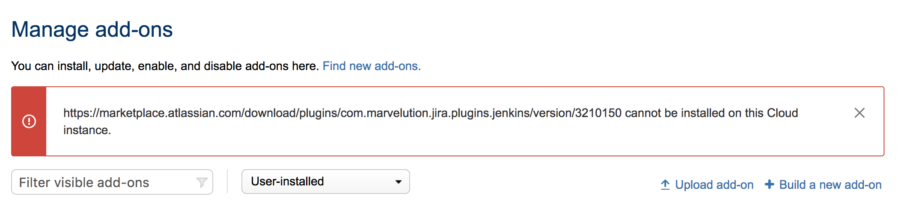

Created ticket



Are we dead in the water?

