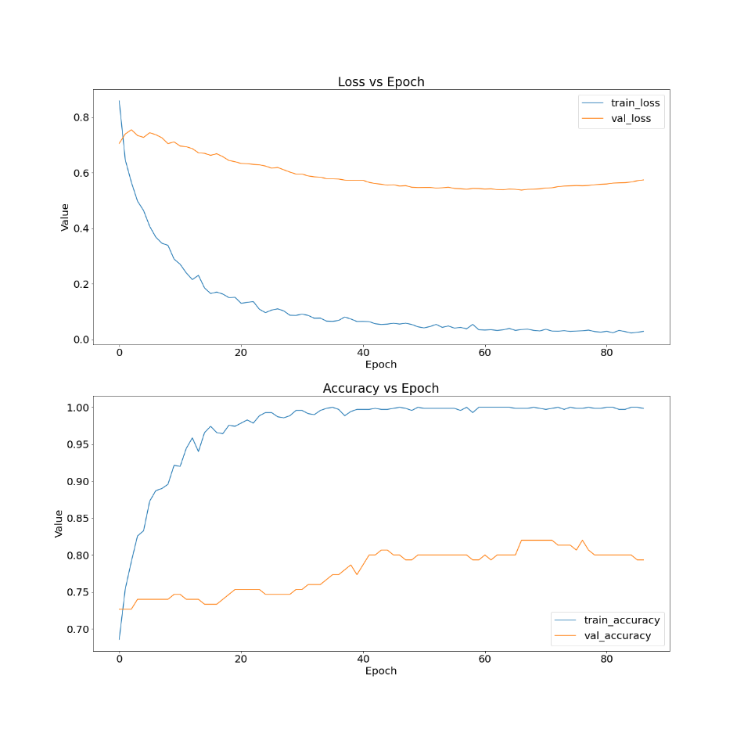

**Unfrozen same model with a 0.0001 Learning Rate**

**Frozen Model with a 0.0001 Learning Rate**

Unfreezing all layers

**Learning Rate of 0.01**

**Learning Rate of 0.1**

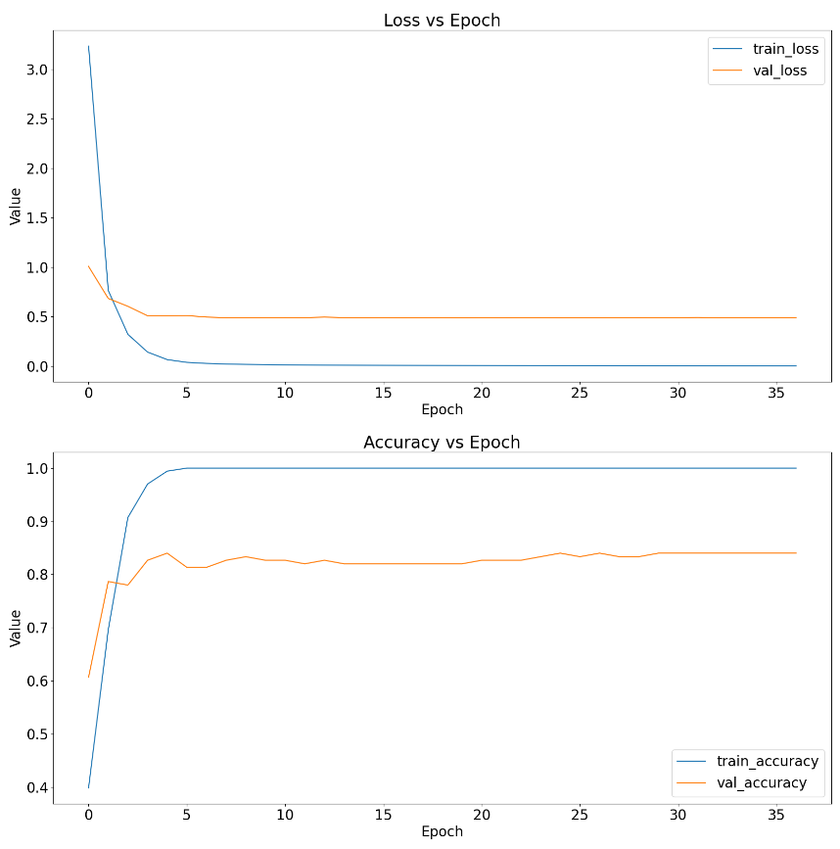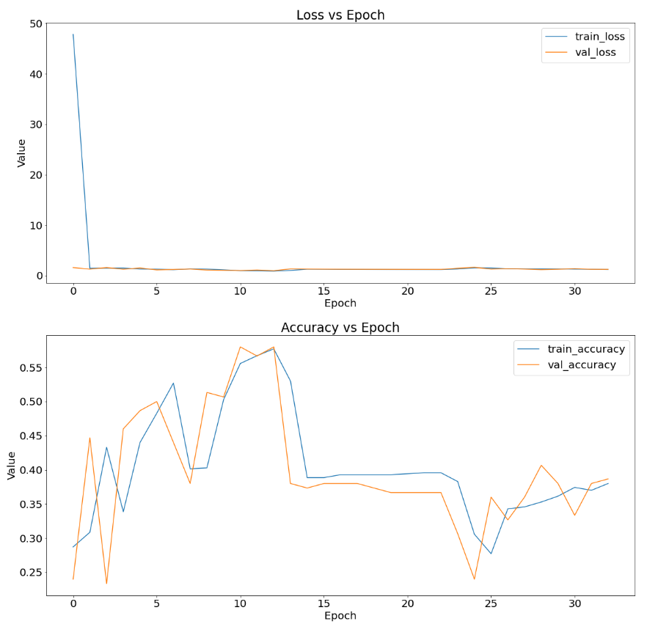

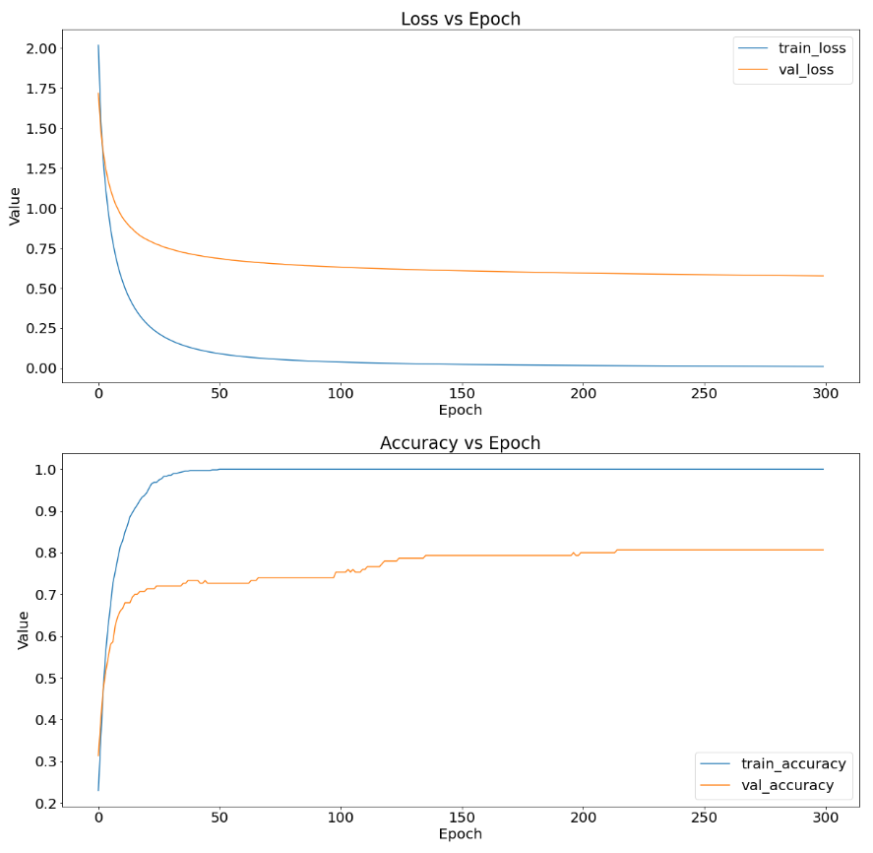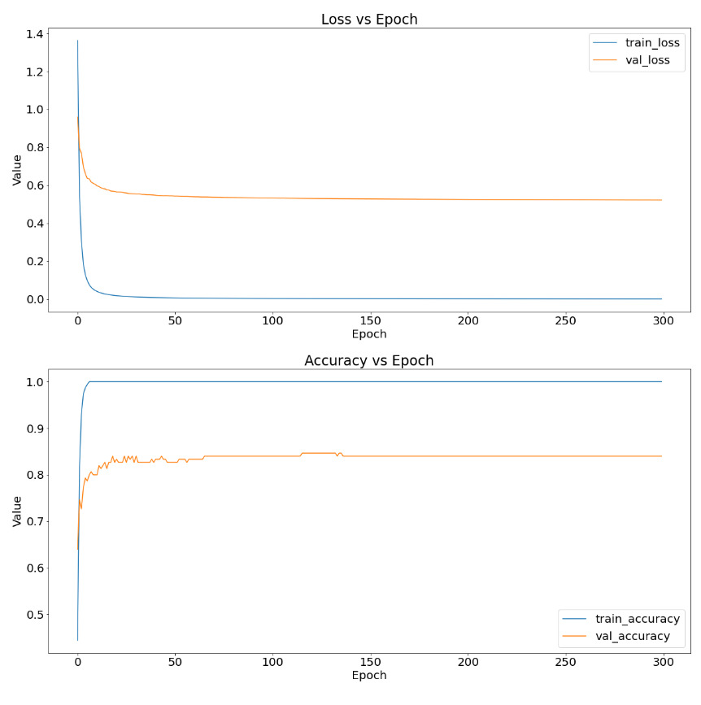

**Learning Rate of 0.001**

**Learning Rate of 0.0001**