## Complete by (12/4):

**Everyone:** Complete week 4 and 5 practicals -> understand search.py

**Mitchel**: Flood fill algorithm

Returns a 2D binary matrix, 1 is outside, 0 is inside

**Jaydon**: Develop function to detect corner

Returns a 2D binary matrix, 1 is corner, 0 is not

Also using Mitchels matrix, remove any corners that are outside of the warehouse

(corner_matrix – inside_matrix)

**Rodo**: Develop sudo-function for highlighted step below

You will get a binary matrix, any cell = 1 is a corner, inside the warehouse

Trying think if will work for all cases and think of any other functions that would be useful

**Zoom next Tuesday @ 11 AM**

Suggested steps from assignment brief:

First, make sure that you understand the Problem classes that we saw in the pracs (the sliding puzzle and the pancake puzzle).

Then implement in the following order the functions

1. taboo_cells
   1. check if cell is corner
   2. Check if cell between 2 corners along a wall are taboo if none of these cells is a target.

Frist check what is inside and outside of warehouse (MS Paint fill from a goal square)

Then for all inside squares, check if corner (if there is wall up and left, left and down, down and….) and NOT goal square

(Rodo) Then for each corner, and for each 4 directions, start march checking if you are still against a wall AND looking for the goal. If goal is not found or you leave the wall you are following, all those cells are also taboo.

2. check_elem_action_seq

3. solve_weighted_sokoban

Notes from prac 5 on Thursday 7th

Heuristics

admissible heuristic would be the (manhattan) distance the player is from the boxes + distance boxes is from the player

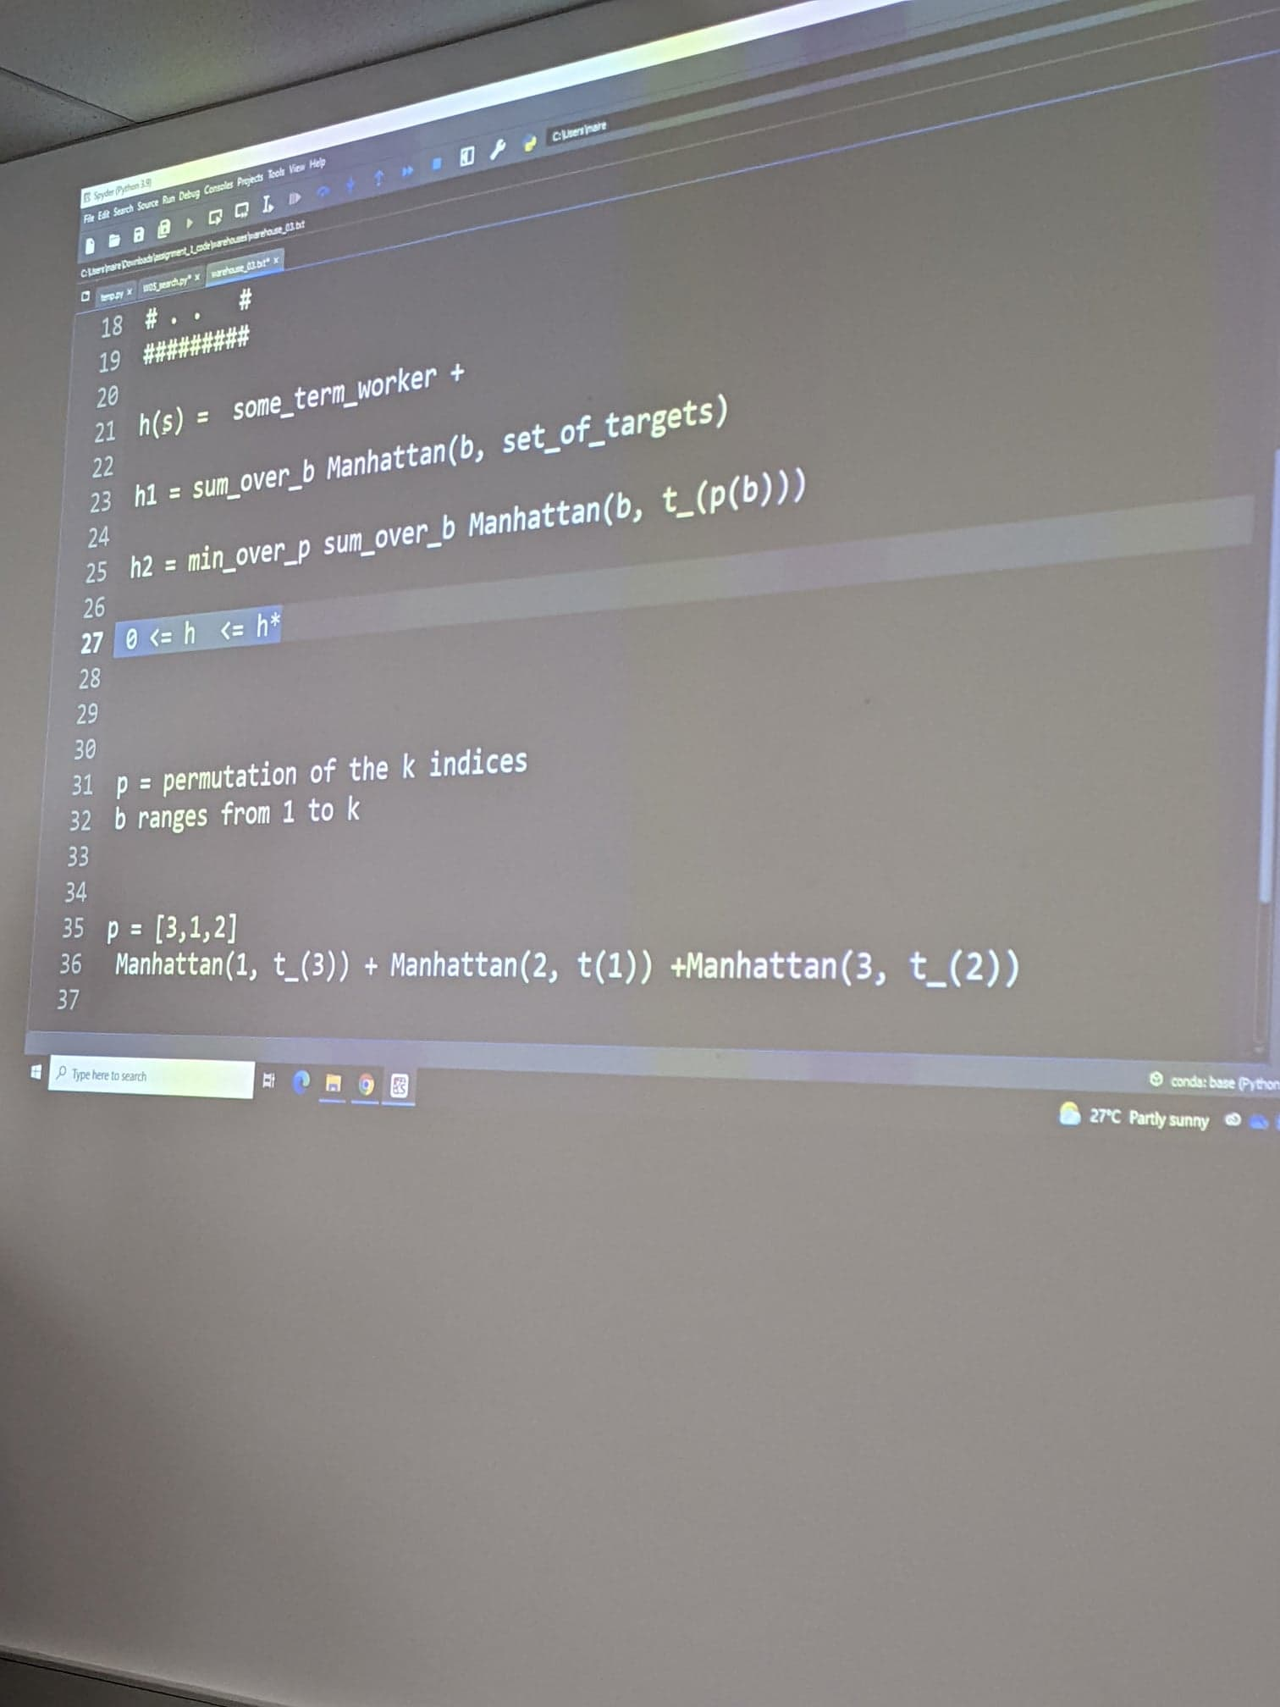

Taboo cells

Use the __str__ function and the copy function in warehouse class to implement **returning a string for taboo cells**

For (x,y) in taboocell, vis[y][x] = “X”

Then use the join function in the returns of __str__

Once you have found list of corner paurs

Use itertools.combinations to generate pairs

Don’t think we have considered this situation

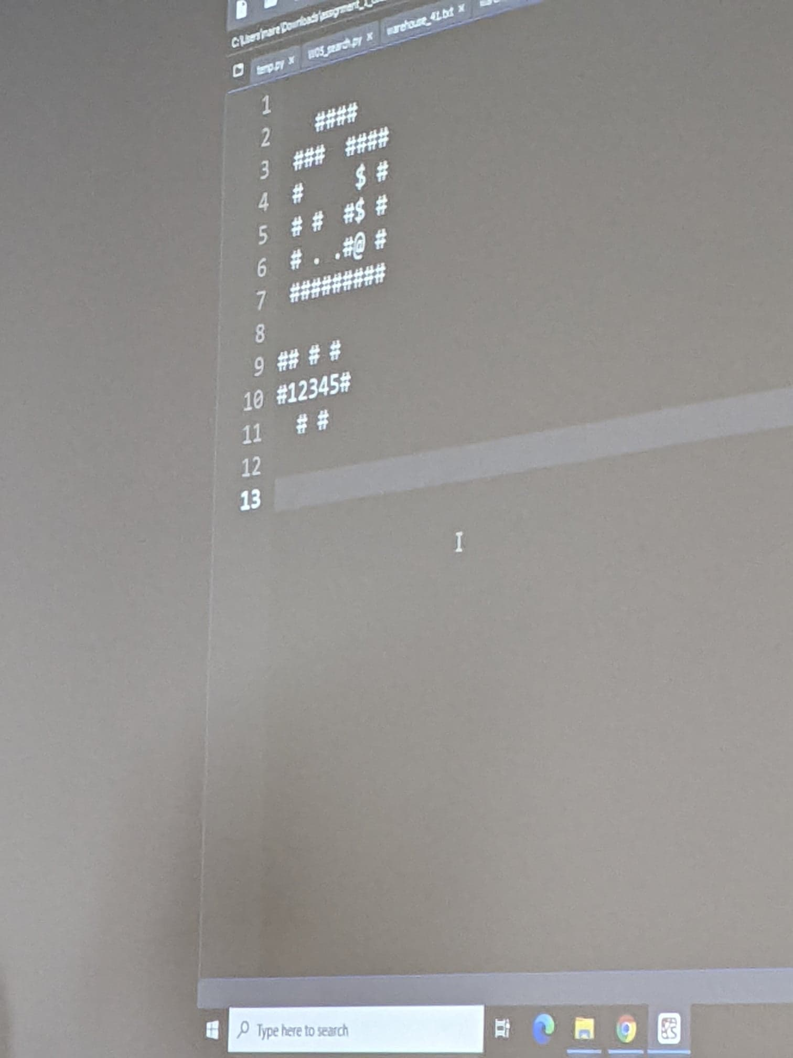

So both walls have to end at the same time, or, 1 of them ends for 2 squares, not just 1?