Assignment 2 – Project proposal

“Twitter Enalyst”

|  |
| --- |
| Tutor feedback:   * Are you using the Twitter search endpoint or the streaming endpoint or both to retrieve the tweets? This decision will impact your architecture choices * What is your proposed scaling policy? * Just doing sentimental analysis may not generate enough load. This is something that you will need to explore |

1. Description

Twitter Enalyst is an app helping user to quickly look up the trending keywords on the Internet and analyze the sentiment level of a keyword that users choose.

2. Architecture diagram

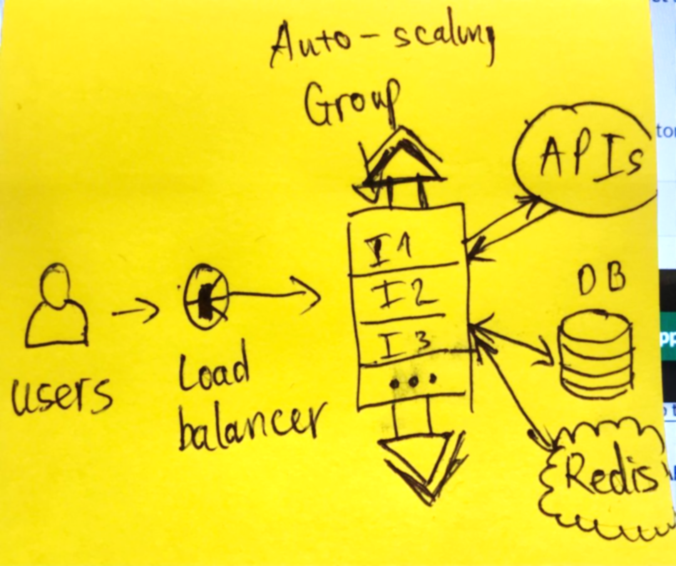

- Maybe… CloudFront for ‘trending keywords for the past 24h’ and background image.

- DynamoDB: stores results of searched words (twitter posts) of the past 7 days (maximum search-allowed duration). Data which is older than that is deleted.

- redis: stores results of searched words generated on the instances where the requests is handled

3. Phases of implementation

App features -> Storage (Database + Redis) -> scaling

4. Persitence choices, scaling metrics, application threshold

5. Use cases

User story 1

|  |  |
| --- | --- |
| As a | User |
| I want | see what keywords are trending right now in Australia or worldwide on google search engine |
| So that | I can catch up with the trending news/events |

User story 2

|  |  |
| --- | --- |
| As a | User |
| I want | To search for a keyword of my choice |
| So that | The app can return the sentiment score of posts containing that keyword |

User story 3

|  |  |
| --- | --- |
| As a | User |
| I want | The app to display the sentiment score of **newly-posted** twitter posts from that moment visually in a chart |
| So that | I can view the sentiment scores more intuitively |

User story 3

|  |  |
| --- | --- |
| As a | User |
| I want | The app to display the **summary** sentiment score of **newly-posted** twitter post visually in a chart |
| So that | I can view the overall sentiment scores of the keyword |

User story 4

|  |  |
| --- | --- |
| As a | User |
| I want | The app to display the sentiment score of the keyword **from the last 7 days/ 24h** in a chart |
| So that | I can view the overall sentiment scores from the past as well |

6. APIs

Google Trends API – User story 1

<https://www.npmjs.com/package/google-trends-api>

Twitter API – User story 2

<https://developer.twitter.com/en/docs/twitter-api/early-access>

Sentatment – User story 3

<https://www.npmjs.com/package/sentiment>