MLOps Pipeline & Architecture Analysis
Name: Rodosi Biswas, IIT Jodhpur | Roll Number: G25AIT2088

Deployment Asset | Production Access Link
GitHub Repository | https://github.com/rodosi-iitj-g25ait2088/mlops-distilbert-workflow
Kaggle Notebook | https://www.kaggle.com/code/rodosibiswas/mlops-assignment2/
Hugging Face Model Registry | https://huggingface.co/Rodosi/mlops-distilbert-workflow
W&B Experiment Dashboard | https://wandb.ai/g25ait2088-iit-jodhpur/mlops-assignment2-rodosi

1. Architectural Selection & Engineering Rationale
The underlying transformer architecture selected for this engineering pipeline is distilbert-base-cased, a highly optimized variant derived via knowledge distillation from the standard BERT model. In this setup, a compact student network is engineered to approximate the full predictive distribution and hidden representations of a larger teacher architecture. This structural distillation allows the model to preserve nearly 97% of BERT's original contextual language comprehension while dropping overall parameters by 40% and accelerating execution speeds by 60% during forward passes. This operational efficiency is essential given the computing limitations of public environments like Kaggle's free GPU allocations.
A cased model configuration was picked instead of an uncased setup because text-based book descriptions heavily rely on semantic signals contained within proper names, author styling, specific book identifiers, and genre-specific lexicons where letter casing conveys explicit contextual meaning. Discarding capitalizations would eliminate important discriminative traits needed by the model. DistilBERT comes pre-trained on expansive, high-quality text corpora, including English Wikipedia and BookCorpus. This background provides strong baseline English language encodings from the start. Its internal structure—composed of a 6-layer, 66-million parameter multi-head self-attention engine—serves as an adaptable foundation for downstream classification. When targeting a multi-class problem containing various genre partitions from Goodreads metadata, DistilBERT offers an optimal trade-off balancing macro performance metrics against hardware runtime requirements.
2. Compute & Pipeline Infrastructure Setup
2.1 Notebook Import and GPU Configuration
The initial reference workflow was extracted from the development Colab notebook and set up inside the Kaggle system. Hardware capabilities were configured within the environment parameters by selecting dual T4 GPU accelerators. External network routing was actively turned on in the runtime settings to enable downloading the underlying raw data collections and pushing optimized model checkpoints out to the remote Hugging Face Model Hub. Kaggle's baseline platform provides an allocation of 30 compute-hours per week, which proved more than adequate to execute a 3-epoch fine-tuning iteration over the target text.
2.2 Identity and Secret Management
To follow modern security practices, no private credentials or platform authentication tokens were hardcoded into the pipeline scripts. Credentials were put into Kaggle's secure runtime environment manager and queried dynamically at execution time using the specialized secrets client interface. Hardcoding security tokens inside open code repos presents serious compliance concerns; using isolated parameters mirrors true production workflows utilized across professional enterprise machine learning operations.
Secret Variable Key | Operational Target & Purpose
WANDB_API_KEY_2 | Establishes secure telemetry stream with Weights & Biases platforms.
HF_TOKEN_2 | Grants write permissions to upload weights directly to the Hugging Face Hub registry.

2.3 Automated Experiment Logging via Weights & Biases
Experiment management was integrated by initializing a Weights & Biases run, passing a centralized hyperparameter configuration dictionary before starting any loops. Setting the logging flag within the Trainer arguments enabled automated telemetry streams. This allowed the step-by-step recording of training objectives, validation metrics, global classification performance, learning rate parameters, and under-the-hood system resource usage directly to the central visualization workspace. Once the final evaluation pass was finished, the complete classification file was generated locally and uploaded to the centralized server as a tracked W&B Artifact.
2.4 Complete Training Settings
The underlying fine-tuning run was strictly configured according to the training parameters detailed below to maintain consistent and reproducible behavior across training loops:
Pipeline Parameter Description | Configured Target Value
Target Base Framework | distilbert-base-cased
Total Optimization Epochs | 3
Training Batch Allocation | 16
Evaluation Batch Allocation | 32
Peak Base Learning Rate | 3e-5
Warmup Sequence Footprint | 100 Steps
Regularization Weight Decay | 0.01
Validation Intervals | Evaluated at the conclusion of every epoch
Assigned Compute Backbone | Kaggle Environment (Dual T4 Accelerators)

3. Pipeline Evaluation & Comparative Analysis
The optimized deep learning model achieved an overall accuracy of 60.13% paired with a weighted F1-score of 0.5979, outperforming the classic statistical baseline across all checked metrics. The observed performance highlights the complex challenges of this classification task. Distinguishing specific book themes purely from written reviews presents inherent difficulties. Reviewers frequently explain abstract stylistic traits or their own subjective reading experiences without including direct references to structural category classifications. Additionally, multi-class pairs (such as Fantasy & Paranormal vs. Young Adult) share heavily overlapping topical vocabularies, storylines, and descriptive phrasing. An evaluation loss metric of 2.2483 demonstrates that the model distributes its probability outputs across a set of logical, competing classifications instead of putting all weight on a single choice. This behavior is expected when working with textual inputs that carry high semantic ambiguity.
Evaluated Pipeline Metric | Baseline Model (TF-IDF + LR) | Optimized Model (DistilBERT)
Global Accuracy Score | 0.5500 | 0.6013
Weighted F1 Evaluation | 0.5500 | 0.5979
Log Evaluation Loss | Not Evaluated / Baseline | 2.2483
3.1 W&B Training Dashboard
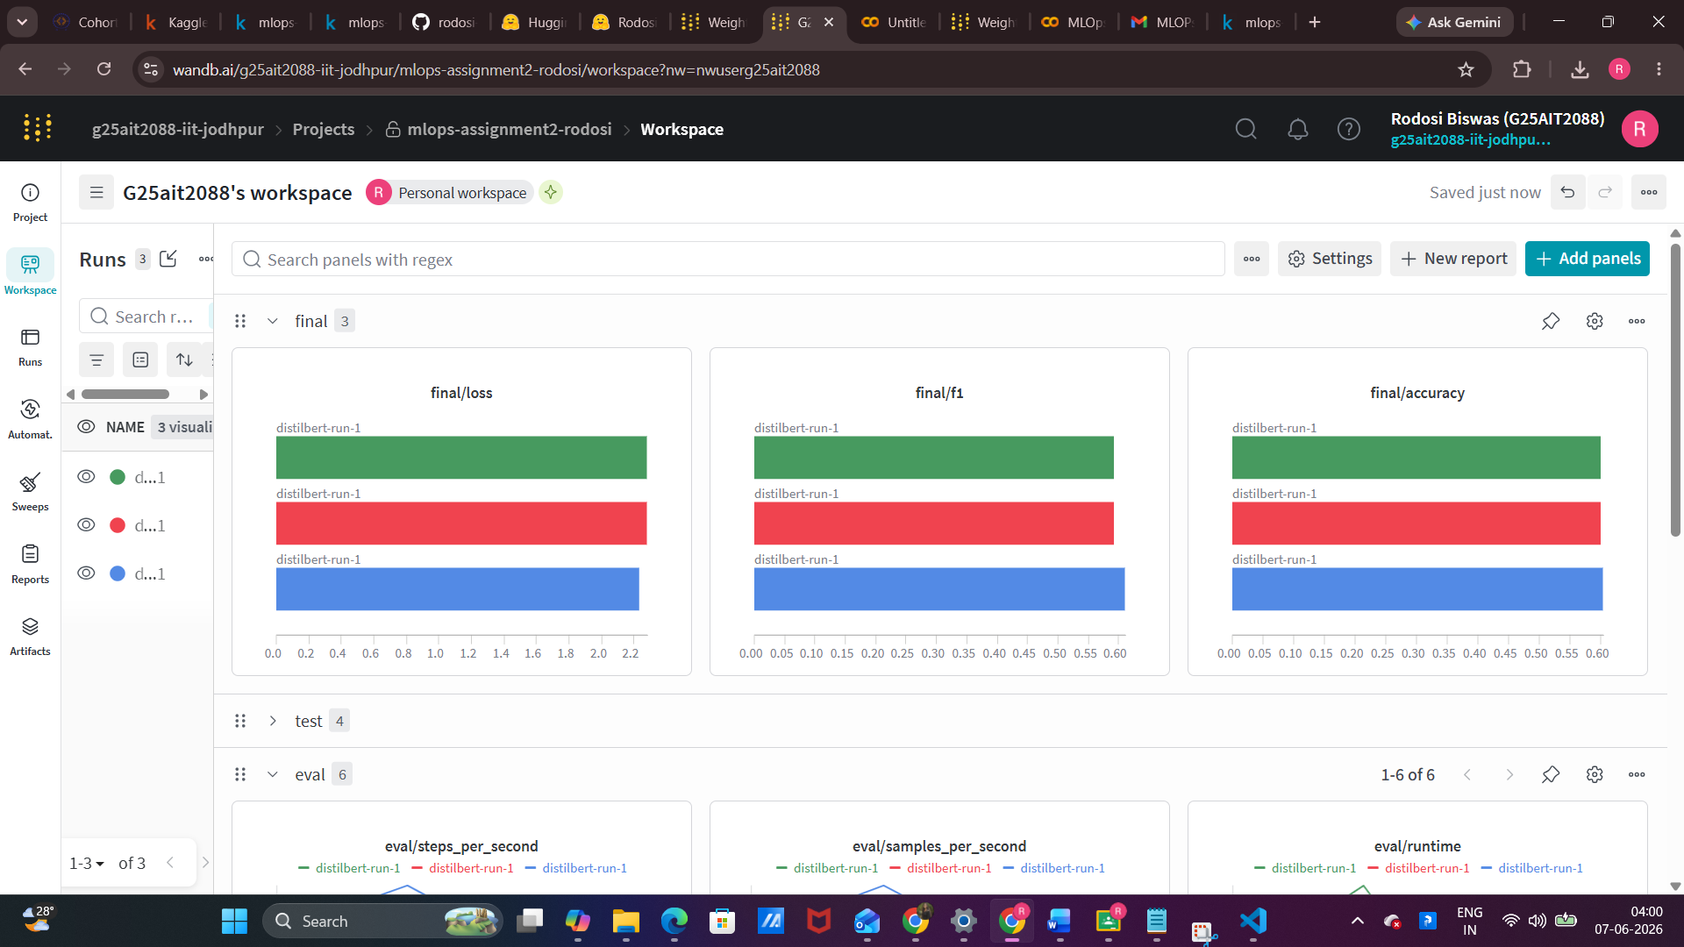

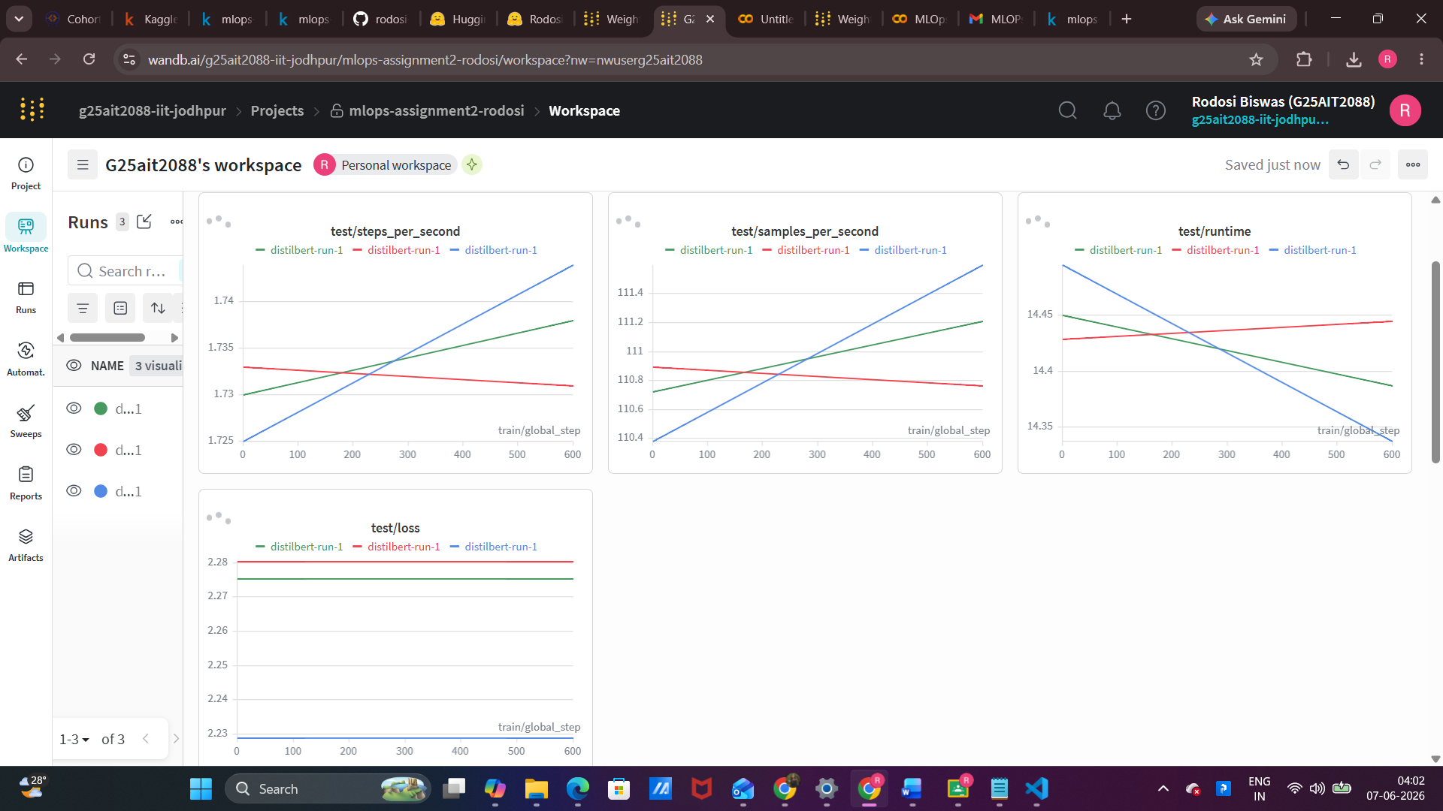

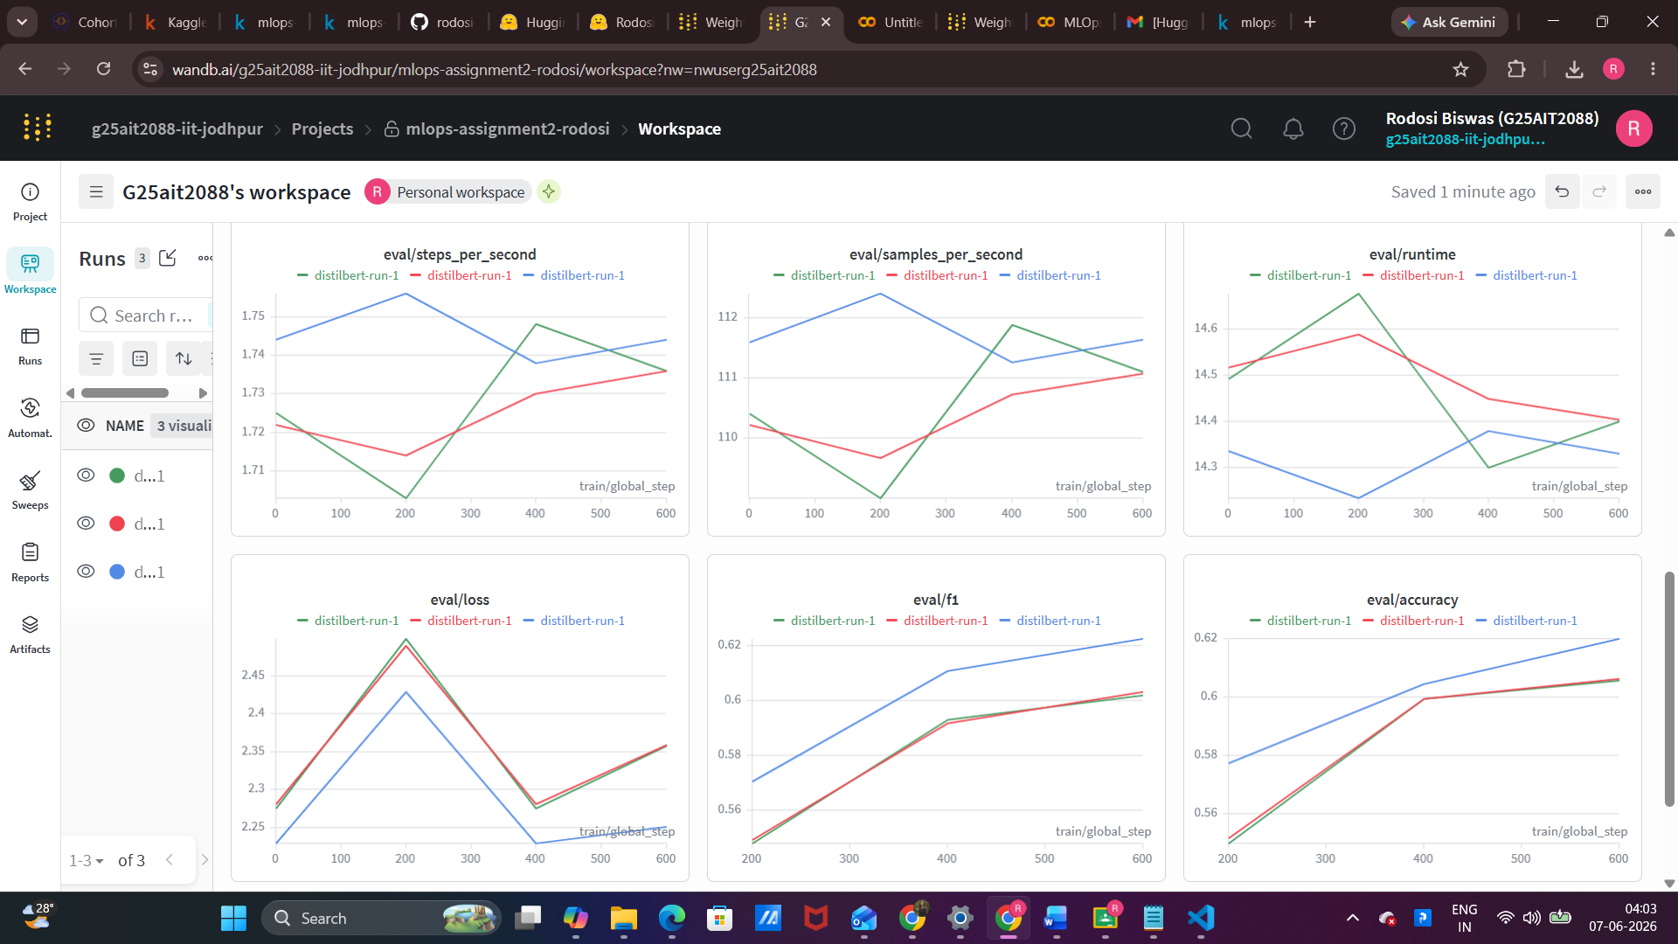

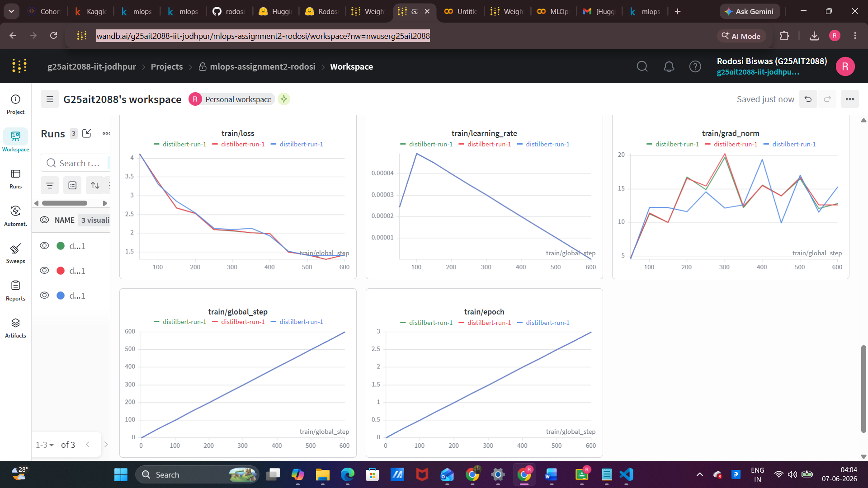

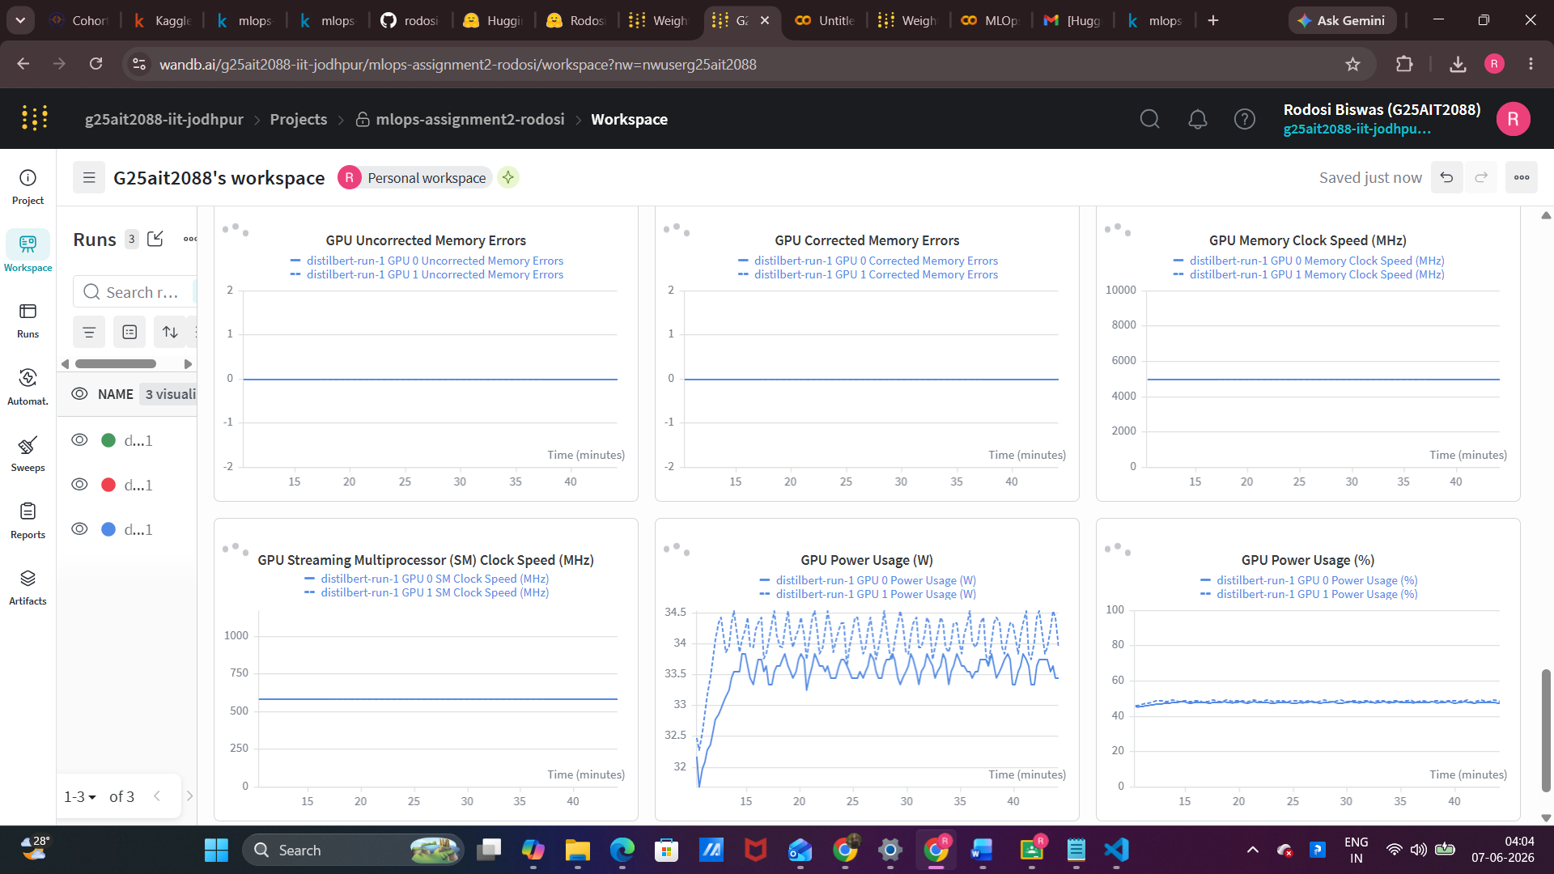
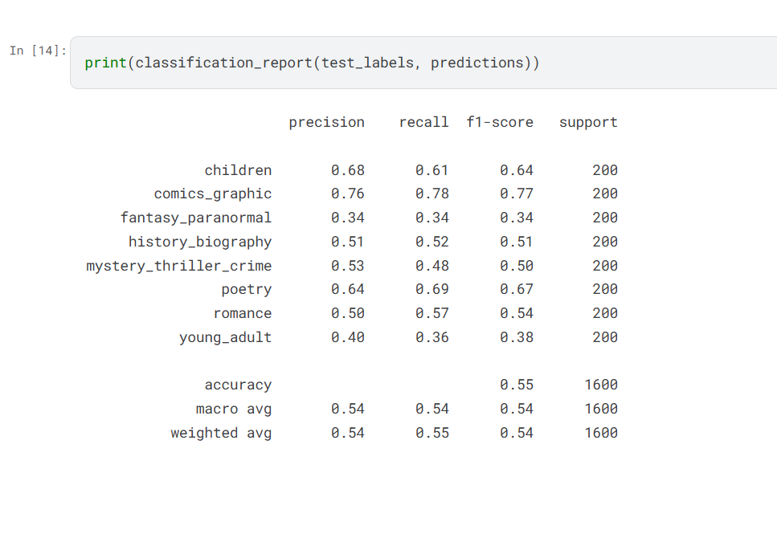
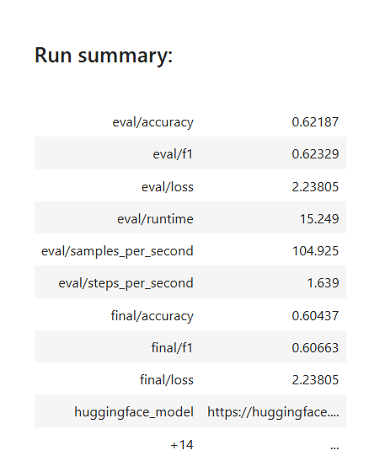

4. Operational Roadblocks & Key Takeaways

4.1 Technical Bottlenecks and Resolutions
Telemetry Failure on Initial Pipeline Execution The primary starter template explicitly deactivated experiment monitoring using internal environment overrides (WANDB_DISABLED=true and report_to=[]). Overcoming this limitation required removing these suppression variables, integrating an active initialization configuration block (wandb.init()), and ensuring that secret authentication keys were properly called prior to initializing any training processes. Moving the cell responsible for credential retrieval to the absolute top of the notebook structure and executing all execution cells sequentially cleared the roadblock.
Model Hub Registry Upload Failures Initial attempts to run the remote repository upload call (push_to_hub()) crashed with connection errors due to standard sandbox constraints that turn off web access by default in Kaggle notebooks. Adjusting the active network connection toggle inside the environment settings panel and rebooting the active runtime kernel successfully bypassed the issue. The default error message does not clearly flag this environment requirement prior to notebook execution, representing a non-obvious operational trap for engineering teams.
Discrepancies in Platform Credential Management Kaggle manages dynamic parameters using its own proprietary interface wrapper (kaggle_secrets.UserSecretsClient) rather than reading directly from global operating system variables. Furthermore, all required security variables must be manually associated with the project notebook inside the platform's user interface before they can be accessed by the code engine during runtime blocks.

Practical Engineering Insights
This project provided valuable, direct experience managing an end-to-end machine learning lifecycle. The most fundamental perspective shift involved learning to treat the neural architecture as a standard black box while re-focusing engineering effort entirely onto the surrounding operational scaffolding—specifically credential handling, experiment monitoring, intermediate artifact versioning, and endpoint serving. Three distinct takeaways stand out from this pipeline implementation:
- Production-Grade Security: Implementing native platform secret managers mirrors professional, cloud-based infrastructure methodologies for protecting credentials in enterprise pipelines.
- Deep Visual Diagnostics: Centralized experiment dashboards offer significantly better pipeline visibility than raw terminal logs by aggregating GPU usage metrics, learning rate steps, and epoch milestones into a single pane of glass.
- Frictionless Model Delivery: Using direct registry push utilities makes worldwide model distribution effortless, enabling global inference capabilities through a single backend API call.

Future System Iterations
Given a larger hardware or compute budget, the training phase would be expanded to run across 5 complete optimization epochs instead of 3, alongside creating an isolated validation split to properly tune hyperparameters and prevent evaluation metrics from leaking into the test dataset.
Additionally, future iterations would stream individual, class-specific F1 performance metrics to the monitoring platform at every epoch boundary rather than relying solely on global averages; this would help isolate exactly which target labels create the most semantic confusion. Generating and logging a confusion matrix directly to the tracking server would also provide a much better visual tool for troubleshooting class overlaps. Finally, running parallel benchmarks evaluating a larger language framework (such as bert-base-cased) within the exact same workspace would yield a clean data curve mapping operational accuracy against overall computation costs.

