Emmanuel Rodriguez Lopez

CPE301 – SPRING 2016

Design Assignment 0

**DO NOT REMOVE THIS PAGE DURING SUBMISSION:**

The student understands that all required components should be submitted in complete for grading of this assignment.

|  |  |  |  |
| --- | --- | --- | --- |
| **NO** | **SUBMISSION ITEM** | **COMPLETED (Y/N)** | **MARKS**  **(/MAX)** |
| 0. | COMPONENTS LIST AND CONNECTION BLOCK DIAGRAM w/ PINS |  |  |
| 1. | INITIAL CODE OF TASK 1/A |  |  |
| 2. | INCREMENTAL / DIFFERENTIAL CODE OF TASK 2/B |  |  |
| 3. | INCREMENTAL / DIFFERENTIAL CODE OF TASK 3/C |  |  |
| 4. | INCREMENTAL / DIFFERENTIAL CODE OF TASK 4/D |  |  |
| 5. | INCREMENTAL / DIFFERENTIAL CODE OF TASK 5/E |  |  |
| 6. | SCHEMATICS |  |  |
| 7. | SCREENSHOTS OF EACH TASK OUTPUT |  |  |
| 8. | SCREENSHOT OF EACH DEMO |  |  |
| 9. | VIDEO LINKS OF EACH DEMO |  |  |
| 10. | GOOGLECODE LINK OF THE DA |  |  |
|  |  |  |  |
|  |  |  |  |

|  |  |  |  |
| --- | --- | --- | --- |
| 0. | COMPONENTS LIST AND CONNECTION BLOCK DIAGRAM w/ PINS |  |  |
| 1. | INITIAL CODE OF TASK 1/A |  |  |

**/\***

**\* DesignAssignment0_rodrie2.asm**

**\***

**\*  Created: 2/14/2016 12:14:22 PM**

**\*   Author: erl25_000**

**\*/**

**LDI R16, 255 ;to compare the overflow**

**;if number ends up negative, an overflow happened**

**;if number ends up positive, no overflow happened**

**LDI R17, 59 ;number 1**

**LDI R27, 59 ;number 2**

**add r17, r27 ;adding number 1 + 2**

**sub r16, r17 ;subtracting from overflow number**

**ldi r27, 59 ;number 3**

**add r17, r27 ;adding of number 3**

**sub r16, r27**

**ldi r27, 50 ;number 4**

**add r17, r27**

**sub r16, r27**

**ldi r27, 59 ;number 5**

**add r17, r27**

**sub r16, r27 ;final check of overflow number**

**cpi r16, 0**

**brlt overflow ;if overflow number is less than 0, an overflow occured, else not.**

**;brvs overflow ;failed attempt to use SREG**

**ldi r28, 0 ;no overflow so PORTB - PIN 2 is low**

**out PORTB, r28**

**jmp done**

**overflow:**

**ldi r28, 4 ;overflow happened so PORTB - PIN 2 is high**

**out PORTB, r28**

**done:**

**sbi DDRB,2 ;makes PORTB - PIN 2 an output**

|  |  |  |  |
| --- | --- | --- | --- |
| 6. | SCHEMATICS |  |  |
| 7. | SCREENSHOTS OF EACH TASK OUTPUT |  |  |

TASK 1/A:

Five random numbers added

First screenshot is of no overflow

Second screenshot is of overflow occurring

1

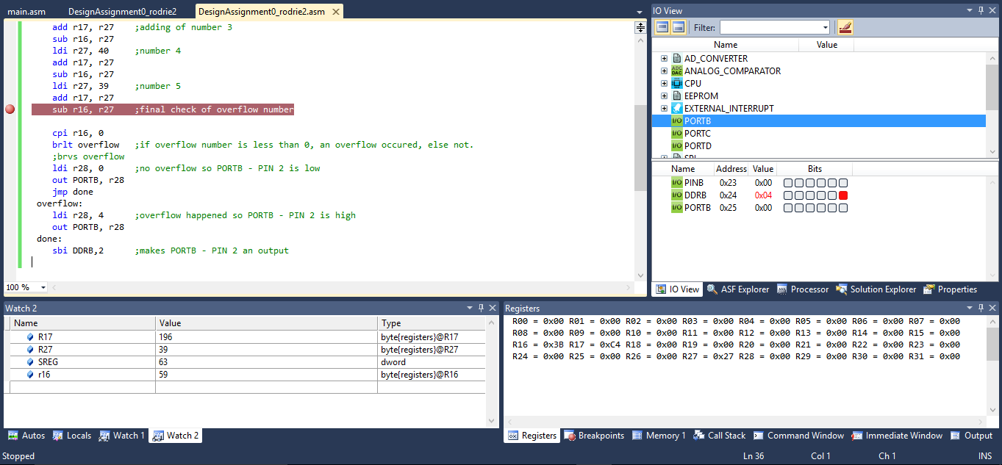

2

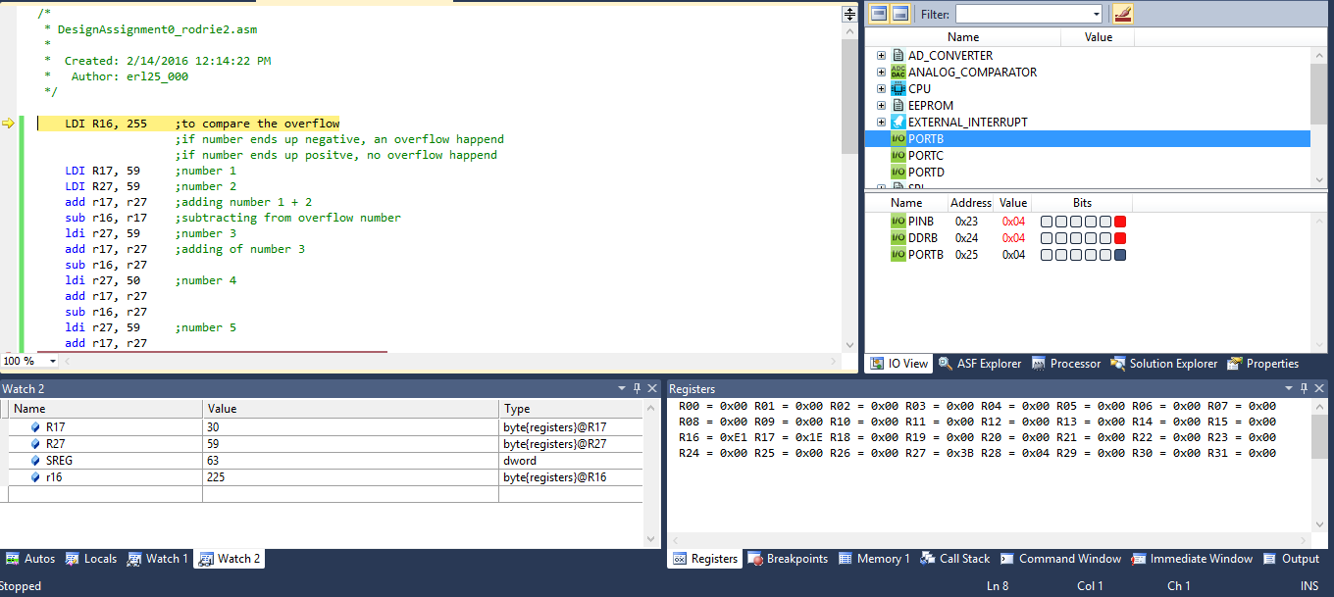

TASK 1/B

Determine the execution time / # of cycles of your algorithm using the simulation. Set CLOCK speed to 8MHz

Running the code for either an overflow or not causes the execution time to be 2.5µs. Since we know the frequency is 8MHz, we can multiply the 2.5µs by it. This gives us the # of cycles and it is 20 cycles. Double checking by applying the correct number to each instruction, it can be observed that it is too 20 cycles either way.

|  |  |  |  |
| --- | --- | --- | --- |
| 8. | SCREENSHOT OF EACH DEMO |  |  |
| 9. | VIDEO LINKS OF EACH DEMO |  |  |
| N/A | | | |
| 10. | GOOGLECODE LINK OF THE DA |  |  |
| http:// https://github.com/rodrie2/UNLVCPE301 | | | |

**Student Academic Misconduct Policy**

<http://studentconduct.unlv.edu/misconduct/policy.html>

“This assignment submission is my own, original work”.

Emmanuel Rodriguez Lopez