Emmanuel Rodriguez Lopez

CPE301 – SPRING 2016

Design Assignment 1

**DO NOT REMOVE THIS PAGE DURING SUBMISSION:**

The student understands that all required components should be submitted in complete for grading of this assignment.

|  |  |  |  |
| --- | --- | --- | --- |
| **NO** | **SUBMISSION ITEM** | **COMPLETED (Y/N)** | **MARKS**  **(/MAX)** |
| 0. | COMPONENTS LIST AND CONNECTION BLOCK DIAGRAM w/ PINS |  |  |
| 1. | INITIAL CODE OF TASK 1/A |  |  |
| 2. | INCREMENTAL / DIFFERENTIAL CODE OF TASK 2/B |  |  |
| 3. | INCREMENTAL / DIFFERENTIAL CODE OF TASK 3/C |  |  |
| 4. | INCREMENTAL / DIFFERENTIAL CODE OF TASK 4/D |  |  |
| 5. | INCREMENTAL / DIFFERENTIAL CODE OF TASK 5/E |  |  |
| 6. | SCHEMATICS |  |  |
| 7. | SCREENSHOTS OF EACH TASK OUTPUT |  |  |
| 8. | SCREENSHOT OF EACH DEMO |  |  |
| 9. | VIDEO LINKS OF EACH DEMO |  |  |
| 10. | GOOGLECODE LINK OF THE DA |  |  |
|  |  |  |  |
|  |  |  |  |

|  |  |  |  |
| --- | --- | --- | --- |
| 0. | COMPONENTS LIST AND CONNECTION BLOCK DIAGRAM w/ PINS |  |  |

LDI ZH, 0x00 ;only way to get values besides 0xff  
LDI ZL, 0x00 ;in theory it should be RAMEND/2

BEGIN:  
 CPI R22, 0x19  
 BREQ END  
 LPM XL, Z+  
 LDI R16, 7  
 LDI R18, 3  
 LDI YH, 0 ;FOR 7 LIMIT  
 LDI XH, 0 ;FOR 3 LIMIT  
 CPI XL, 0 ;NEXT NUMBER IF 0  
 BREQ NXT

SEVENLOOP:  
 CPI YH, 36  
 BREQ THREELOOP  
 CP XL, R16  
 BREQ ADDSEV  
 SUBI R16, -7  
 INC YH  
 JMP SEVENLOOP

ADDSEV:  
 ADD R21, XL  
 ADC R20, R17

THREELOOP:  
 CPI XH, 85  
 BREQ NXT  
 CP XL, R18  
 BREQ ADDTHR  
 SUBI R18, -3  
 INC XH  
 JMP THREELOOP

ADDTHR:  
 ADD R24, XL  
 ADC R23, R17

NXT:  
 INC R22  
 JMP BEGIN

END:  
 JMP END

|  |  |  |  |
| --- | --- | --- | --- |
| 6. | SCHEMATICS |  |  |
| 7. | SCREENSHOTS OF EACH TASK OUTPUT |  |  |

TASK 1/e:

Determine the execution time @16MHz/#cycles

Taking the average amount of cycles gives us 1+1+25*9+25*36*7+25*85*7+50+1 * 1/16M = 1340us  
In the simulation below that includes the 25 numbers, the real value was 1548us which meant that there were 24768 cycles.

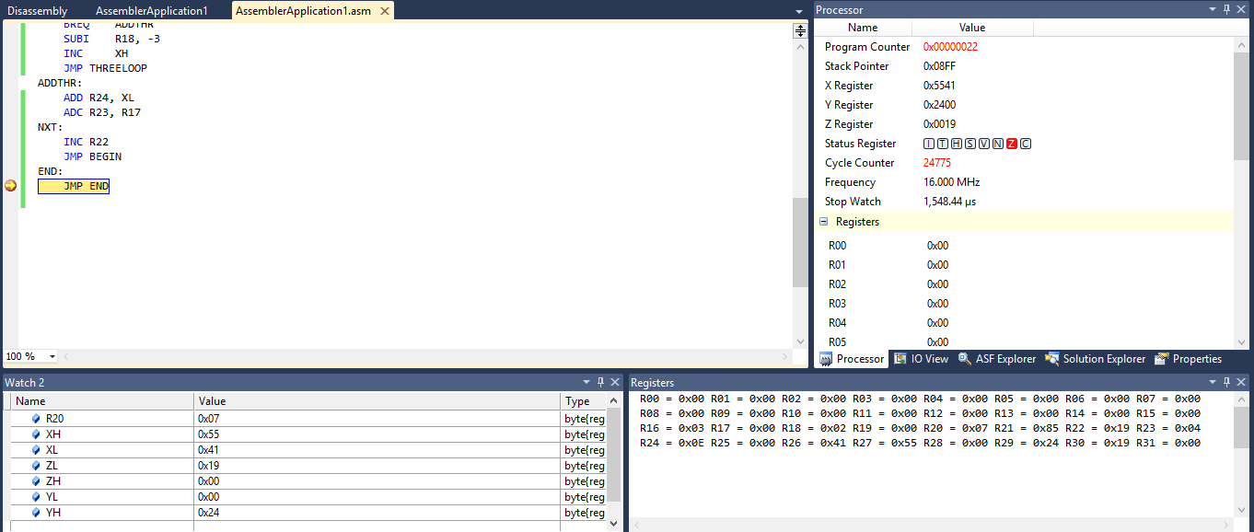

The screenshot above also serve to identify task b and c. The registers R20:21 contain the addition of the numbers divisible by 7 and the R23:24 contain the addition of the numbers divisible by 3.

The following screenshot shows task a, the only way I could manage it. Using the Z register to point to RAMEND/2 gave only the value of 0xFF for all 25 numbers. Looking at the memory, only the start of 0x0000 had usable numbers. So Z is set to that as shown here.

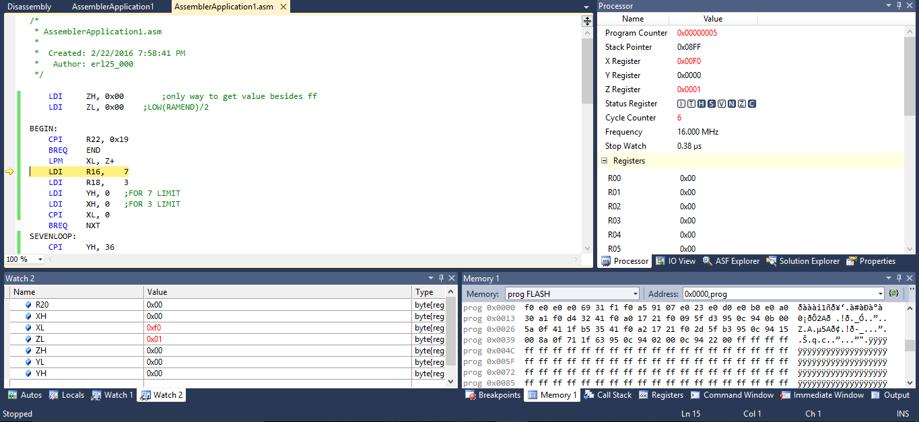

|  |  |  |  |
| --- | --- | --- | --- |
| 8. | SCREENSHOT OF EACH DEMO |  |  |
| 9. | VIDEO LINKS OF EACH DEMO |  |  |
| http:// @youtube | | | |
| 10. | GOOGLECODE LINK OF THE DA |  |  |
|  | | | |

**Student Academic Misconduct Policy**

<http://studentconduct.unlv.edu/misconduct/policy.html>

“This assignment submission is my own, original work”.

Emmanuel Rodriguez Lopez