Your NAME

CPE301 – SPRING 2016

Design Assignment X

**DO NOT REMOVE THIS PAGE DURING SUBMISSION:**

The student understands that all required components should be submitted in complete for grading of this assignment.

|  |  |  |  |
| --- | --- | --- | --- |
| **NO** | **SUBMISSION ITEM** | **COMPLETED (Y/N)** | **MARKS**  **(/MAX)** |
| 0. | COMPONENTS LIST AND CONNECTION BLOCK DIAGRAM w/ PINS |  |  |
| 1. | INITIAL CODE OF TASK 1/A |  |  |
| 2. | INCREMENTAL / DIFFERENTIAL CODE OF TASK 2/B |  |  |
| 3. | INCREMENTAL / DIFFERENTIAL CODE OF TASK 3/C |  |  |
| 4. | INCREMENTAL / DIFFERENTIAL CODE OF TASK 4/D |  |  |
| 5. | INCREMENTAL / DIFFERENTIAL CODE OF TASK 5/E |  |  |
| 6. | SCHEMATICS |  |  |
| 7. | SCREENSHOTS OF EACH TASK OUTPUT |  |  |
| 8. | SCREENSHOT OF EACH DEMO |  |  |
| 9. | VIDEO LINKS OF EACH DEMO |  |  |
| 10. | GOOGLECODE LINK OF THE DA |  |  |
|  |  |  |  |
|  |  |  |  |

|  |  |  |  |
| --- | --- | --- | --- |
| 0. | COMPONENTS LIST AND CONNECTION BLOCK DIAGRAM w/ PINS |  |  |

|  |  |  |  |
| --- | --- | --- | --- |
| 1. | INITIAL CODE OF TASK 1/A |  |  |

/*

* CPE_301_Design_Assignment_2.c

* Created: 3/7/2014 4:12:28 PM

* Author: l

*/

#include <avr/io.h>

//#include <util/delay.h>

#include <avr/interrupt.h>

unsigned char counter; // # of falling edges of generated waveform (50% duty cycle, 0.5 sec period)

unsigned char edge_count; // # of edges of generated waveform

unsigned char int0_count; // # of INT0 (LED9) interrupts

void delay_ms(int d);

int main(int argc, char* argv[])

{

// Initialization

…

}

|  |  |  |  |
| --- | --- | --- | --- |
| 6. | SCHEMATICS |  |  |

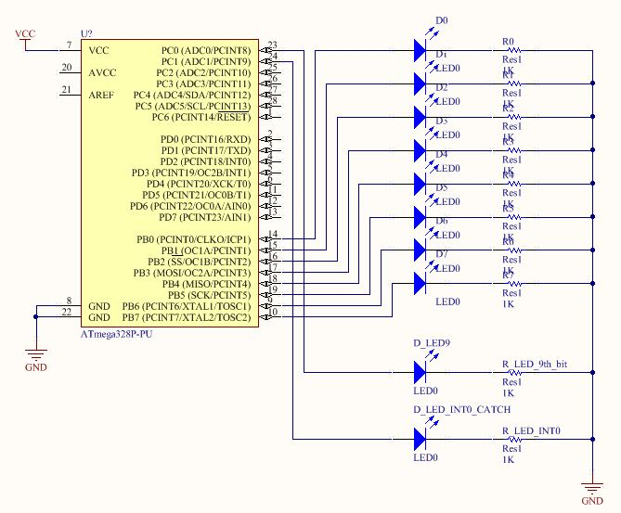

|  |  |  |  |
| --- | --- | --- | --- |
| 7. | SCREENSHOTS OF EACH TASK OUTPUT |  |  |

TASK 1/A:

Verify duty cycle and period: 50% duty cycle, period = 0.5 second

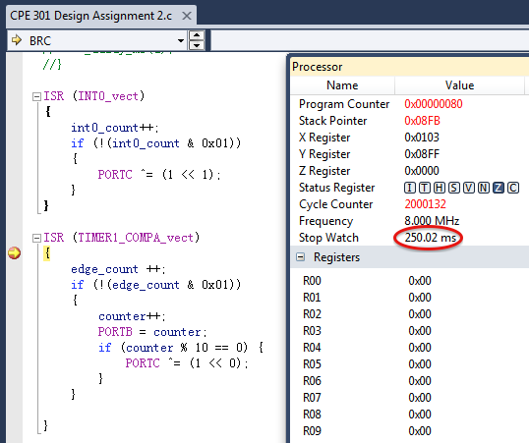

|  |  |  |  |
| --- | --- | --- | --- |
| 8. | SCREENSHOT OF EACH DEMO |  |  |

TASK 1/A: Counter reaches 10, the 9th LED is toggled on

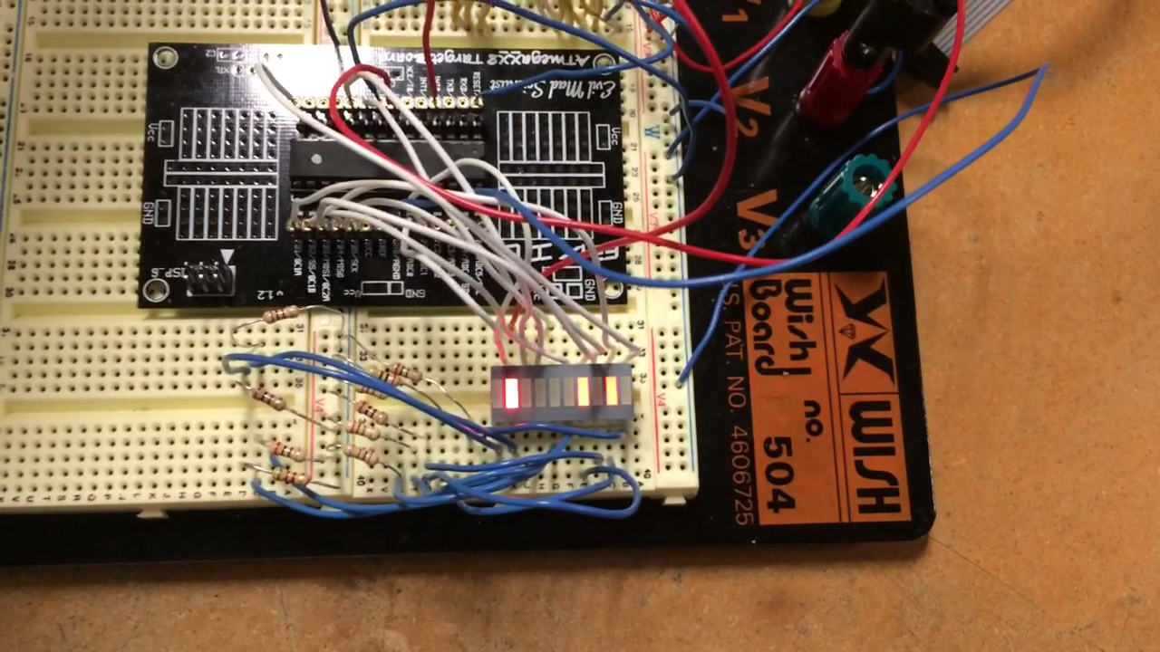

When the 9th LED is toggled off for the 2nd time (falling edge), the 10th bit is toggled on. (see video)

|  |  |  |  |
| --- | --- | --- | --- |
| 9. | VIDEO LINKS OF EACH DEMO |  |  |
| http:// @youtube | | | |
| 10. | GOOGLECODE LINK OF THE DA |  |  |
| http:// @svn or github repository link | | | |

**Student Academic Misconduct Policy**

<http://studentconduct.unlv.edu/misconduct/policy.html>

“This assignment submission is my own, original work”.

NAME OF THE STUDENT