Emmanuel Rodriguez Lopez

**CPE301 – SPRING 2016**

Design Assignment 3

**DO NOT REMOVE THIS PAGE DURING SUBMISSION:**

The student understands that all required components should be submitted in complete for grading of this assignment.

|  |  |  |  |
| --- | --- | --- | --- |
| **NO** | **SUBMISSION ITEM** | **COMPLETED (Y/N)** | **MARKS**  **(/MAX)** |
| 0. | COMPONENTS LIST AND CONNECTION BLOCK DIAGRAM w/ PINS |  |  |
| 1. | INITIAL CODE OF TASK 1/A |  |  |
| 2. | INCREMENTAL / DIFFERENTIAL CODE OF TASK 2/B |  |  |
| 3. | INCREMENTAL / DIFFERENTIAL CODE OF TASK 3/C |  |  |
| 4. | INCREMENTAL / DIFFERENTIAL CODE OF TASK 4/D |  |  |
| 5. | INCREMENTAL / DIFFERENTIAL CODE OF TASK 5/E |  |  |
| 6. | SCHEMATICS |  |  |
| 7. | SCREENSHOTS OF EACH TASK OUTPUT |  |  |
| 8. | SCREENSHOT OF EACH DEMO |  |  |
| 9. | VIDEO LINKS OF EACH DEMO |  |  |
| 10. | GOOGLECODE LINK OF THE DA |  |  |
|  |  |  |  |
|  |  |  |  |

|  |  |  |  |
| --- | --- | --- | --- |
| 0. | COMPONENTS LIST AND CONNECTION BLOCK DIAGRAM w/ PINS |  |  |

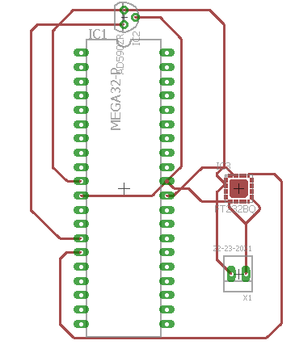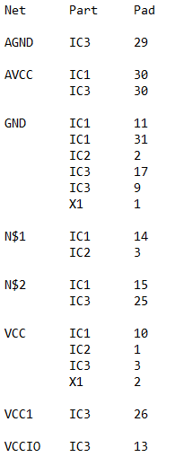

|  |  |  |  |
| --- | --- | --- | --- |
| 1. | INITIAL CODE OF TASK 1/A |  |  |

#include <avr/io.h>

#include <avr/interrupt.h>

#define FOSC 8000000

#define BAUD 9600

#define MYUBRR FOSC/16/BAUD-1 //52

volatile int RECH;

char outs[5]; //space for 3 digits and decimal

void usart_init(void)

{

UBRR0H = (MYUBRR >> 8); //0

UBRR0L = MYUBRR;

UCSR0B |= (1<<RXEN0)|(1<<TXEN0);//|(1<<RXCIE0);

UCSR0C |= (1<<UCSZ01)|(1<<UCSZ00);

}

void usart_rx(void)

{

while(!(UCSR0A & (1<<RXC0)))

{

RECH = UDR0;

}

}

int main(void)

{

usart_init();

TCCR1A = 0x00;

TCCR1B = 0x0D;

OCR1A = 0x1E85;

TIMSK1 |= (1<<OCIE1A);

sei();

while(1)

{

usart_rx();

}

}

ISR(TIMER1_COMPA_vect)

{

printf(outs, sizeof(outs), "%3d\r\n", RECH); //PRINT

while (!(UCSR0A & (1<<UDRE0)))

{

UDR0 = outs;

}

TCCR1A = 0x00;

TCCR1B = 0x0D;

OCR1A = 0x1E85;

}

|  |  |  |  |
| --- | --- | --- | --- |
| 6. | SCHEMATICS |  |  |

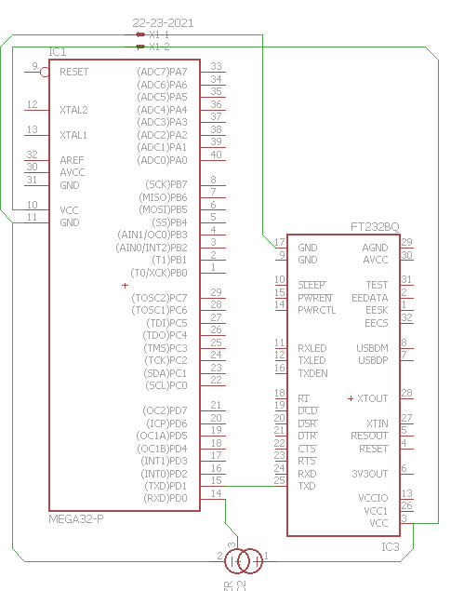

|  |  |  |  |
| --- | --- | --- | --- |
| 7. | SCREENSHOTS OF EACH TASK OUTPUT |  |  |

TASK 1/A:

The screenshot shows an interrupt happening every one second so it can transmit the temperature that was recorded during the normal code.

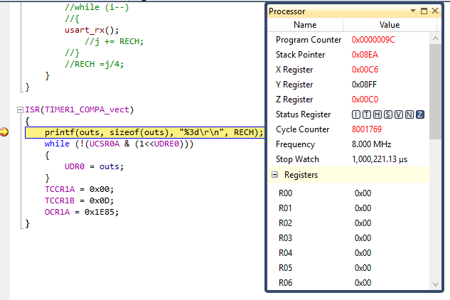

|  |  |  |  |
| --- | --- | --- | --- |
| 8. | SCREENSHOT OF EACH DEMO |  |  |

|  |  |  |  |
| --- | --- | --- | --- |
| 9. | VIDEO LINKS OF EACH DEMO |  |  |
| http:// @youtube | | | |
| 10. | GOOGLECODE LINK OF THE DA |  |  |
| http:// @svn or github repository link | | | |

**Student Academic Misconduct Policy**

<http://studentconduct.unlv.edu/misconduct/policy.html>

“*This assignment submission is my own, original work*”.

Emmanuel Rodriguez Lopez