Emmanuel Rodriguez Lopez

CPE301 – SPRING 2016

Design Assignment 4

**DO NOT REMOVE THIS PAGE DURING SUBMISSION:**

The student understands that all required components should be submitted in complete for grading of this assignment.

|  |  |  |  |
| --- | --- | --- | --- |
| **NO** | **SUBMISSION ITEM** | **COMPLETED (Y/N)** | **MARKS**  **(/MAX)** |
| 0. | COMPONENTS LIST AND CONNECTION BLOCK DIAGRAM w/ PINS |  |  |
| 1. | INITIAL CODE OF TASK 1/A |  |  |
| 2. | INCREMENTAL / DIFFERENTIAL CODE OF TASK 2/B |  |  |
| 3. | INCREMENTAL / DIFFERENTIAL CODE OF TASK 3/C |  |  |
| 4. | INCREMENTAL / DIFFERENTIAL CODE OF TASK 4/D |  |  |
| 5. | INCREMENTAL / DIFFERENTIAL CODE OF TASK 5/E |  |  |
| 6. | SCHEMATICS |  |  |
| 7. | SCREENSHOTS OF EACH TASK OUTPUT |  |  |
| 8. | SCREENSHOT OF EACH DEMO |  |  |
| 9. | VIDEO LINKS OF EACH DEMO |  |  |
| 10. | GOOGLECODE LINK OF THE DA |  |  |
|  |  |  |  |
|  |  |  |  |

|  |  |  |  |
| --- | --- | --- | --- |
| 0. | COMPONENTS LIST AND CONNECTION BLOCK DIAGRAM w/ PINS |  |  |

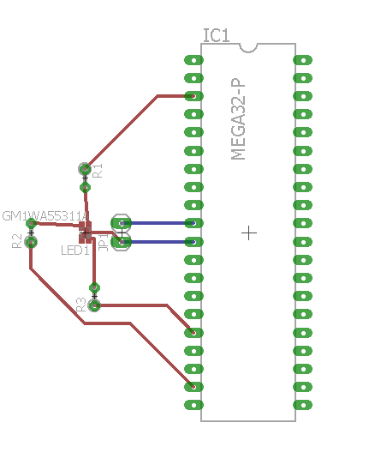

Netlist (components and connections)

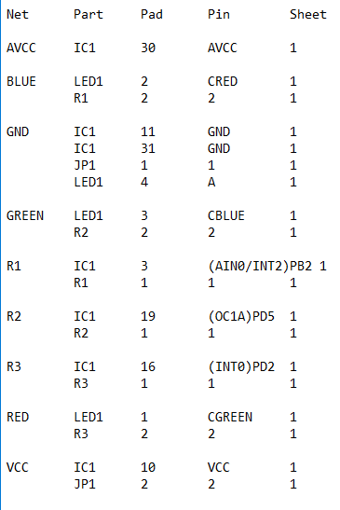

|  |  |  |  |
| --- | --- | --- | --- |
| 1. | INITIAL CODE OF TASK 1/A&B |  |  |

/*

* DA4.c

*

* Created: 4/5/2016 8:28:35 PM

* Author: Rodriguez

*/

#define F_CPU 8000000UL

#include <avr/io.h>

#include <util/delay.h>

int main(void)

{

//3 timers

//3 loops in 3 loops that increase all frequencies to 90%

//Then 3 loops to decrease all to 10%

//one more loop to exentuate green

//go through one period, and all the intensities

DDRB = 0xFF;

DDRD = 0xFF;

//TIMER 1 BLUE

TCCR1A |= (1<<COM1B1)|(1<<WGM11)|(1<<WGM10); //Outputs in OC1B (pb2)

TCCR1B |= (1<<WGM13)|(1<<WGM12)|(1<<CS11)|(1<<CS10);

OCR1A = 25;//top, thus changing is changing frequency

OCR1B = 5;//n, thus changing is changing the DC

//TIMER 0 GREEN

TCCR0A |= (1<<COM0B1)|(1<<WGM01)|(1<<WGM00); //OUTS in pd5

TCCR0B |= (1<<WGM02)|(1<<CS01)|(1<<CS00);

OCR0A = 25;

OCR0B = 5;

//TIMER 2 RED

TCCR2A |= (1<<COM2B1)|(1<<WGM21)|(1<<WGM20);

TCCR2B |= (1<<WGM22)|(1<<CS21)|(1<<CS20);

OCR2A = 25;

OCR2B = 5;

while(1)

{

//BLUE+

while (OCR1A<230)

{

OCR1A += 15;

_delay_us(500000); //to hold color

while (OCR1B<OCR1A)

{

OCR1B += 5;

// _delay_us(500);

}

OCR1B = 5;

}

//GREEN+

while (OCR0A<230)

{

OCR0A += 15;

_delay_us(500000);

while (OCR0B<OCR0A)

{

OCR0B += 5;

// _delay_us(500);

}

OCR0B = 5;

}

//RED+

while (OCR2A<230)

{

OCR2A += 15;

_delay_us(500000);

while (OCR2B<OCR2A)

{

OCR2B += 1;

// _delay_us(500);

}

OCR2B = 5;

}

//all max

//BLUE -

while (OCR1A>30)

{

OCR1A -= 15;

_delay_us(500000);

while (OCR1B>25)

{

OCR1B -= 1;

// _delay_ms(500);

}

OCR1B = 5;

}

//GREEN-

while (OCR0A>30)

{

OCR0A -= 15;

_delay_us(500000);

while (OCR0B>25)

{

OCR0B -= 1;

// _delay_us(500);

}

OCR0B = 5;

}

//RED-

while (OCR2A>30)

{

OCR2A -= 15;

_delay_us(500000);

while (OCR2B>25)

{

OCR2B -= 1;

// _delay_us(500);

}

OCR2B = 5;

}

//GREEN+

while (OCR0A<230)

{

OCR0A += 15;

_delay_us(500000);

while (OCR0B<OCR0A)

{

OCR0B += 1;

// _delay_us(500);

}

OCR0B = 5;

}

}

return 0;

}

|  |  |  |  |
| --- | --- | --- | --- |
| 6. | SCHEMATICS |  |  |

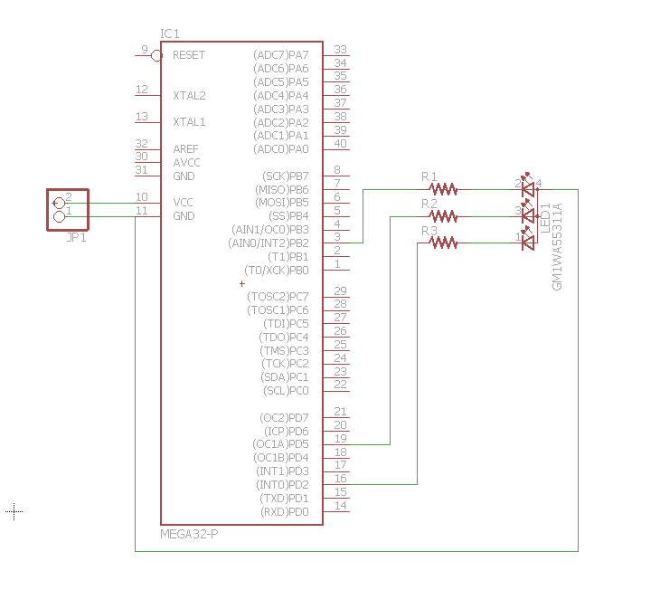

|  |  |  |  |
| --- | --- | --- | --- |
| 7. | SCREENSHOTS OF EACH TASK OUTPUT |  |  |

TASK 1/A:

OCR0A (by 25) and OCR0B (by 5) are increasing to hit every 10th percent to show different colors

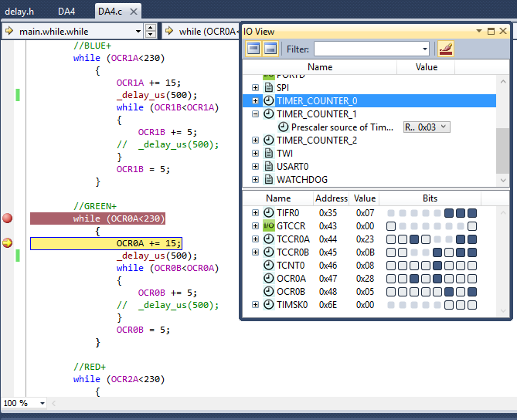

|  |  |  |  |
| --- | --- | --- | --- |
| 8. | SCREENSHOT OF EACH DEMO |  |  |

TASK 1/A: Make RGB LED cycle through frequencies of 10% - 90% and increasing intensities.  
Video included too.

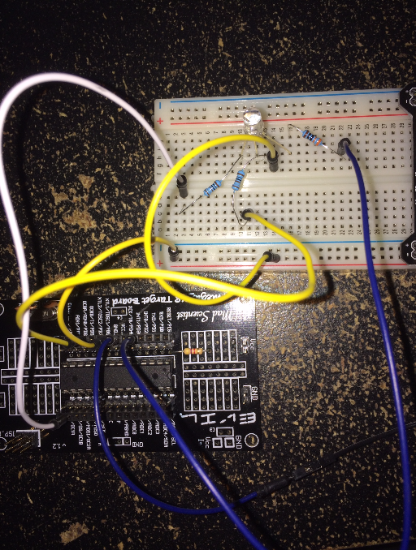

|  |  |  |  |
| --- | --- | --- | --- |
| 9. | VIDEO LINKS OF EACH DEMO |  |  |
| https://www.youtube.com/watch?v=MHoxBKWpK64 | | | |
| 10. | GOOGLECODE LINK OF THE DA |  |  |
| http:// @svn or github repository link | | | |

**Student Academic Misconduct Policy**

<http://studentconduct.unlv.edu/misconduct/policy.html>

“This assignment submission is my own, original work”.

Emmanuel Rodriguez Lopez