Emmanuel Rodriguez Lopez

CPE301 – SPRING 2016

Design Assignment 5

**DO NOT REMOVE THIS PAGE DURING SUBMISSION:**

The student understands that all required components should be submitted in complete for grading of this assignment.

|  |  |  |  |
| --- | --- | --- | --- |
| **NO** | **SUBMISSION ITEM** | **COMPLETED (Y/N)** | **MARKS**  **(/MAX)** |
| 0. | COMPONENTS LIST AND CONNECTION BLOCK DIAGRAM w/ PINS |  |  |
| 1. | INITIAL CODE OF TASK 1/A |  |  |
| 2. | INCREMENTAL / DIFFERENTIAL CODE OF TASK 2/B |  |  |
| 3. | INCREMENTAL / DIFFERENTIAL CODE OF TASK 3/C |  |  |
| 4. | INCREMENTAL / DIFFERENTIAL CODE OF TASK 4/D |  |  |
| 5. | INCREMENTAL / DIFFERENTIAL CODE OF TASK 5/E |  |  |
| 6. | SCHEMATICS |  |  |
| 7. | SCREENSHOTS OF EACH TASK OUTPUT |  |  |
| 8. | SCREENSHOT OF EACH DEMO |  |  |
| 9. | VIDEO LINKS OF EACH DEMO |  |  |
| 10. | GOOGLECODE LINK OF THE DA |  |  |
|  |  |  |  |
|  |  |  |  |

|  |  |  |  |
| --- | --- | --- | --- |
| 0. | COMPONENTS LIST AND CONNECTION DIAGRAM w/ PINS |  |  |

TASK 1 DC MOTOR

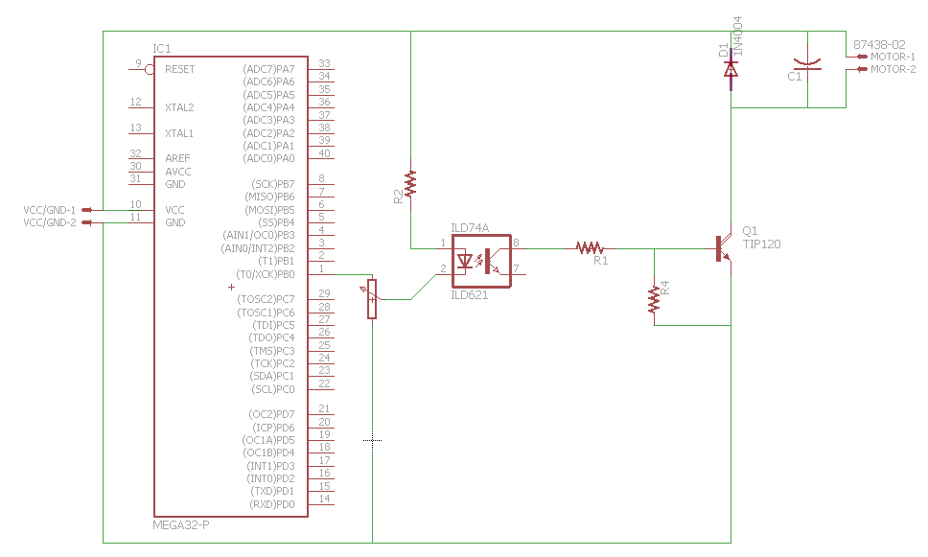

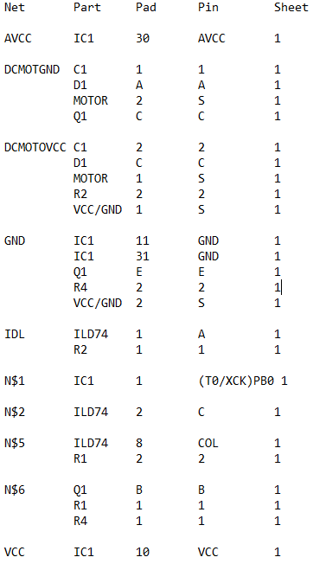

TASK 2 STEPPER MOTOR

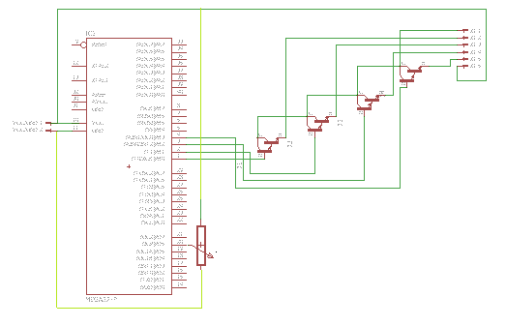 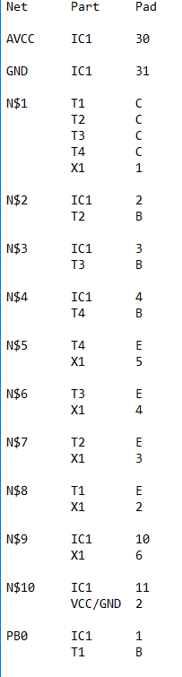

TASK 3 SERVO

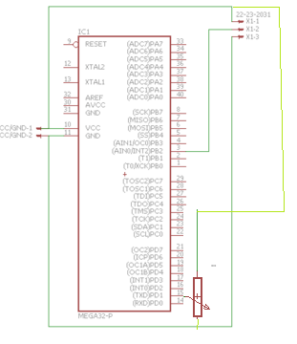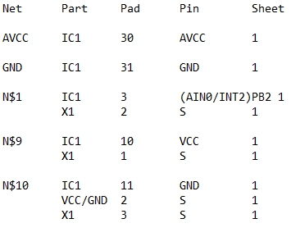

|  |  |  |  |
| --- | --- | --- | --- |
| 1 | INITIAL CODE OF TASK 1 |  |  |

#define F_CPU 8000000UL

#include <avr/io.h>

#include <util/delay.h>

int main(void)

{

DDRC = 0xFF;

while (1)

{

PORTC = 0x20; //pc5

_delay_ms(100);

PORTC = 0x00;

_delay_ms(100);

}

return 0;

}

|  |  |  |  |
| --- | --- | --- | --- |
| 2 | INITIAL CODE OF TASK 2 |  |  |

#define F_CPU 8000000UL

#include <avr/io.h>

#include <util/delay.h>

int main()

{

DDRD = 0x00;

DDRC = 0xFF;

while (1)

{

while (PIND == 0x02) //PD1 to pot, if on do following

{

PORTC = 0x6; //fast speed

_delay_ms(10);

PORTC = 0xC;

_delay_ms(10);

PORTC = 0x9;

_delay_ms(10);

PORTC = 0x3;

_delay_ms(10);

}

//if PD1 to pot registers 0

//slower speed

PORTC = 0x6;

_delay_ms(100);

PORTC = 0xC;

_delay_ms(100);

PORTC = 0x9;

_delay_ms(100);

PORTC = 0x3;

_delay_ms(100);

}

return 0;

}

|  |  |  |  |
| --- | --- | --- | --- |
| 3 | INITIAL CODE OF TASK 3 |  |  |

#define F_CPU 8000000UL

#include <avr/io.h>

#include <util/delay.h>

int main()

{

DDRD = 0x00;

DDRB = 0xFF;

ICR1 = 20000;

TCCR1A |= (1<<COM1A1)|(1<<WGM11); //

TCCR1B |= (1<<WGM12)|(1<<WGM13)|(1<<CS11);

while (1)

{

while (PIND == 0x02) //When pot is high, PD1 is high, thus motor turns clockwise

{

_delay_ms(20);

OCR1A = 2900;

}

//When pot is low, PD1 is low, thus motor turns counterclockwise

_delay_ms(20);

OCR1A = 400;

}

}

|  |  |  |  |
| --- | --- | --- | --- |
| 6. | SCHEMATICS |  |  |

TASK 1

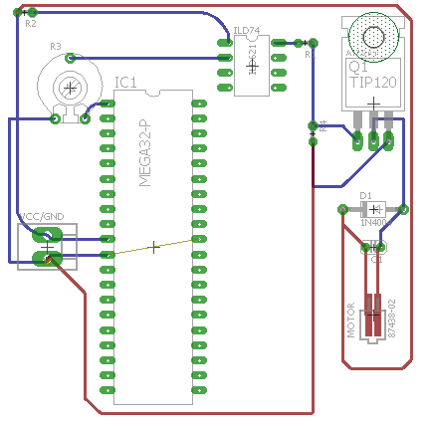

TASK 2

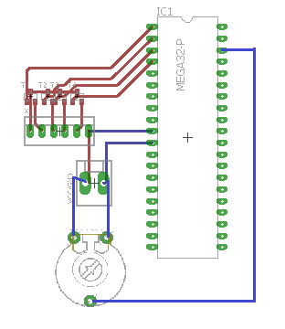

TASK 3

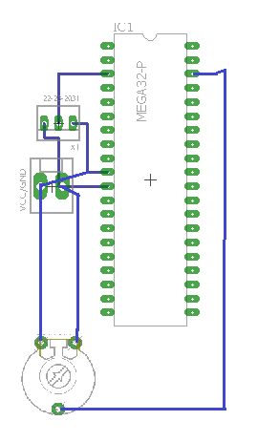

|  |  |  |  |
| --- | --- | --- | --- |
| 7. | SCREENSHOTS OF EACH TASK OUTPUT |  |  |

Simulations do not anything useful.

|  |  |  |  |
| --- | --- | --- | --- |
| 8. | SCREENSHOT |  |  |

TASK 1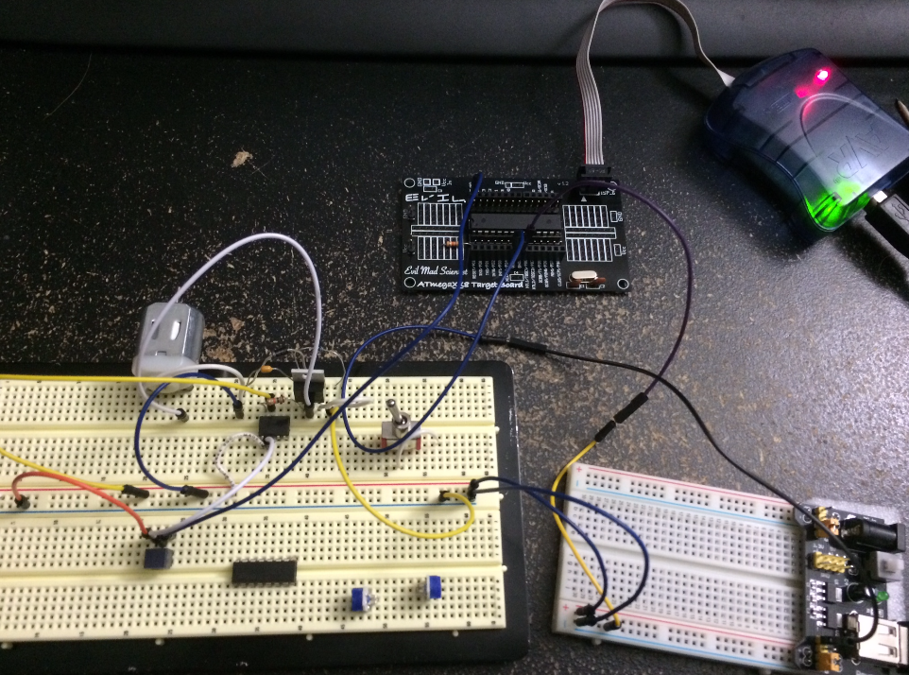

TASK2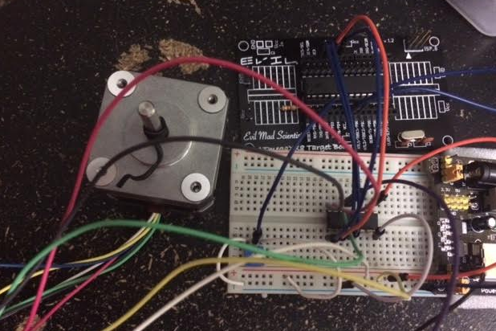

TASK3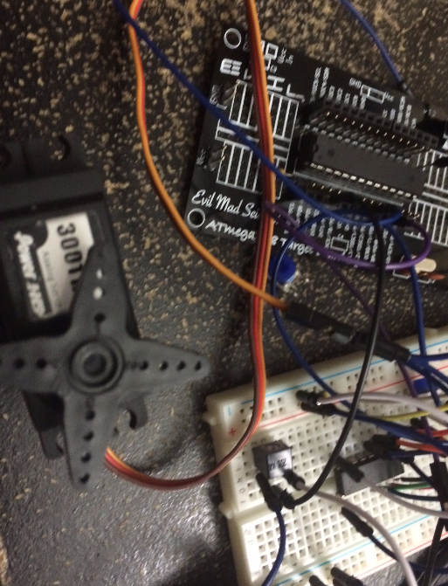

|  |  |  |  |
| --- | --- | --- | --- |
| 9. | VIDEO LINKS OF EACH DEMO |  |  |
| 1: <https://www.youtube.com/watch?v=87XC5gDS9u0>  2: <https://www.youtube.com/watch?v=Q6BKxLB7vZs>  3: <https://www.youtube.com/watch?v=2VpFoAMu9oU> | | | |
| 10. | GOOGLECODE LINK OF THE DA |  |  |
| http:// @svn or github repository link | | | |

**Student Academic Misconduct Policy**

<http://studentconduct.unlv.edu/misconduct/policy.html>

“This assignment submission is my own, original work”.

Emmanuel Rodriguez Lopez