Emmanuel Rodriguez Lopez

CPE301 – SPRING 2016

Design Assignment 6

**DO NOT REMOVE THIS PAGE DURING SUBMISSION:**

The student understands that all required components should be submitted in complete for grading of this assignment.

|  |  |  |  |
| --- | --- | --- | --- |
| **NO** | **SUBMISSION ITEM** | **COMPLETED (Y/N)** | **MARKS**  **(/MAX)** |
| 0. | COMPONENTS LIST AND CONNECTION BLOCK DIAGRAM w/ PINS |  |  |
| 1. | INITIAL CODE OF TASK 1/A |  |  |
| 2. | INCREMENTAL / DIFFERENTIAL CODE OF TASK 2/B |  |  |
| 3. | INCREMENTAL / DIFFERENTIAL CODE OF TASK 3/C |  |  |
| 4. | INCREMENTAL / DIFFERENTIAL CODE OF TASK 4/D |  |  |
| 5. | INCREMENTAL / DIFFERENTIAL CODE OF TASK 5/E |  |  |
| 6. | SCHEMATICS |  |  |
| 7. | SCREENSHOTS OF EACH TASK OUTPUT |  |  |
| 8. | SCREENSHOT OF EACH DEMO |  |  |
| 9. | VIDEO LINKS OF EACH DEMO |  |  |
| 10. | GOOGLECODE LINK OF THE DA |  |  |
|  |  |  |  |
|  |  |  |  |

|  |  |  |  |
| --- | --- | --- | --- |
| 0. | COMPONENTS LIST AND CONNECTION BLOCK DIAGRAM w/ PINS |  |  |

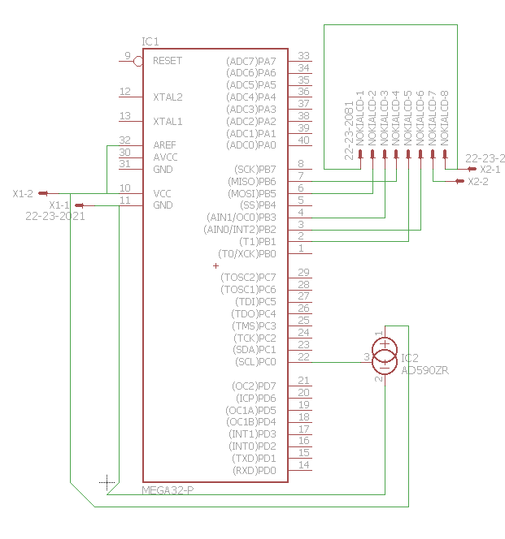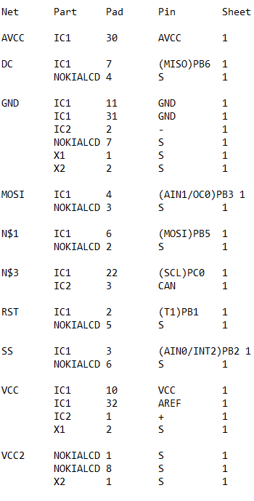

|  |  |  |  |
| --- | --- | --- | --- |
| 1. | INITIAL CODE OF TASK 1 |  |  |

/*

* DA6NOKIA.c

*

* Created: 4/28/2016 8:58:41 AM

* Author: rodrie2

*/

#include <avr/io.h>

#include <util/delay.h>

#define *F_CPU* 8000000UL

#include "nokia5110.c"

//full c and header files provided through github

//Original library written by SkewPL, <http://skew.tk>

//from .h

/*#define LCD_SCE PB2

#define LCD_RST PB1

#define LCD_DC PB6

#define LCD_DIN PB3

#define LCD_CLK PB5*/

#define ACD_0 PC0

int main(void)

{

int adc_temp;

char temp[8];

DDRB = 0xFF;

SPI_MasterInit();

//from nokia5110.c

//inserted transmit function in file.

nokia_lcd_init();

nokia_lcd_write_string("The current", 1);

nokia_lcd_set_cursor(0,10);

nokia_lcd_write_string("temperature is", 1);

ADC_init();

while(1)

{

adc_temp = adc_read();

adc_temp = (adc_temp)/3;

*sprintf*(temp, "%d", adc_temp); //converts temp into char string for printing

nokia_lcd_set_cursor(0, 20);

nokia_lcd_write_string(temp, 1);

nokia_lcd_write_string(" degrees", 1);

nokia_lcd_set_cursor(0, 30);

nokia_lcd_write_string("Fahrenheit", 1);

nokia_lcd_render();

//ADCSRA |= (1<<ADIF);

*_delay_ms*(1000);

}

return 0;

}

int adc_read()

{

//selects PC0 as analogue pin

ADMUX &= 0x00;

//starts converstion

ADCSRA |= (1<<ADSC);

while((ADCSRA & (1<<ADSC)));

return ADC; //returns temperature value

}

void ADC_init(void)

{

//activates ADC

ADCSRA = (1<<ADEN);//|(1<<ADSC);//|(1<<ADIF);

}

//ADOPTED FROM ATMEGA328P DATASHEET

void SPI_MasterInit(void)

{

/* Set MOSI and SCK output, all others input */

//ALREADY DONE OUTSIDE FUNCTION

//DDR_SPI = (1<<DD_MOSI)|(1<<DD_SCK);

/* Enable SPI, Master, set clock rate fck/16 */

SPCR = (1<<SPE)|(1<<MSTR)|(1<<SPR0);

}

/*

//PLACED IN OTHER FUNCTION

void SPI_MasterTransmit(char cData)

{

/* Start transmission //

SPDR = cData;

/* Wait for transmission complete /

while(!(SPSR & (1<<SPIF)))

;

}*/

|  |  |  |  |
| --- | --- | --- | --- |
| 6. | SCHEMATICS |  |  |

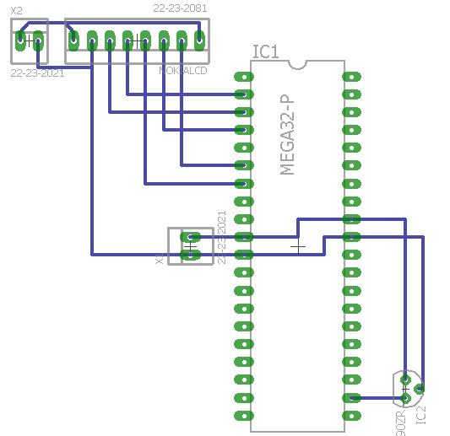

|  |  |  |  |
| --- | --- | --- | --- |
| 7. | SCREENSHOTS OF EACH TASK OUTPUT |  |  |

|  |  |  |  |
| --- | --- | --- | --- |
| 8. | SCREENSHOT OF EACH DEMO |  |  |

TASK 1  
First image shows room temperature, second shows temperature risen due to holding of sensor

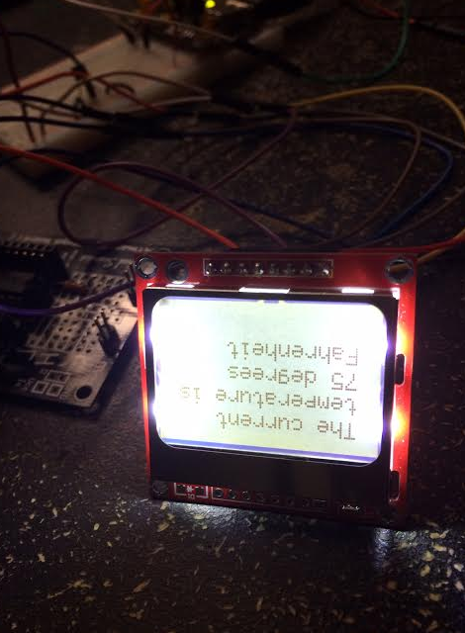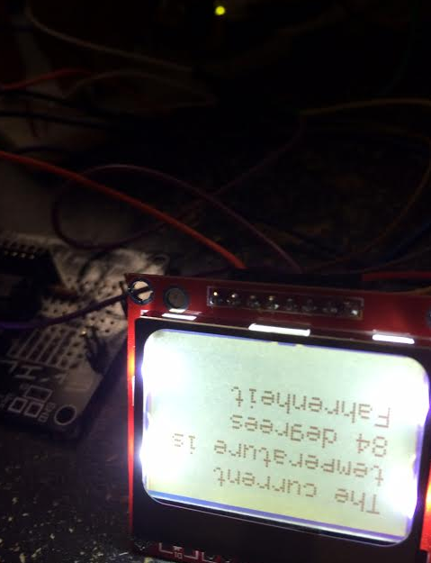

Connections image

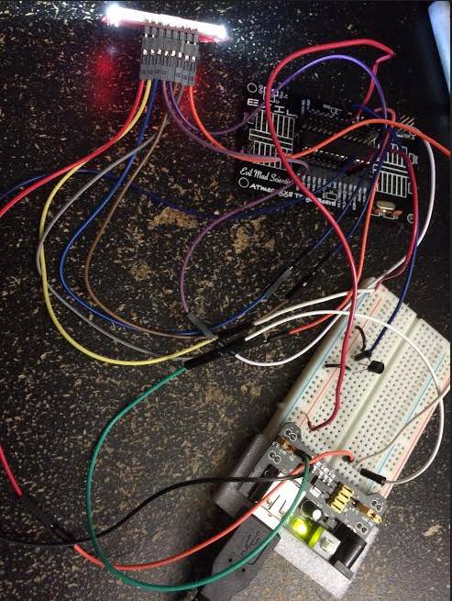

|  |  |  |  |
| --- | --- | --- | --- |
| 9. | VIDEO LINKS OF EACH DEMO |  |  |
| https://www.youtube.com/watch?v=vPHYA3BJxb8 | | | |
| 10. | GOOGLECODE LINK OF THE DA |  |  |
| http:// @svn or github repository link | | | |

**Student Academic Misconduct Policy**

<http://studentconduct.unlv.edu/misconduct/policy.html>

“This assignment submission is my own, original work”.

Emmanuel Rodriguez Lopez