Decomposição de Série Temporal

R Ballini

07/03/2023

Table of Contents

# Exemplo - PIB trimestral (1995=100) - Dados observados - Produto Interno Bruto a preços de mercado

library(readxl)  
  
dados= read_excel('PIB_Agropecuaria.xlsx')  
View(dados)  
  
pib = ts(dados[,2], start=c(1996,1), freq=4)  
plot(pib,ylab='PIB',xlab='Anos')

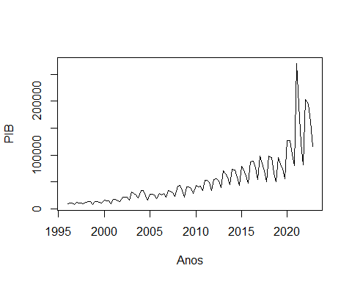

lpib=ts(log(dados[,2]), start=c(1996,1), freq=4)  
plot(lpib,ylab='log(PIB)',xlab='Anos')

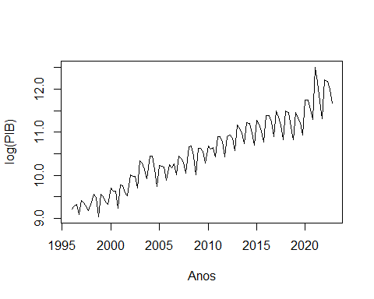

## Decomposição da Série Temporal

t=ts(seq(1:length(lpib)),start=c(1996,1), freq=4)  
  
#Construir as binárias  
#install.packages('gets')  
library(gets)

## Carregando pacotes exigidos: zoo

##   
## Attaching package: 'zoo'

## The following objects are masked from 'package:base':  
##   
## as.Date, as.Date.numeric

## Carregando pacotes exigidos: parallel

d=ts(periodicdummies(lpib),start=c(1996,1), freq=4)  
View(d)  
  
modelo = lm(lpib ~ t +d[,1:3])  
summary(modelo)

##   
## Call:  
## lm(formula = lpib ~ t + d[, 1:3])  
##   
## Residuals:  
## Min 1Q Median 3Q Max   
## -0.30336 -0.09013 0.00021 0.06874 0.63243   
##   
## Coefficients:  
## Estimate Std. Error t value Pr(>|t|)   
## (Intercept) 8.8483307 0.0384747 229.98 < 2e-16 ***  
## t 0.0247937 0.0004592 53.99 < 2e-16 ***  
## d[, 1:3]dum1 0.5209461 0.0404929 12.87 < 2e-16 ***  
## d[, 1:3]dum2 0.4575883 0.0404799 11.30 < 2e-16 ***  
## d[, 1:3]dum3 0.3031552 0.0404721 7.49 2.44e-11 ***  
## ---  
## Signif. codes: 0 '***' 0.001 '**' 0.01 '*' 0.05 '.' 0.1 ' ' 1  
##   
## Residual standard error: 0.1487 on 103 degrees of freedom  
## Multiple R-squared: 0.9675, Adjusted R-squared: 0.9662   
## F-statistic: 766.1 on 4 and 103 DF, p-value: < 2.2e-16

b=modelo$coefficients  
b

## (Intercept) t d[, 1:3]dum1 d[, 1:3]dum2 d[, 1:3]dum3   
## 8.84833071 0.02479372 0.52094611 0.45758825 0.30315522

tendencia=ts(b[1] + b[2]*t,start=c(1996,1), freq=4)  
View(tendencia)  
sazonal = ts(b[3]*d[,1] + b[4]*d[,2] + b[5]*d[,3],start=c(1996,1),freq=4)  
View(sazonal)  
res=ts(modelo$residuals,start=c(1996,1),freq=4)  
View(res)  
  
par(mfrow=c(2,2))  
plot(lpib, ylab='log(PIB)')  
plot(tendencia)  
plot(sazonal)  
plot(res)

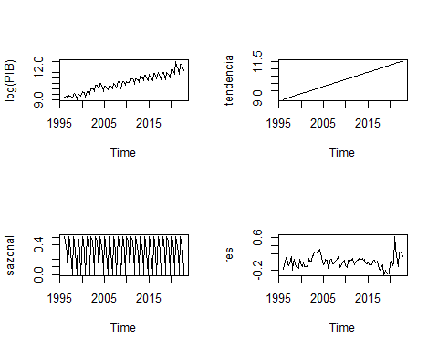

#Série Dessazonalizada  
par(mfrow=c(1,1))  
lpib.sa=lpib - sazonal  
plot(exp(lpib.sa))

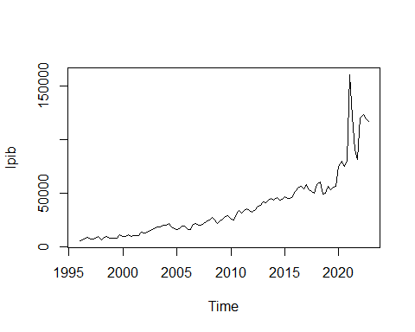

# Decomposição Por Médias Móveis

#Modelo Multiplicativo  
decomp.mm= decompose(pib,type='multiplicative')  
plot(decomp.mm)

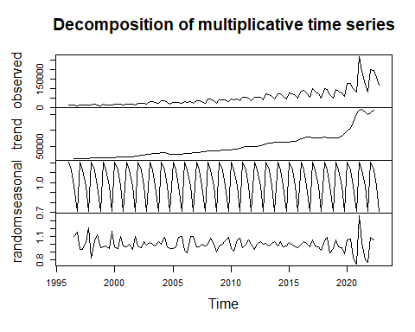

sazonal.mm=decomp.mm$seasonal  
View(sazonal.mm)  
  
tendencia.mm=decomp.mm$trend  
View(tendencia.mm)  
  
residuos.mm=decomp.mm$random  
View(residuos.mm)  
  
indice.saz=decomp.mm$figure  
indice.saz

## [1] 1.2025213 1.1260160 0.9626454 0.7088173

dessaz.pib=ts(pib/sazonal.mm,start=c(1996,1),freq=4)  
plot(dessaz.pib, main='Log(PIB) dessazonalizado')

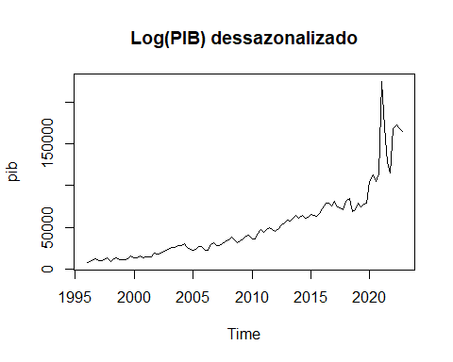

#Modelo Aditivo  
aditivo.mm= decompose(pib,type='additive')  
plot(aditivo.mm)

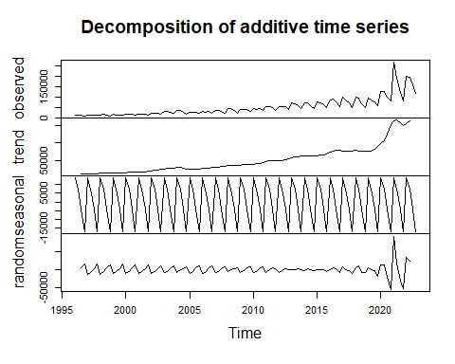

Saz.aditivo=aditivo.mm$seasonal  
View(Saz.aditivo)  
  
tendencia.aditivo=aditivo.mm$trend  
View(tendencia.aditivo)  
  
residuos.aditivo=aditivo.mm$random  
View(residuos.aditivo)  
  
aditivo.saz=aditivo.mm$figure  
aditivo.saz

## [1] 13609.410 7287.356 -3978.587 -16918.179

pib.aditivo=ts(pib - Saz.aditivo,start=c(1996,1),freq=4)  
plot(pib.aditivo, main='PIB dessazonalizado')

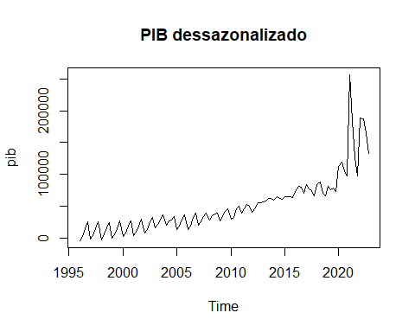

# Modelo de suavização exponencial simples

ajuste<-HoltWinters(pib,beta=FALSE, gamma=FALSE)  
ajuste

## Holt-Winters exponential smoothing without trend and without seasonal component.  
##   
## Call:  
## HoltWinters(x = pib, beta = FALSE, gamma = FALSE)  
##   
## Smoothing parameters:  
## alpha: 0.2716791  
## beta : FALSE  
## gamma: FALSE  
##   
## Coefficients:  
## [,1]  
## a 149201.4

fitted(ajuste)

## xhat level  
## 1996 Q2 10053.71 10053.71  
## 1996 Q3 10230.04 10230.04  
## 1996 Q4 10465.31 10465.31  
## 1997 Q1 10041.73 10041.73  
## 1997 Q2 10665.55 10665.55  
## 1997 Q3 10926.24 10926.24  
## 1997 Q4 10911.33 10911.33  
## 1998 Q1 10601.65 10601.65  
## 1998 Q2 10945.92 10945.92  
## 1998 Q3 11830.44 11830.44  
## 1998 Q4 12186.96 12186.96  
## 1999 Q1 11157.82 11157.82  
## 1999 Q2 11981.65 11981.65  
## 1999 Q3 12390.70 12390.70  
## 1999 Q4 12212.83 12212.83  
## 2000 Q1 11916.30 11916.30  
## 2000 Q2 13119.99 13119.99  
## 2000 Q3 13689.91 13689.91  
## 2000 Q4 14094.12 14094.12  
## 2001 Q1 13041.61 13041.61  
## 2001 Q2 14248.89 14248.89  
## 2001 Q3 15081.67 15081.67  
## 2001 Q4 14976.49 14976.49  
## 2002 Q1 14623.14 14623.14  
## 2002 Q2 16647.42 16647.42  
## 2002 Q3 17975.03 17975.03  
## 2002 Q4 18922.59 18922.59  
## 2003 Q1 18249.25 18249.25  
## 2003 Q2 21672.49 21672.49  
## 2003 Q3 23718.89 23718.89  
## 2003 Q4 24180.39 24180.39  
## 2004 Q1 23174.29 23174.29  
## 2004 Q2 26208.69 26208.69  
## 2004 Q3 28484.45 28484.45  
## 2004 Q4 27571.36 27571.36  
## 2005 Q1 24661.44 24661.44  
## 2005 Q2 25456.70 25456.70  
## 2005 Q3 25923.26 25923.26  
## 2005 Q4 26072.40 26072.40  
## 2006 Q1 24347.31 24347.31  
## 2006 Q2 25357.44 25357.44  
## 2006 Q3 25586.64 25586.64  
## 2006 Q4 26422.12 26422.12  
## 2007 Q1 25320.06 25320.06  
## 2007 Q2 27772.21 27772.21  
## 2007 Q3 29115.88 29115.88  
## 2007 Q4 29307.51 29307.51  
## 2008 Q1 27666.30 27666.30  
## 2008 Q2 31672.58 31672.58  
## 2008 Q3 34828.51 34828.51  
## 2008 Q4 34612.84 34612.84  
## 2009 Q1 31271.74 31271.74  
## 2009 Q2 33963.08 33963.08  
## 2009 Q3 35856.14 35856.14  
## 2009 Q4 36434.84 36434.84  
## 2010 Q1 34446.81 34446.81  
## 2010 Q2 36977.91 36977.91  
## 2010 Q3 37897.25 37897.25  
## 2010 Q4 38980.33 38980.33  
## 2011 Q1 37606.35 37606.35  
## 2011 Q2 41989.04 41989.04  
## 2011 Q3 45205.43 45205.43  
## 2011 Q4 46114.29 46114.29  
## 2012 Q1 42797.84 42797.84  
## 2012 Q2 45925.32 45925.32  
## 2012 Q3 48531.53 48531.53  
## 2012 Q4 49392.14 49392.14  
## 2013 Q1 46614.43 46614.43  
## 2013 Q2 53071.76 53071.76  
## 2013 Q3 56477.17 56477.17  
## 2013 Q4 57075.10 57075.10  
## 2014 Q1 53963.78 53963.78  
## 2014 Q2 59443.55 59443.55  
## 2014 Q3 63070.71 63070.71  
## 2014 Q4 61931.05 61931.05  
## 2015 Q1 57105.99 57105.99  
## 2015 Q2 62943.59 62943.59  
## 2015 Q3 65437.92 65437.92  
## 2015 Q4 64266.80 64266.80  
## 2016 Q1 59608.89 59608.89  
## 2016 Q2 67242.31 67242.31  
## 2016 Q3 73040.47 73040.47  
## 2016 Q4 73928.17 73928.17  
## 2017 Q1 68529.52 68529.52  
## 2017 Q2 76511.73 76511.73  
## 2017 Q3 78655.53 78655.53  
## 2017 Q4 76409.36 76409.36  
## 2018 Q1 69307.84 69307.84  
## 2018 Q2 77006.37 77006.37  
## 2018 Q3 81922.02 81922.02  
## 2018 Q4 77721.33 77721.33  
## 2019 Q1 70300.40 70300.40  
## 2019 Q2 77083.86 77083.86  
## 2019 Q3 78892.35 78892.35  
## 2019 Q4 77927.10 77927.10  
## 2020 Q1 72069.11 72069.11  
## 2020 Q2 86744.53 86744.53  
## 2020 Q3 97565.02 97565.02  
## 2020 Q4 98590.55 98590.55  
## 2021 Q1 93708.84 93708.84  
## 2021 Q2 141581.38 141581.38  
## 2021 Q3 155332.60 155332.60  
## 2021 Q4 146467.67 146467.67  
## 2022 Q1 128796.26 128796.26  
## 2022 Q2 148877.79 148877.79  
## 2022 Q3 161359.23 161359.23  
## 2022 Q4 161407.62 161407.62

par(mfrow=c(1,1))  
plot(ajuste)

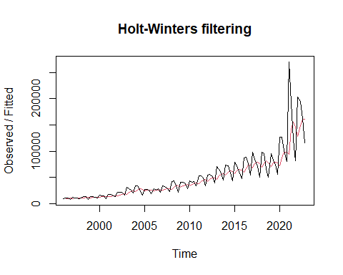

#Modelo de suavização exponencial de Holt

ajuste_holt=HoltWinters(pib, gamma=FALSE)

## Warning in HoltWinters(pib, gamma = FALSE): optimization difficulties: ERROR:  
## ABNORMAL_TERMINATION_IN_LNSRCH

ajuste_holt

## Holt-Winters exponential smoothing with trend and without seasonal component.  
##   
## Call:  
## HoltWinters(x = pib, gamma = FALSE)  
##   
## Smoothing parameters:  
## alpha: 0.1644466  
## beta : 0.06496063  
## gamma: FALSE  
##   
## Coefficients:  
## [,1]  
## a 158246.274  
## b 3683.811

fitted(ajuste_holt)

## xhat level trend  
## 1996 Q3 11351.72 10702.72 649.0024  
## 1996 Q4 11955.95 11309.67 646.2711  
## 1997 Q1 12068.11 11454.42 613.6917  
## 1997 Q2 12729.06 12112.48 616.5740  
## 1997 Q3 13152.30 12547.51 604.7810  
## 1997 Q4 13357.61 12777.20 580.4145  
## 1998 Q1 13309.99 12767.88 542.1052  
## 1998 Q2 13599.71 13073.00 526.7101  
## 1998 Q3 14231.84 13698.70 533.1407  
## 1998 Q4 14574.24 14052.74 521.5061  
## 1999 Q1 14014.26 13558.73 455.5375  
## 1999 Q2 14500.61 14043.19 457.4167  
## 1999 Q3 14780.56 14333.97 446.5917  
## 1999 Q4 14693.96 14279.90 414.0681  
## 2000 Q1 14482.36 14106.46 375.9036  
## 2000 Q2 15184.80 14788.97 395.8211  
## 2000 Q3 15586.39 15190.22 396.1732  
## 2000 Q4 15910.99 15519.19 391.8077  
## 2001 Q1 15306.15 14975.14 331.0138  
## 2001 Q2 16018.81 15664.52 354.2936  
## 2001 Q3 16599.97 16231.83 368.1317  
## 2001 Q4 16634.39 16286.62 347.7764  
## 2002 Q1 16464.05 16147.88 316.1722  
## 2002 Q2 17762.71 17386.61 376.1021  
## 2002 Q3 18799.29 18382.90 416.3901  
## 2002 Q4 19682.15 19237.30 444.8435  
## 2003 Q1 19559.92 19149.67 410.2533  
## 2003 Q2 21947.32 21416.46 530.8554  
## 2003 Q3 23749.19 23140.80 608.3849  
## 2003 Q4 24649.76 24023.55 626.2079  
## 2004 Q1 24545.22 23963.58 581.6334  
## 2004 Q2 26842.79 26156.49 686.3026  
## 2004 Q3 28885.04 28116.02 769.0126  
## 2004 Q4 28995.30 28266.47 728.8302  
## 2005 Q1 27598.97 26999.77 599.1993  
## 2005 Q2 28196.36 27597.27 599.0891  
## 2005 Q3 28616.41 28028.24 588.1677  
## 2005 Q4 28829.06 28263.80 565.2622  
## 2006 Q1 27799.53 27331.55 467.9828  
## 2006 Q2 28314.08 27843.25 470.8230  
## 2006 Q3 28414.85 27966.60 448.2506  
## 2006 Q4 28906.36 28455.47 450.8895  
## 2007 Q1 28211.79 27830.77 381.0181  
## 2007 Q2 29667.08 29220.53 446.5469  
## 2007 Q3 30647.93 30168.79 479.1386  
## 2007 Q4 30982.29 30511.98 470.3073  
## 2008 Q1 30101.34 29713.46 387.8830  
## 2008 Q2 32645.30 32125.90 519.3995  
## 2008 Q3 35028.71 34395.61 633.1011  
## 2008 Q4 35487.73 34865.25 622.4822  
## 2009 Q1 33803.26 33321.50 481.7624  
## 2009 Q2 35576.56 35016.02 560.5442  
## 2009 Q3 37074.84 36457.09 617.7440  
## 2009 Q4 37852.20 37224.72 627.4801  
## 2010 Q1 36949.93 36415.77 534.1687  
## 2010 Q2 38677.33 38070.37 606.9531  
## 2010 Q3 39579.29 38954.34 624.9480  
## 2010 Q4 40607.83 39958.27 649.5669  
## 2011 Q1 40086.69 39508.53 578.1554  
## 2011 Q2 43055.62 42331.63 723.9885  
## 2011 Q3 45666.16 44827.10 839.0646  
## 2011 Q4 47010.41 46140.53 869.8798  
## 2012 Q1 45585.51 44855.60 729.9025  
## 2012 Q2 47843.23 47020.14 823.0970  
## 2012 Q3 50010.46 49105.38 905.0865  
## 2012 Q4 51211.30 50288.18 923.1270  
## 2013 Q1 50025.29 49230.81 794.4731  
## 2013 Q2 54384.92 53372.98 1011.9415  
## 2013 Q3 57362.08 56230.26 1131.8159  
## 2013 Q4 58724.36 57578.48 1145.8737  
## 2014 Q1 57575.78 56569.87 1005.9167  
## 2014 Q2 61481.49 60298.69 1182.7985  
## 2014 Q3 64645.52 63341.87 1303.6498  
## 2014 Q4 64938.73 63696.71 1242.0148  
## 2015 Q1 62543.70 61523.53 1020.1616  
## 2015 Q2 66374.57 65182.96 1191.6100  
## 2015 Q3 68573.21 67320.17 1253.0369  
## 2015 Q4 68522.24 67348.74 1173.4948  
## 2016 Q1 65947.91 65003.03 944.8847  
## 2016 Q2 70703.29 69525.97 1177.3176  
## 2016 Q3 75012.08 73643.75 1368.3318  
## 2016 Q4 76607.35 75225.18 1382.1748  
## 2017 Q1 74040.26 72898.98 1141.2767  
## 2017 Q2 79361.92 77965.65 1396.2725  
## 2017 Q3 81640.98 80190.85 1450.1205  
## 2017 Q4 81120.34 79790.43 1329.9077  
## 2018 Q1 77047.45 76047.10 1000.3471  
## 2018 Q2 81654.97 80434.59 1220.3781  
## 2018 Q3 85229.96 83865.95 1364.0051  
## 2018 Q4 83306.81 82143.31 1163.4947  
## 2019 Q1 78708.46 77896.43 812.0331  
## 2019 Q2 82420.74 81431.80 988.9425  
## 2019 Q3 83640.82 82637.78 1003.0416  
## 2019 Q4 83190.05 82275.69 914.3617  
## 2020 Q1 79406.55 78778.75 627.8010  
## 2020 Q2 88209.39 87082.92 1126.4629  
## 2020 Q3 96054.39 94518.11 1536.2816  
## 2020 Q4 98516.30 96923.56 1592.7433  
## 2021 Q1 96975.21 95573.63 1401.5852  
## 2021 Q2 128664.25 125415.18 3249.0637  
## 2021 Q3 143039.76 139112.00 3927.7564  
## 2021 Q4 143405.86 139695.36 3710.5021  
## 2022 Q1 136261.27 133212.91 3048.3615  
## 2022 Q2 150947.20 147188.97 3758.2315  
## 2022 Q3 162388.78 158161.88 4226.9015  
## 2022 Q4 166466.57 162248.76 4217.8061

plot.ts(pib,ylab='Valores Observados/Ajustados',xlab='Tempo',main='')  
lines(fitted(ajuste_holt)[,1],lwd=1,col='red')

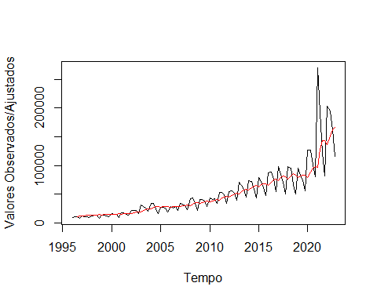

#Modelo de suavização exponencial de Holt-Winters (additive ou multiplicative)

ajuste_hw=HoltWinters(pib,seasonal = 'multiplicative')  
ajuste_hw

## Holt-Winters exponential smoothing with trend and multiplicative seasonal component.  
##   
## Call:  
## HoltWinters(x = pib, seasonal = "multiplicative")  
##   
## Smoothing parameters:  
## alpha: 0.656106  
## beta : 0.05846886  
## gamma: 1  
##   
## Coefficients:  
## [,1]  
## a 1.766363e+05  
## b 4.567402e+03  
## s1 1.627381e+00  
## s2 1.299161e+00  
## s3 9.311304e-01  
## s4 6.594281e-01

fitted(ajuste_hw)

## xhat level trend season  
## 1997 Q1 11731.277 10391.55 179.1536 1.1097920  
## 1997 Q2 11553.413 10929.35 200.1234 1.0380918  
## 1997 Q3 11884.825 11174.78 202.7726 1.0445853  
## 1997 Q4 8807.362 10740.98 165.5530 0.8075308  
## 1998 Q1 13435.031 11689.85 211.3524 1.1288803  
## 1998 Q2 11598.344 10990.93 158.1299 1.0402980  
## 1998 Q3 13203.413 12790.96 254.1300 1.0121366  
## 1998 Q4 11081.911 13005.75 251.8296 0.8358928  
## 1999 Q1 12181.343 11151.62 128.6968 1.0798759  
## 1999 Q2 14101.686 12500.84 200.0592 1.1102907  
## 1999 Q3 12648.475 12337.82 178.8307 1.0105317  
## 1999 Q4 9089.363 11924.22 144.1916 0.7531534  
## 2000 Q1 15989.861 13838.58 247.6912 1.1351383  
## 2000 Q2 15908.140 14292.61 259.7559 1.0931652  
## 2000 Q3 14146.661 14138.00 235.5286 0.9842161  
## 2000 Q4 12325.242 15060.87 275.7167 0.8036494  
## 2001 Q1 15775.572 13617.89 175.2262 1.1437280  
## 2001 Q2 16152.615 14773.96 232.5750 1.0763722  
## 2001 Q3 16112.614 15714.58 273.9737 1.0077593  
## 2001 Q4 11471.394 15065.28 219.9912 0.7504866  
## 2002 Q1 20765.253 17212.55 332.6765 1.1835274  
## 2002 Q2 20543.926 18270.82 375.1012 1.1017920  
## 2002 Q3 19161.626 19235.55 409.5765 0.9753881  
## 2002 Q4 17235.878 21193.06 500.0824 0.7945310  
## 2003 Q1 25976.959 21039.35 461.8555 1.2081631  
## 2003 Q2 27723.026 24147.31 616.5706 1.1194943  
## 2003 Q3 26634.494 25632.37 667.3501 1.0127291  
## 2003 Q4 20424.978 25511.35 621.2548 0.7815898  
## 2004 Q1 34238.739 26176.37 623.8139 1.2775560  
## 2004 Q2 31311.035 26853.92 626.9554 1.1393757  
## 2004 Q3 29992.939 29366.36 737.1978 0.9963254  
## 2004 Q4 21470.815 26896.93 549.7099 0.7822748  
## 2005 Q1 30570.100 23579.89 323.6252 1.2788958  
## 2005 Q2 26626.043 22373.95 234.1935 1.1777191  
## 2005 Q3 21638.089 22913.41 252.0422 0.9340671  
## 2005 Q4 19314.296 26561.03 450.5778 0.7150368  
## 2006 Q1 34351.888 27386.34 472.4879 1.2330701  
## 2006 Q2 29400.426 24513.84 276.9105 1.1859432  
## 2006 Q3 23116.616 23020.76 173.4207 0.9966560  
## 2006 Q4 19611.193 26844.67 386.8606 0.7201650  
## 2007 Q1 34660.742 29740.98 533.5857 1.1448797  
## 2007 Q2 34846.986 30094.18 523.0388 1.1381498  
## 2007 Q3 31861.274 29389.93 451.2805 1.0676937  
## 2007 Q4 21782.539 28587.59 377.9825 0.7520149  
## 2008 Q1 35053.322 30260.28 453.6829 1.1412828  
## 2008 Q2 39682.267 34944.74 701.0516 1.1132384  
## 2008 Q3 40262.365 37771.46 825.3370 1.0431529  
## 2008 Q4 27123.085 34679.80 596.3147 0.7688795  
## 2009 Q1 38267.631 31173.14 356.4179 1.2137068  
## 2009 Q2 38452.316 33102.87 448.4082 1.1460759  
## 2009 Q3 34841.281 34970.32 531.3778 0.9813975  
## 2009 Q4 27386.865 37604.24 654.3108 0.7158365  
## 2010 Q1 50493.611 39844.56 747.0433 1.2439422  
## 2010 Q2 43987.057 37041.78 539.4889 1.1704517  
## 2010 Q3 36335.187 35549.12 420.6715 1.0101584  
## 2010 Q4 29380.735 39573.71 631.3885 0.7307714  
## 2011 Q1 53346.475 44283.23 869.8324 1.1814586  
## 2011 Q2 52515.006 45370.60 882.5517 1.1353821  
## 2011 Q3 50737.279 47011.88 926.9132 1.0583763  
## 2011 Q4 36334.305 46583.35 847.6620 0.7660454  
## 2012 Q1 54576.312 45352.10 726.1107 1.1844277  
## 2012 Q2 53411.191 45930.41 717.4690 1.1449864  
## 2012 Q3 50697.834 47855.32 788.0665 1.0422349  
## 2012 Q4 37455.811 49273.79 824.9257 0.7476401  
## 2013 Q1 62094.135 51601.23 912.7758 1.1824300  
## 2013 Q2 67629.452 57113.12 1181.6805 1.1601285  
## 2013 Q3 61133.535 57150.69 1114.7859 1.0492240  
## 2013 Q4 43838.961 56729.99 1025.0079 0.7590505  
## 2014 Q1 74448.162 59297.00 1115.1668 1.2323373  
## 2014 Q2 70427.255 60244.79 1105.3806 1.1479554  
## 2014 Q3 66081.441 62703.12 1184.4862 1.0343389  
## 2014 Q4 46343.953 59316.92 917.2431 0.7693965  
## 2015 Q1 72835.831 58381.11 808.8971 1.2305428  
## 2015 Q2 73427.077 62259.67 988.3773 1.1609382  
## 2015 Q3 62985.526 62512.06 945.3444 0.9925639  
## 2015 Q4 47743.155 62229.03 873.5228 0.7565963  
## 2016 Q1 80039.939 62563.82 842.0242 1.2623431  
## 2016 Q2 78993.527 67390.35 1074.9934 1.1537739  
## 2016 Q3 73979.618 73919.20 1393.8743 0.9822945  
## 2016 Q4 59014.057 76868.23 1484.8024 0.7531816  
## 2017 Q1 97957.225 74034.66 1232.3121 1.3014636  
## 2017 Q2 91646.341 75243.45 1230.9365 1.1983927  
## 2017 Q3 72971.806 72508.55 999.0589 0.9927109  
## 2017 Q4 53081.501 71799.78 899.2039 0.7301547  
## 2018 Q1 92289.987 70172.59 751.4889 1.3012503  
## 2018 Q2 86759.577 73623.98 909.3488 1.1640373  
## 2018 Q3 78837.104 79234.36 1184.2130 0.9803345  
## 2018 Q4 52177.206 72135.03 699.8834 0.7163763  
## 2019 Q1 95249.522 71212.99 605.0513 1.3262618  
## 2019 Q2 86937.103 71827.70 605.6161 1.2002364  
## 2019 Q3 65588.820 70685.94 503.4489 0.9213286  
## 2019 Q4 55948.239 78133.10 909.4400 0.7078244  
## 2020 Q1 106586.999 79428.80 932.0239 1.3263553  
## 2020 Q2 108401.809 90006.64 1496.0042 1.1846849  
## 2020 Q3 99944.501 101566.13 2084.4047 0.9642449  
## 2020 Q4 75745.654 104599.95 2139.9157 0.7096285  
## 2021 Q1 159210.137 111248.31 2403.5196 1.4008585  
## 2021 Q2 213025.296 165503.29 5435.2155 1.2462101  
## 2021 Q3 159631.476 159972.83 4794.0647 0.9688322  
## 2021 Q4 103697.551 139758.08 3331.8276 0.7247021  
## 2022 Q1 203985.979 122923.29 2152.7085 1.6308963  
## 2022 Q2 152205.636 124563.72 2122.7561 1.2014356  
## 2022 Q3 134715.994 149958.06 3483.4196 0.8779633  
## 2022 Q4 117997.589 173485.21 4655.3533 0.6623848

plot(pib,ylim=c(min(pib),max(pib)),ylab='Valores Observados/Ajustados',xlab='Tempo',main='')  
lines(fitted(ajuste_hw)[,1],lwd=1,col='red')

