Technical Advisory Report
WINNEST - Breeding Intelligence Platform
Project Innovate | Information Technology Program | Year 1 Period 4

Item | Details
Project | WINNEST - Breeding Intelligence Platform
Client / Context | Racing pigeon breeders and loft staff
Team | Team IT-1A
Author | Oleksii Khomiak
Institution | NHL Stenden University of Applied Sciences
Version | 1.0
Date | 09 June 2026

Purpose of this report
This document provides professional technical advice for developing WINNEST from a project concept into a reliable MVP. It combines user analysis, functional scope, technical design, database reasoning, feasibility, risks, and recommendations for further development.

Prepared for assessment and project documentation purposes

Table of Contents
Section | Title
1 | Executive Summary
2 | Introduction
3 | Advisory Basis and Project Context
4 | User and Communication Analysis
5 | Problem Analysis
6 | Functional Scope and MVP Requirements
7 | Technical Design Advice
8 | Database and Data Model Advice
9 | Analytics and Breeding Intelligence Logic
10 | Feasibility Analysis
11 | Research Comparison and Innovation
12 | Development Process and Quality Advice
13 | Challenges, Risks and Solutions
14 | Recommendations and Roadmap
15 | Conclusion
Appendix A | ERD and Data Dictionary
Appendix B | Full Requirements Matrix
Appendix C | Sources

1. Executive Summary
WINNEST is a web-based breeding intelligence platform designed for racing pigeon breeders. Its main purpose is to replace fragmented handwritten records with a structured digital system that connects breeding pairs, nest activity, egg and hatch data, youngster development, health records, and race performance. The final value of the platform is not only record keeping, but improved breeding decision-making through clear analytics and pair performance insights.
The main problem is that many breeders collect important data, but the data is often spread across notebooks, spreadsheets, memory, and separate racing information. This makes it difficult to identify which breeding pairs consistently produce strong youngsters. WINNEST should solve this by centralizing the data lifecycle and translating it into understandable breeding intelligence.
Main recommendation
Develop WINNEST as a focused MVP around the breeding lifecycle: Pair Management -> Nest Management -> Youngster Registration -> Health and Race Records -> Analytics Dashboard. Avoid expanding too early into non-core features. The strongest technical decision is to build a clean relational data model first, because the quality of the analytics depends directly on the quality of the relationships between pairs, eggs, pigeons, and performances.

The recommended technical direction is a modular web application with a clear separation between frontend, backend/API, and database. The database should remain relational because the project depends on structured relationships and historical tracking. The system should include validation, role-based access, consistent data-entry forms, and a simple analytics layer for hatch rate, survival rate, race success, and pair performance scoring.

2. Introduction

2.1 Background
Racing pigeon breeding is a data-intensive activity. Breeders need to track parent pairs, egg dates, hatch dates, youngsters, health information, and race performance. Traditionally, this information can be stored in handwritten records or informal spreadsheets. These methods can work for small lofts, but they become difficult to maintain when the breeder wants to compare multiple breeding seasons and evaluate which pairs produce the best results.
WINNEST addresses this context by creating a breeding intelligence platform. The project documentation defines the product as a system that digitizes breeding records and connects breeding data with performance tracking. The platform is aimed at loft owners and loft staff, with the goal of making breeding data easier to manage and analyze.

2.2 Problem Statement
The core problem is not only the absence of digital records. The deeper problem is that breeding data is difficult to interpret when it is not connected. A youngster record is much more valuable when it is linked to its parents, nest record, hatch date, health record, and later race performance. Without these links, the breeder must manually search through notes and make decisions based on incomplete information.
- Breeding records are often fragmented and difficult to compare across seasons.
- Parent-child relationships are hard to follow when data is stored manually.
- Race performance is often separated from breeding history.
- It is difficult to calculate hatch rate, survival rate, or pair performance consistently.
- Loft staff may enter data differently without a structured workflow.

2.3 Aim of the Report
The aim of this Technical Advisory Report is to give practical and technical advice for developing WINNEST into a professional MVP. The report explains what should be built first, why the chosen technical structure is suitable, what risks should be managed, and how the project can be improved after the MVP.

2.4 Scope
This report focuses on the project concept, users, functional requirements, technical design, database design, analytics logic, feasibility, risks, development process, and recommendations. It does not include full source code, detailed UI mockups, or a complete test report, but it gives enough technical direction to guide development and assessment.

3. Advisory Basis and Project Context

3.1 What a Technical Advisory Report Should Do
A technical advisory report should be written for the reader and should help the reader make a decision. It should explain the problem, analyze possible approaches, justify technical choices, and finish with clear recommendations. For a software project, the report should also connect user needs with system design, because technical decisions only make sense when they support the actual workflow of the users.
For WINNEST, the reader is likely a teacher, project evaluator, client representative, or future developer. Therefore, the report must be clear enough for non-developers to understand, but detailed enough to show technical reasoning.

3.2 Project Inputs Used
Input | How it was used
Previous Technical Advisory Report example | Used as a structure reference for sections such as summary, introduction, problem statement, user analysis, requirements, system design, and conclusion.
WINNEST Project Documentation Overview | Used as the main project source for goals, workflows, responsibilities, core features, functional requirements, and deliverables.
Entity Relationship Diagram document | Used to analyze the data model, entities, relationships, and database advice.
External technical report guidance | Used to shape the professional report structure and advisory style.

4. User and Communication Analysis

4.1 Primary Users
User role | Needs | Main tasks in WINNEST
Loft Owner | Clear overview of breeding performance, reliable data, decision support, quick comparison between pairs. | Manage breeding pairs, review analytics, monitor youngsters, evaluate pair performance, plan future breeding decisions.
Loft Staff | Simple data-entry flow, low risk of mistakes, clear forms, easy updates during daily work. | Record eggs, hatch dates, youngsters, health notes, treatments, and breeding activity.
Teacher / Tester | Evidence that the project is technically logical and usable as an MVP. | Review documentation, test functionality, evaluate technical choices and product demonstration.

4.2 Communication Problem
The project includes a communication problem between raw breeding data and useful breeding decisions. Breeders may already know many details about their birds, but the system must translate these details into structured records and simple analytics. This means the interface should not only store data; it should guide the user through the real-world breeding lifecycle.

4.3 Main Message for the Client
Main message
WINNEST should focus on transforming breeding records into breeding intelligence. The system should make it easy to enter data, difficult to break relationships, and simple to interpret pair performance.

5. Problem Analysis
Problem area | Impact | Technical implication
Handwritten or scattered records | Important breeding history can be lost or hard to compare. | Use a centralized database with structured entities and mandatory relationships.
Separated breeding and race data | A breeder cannot easily know which pair produced successful racers. | Link youngsters to parent pairs and link race performance to individual pigeons.
Inconsistent data entry | Analytics become unreliable when fields are missing or entered differently. | Use validation rules, required fields, dropdowns, and controlled statuses.
Too many possible features | The project may become too large for the timeline. | Prioritize MVP features and postpone advanced modules.
Low technical users | Complex screens may reduce adoption. | Use simple navigation, dashboard summaries, and clear workflows.

5.1 Root Cause
The root cause is that breeding decisions depend on connected historical data, but traditional record methods do not maintain these connections in a reliable and searchable way. Therefore, the technical solution must prioritize data relationships and user workflow over visual complexity.

6. Functional Scope and MVP Requirements
The recommended MVP should include the minimum set of features needed to complete the breeding intelligence workflow. Every feature should support one of five core steps: pair management, nest management, youngster registration, health/race tracking, and analytics.

6.1 MVP Feature Set
Feature | Purpose | Priority
User login and role access | Protect breeder data and allow different responsibilities for owner and staff. | High
Dashboard overview | Provide quick access to rankings, recent activity, statistics, and alerts. | High
Pair management | Create and manage sire/dam pairings and breeding history. | High
Nest and egg records | Record breeding rounds, eggs, hatch dates, and statuses. | High
Youngster management | Register youngsters and connect them to parent pair and egg history. | High
Health records | Track vaccinations, treatments, conditions, and notes. | Medium
Race performance records | Store race participation, positions, speed, prize status, and conditions. | Medium
Analytics screen | Calculate pair rankings, hatch rate, survival rate, and performance score. | High
Search and filtering | Help users find pigeons, pairs, records, and performances quickly. | Medium
Export / report generation | Allow breeders to share or archive performance insights. | Future

6.2 Functional Requirements
ID | Requirement | Advisory note
FR-01 | User can add breeding pairs. | Must require sire and dam selection and prevent invalid empty pairs.
FR-02 | User can edit breeding pair information. | Keep historical records; avoid deleting history when pair data changes.
FR-03 | User can record eggs and hatch dates. | Use date validation and egg status options.
FR-04 | User can register youngsters. | Youngsters should be linked to parent pair and egg when possible.
FR-05 | User can record health information. | Use structured health types plus free-text notes.
FR-06 | User can record race performance. | Race results should support future analytics.
FR-07 | System stores breeding history. | This is a core value of the platform and should be protected from accidental deletion.
FR-08 | System displays pair statistics. | Statistics should be transparent and explain how they are calculated.
FR-09 | System displays breeding analytics. | Start with simple metrics before complex predictions.
FR-10 | System provides dashboard overview. | The dashboard should show only the most important insights.
FR-11 | User can search and filter records. | Important for larger lofts with many pigeons and seasons.
FR-12 | System links youngsters to parent pairs. | This is essential for breeding intelligence and database integrity.

7. Technical Design Advice

7.1 Recommended Architecture
WINNEST should be developed as a modular web application with three main layers: frontend, backend/API, and relational database. This separation makes the system easier to test, maintain, and extend. It also allows the team to divide work between UI development, backend logic, and database design.
Layer | Responsibility | Recommended advice
Frontend | Screens, forms, navigation, dashboard visualizations. | Keep forms simple and consistent. Use reusable components for tables, cards, filters, and detail pages.
Backend / API | Business logic, validation, authentication, database communication. | Place analytics calculations and data validation in the backend to keep data consistent.
Database | Stores users, pigeons, pairs, breeding records, eggs, health records, and race performances. | Use relational tables with foreign keys because the project depends on real-world relationships.
VCS / GitHub | Version control and collaboration. | Use branches, clear commit messages, pull requests or merge checks, and documentation of major changes.

7.2 Technology Decision Reasoning
The project documentation mentions a web-based direction and gives examples such as a frontend, backend, and MySQL database. For this project, MySQL is a suitable database option because the data is highly structured and relational. A backend API is recommended because it can protect the database from direct frontend access and centralize validation rules.
Decision | Reasoning | Risk if ignored
Use a relational database | Breeding data has clear one-to-many and many-to-one relationships. | Analytics may become inaccurate or difficult to implement.
Use backend validation | Users may enter incorrect dates, duplicate ring numbers, or incomplete pair records. | Bad data will reduce trust in the system.
Use role-based access | Loft owners and staff have different responsibilities. | Staff may accidentally change sensitive analytics or pair settings.
Use modular screens | The system includes multiple connected workflows. | Code becomes difficult to maintain and expand.
Keep MVP focused | The project timeline is limited. | The team may deliver many unfinished features instead of a working core.

7.3 Suggested API Structure
Endpoint area | Example endpoints | Purpose
Authentication | POST /login, POST /logout | User access and session/token management.
Pigeons | GET /pigeons, POST /pigeons, GET /pigeons/{id} | Manage individual birds and profiles.
Breeding pairs | GET /pairs, POST /pairs, PUT /pairs/{id} | Create and edit sire/dam pairings.
Breeding records | GET /breeding-records, POST /breeding-records | Track breeding rounds and seasons.
Eggs | POST /eggs, PUT /eggs/{id} | Record lay date, expected hatch date, actual hatch date, and status.
Health | POST /health-records, GET /pigeons/{id}/health | Track health events for each pigeon.
Races | POST /race-performances, GET /pigeons/{id}/races | Record race results and performance history.
Analytics | GET /analytics/dashboard, GET /analytics/pairs | Return calculated indicators for dashboard and pair ranking.

8. Database and Data Model Advice
The database is the most important technical foundation of WINNEST. The ERD shows a lifecycle model where a user owns pigeons and creates breeding pairs; breeding pairs produce breeding records; breeding records contain eggs; eggs may hatch into pigeons; pigeons can then receive health records and race performance records.
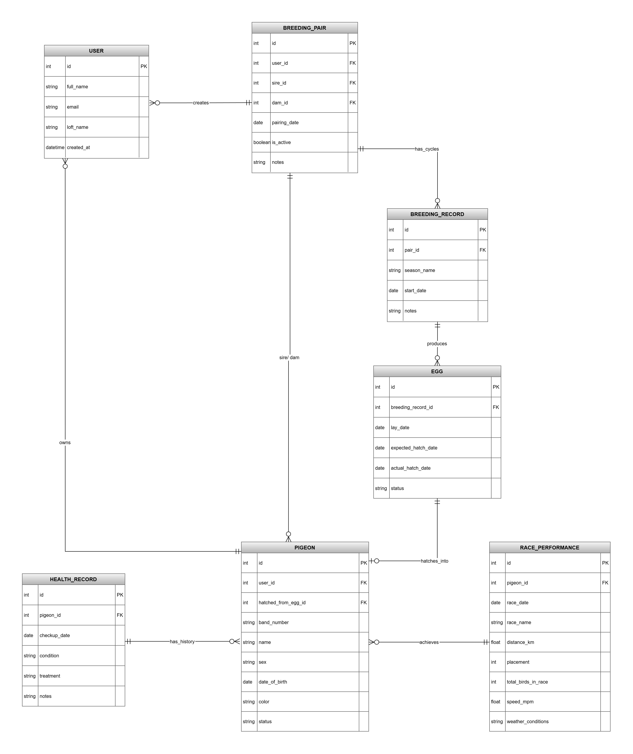
Figure 1. Entity Relationship Diagram for WINNEST breeding lifecycle.

8.1 Core Entities
Entity | Purpose | Important fields / relationships
USER | Stores account details for breeder or staff user. | Owns pigeons and breeding pairs. Should include role and secure password handling.
PIGEON | Represents an individual bird. | Belongs to user; can be sire/dam in pairs; may originate from an egg; has health and race records.
BREEDING_PAIR | Represents a sire and dam combination. | Links sire_id and dam_id to PIGEON; belongs to a user; has breeding records.
BREEDING_RECORD | Represents a breeding round or season for a pair. | Belongs to breeding pair; contains multiple eggs.
EGG | Tracks egg lifecycle. | Belongs to breeding record; status can be laid, hatched, failed, unknown; may hatch into one pigeon.
HEALTH_RECORD | Tracks health events for a pigeon. | Belongs to pigeon; includes date, condition, treatment, vet notes.
RACE_PERFORMANCE | Stores race results for a pigeon. | Belongs to pigeon; includes race details, position, speed, prize/finalist status.

8.2 Database Integrity Recommendations
- Use primary keys for every table and foreign keys for all relationships shown in the ERD.
- Make ring_number unique per user or per loft to prevent duplicate bird profiles.
- Do not allow a breeding pair without both sire_id and dam_id.
- Prevent sire_id and dam_id from being the same pigeon.
- Use controlled status values for eggs and pigeons to keep analytics consistent.
- Use soft delete or archive for important historical records instead of permanent deletion.
- Index foreign keys such as user_id, pigeon_id, pair_id, breeding_record_id to improve dashboard performance.

9. Analytics and Breeding Intelligence Logic
WINNEST should start with simple, explainable analytics. The goal is not to create an advanced artificial intelligence system immediately, but to provide breeders with reliable indicators that support decisions.
Metric | Suggested formula | Meaning
Hatch Rate | hatched eggs / total eggs x 100 | Shows how successful a pair is at producing hatchlings.
Survival Rate | surviving youngsters / hatched youngsters x 100 | Shows how many hatched birds survive to a defined stage.
Race Participation Rate | youngsters with race records / total youngsters x 100 | Shows how many offspring reached race tracking.
Prize Rate | prize-winning youngsters / raced youngsters x 100 | Shows performance quality among raced offspring.
Pair Performance Score | weighted score based on hatch rate, survival rate, race results, prize winners, and consistency | Creates a ranking for breeding pairs.

9.1 Suggested Pair Performance Score
A transparent MVP scoring model could use weights. The exact weights should be confirmed with real breeders, but the following model is practical for a first version:
Component | Weight | Reasoning
Hatch success | 25% | A strong pair should produce viable eggs.
Youngster survival | 25% | Survival is important for practical breeding success.
Race performance | 30% | Racing results connect breeding choices with the sport outcome.
Prize/finalist results | 10% | Rewards high-quality offspring.
Consistency across rounds | 10% | Avoids ranking a pair too highly based on one lucky result.
Important limitation
A performance score should support decisions, not replace breeder judgement. The system should show how the score is calculated so users can trust it.

10. Feasibility Analysis
Feasibility type | Assessment | Advice
Technical feasibility | Achievable for a Year 1 web project if the scope stays focused on CRUD, relational database, and basic analytics. | Use proven technologies and avoid complex AI features in the MVP.
Time feasibility | Limited because the project timeline includes planning, design, development, testing, and documentation. | Prioritize dashboard, pairs, eggs, youngsters, and analytics before optional features.
Resource feasibility | The team can divide work across frontend, backend, database, documentation, and testing. | Use a clear task board and weekly progress checks.
Operational feasibility | The product is useful if screens match real breeding workflow and remain simple for non-technical users. | Test forms with real or realistic breeder scenarios.
Data feasibility | Analytics require clean and connected data. | Add validation and avoid free-text-only data for important fields.

10.1 MVP Feasibility Decision
The project is feasible if WINNEST is treated as a breeding management and basic analytics MVP. It becomes less feasible if the team tries to build complex prediction, mobile apps, payment systems, advanced user management, and full reporting in the same period. The advisory recommendation is to deliver one stable workflow before expanding.

11. Research Comparison and Innovation
The innovation of WINNEST is its focus on breeding intelligence rather than only racing results. Existing approaches may include handwritten breeding records, spreadsheets, and race-focused systems. These methods can store information, but they do not always connect breeding pairs, eggs, youngsters, health, and race performance into one decision-making workflow.
Alternative | Strengths | Weaknesses | WINNEST advantage
Handwritten records | Simple, familiar, no technical setup. | Hard to search, compare, back up, or analyze. | Digital structure and searchable breeding history.
Spreadsheets | Flexible and cheap. | Easy to make mistakes; relationships and analytics require manual work. | Controlled forms, relationships, and automated metrics.
Race-focused systems | Good for race results and performance tracking. | May not focus deeply on breeding lifecycle and pair analytics. | Connects breeding pairs to offspring and later performance.
Generic animal management tools | Can store animal profiles. | May not match pigeon breeding workflow. | Specific to racing pigeon breeding lifecycle.

12. Development Process and Quality Advice

12.1 Recommended Workflow
- Confirm final MVP scope and avoid adding new features without priority review.
- Finalize the ERD and database constraints before building all screens.
- Create backend endpoints for core entities and test them with sample data.
- Build frontend screens according to the breeding lifecycle workflow.
- Connect dashboard analytics only after the main records are stored correctly.
- Test with realistic examples: at least two pairs, multiple eggs, hatched and failed eggs, health records, and race results.
- Document setup, Git workflow, source code structure, and user manual.

12.2 Testing Advice
Test area | Example test
Validation tests | Try to create a pair without sire or dam; try duplicate ring numbers; try impossible hatch dates.
Relationship tests | Register a youngster from an egg and check if it appears under the correct parent pair.
Analytics tests | Enter known numbers of eggs and hatched youngsters and verify hatch rate calculation.
Role tests | Check if loft staff can enter daily records without changing owner-level settings.
UI tests | Ask a non-team user to add a pair and register an egg without explanation.

13. Challenges, Risks and Solutions
Risk / challenge | Impact | Solution
Scope becomes too large | Incomplete final product. | Use MVP priority and move non-core features to future roadmap.
ERD changes late in the project | Backend and frontend may break. | Freeze core data model after review; document changes carefully.
Incorrect relationships between eggs, pigeons, and pairs | Analytics become unreliable. | Use foreign keys and test lifecycle scenarios.
Weak data validation | Bad data enters the system. | Add required fields, dropdown statuses, date rules, and unique constraints.
Dashboard becomes too complex | Users may not understand the product value. | Start with simple cards and clear metrics.
Team coordination issues | Merge conflicts and duplicated work. | Use Git workflow, tasks, meetings, and assigned responsibilities.
Limited user testing | Product may not match real breeder habits. | Use realistic breeder scenarios and collect feedback early.

14. Recommendations and Roadmap

14.1 Final Recommendations
- Build the MVP around the breeding lifecycle workflow instead of separate disconnected pages.
- Treat the database as the project foundation and protect relationships with foreign keys and validation.
- Start analytics with transparent formulas that users can understand.
- Design the dashboard as a decision-support page, not just a decorative overview.
- Keep staff data-entry screens simple and fast, because daily use determines whether the system succeeds.
- Use realistic sample data for testing and presentation to show the full value of breeding intelligence.
- Document technical decisions, known limitations, and future improvements honestly.

14.2 Roadmap
Stage | Timeframe | Focus
MVP completion | Project period | Core CRUD, breeding lifecycle, dashboard, basic analytics, user manual, documentation.
Improvement phase | After MVP | Better filtering, export reports, improved analytics explanations, more user testing.
Future product phase | Long term | Mobile-friendly offline data entry, advanced breeding predictions, integration with race result sources, multi-loft support.

15. Conclusion
WINNEST is a strong project idea because it solves a real information problem in racing pigeon breeding. The project becomes valuable when it connects breeding pairs, nest activity, eggs, youngsters, health records, and race performance into one understandable workflow. The technical success of the platform depends on a clear relational database, simple user flows, reliable validation, and transparent analytics.
The most important advice is to avoid building the project as a collection of separate pages. WINNEST should be built as a lifecycle system where every record contributes to breeding intelligence. If the team focuses on the MVP workflow, protects the data model, and presents analytics clearly, the project can become a professional and convincing final product.

Appendix A - ERD and Data Dictionary
The ERD represents the full breeding lifecycle. The following data dictionary summarizes the recommended database structure. Field names may be adjusted to match the final implementation, but the relationships should remain consistent.
Table | Suggested key fields | Notes
users | id, first_name, last_name, email, password_hash, role, created_at | Use password_hash instead of storing plain passwords.
pigeons | id, user_id, name, ring_number, sex, color, status, date_of_birth, hatched_from_egg_id | ring_number should be unique within a user/loft.
breeding_pairs | id, user_id, sire_id, dam_id, pairing_date, status | sire_id and dam_id reference pigeons.
breeding_records | id, pair_id, season_year, round_number, start_date, notes | Groups eggs by pair and breeding round.
eggs | id, breeding_record_id, lay_date, expected_hatch_date, actual_hatch_date, status | Status supports hatch rate and failed egg tracking.
health_records | id, pigeon_id, check_date, condition, treatment, notes | Supports health history.
race_performances | id, pigeon_id, race_date, race_name, distance_km, position, speed, prize_status, weather_conditions | Supports performance analytics.

Appendix B - Full Requirements Matrix
Requirement | MVP? | Acceptance check
Add and edit breeding pairs | Yes | A user can create a pair with sire and dam and later view its history.
Record nest activity and eggs | Yes | A breeding record can contain several eggs with dates and status.
Register youngsters | Yes | A youngster can be linked to an egg and parent pair.
Record health information | Yes | A pigeon profile can show multiple health records.
Record race performance | Yes | A pigeon profile can show multiple race results.
Dashboard analytics | Yes | Dashboard shows pair statistics, hatch rate, survival rate, and recent activity.
Search and filter | Recommended | Users can search pigeons or pairs by important fields.
Advanced predictions | No | Postponed until enough historical data exists.
Export report | Future | Can be added after MVP if time allows.

Appendix C - Sources
- Project source: Technical Advisory Report: Recipe App, version 2.0, 30-03-2026. Used as formatting and structure reference.
- Project source: WINNEST Project Documentation Overview, Team IT-1A, NHL Stenden University of Applied Sciences, Year 1 Period 4, 2025-2026.
- Project source: Entity Relationship Diagram document for WINNEST.
- IET. A Guide to Technical Report Writing. Used for reader-focused, concise, well-organized technical reporting principles.
- University of Melbourne, Academic Skills. Technical reports. Used for common structure: title page, summary, contents, introduction, body, figures/tables, conclusion.
- Scribbr. Purpose and structure of an advisory report. Used for advisory logic: problem, recommendation, justification, implementation steps, and sources.

