Google Cloud Fundamentals: Getting Started with GKE

35 minutesFree

**Overview**

In this lab, you create a Google Kubernetes Engine cluster containing several containers, each containing a web server. You place a load balancer in front of the cluster and view its contents.

**Objectives**

In this lab, you learn how to perform the following tasks:

* Provision a [Kubernetes](http://kubernetes.io/) cluster using [Kubernetes Engine.](https://cloud.google.com/container-engine)
* Deploy and manage Docker containers using kubectl.

**Task 1. Sign in to the Google Cloud**

For each lab, you get a new Google Cloud project and set of resources for a fixed time at no cost.

1. Sign in to Qwiklabs using an **incognito window**.
2. Note the lab's access time (for example, 1:15:00), and make sure you can finish within that time.  
   There is no pause feature. You can restart if needed, but you have to start at the beginning.
3. When ready, click **Start lab**.
4. Note your lab credentials (**Username** and **Password**). You will use them to sign in to the Google Cloud Console.
5. Click **Open Google Console**.
6. Click **Use another account** and copy/paste credentials for **this** lab into the prompts.  
   If you use other credentials, you'll receive errors or **incur charges**.
7. Accept the terms and skip the recovery resource page.

**Note:** Do not click **End Lab** unless you have finished the lab or want to restart it. This clears your work and removes the project.

**Task 2. Confirm that needed APIs are enabled**

1. Make a note of the name of your Google Cloud project. This value is shown in the top bar of the Google Cloud Console. It will be of the form qwiklabs-gcp- followed by hexadecimal numbers.
2. In the Google Cloud Console, on the **Navigation menu** (Navigation menu icon), click **APIs & Services**.
3. Scroll down in the list of enabled APIs, and confirm that both of these APIs are enabled:

* Kubernetes Engine API
* Container Registry API

If either API is missing, click **Enable APIs and Services** at the top. Search for the above APIs by name and enable each for your current project. (You noted the name of your GCP project above.)

**Task 3. Start a Kubernetes Engine cluster**

1. In Google CLoud console, on the top right toolbar, click the **Activate Cloud Shell** button.

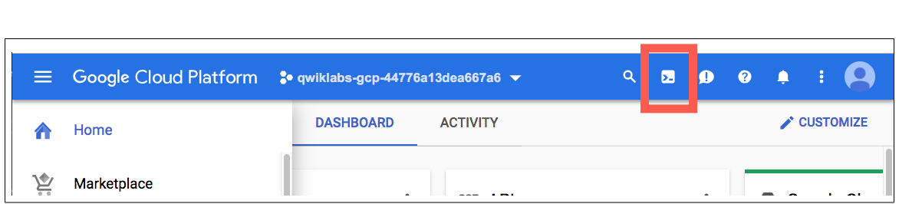

1. Click **Continue**.
2. For convenience, place the zone that Qwiklabs assigned to you into an environment variable called MY_ZONE. At the Cloud Shell prompt, type this partial command:

export MY_ZONE=

Copied!

content_copy

followed by the zone that Qwiklabs assigned to you. Your complete command will look similar to this:

export MY_ZONE=us-central1-a

Copied!

content_copy

1. Start a Kubernetes cluster managed by Kubernetes Engine. Name the cluster **webfrontend** and configure it to run 2 nodes:

gcloud container clusters create webfrontend --zone $MY_ZONE --num-nodes 2

Copied!

content_copy

It takes several minutes to create a cluster as Kubernetes Engine provisions virtual machines for you.

1. After the cluster is created, check your installed version of Kubernetes using the kubectl version command:

kubectl version

Copied!

content_copy

The gcloud container clusters create command automatically authenticated kubectl for you.

1. View your running nodes in the GCP Console. On the **Navigation menu** (Navigation menu icon), click **Compute Engine > VM Instances**.

Your Kubernetes cluster is now ready for use.

Click *Check my progress* to verify the objective.

Start a Kubernetes Engine cluster

Check my progress

**Task 4. Run and deploy a container**

1. From your Cloud Shell prompt, launch a single instance of the nginx container. (Nginx is a popular web server.)

kubectl create deploy nginx --image=nginx:1.17.10

Copied!

content_copy

In Kubernetes, all containers run in pods. This use of the kubectl create command caused Kubernetes to create a deployment consisting of a single pod containing the nginx container. A Kubernetes deployment keeps a given number of pods up and running even in the event of failures among the nodes on which they run. In this command, you launched the default number of pods, which is 1.

**Note:** If you see any deprecation warning about future versions, you can simply ignore it for now and can proceed further.

1. View the pod running the nginx container:

kubectl get pods

Copied!

content_copy

1. Expose the nginx container to the Internet:

kubectl expose deployment nginx --port 80 --type LoadBalancer

Copied!

content_copy

Kubernetes created a service and an external load balancer with a public IP address attached to it. The IP address remains the same for the life of the service. Any network traffic to that public IP address is routed to pods behind the service: in this case, the nginx pod.

1. View the new service:

kubectl get services

Copied!

content_copy

You can use the displayed external IP address to test and contact the nginx container remotely.

It may take a few seconds before the **External-IP** field is populated for your service. This is normal. Just re-run the kubectl get services command every few seconds until the field is populated.

1. Open a new web browser tab and paste your cluster's external IP address into the address bar. The default home page of the Nginx browser is displayed.
2. Scale up the number of pods running on your service:

kubectl scale deployment nginx --replicas 3

Copied!

content_copy

Scaling up a deployment is useful when you want to increase available resources for an application that is becoming more popular.

1. Confirm that Kubernetes has updated the number of pods:

kubectl get pods

Copied!

content_copy

1. Confirm that your external IP address has not changed:

kubectl get services

Copied!

content_copy

1. Return to the web browser tab in which you viewed your cluster's external IP address. Refresh the page to confirm that the nginx web server is still responding.

Click *Check my progress* to verify the objective.

Run and deploy a container

Check my progress

**Congratulations!**

In this lab, you configured a Kubernetes cluster in Kubernetes Engine. You populated the cluster with several pods containing an application, exposed the application, and scaled the application.

**End your lab**

When you have completed your lab, click **End Lab**. Google Cloud Skills Boost removes the resources you’ve used and cleans the account for you.

You will be given an opportunity to rate the lab experience. Select the applicable number of stars, type a comment, and then click **Submit**.