Programming Project I - Small Sample Examples

Individual Route Planning Tool

DA 2024/2025 Instructors Team

Departamento de Engenharia Informática (DEI)/Departamento de Ciências de Computadores (DCC)
Faculdade de Eng. da Univ. do Porto (FEUP)/Faculdade de Ciências da Univ. do Porto (FCUP)

Spring 2025

Due Date: March 30, 2025, at 23:59 (PT time)

Description:
This document includes a series of small project 1 sample data sets or examples you can use to validade your algorithm implementation. In Figure 1 below you can find a diagram of a simple data set with 8 nodes representing specific locations of the city of Porto. Dashes edges correspond to walking distance whereas full edges correspond to segments where you can drive. The figures associated with each edge denote travel time.

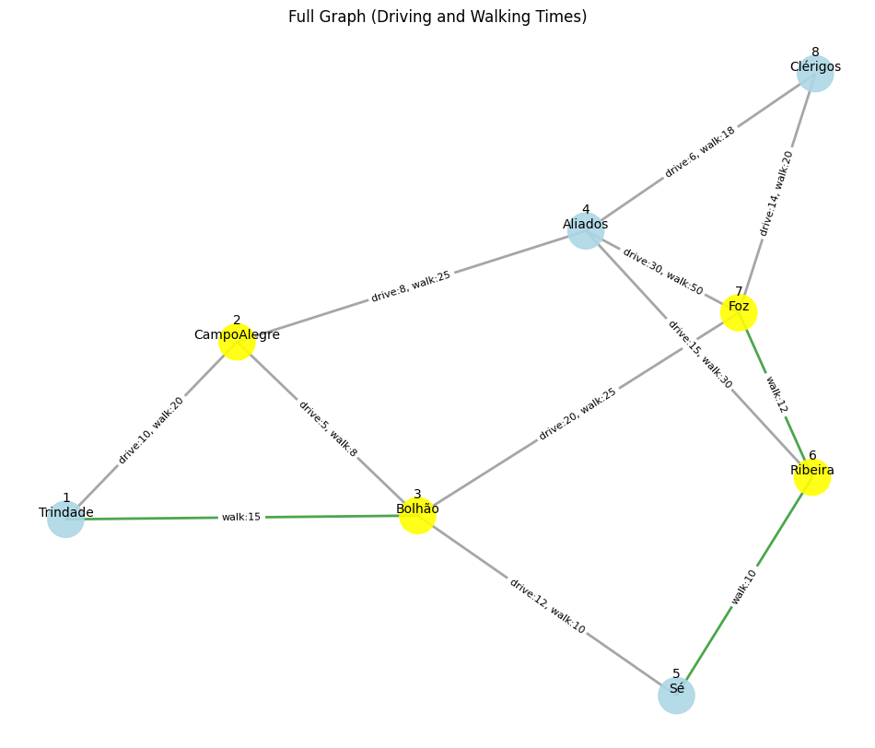

For this example graph we now indicate the correct output(s) for each specific routing problem.

Independent Route Planning

Determine the best (fastest) route between a source and destination

Input:
Source: 3
Destination: 8
Output:
Fastest Driving Route: [3, 2, 4, 8] Time: 19

Identify a best alternative independent route
Input:
Source: 3
Destination: 8
Output:
Best alternative independent route: [3, 7, 8], Time: 34

3. Determine the best (fastest) route between a source and destination
Input:
Source: 8
Destination: 1
Output:
Fastest Driving Route: [8, 4, 2, 1] Time: 24

4. Identify a best alternative independent route
Input:
Source: 8
Destination: 1
Best Alternative to Route: [8, 4, 2, 1] Time: 24
Output:
No best alternative independent route found.

Note: This is a test case for assessing if you can handle error/not found cases.

5. Restricted (best) Route Planning Excluding specific nodes
Input:
Source: 5
Destination: 4
Nodes to exclude: 2
Output:
Restricted Route: [5, 3, 7, 8, 4] Time: 52

Note: By including node 2, the fastest route would be [5, 3, 2, 4] Time: 25

6. Restricted (best) Route Planning Excluding specific segments
Input:
Source: 5
Destination: 4
Edges to exclude: (3,2) and (7,8)
Output:
Restricted Route: [5, 3, 7, 4] Time: 62

7. Restricted (best) Route Planning Excluding specific nodes and segments
Input:
Source: 5
Destination: 4
Nodes to exclude: 2
Edges to exclude: (3,7)
Output:
Restricted Route: [5, 3, 7, 4] Time: 62

7. Restricted (best) Route Planning Including specific nodes and/or segments
Input:
Source: 5
Destination: 4
Nodes to exclude: None
Edges to exclude: None
Preferred Nodes: 3
Preferred Segments: (3,7)
Output:
Restricted Route: [5, 3, 7, 8, 4] Time: 52

Note: Other possible route would be [5, 3, 7, 4] (time: 62) but it not the fastest

8. Best Route for driving and walking
Input:
Source: 8
Destination: 5
Max. Total Time: 50
Max. Walking Time: 17

Output:
Best Parking Node: 3
Driving Route: [8, 4, 2, 3] (Time: 19 minutes)
Walking Route: [3, 5] (Time: 10 minutes)
Total Time: 29 minutes

9. Best Route for driving and walking
Input:
Source: 8
Destination: 5
Max. Total Time: 50
Max. Walking Time: 18

Output:
Best Parking Node: 2
Driving Route: [8, 4, 2] (Time: 14 minutes)
Walking Route: [2, 3, 5] (Time: 18 minutes)
Total Time: 32 minutes

Display feedback if no suitable route is found that satisfies the requirements (state what parameters have not been satisfied)
Input:
Source: 8
Destination: 5
Max. Total Time: 25
Max. Walking Time: 10
Output:
No suitable route found that satisfies the constraints.
Feedback: It is not possible to find a route with max. total time of 25 minutes

Display feedback if no suitable route is found that satisfies the requirements (state what parameters have not been satisfied)

Input:
Source: 8
Destination: 5
Max. Total Time: 30
Max. Walking Time: 5

Output:
No suitable route found that satisfies the constraints.
Feedback: It is not possible to find a route with max. walking time of 5 minutes.

10. Approximate Solution
Input:
Source: 8
Destination: 5
Max. Total Time: 25
Max. Walking Time: 10

Output:
No suitable route found that satisfies the constraints.
Reason: It is not possible to find a route with max. total time of 25 minutes.

11. Approximate Solution
Consider max. total time up to 29 minutes
Best Parking Node: 3
Driving Route: [8, 4, 2, 3] (Time: 19 minutes)
Walking Route: [3, 5] (Time: 10 minutes)
Total Time: 29 minutes

12. Approximate Solution
Input:
Source: 8
Destination: 5
Max. Total Time: 40
Max. Walking Time: 5

Output:
No suitable route found that satisfies the constraints.
Reason: It is not possible to find a route with max. walking time of 5 minutes.

13. Approximate Solution
-> Consider max. walking time up to 10 minutes
Best Parking Node: 3
Driving Route: [8, 4, 2, 3] (Time: 19 minutes)
Walking Route: [3, 5] (Time: 10 minutes)
Total Time: 29 minutes

