**TECHNICAL DETAILS**

**Game Name:** The Wall is Down (1989-2012)

**Author:** Rodrigo Santamaría

**Number of players:** 2 to 4

**Minimum age:** 16 years

**Public**: experimented players

**Estimated play game:** 2-4h

**Game materials:**

* Rules (this document, file *rules.pdf*)
* Board (60x90cm world map, file *board.png*)
* 88 (+3 promo) operation 63.5x88mm cards (in two decks, file *cards.pdf*)
* 160 influence 8x8mm cube tokens (40 of colours: red, yellow, blue, white)
* 1 black 10x10mm cube (round token).
* 7 veto/ahead tokens.
* A 6-sided dice.

**LICENSE**

The Wall is Down (1989-2019) is a boardgame distributed under a **Creative Commons (CC-BY Attribution 4.0)** **International License.** It includes this rulebook (*rulesTWID.pdf*), the card list (*cardsTWID.pdf*) and the board map (*boardTWID.png*), distributed in the bundle *twid.zip*

**You are free to**:

Share — copy and redistribute the material in any medium or format

Adapt — remix, transform, and build upon the material for any purpose, even commercially.

Under the following terms:

Attribution — You must give [appropriate credit](https://creativecommons.org/licenses/by/4.0/), provide a link to the license, and [indicate if changes were made](https://creativecommons.org/licenses/by/4.0/). You may do so in any reasonable manner, but not in any way that suggests the licensor endorses you or your use.

No additional restrictions — You may not apply legal terms or [technological measures](https://creativecommons.org/licenses/by/4.0/) that legally restrict others from doing anything the license permits.



For the complete legal code of the license please [click here](https://creativecommons.org/licenses/by/4.0/legalcode).

*Life after Bush*

*And Gorbachev*

*The wall is down*

*But something is lost*

*Turn on the news*

*It looks like a movie*

[Louie Louie by Iggy Pop]

**The Wall is Down**

**1989-2012**

**Introduction**

1989. Cold war is over. The Berlin wall is down. URSS breaks into pieces and USA becomes the global superpower. However, the world is not totally polarized. New powers acquire nuclear weapons: France, UK, Israel, India, Pakistan. China adapts a more active role. Russia is still a relevant factor and Europe joins into a common but hard to coordinate agenda.

25 years since the wall fell, the cold war has become global, muti-modal, and more complex than ever.

**Design goals**

*The Wall is Down* is inspired in the famous game *Twilight Struggle*, however, we decided to modify some of the rules in order to make the game multi-modal, and better reflect current political, economic and military conditions.

*Not so easy to control*

One clear post-cold war conclusion is that controlling countries is not that easy. The eastern block fell apart quickly, US backyard’s juntas crumbled into socialist governments. More actors are into play, new technologies, better communications, globalization… everything is set for a harder way to control, right?

To reflect that, stability and influence is still a key feature of the game, but now you must beat more actors in order to get the edge (no longer the control) on any country. Communications and technologies will also make simpler to gain at least some influence in a country.

*Timing*

It’s only 30 years of post-cold war era versus more than 40 years of cold war. Also, there might be more than two players, so we simplified some rules and reduce to two epochs instead of three: pre 9/11 and post 9/11.

*More polarized than ever*

The game now goes multiplayer for 2 to 4 actors: US, Russia, China and EU. We keep it compatible with a 2-players, 2-blocks (East and West) game.

No nation is untouchable. Although highly stable, China, US and Russia are now regular countries.

**Players**

The game can be played with 1 to 4 players, which represents *superpowers* (US, Russia, China, EU) or *blocks* (East, West, the elite or the planet):

1 player: the Elite or the Planet (see variant: solo game at page 8)

2 players: West and East

3 players: three out of four from US, Russia, EU and China (the extra superpower does the setup and may influence with cards, but otherwise remains static)

4 players: US, EU, Russia and China (recommended).

In 3-4 player games, East stands for (Russia or China) and West for (US or EU).

In 2 player games, China and Russia stand for East and US and EU for West.

Colours:

* US-Blue (West)
* EU-Yellow (West)
* Russia-White (East)
* China-Red (East)

**1. Goal**

There is a single VP track per player. If a player has 10 or more VP on her track at the end of any of the players’ actions, or at the end of the header phase, she wins the game. If, after round 8, no player has reached 10VP, the player with more VP wins the game. In case of a tie, the game is won by the player with more edged conflictive and oil countries (conflictive oil countries count double). If there’s still a tie, the game is untied by the turn initiative sequence (see section 4.1)

Note that the VP track is sort (10 VPs), so even if there are several ways of losing VPs, the players must be aware of other player’s actions to avoid quick wins.

If a player loses VP below 0, he must give them evenly to the player or players with the lowest number of VPs except himself, starting with the player of her block if any. Example: US has 1VP and loses 3 VP. EU and China have 0 VP, Russia has 2 VP. US loses 1 VP, then gives 1VP to EU, and then 1VP to China.

Alternate goal:

If you want to extend the game after a quick win (which can be usual in the first games), you can keep playing. Just record the player which reached 10 or more VPs as a *‘dominant superpower on turn X’* (marking it with a counter in the start of her VP track), and set the VP track for the winner player to the VPs above 10 she got at he end of the phase. Then continue playing as normal. Count each of such counters as 10 additional VPs for determining the winner at the end of turn 8.

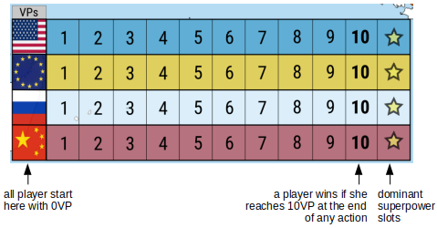

**2. Setup**

Follow these five steps:

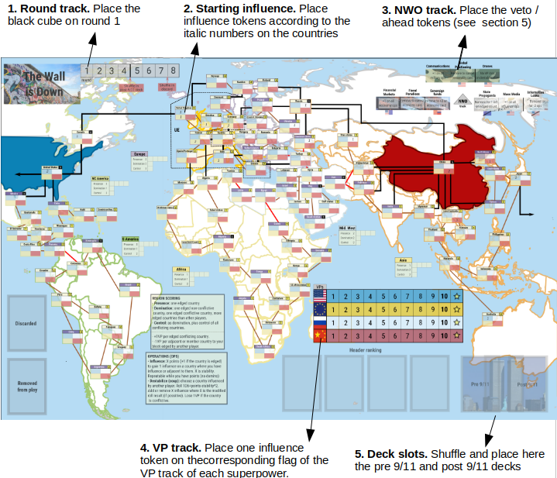

Setup is the same with any number of players. In games with three players, the superpower not used by any player remain static except for the text on some cards. In games with two players, use one of the UE/US VP tracks as a single West block track, and one of the Russia/China VP tracks as a single East block track.

**3. Influence slots**

Players place influence for each superpower or block (US, EU, Russia, China; or West and East) according to the numbers printed on the influence slots of the map.

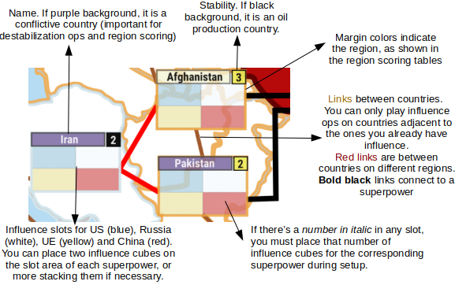

Each country in the map has four influence slots. Influence tokens from the same player are stacked together on its influence slot.

You have **influence** on a country if you have one or more influence tokens on it.

You have the **edge** on a country if you have more influence tokens than any other single player.

There are six **regions** in the board: Europe, Middle East, Asia, Africa, N/C America and South America. They are marked by different colours on the country boundaries. There is one scoring card for each and to try to influence or control them is a key feature of the game (see section 6.2.2).

Extra influence:

In the uncommon case that you have more than two influence on a country, you may place the extra influence tokens on any orthogonal influence slot from another superpower. A player may only place one influence if half of her influence slot is occupied by another superpower. If both of a player’s slots are file by another players’ tokens, she may not play influence or destabilization ops in the country.

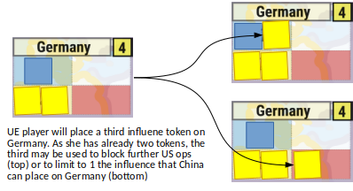

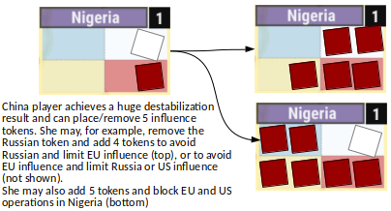

**4. Cards**

Form a deck with pre-9/11 cards (first epoch deck) and another with post-9/11 cards (second epoch deck). You may include or not any of the promo cards.

Cards have the following sections:

* Number (top-left): used when the card is used for operations.
* Block (besides number): either an E (East) or W (West), determines if the text is triggered when the card is used for operations (in the case it is played by a player of the opposing block). Some cards are marked as E/W, meaning that they are playable by either block.
* Pre or post 9/11 (bottom right): cards are in a different deck depending on this text. pre-9/11 is the deck used in the first 4 rounds (main deck). If the deck is depleted, the discarded (non removed) cards are reshuffled into a new deck. At the beginning of the 5th turn, the post-9/11 deck is shuffled with the remaining cards in the main deck.
* Name (top): name of the card, usually a historic event or personality. If it has an asterisk (*) after it, the card is removed from the game if its text is triggered.
* Type (below name): one or more keywords that may have some influence during the game (mostly because of the NWO track -see below- and the card texts)
* Image (center): a flavour photo
* Text (bottom): text of the card which is triggered if the card is selected in the header phase, played by the text on the action phase, or played by the operations, if you are a player from the opposite block to the card.

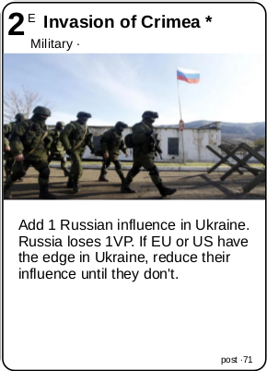

**5. Rounds**

The game is divided into 8 rounds, and two epochs: pre 9/11 (1989-2001), focused on the Balkans conflict and the oil crisis and post 9/11 (2001-2012) focused on war on terrorism and economic crisis.

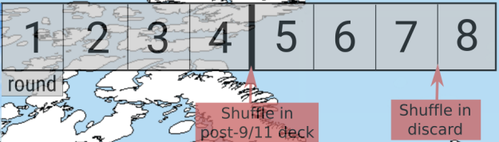**Round track**. Start at turn 1 and modify the deck after turn 4 and 7, and when the deck is emptied (usually, at the start of round 4)

At the beginning of each round, cards are dealt one by one to each player until they reach the following number of cards in hand:

* 2 players: 7 cards
* 3 players: 5 cards
* 4 players: 4 cards

***Note****: in 3 and 4 player games, in the rare case that a player draws 4 or more punctuation cards, he must reveal his hand, shuffle all her cards back in the deck and draw again the allotted number of cards.*

If there are no cards left on the deck, shuffle the discard pile as a new deck. This usually happens when dealing cards on round 4.

On round 5, before dealing cards, shuffle into the deck the post 9/11 cards.

On round 7, before dealing cards, shuffle into the deck the discard pile.

**6. Phases**

On each round, there are 2 phases: header and action phase.

6.1 Header phase:

Each player selects one of his cards and play it downside. When all the players have selected their header cards, they reveal them, putting one of their player counters on the selected card. Align the cards in order from the one with the highest number (place it at the leftmost side of a row) to the lowest number on the rightmost side. Punctuation cards used as headers are considered number 0. Ties are solved by the choice of the US player, generating a ranking that alternates block players, whenever possible. This *header ranking* will be the play order during the action phases.

Finally, the text of the cards is resolved from left to right on the row.

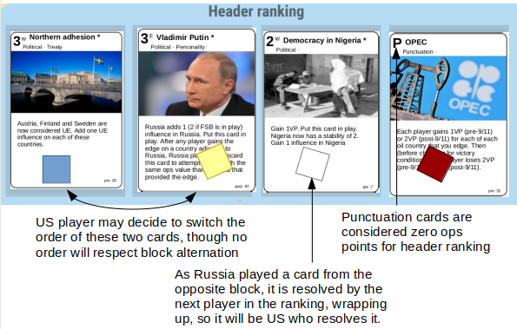

6.2 Action phases

There will be 2/3/5 action phases in games with 2/3/4 players.

On each of the action phases, following the order set on the header ranking, each player plays one card from her hand for one of these effects:

* Operations (influence or destabilize) for the number of the card
* Use the card text, if it corresponds to the player’s block
* Score it, if it is a Punctuation card (this is the only action you can do with a punctuation card)
* Alter the NWO track (see section 7)

6.2.1 Operations (also named ops):

There are two types of operation actions, for which you generate as many points as the number of the card used for the operation:

* *Influence*: choose a country where you have influence or adjacent to a country where you already have influence. Pay X points (+1 if anybody else has the edge on the country) where X is the country stability, to add 1 influence on that country. If you have remaining points, you can use them to gain influence on that country or any other country, under the same rules (no domino effect).
* *Destabilization (it is also referenced on some cards as to make a coup)*: Choose one country where there is influence of any other player. You roll 1D6+points-country_stability*2. If the country is conflictive, you lose 1VP. If the roll is a positive number X, you can add or remove up to X points of influence. The influence added must be of your faction and the influence removed can be split among the influence of the rest of players as you wish. You cannot use destabilization ops on countries belonging to any player (i.e. Russia, China, US or any UE country)

If the card is played by operations and the card block corresponds to the opposite block only, the text is resolved anyway. The next opposite block player in the header ranking resolves the text. The card text can be resolved before or after the operation, the player who played the card decides.

Note that, usually, each player will have one remaining card at the end of the action phases. A player cannot have any punctuation card in her hand at the end of the phase.

6.2.2 Punctuation cards

Cards marked by a P instead of a number are punctuation cards, and cannot be in your hand when a round ends. These cards have 3 values X/Y/Z. When one of these cards are played, resolve as follows:

1. Presence: each player that edges at least one country in the corresponding region, gains points X points
2. Domination: if a player edges more countries than any other player, and at least one conflictive and one non conflictive country, he gets Y points
3. Control: If a player edges more countries than any other player, and at least one non conflictive country and all conflictive countries, he gets Z points (note X, Y and Z are cumulative)
4. Each player gains 1VP per conflictive country in the corresponding region she edges.
5. Each player loses 1VP per country in the scoring region which is adjacent to his superpower country (or countries) and edged by another player. He also loses 1VP per each of her superpower countries edged by another player.

The oil production card is a bit different and gives VPs depending on the edged oil production countries (marked with a black number on the map).

Punctuation cards have a point value of zero for purposes or ranking if used as headers.

Punctuation region aids on the board reflect the number of VPs obtained for presence, domination and control, as well as slots to keep track of the situation on the region (this is optional).

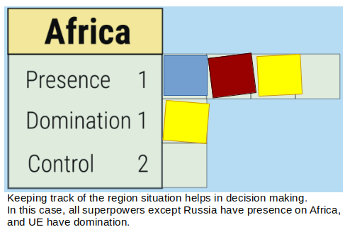

6.2.3 Card texts

A card can be used by its text instead of performing an operation, if it is a card of the same block as the player that plays it.

If a card is played for operations and it is of the opposite block, the text is also resolved (see section 6.2.1).

If part of the text cannot be applied (for example, remove influence when there is none), the card can still be played, being such part ignored.

**7. New world order (NWO)**

NWO is reflected by three aspects: public opinion, economy and technology. A player can, as send a card to any slot of the NWO to put her supremacy token on that slot if it is empty, or remove the token of an opposing player if not. Only a player can have supremacy on each slot at the same time.

Each NWO track has three slots, the third one is only available post 9/11.

*Veto*: some NWO slots have a veto to some players. In that case, the player cannot put her supremacy token on the slot for the first time on the game. After any allowed player has made it, he can add or remove supremacy on that slot as usual.

*Ahead:* if a player is ahead in any NWO slot, it means he can be the only one to get supremacy on that slot for the first time in the game. After getting supremacy, any player can add or remove supremacy on that slot as usual.

Once you have the supremacy of a slot, you gain either a permanent benefit or a 1-use benefit as described below:

|  |  |  |  |  |  |
| --- | --- | --- | --- | --- | --- |
| **Type** | **Name** | **Epoch** | **Veto** | **Ahead** | **Text** |
| Economy | Financial markets | pre 9/11 |  | West | You get +1 on all economy ops |
| Fiscal paradises | pre 9/11 |  |  | You may cancel the text of any economy card as it is played for the event or for operations of the opposite block |
| Sovereign funds | post 9/11 |  | East | You may remove this supremacy to give +2 points to an economy card used for an influence operation |
| Public opinion | State propaganda | pre 9/11 | EU |  | Remove supremacy to add 1 influence to an already controlled country (usable before or after any action, yours or from other player, event or operation) |
| Mass media | pre 9/11 |  | US | You get +1 on all influence ops |
| Information leaks | post 9/11 | US |  | Remove supremacy to reduce by 2 the op value of an opponent card used to influence |
| Technology | Communications | pre 9/11 |  |  | You get +1 on military card ops |
| Global positioning | pre 9/11 |  | US | Remove supremacy to cancel a personality card text as its text is about to resolve, or to discard a personality in play. |
| Drones | post 9/11 |  | US | You lose 1 less VP on destabilization ops |

**8. Variant: solo play**

**8.1. Goal**

There are two alternative goals: The Elite and The Planet.

The Elite: the goal is to make each superpower (US, Russia, EU and China) gain as much VPs as possible, but without reaching 10VP. You want to set up a balanced NWO where everyone prospers evenly… at the expense of the rest of the world. In this mode, you win if you reach the end of round 8 without any player getting to 10VP. Your final score is the lowest VP among superpowers.

The Planet: alternatively, you may want to set up a NWO where the superpowers do not prosper too much, leaving space for the rest of the planet. But them crumbling around might be dangerous as they may push the nuclear button. In this mode, the four superpowers start with the following VPs: US 8, Russia 3, China 4, EU 5. You lose if any player reaches 10 or 0VP. At the end of the game, your score is equal to 10 minus the highest VP among superpowers.

On any of the modes, you may keep playing after any player reaches the forbidden limits, just keep track of it to know how many times you ‘failed’ to control the situation and which player reached success or failure. In the planet version, if a superpower reaches 0VP, you may oust it from the game (use the rules for the remaining superpower in 3-player games) and keep playing for the rest of the superpowers.

**8.2. Setup**

Setup is the same as described in section 2. The NWO track is not used in solo play. Remove the following cards from the deck:

* IMF Intervention (pre)
* Black Monday (pre)
* Russian oligarchs (pre)
* Rupert Murdoch (pre)
* Petrodollars (pre)
* Shock doctrine (pre)
* New START (post)

**8.3. Rounds**

For each of the 8 rounds, draw cards for each for the 4 superpowers on the VP and play rounds as usual, as if you control each of the 4 superpowers, but with open hands. You must play them as normal (see sections 5 and 6), trying to maximize or minimize overall VPs, without reaching the limits, and respecting the limitations described below.

Keep playing until the end of round 8 or until some player surpass the forbidden limits (see Goal above). Alternative, if some of the players surpass the limits, you may just mark a tick of unfulfilled goal and keep playing, ignoring from now on that player for rounds (but not removing its influence, and playing card texts as if it is still active).

**8.4. Limitations to playing cards:**

* Influence ops and card texts must be played to change the status quo of a country (that is, to get or remove the edge)
* Influence ops must be played on a country without influence from any other player, if able.
* Influence ops must be played by its entire influence points.
* Destabilization ops must be played on countries with 1 or 2 stability.
* NWO track is not available to send cards for any purpose.