Referências

Kubernetes

<https://jamesdefabia.github.io/docs/reference/>

Docker

<https://docs.docker.com/engine/reference/commandline/docker/>

[kubectl Cheat Sheet | Kubernetes](https://kubernetes.io/pt-br/docs/reference/kubectl/cheatsheet/)

++++++++++++++++++++++++++++++++++++++++++++++++++++++++++++++++++++++

az aks get-credentials --resource-group myResourceGroup --name myAKSCluster

kubectl apply -f azure-vote.yaml

kubectl – comando Kubernetes

apply – cria objeto

-f azure-vote.yaml – Aplicação

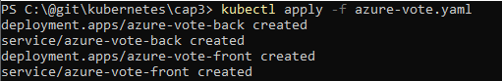

kubectl delete -f azure-vote.yaml

kubectl – comando Kubernetes

delete – comando para deletar

-f azure-vote.yaml – Aplicação

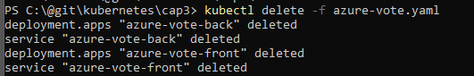

kubectl get service azure-vote-front --watch

kubectl – comando Kubernetes

get – consulta informação

service – consulta serviço “azure-vote-front”

--watch – consulta em tempo real



kubectl get service azure-vote-front –watch -o wide



kubectl get pods -o wide

kubectl – comando Kubernetes

get – consulta informação

pods – get pods – consulta os pods

-o wide – exibe detalhes

-o json – exibe detalhes em formato JSON

-o yaml – exibe detalhes em formato YAML



kubectl get pods azure-vote-back-6c4dd64bdf-ds27q



Lista os nodes

kubectl get nodes



Lista os recursos do node

kubectl describe nodes aks-agentpool-39879146-vmss000002

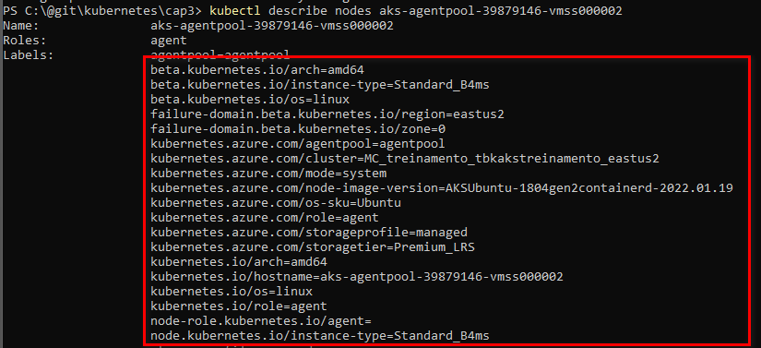

Se trabalhar com mais de um contexto isso é objetos

Listar os contextos

kubectl config get-contexts



Altera para outro contexto

config use-context docker-desktop

kubectl config set-context my-context –namespace=mystuff

kubectl config get-contexts

kubectl config set-context tbk-aks-hml-001

kubectl config use-context tbk-aks-hml-001

subindo um pod e publicando a porta

usaremos o kuard-pod.yaml

kubectl apply -f kuard-pod.yaml

verificar os pods

kubectl get pods

fazer o redirect

kubectl port-forward kuard 8080:8080

Executar bash

kubectl exec -it deploy-econtrato-api-79dfcd8c47-ptknk – bash

Kubectl auto complete

>> kubectl completion –help

[Install and Set Up kubectl on Windows | Kubernetes](https://kubernetes.io/docs/tasks/tools/install-kubectl-windows/#enable-shell-autocompletion)

>> kubectl completion powershell | Out-String | Invoke-Expression

>> kubectl completion powershell >> $PROFILE