# LAS 2 CSV

Script to convert LAS 3.0 files into multiple CSV files that can be imported in acQuire 4 using regular Import objects.

Version: 1.1

Author: Rodrigo Nobrega

Dates: 14 Aug 2015 V1.1 ::: 15 Jul 2015 V1.0

## Installation

Download and install the latest version of Python: <https://www.python.org/downloads/>

It needs to be version 3.x or above. Python 2.x will not run this script.

Save the Python script **Las2csv.py** and the **Las2csv.qsql** acQuire 4.4.2.3 Script object to a folder in your hard disk. It doesn’t need to be the same folder where the LAS files are located.

## Usage

Add the **Las2csv.qsql** acQuire 4.4.2.3 Script object to the acQuire Workspace, or add the base folder containing the acQuire script object in the workspace with Tools > Options menu.

Run the **Las2csv** script object on the acQuire 4 workspace.

### Setup

Before running the script the first time some configuration needs to be done. It consists in informing to the object the location of the Python.exe interpreter executable, and the location of the Las2csv.py Python script. On the **Setup** tab, select the checkbox toEdit configurations and select the folders for the two files. Save the object after setting them up.

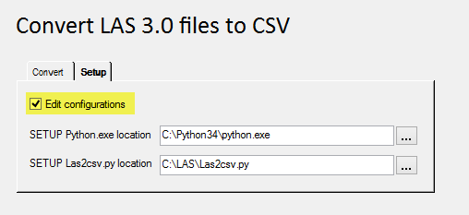

### Execution

On the **Convert** tab, select a LAS file you want to convert to CSV. Press Convert to CSV button and observe the console output under the script Control Sheet, as well as the contents of the LAS file folder for the output CSVs.

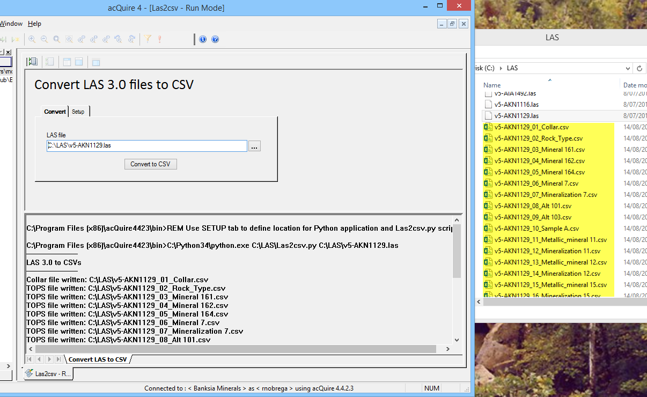

## Future improvements (optional)

* ~~A graphical user interface.~~ Developed in the acQuire 4 workspace in version 1.1
* Insert the CSV data directly in the acQuire database without the need to import them.