# Software Engineering Group Project - Project Plan

# Group 9:

# Robert Streeting - rsws1g09@ecs.soton.ac.uk

# Ruxandra Geana - rg4g09@ecs.soton.ac.uk

# Weike Liao - wl15g09@ecs.soton.ac.uk

# Mark Salvin - ms28g09@ecs.soton.ac.uk

# Rodrigo Escobar - [raeb1g08@ecs.soton.ac.uk](https://www.outlook.soton.ac.uk/owa/?ae=Item&t=IPM.Note&a=New&to=raeb1g08%40ecs.soton.ac.uk&nm=raeb1g08%40ecs.soton.ac.uk)

# 10 February 2011

# Contents

# Document control............................................................................................................................................................................... 3

# Gantt chart........................................................................................................................................................................................... 4

# Risk Analysis....................................................................................................................................................................................... 5

# Work breakdown................................................................................................................................................................................. 6

# Time record.......................................................................................................................................................................................... 7

# Planned form of time expenditure reporting..................................................................................................................................... 8

# Version management.......................................................................................................................................................................... 9

# Index..................................................................................................................................................................................................... 10

# Document control

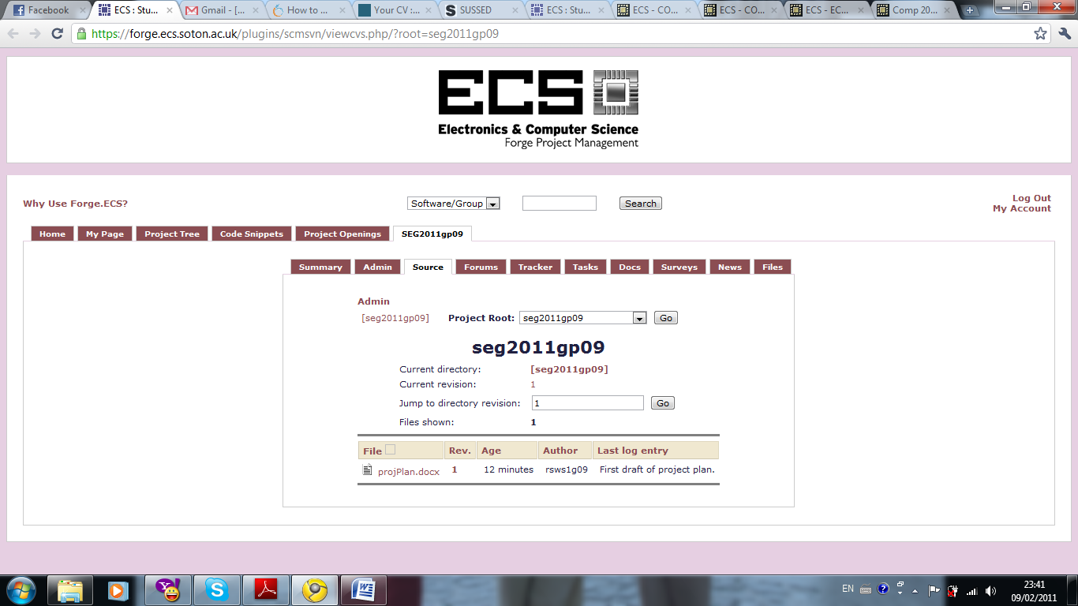

# Figure 1: Repository for Project Plan

# Gantt chart

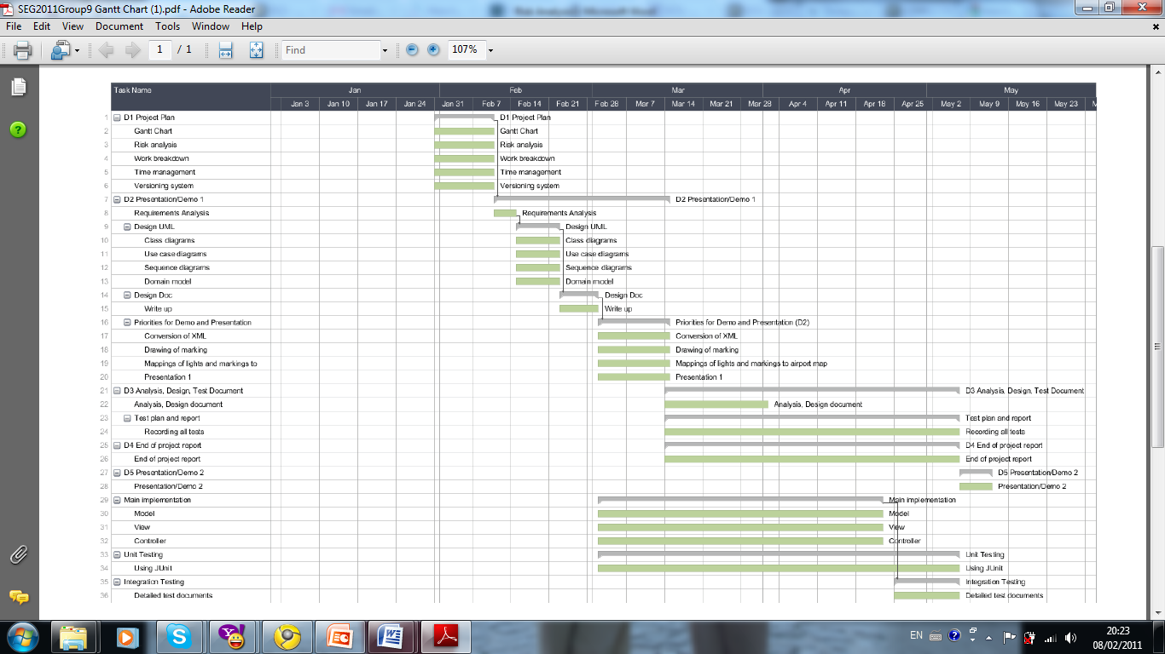

# Figure 2: Gantt Chart

# Risk Analysis

|  |  |  |  |  |
| --- | --- | --- | --- | --- |
| Risk | Probability of  occurring | Impact on the project | Avoidance strategy | Reduction of impact |
| Team member  dropping out  of project | Unlikely | High impact:   * Reduces the workforce. * Extra work needed to understand and continue the work that was in progress by the team member. | Unavoidable | * Proper use of versioning system. * Standard coding style to make it easier for other team members to continue work. * Progress reports in meetings so that everyone in the team knows what each other are doing. |
| Change of  requirements | Possible | High impact:   * Redesign/recode of system. * Regression testing. | Unavoidable | * Designing classes with high cohesion/low coupling to reduce the amount of work needed to accommodate the changes. |
| Team member  not doing  work allocated  to them | Likely | Medium impact:   * Project gets behind schedule. | * Good personal time management. * Fair delegation of tasks. | * Set deadlines early so that they can afford to be passed if needed. |
| Unrealistic  deadlines | Fairly likely | Low to medium impact depending on how unrealistic:   * Project schedule needs to be rethought. * Parts of the project get rushed. | * Clever planning of task deadlines. | * Assigning more time than needed to tasks. |
| Illness | Likely | Low impact:   * Some work does not get done, but ill member can still communicate with team. | Unavoidable | * Same as for team members dropping out. |
| Team member  not turning up  to a meeting | Fairly likely | Low impact:   * Team member is not sure what he/she needs to do. | * Circulation of agenda before meeting. | * Circulation of minutes. |

# Work breakdown

|  |  |  |  |  |
| --- | --- | --- | --- | --- |
|  | **Agenda item** | **Action** | **Person responsible** | **Time per person in hours** |
|  | Requirements analysis | Need to add requirements analysis into the Gantt chart | All | 0.5 |
|  | View | Managing the design of the GUI | Rodrigo | 5 |
|  | Design document | Writing the design documentation | Mark | 5 |
|  | Drawing markings | Drawing out the various light markings | Mark | 10 |
|  | XML Conversion | Coding the conversion of the XML file for the runway light markings | Rodrigo | 10 |
|  | Drawing markings | Drawing the lines and markings on the GUI | Robert | 6 |
|  | Test document | Recording of tests. | Robert | 4 |
|  | End of project report | Writing up the end of project report | All | 5 |
|  | Presentation | Doing the presentation | All | 4 |
|  | Requirements analysis write up | Writing up the requirements analysis | Ruxandra | 5 |
|  | Class diagram | Creating a class diagram | Wane | 2 |
|  | Use case diagram | Creating a use case diagram | Robert | 2 |
|  | Sequence diagram | Creating a sequence diagram | Wane | 2 |
|  | Final presentation | Doing the final presentation | All | 5 |
|  | Model | Managing the model | Mark, Wane | 6 |
|  | Controller | Managing the controller | Robert, Ruxandra | 3 |
|  | Unit and integration testing | Performing unit testing and integration testing. Test other peoples code | All | 5 |
|  | Time planning | Copy the minutes, add an extra column for time taken, and predict time for each task, should average at 60-80 hours each | Mark | 0.5 |
|  | Meetings | Meet up informally and formally once a week | All | 33 |

# Time record

# 

# Figure 3

# Figure : Time Recording System

Figure

Figure

# Planned form of time expenditure reporting

* The time expenditure reporting record will be done in an online spreadsheet (Figure 3) which can be modified by all members. The members will record in the different fields: the time they spent in that week doing work, the task or tasks done by the user in that week and detailed information on what changes were applied to it.
* A bar chart will be generated with the work done for each member in every part of the development (documentation, implementation, coding and design). This chart will be generated from the information gathered in the spreadsheet. The information will be checked at the beginning of the project, in the middle of the development and when is it finished.

# Version management

* + We will use the Subversion (SVN) repository at http://forge.ecs.soton.ac.uk to control our version management.
  + We will most likely access this repository using TortoiseSVN or PuTTY on Windows, and using the command line on Mac and Linux.
  + We will commit updates regularly, whenever a change is made to a source file or document.
  + When committing an update, we will always include a description of the update, which will specify what changes were made and why they were made.
  + The date, time, and revision number will be generated automatically by the Subversion system.
  + The convention we will adopt for our file system structure, is storing all of our documents inside a directory named documents, and placing all of the code inside a directory named code. All files will be named with a short, concise, yet adequately descriptive name.

# Index

# document control, 3

# Gantt chart, 4

# risk analysis, 5

# time expenditure, 8

# time record, 7

# version management, 9

# work breakdown, 6