Analysis, Design and Test

Software Engineering Group Project

Group 9:

Robert Streeting - rsws1g09@ecs.soton.ac.uk

Ruxandra Geana - rg4g09@ecs.soton.ac.uk

Weike Liao - wl15g09@ecs.soton.ac.uk

Mark Salvin - ms28g09@ecs.soton.ac.uk

Rodrigo Escobar - raeb1g08@ecs.soton.ac.uk

12 May 2011
Contents

The approach taken 3
1) Techical 3
2) Modelling 4
Project Analysis 4
1) Class diagram 4
2) Sequence diagram 5
3) State chart diagram 5
4) Explanatry narative 6
Test Plan 8
Test Report 10
Unit tests 10
Intergration tests 12
System tests 13
User acceptance tests 14

The approach taken

- Technical

The programming language used for writing the code is Java. One of the main reasons this choice was made is that Java is simple, object-oriented, platform-independent, distributed, interpreted, secured and robust. It also provides powerful GUI widget toolkits such as Swing and Awt, which are extremely important when a learning tool is designed and implemented. In addition to this, all team members have an advanced knowledge of Java programming and feel much more comfortable using it, rather than other programming languages.
Eclipse IDE was chosen because it offers a superior Java development environment with numerous features such as: refactoring, code formatting and cleanup tools, code completion, templates etc.
For an accurate and efficient testing process Junit has been used. JUnit permits both coding and testing during the development, making sure that the modifications in the code will not break the system without the programmer’s knowledge.
To control the version management, the Subversion (SVN) repository at http://forge.ecs.soton.ac.uk was used. Updates were committed regularly and were accompanied by a description specifying what changes were made.
The software used to design the UML diagram is Visual Paradigm for UML as it provides an intuitive all-in-one development platform, enabling use case specification to be further refined into other analysis and design deliverables.
The created set of UML diagrams has been used to specify, visualize and construct the system. It also offers a standard way to visualize the tool's architectural blueprints. Therefore, the team members were able to completely understand the system before they started its construction. The types of diagrams used are described below.
The Class Diagram is a type of static structure diagram that was used to describe the structure of the system by showing its classes and the relationships between them, as well as their attributes, operations and methods. (http://en.wikipedia.org/wiki/Class_diagram).
The Use-Case diagram is a type of behavioural diagram defined by and created from a use-case analysis. Its purpose was to present a graphical overview of the functionality provided by the system in terms of actors, their goals (represented as use cases), and any dependencies between those use cases. (http://en.wikipedia.org/wiki/Use_case_diagram)
The Sequence diagram is a kind of interaction diagram (a construct of a Message Sequence Chart) that was used to show how processes operate with one another and in what order. (http://en.wikipedia.org/wiki/Sequence_diagram)
The State Chart Diagram describes different states of an object (AirportVisualisation) in the system. During its lifetime, the states are changed by events.

- Modelling

Abstraction is one of the most important techniques in software engineering used to reduce complexities in processing and programming. In Java, abstraction refers to the process of representing some essential features without knowing the background details. Because an object oriented programming language was used, the code is structured in classes, some corresponding to real-world objects (i.e. Runway, Taxiway), some used to read and interpret data (i.e. XMLConverter) or to design and display the learning tool’s graphical user interface (i.e. GUI). Each type of light and marking is represented by a class (i.e. Papi, Centreline) that implements an interface (AirportComponent). This approach was used to encode the similarities shared by these classes (a method that draws the component on the GUI) and to simulate multiple inheritance. In other words, the code behind the tool displays the airport by drawing every component element.
As a basis for the design, the Model View Controller (MVC) architectural pattern was used because it allows the user interface to be independent from the inner workings of the code. Therefore, different user interfaces can be applied to same model without changing it.
The Model is the domain specific representation of the underlying structure of the system, and specifies how certain data is stored. It corresponds to a collection of Java objects which store and manipulate data (i.e. objects representing an airport, lights, markings). An important part of the Model is the XMLConverter class which takes an XML file, reads its content, extracts the relevant information and stores it in variables that will be used afterwards.
The View renders the model into a suitably visual form appropriate for user interaction. It corresponds to a collection of GUI Java objects (the graphical components). For example, the airport is displayed in a JPannel and a JComboBox can be used to switch between categorisations. Different views (i.e. a selected airport and category) are applied to the model and navigated between.
The Controller processes and responds to events (user actions) and modifies the model accordingly by invoking back-end code in the model. The view is then updated based on the changes made. The controller corresponds to a collection of Java EventListener objects and their handling code. An example would be the listener added to a button in order to switch between the day and night views.

Project Analysis

- Class diagram

The purpose of the class diagram is to describe the responsibilities of the system and to analyse and design the static view of the application. Some classes are intentionally omitted as their role is to help with writing a more structured and easy to understand code. The GUI class is responsible of the interaction between the tool and the user. Therefore, a GUI object will display an AirportVisualisation object (the actual airport decorated with lights and markings); this relation is modelled by a 1 to 1 association. Composition is used to show that the GUI is a container for the MyMouseListener, MyKeyListener and MyWheelListener classes. If the GUI is destroyed then all the Listener classes will be destroyed as well. The AirportVisualisation is a JFrame subclass; this is modelled using a generalisation between them. In order for the lights and markings to be displayed, the AirportVisualisation creates and draws objects of AirportComponent type. A 1 to 1 association illustrates the fact that each AirportVisualisation corresponds to an Airport. There is a dependency between the Airport class and the XMLConverter class which actually creates it. The aggregation relation shows that the TaxiwayJoin, TaxiwayRunwayJoin and TaxiwaySection classes are contained by the Airport class, but these three classes don’t essentially have a strong lifecycle dependency on the container. All the lights/markings classes are part of the Lights/Markings package. They implement the AirportComponent interface, relation which is represented by a generalisation. Because these packages contain a high number of lights/markings, only one class of each category is represented in the diagram. The other classes follow exactly the same pattern.

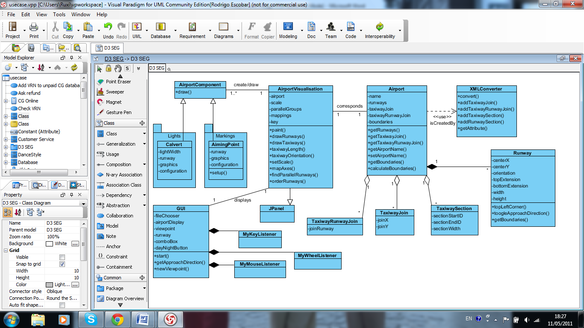

- Sequence diagram

- State chart diagram

The state-chart diagram was used to model the dynamic aspects of the system. It shows the life time of an AirportVisualisation object from creation to termination. After all the initializations are done, the object is in its first state and the airport is displayed. A loop indicates the fact that a new loaded airport will lead the object to this first state. When toggling the approach direction, a new state is entered and the displayed Papi lights will change their colour accordingly. If another category is chosen, a different set of lights and markings will be redrawn. When the day and night view is changed, the background will be different and additional lights will be drawn. It is also possible to display a help window. Zooming will lead to a scale change and panning to a viewport translation.

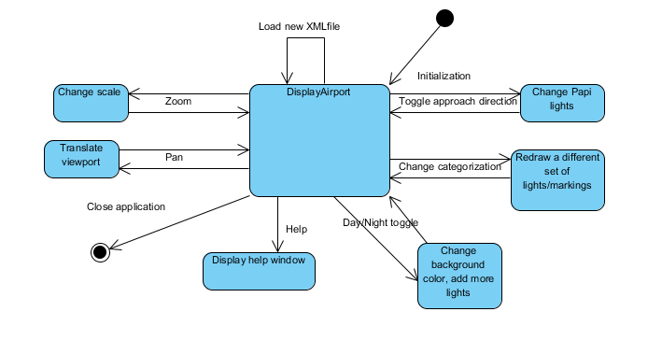
- Explanatory narrative

For this project, some XML files have been provided that contain the information for the visualisation of different airports. The application needs to be able to extract the information out of these files, draw the airports and decorate them with markings and lights.

Model
Firstly, the information inside the XML files is extracted with a class called XMLConverter. The XML file is read line by line and the relevant information is extracted and saved into global variables. These variables are used to construct objects that constitute elements of the airport.
These objects are defined in four individual classes which are named Runway, TaxiwayJoin, TaxiwayRunwayJoin and TaxiwaySection.
The information used to construct the Runway objects are its length, orientation, width, positioning, and its unique identifier. Runways sometimes have Top or Bottom extensions which are not dissimilar from the Runway class. They are nested classes within Runway so that they have access to the Runway's variables (such as the position of the runway and its width, which are needed by the Extension classes). Top and Bottom extensions are a subclass of the abstract class Extension; this means that Extensions of both types can be treated in the same way, when iterating through them for instance.
The rest of these classes contain information that maps directly to that contained in the XML file. Note that this information is stored as-is, without applying any scale or mapping to the values. This is the job of the View, which is discussed later in this section.
Inside the XMLConverter class there are four methods; addRunway(), addTaxiwaySection(), addTaxiwayJoin() and addTaxiwayRunwayJoin(). These methods are used to construct objects of the classes previously mentioned and add them to collections in the Airport object.
The collections that hold the objects created in the XMLConverter class are stored in the Airport class. The method calculateBoundaries() calculates how big the Airport will be and returns a Boundaries object which has the information of the top, bottom, right and left ends of the airport. This is used to calculate the height and width that the Airport must be visualised at in the View. In the constructor of this class, the XMLConverter method convert() is called to extract the information.

View
At the heart of the View is another class called AirportVisualisation. This is used to take the information of all the collections in the Airport class and draw them at the correct size in the panel, along with all of the respective lights and markings.
For the lights and markings, several classes are used which represent different types of marking and lights. Each class implements an interface 'AirportComponent' that forces each one to implement a 'draw' method. This means that they can all be drawn in a standard way.
The lights classes are ApproachSimple, Calvert, CentreLight, EdgeLight, EndLight, Papi, StarterExtensionLight, StopwayLighting, ThresholdLight and TouchdownLight. Each of these implements a 'drawLight' method that draws each light, and the positions for these lights are calculated in the 'draw' method.
The markings classes are AimingPoint, Arrows, Chevron, Centreline, Crosses, Designator, Edges, Threshold and TouchdownZone. Another class that is being used is PreThresholdMarking, which decides which marking to draw on each extension based on the extension's type. This allows Cross, Arrow or Chevron objects to be drawn mutually exclusive to each other, making sure that only one of these can appear on the extension at a time.

Controller
The User Interface is handled by the 'GUI' class. This class creates an AirportVisualisation object, from which an Airport object is created. The main() method is run from here as well as all the components from the User Interface. JComboBox, JRadioButton and JButton objects are used to visualise the elements needed for the user to perform changes on the marking and lightings displayed according the type of airport requested.
Different listener classes have been implemented to give functionality to the components mentioned above.
In order to implement the ability to change categories of airports, a matrix (a two-dimensional array) is implemented that stores which markings and lights are displayed for each individual categorisation. A hash map maps each co-ordinate in the matrix to an object representing a single light pattern or marking, and then these together provide a way to decide which objects to draw when the category is changed. The matrix contains the values 1 for Operational desirable components, 0 for operational desirable components and -1 for not applicable. The draw method checks the position for each value in the matrix and applies the formula 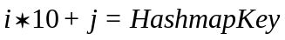, where i and j are the values of the 2 dimensional array (i.e. matrix[i][j]).
In the GUI class, a listener has been applied to a JComboBox which change the matrix values depending on the categorisation, and repaints the visualisation.
Within this project there are several Listener classes which perform different tasks such as zooming in or out and switching the approach direction of the lights on the displayed Runways.
A learning tool has been implemented on the shape of a glossary which contains all the definitions for every light, marking and airport element. A Glossary class reads a file with the entries for the glossary and display the options on a JList and the meaning of such words are showed in a JLabel just beside it.

Test Plan

ID | Test Stage | Area | Objective | Method
1 | Unit | Model | Test validity of objects created by XML converter. | Black Box testing: Test harness that checks attributes of objects created against XML definitions. Test cases a-d test the converter on four different XML files.
2 | Unit | View | Test axes mapping algorithm. | Black Box testing: test cases take the form of points on a simple graph.
3 | Unit | View | Test scale calculation algorithm. | Black Box testing: test with different Dimensions (sizes of panel).
4 | Unit | View | Test correct images are selected for all possible designator digits. | White Box testing (deriving test cases to drive algorithm down all code paths).
5 | Unit | View | Test parallel runway detection algorithm. | Black Box testing: for groups of 1,2,3 and 4 parallel runways and for 1,2 and 3 groups. Also tested for different orientations.
6 | Unit | View | Test runway drawing. | Black Box testing: test cases will be synthesized runway objects that test each attribute is drawn correctly. (A control runway is also drawn to see the changes for each test)
7 | Unit | View | Test taxiway drawing. | Black Box testing: test cases involve TaxiwayJoins being at different angles to each other.
8 | Unit | Controller | Test that all GUI components appear correctly. | Black Box testing: test cases will involve resizing the window.
9 | Unit | Controller | Test zooming. | Black Box testing: test cases will include differing amounts of keyboard presses/mouse wheel rolls.
10 | Unit | Controller | Test panning. | Black Box testing, with keyboard presses and use of scroll bar.
11 | Integration | Model/View | Test integration of XML converter, boundary calculation, axes mapping and scaling algorithms. | Black Box testing: Test harness that will draw a simple airport loaded from file. Test cases will involve loading in multiple airports and resizing the window.
12 | Integration | View | Test that each runway marking and light appears correctly. | White Box testing: Test that markings and lightings appear in the correct position relative to the runway and the approach direction.
13 | Integration | View/Controller | Test that the airport 2D plan view appears correctly in the GUI. | Test cases to include resizing GUI window.
14 | Integration | View/Controller | Test that zooming works correctly with View. | Test that zooming updates scroll bars and works correctly with scaling algorithm.
15 | System | View | Test runway markings display correctly on 2D plan view. | Observe drawing of all individual runway markings for all categories and check against CAP637/168.
16 | System | View | Test runway lights display correctly on 2D plan view. | Observe drawing of all individual groups of runway lights for all categories and check against CAP637/168.
17 | System | All | Test changing of categorisation. | Observe the changes in runway markings/lights when categorisation is changed.
18 | System | All | Test changing of approach direction. | Observe the changes in runway markings/lights when approach direction is changed.
19 | System | All | Test changing between day and night view. | Observe the changes in the View when day/night setting is changed.
20 | User Acceptance | All | Demonstrate how each requirement has been fulfilled. | Demonstration to client.
Notes:
In some cases where Black Box testing was used, JUnit test drivers were utilised to make this process quicker.
Some of the tests on the smaller modules (such as the smaller individual methods/functions) were omitted from this report for clarity. These modules were generally verified by inspection.
Test Report
- Unit Tests
ID | Test Cases | Expected Result | Passed? (What was wrong otherwise) | Measures taken to fix bug
1 | ultra-simple.xml  simple.xml  standard.xml  complex.xml | All XML attributes match object attributes. | Pass  Pass  Pass  Pass | -  -  -  -
2 | (0,0)  (5,5)  (-5,5)  (5,-5)  (-5,-5)  (-100,100) | (5,5)  (10,0)  (0,0)  (10,10)  (0,10)  error | Pass  Pass  Pass  Pass  Pass  Fail – no error given. | -  -  -  -  -  Editing original code to check co-ordinates were inside the boundaries. (Edit – had to reverse this change, because it was causing trouble when the axes were rotated to draw runways.)
3 | 0x0  0x100  100x0  100x100  50x100  100x50 | 0  0  0  10  5  5 | Pass  Pass  Pass  Pass  Pass  Pass | -  -  -  -  -  -
4 | 0-9  L,C,R | 0-9.png  l,c,r.png | Pass  Pass | -  -
5 | Single runway  1 group of 2  1 group of 3  1 group of 4  2 groups of 2  2 groups of 3  3 groups of 2  3 groups of 3 | No groups  Correct amount of groups with correct runway objects within.  More than three runways should return an error. | Pass  Pass  Pass  Fail – no error given.  Pass  Pass  Pass  Pass | -  -  -  Check for groups >4.  -  -  -  -
6 | Null  X position – left  X position - right  Y position – up  Y position - down  Orientation <180  Orientation >180  Width  Height  TopExtension  -width  -height  BottomExtension  -width  -height | No runway drawn;  translated to left;  translated to right;  translated up;  translated down;  rotated by angle;  rotated by angle;  width changes;  height changes;  width changes;  height changes;  width changes;  height changes; | Pass  Pass  Pass  Pass  Pass  Pass  Pass  Pass  Pass  Pass  Pass  Pass  Pass | -  -  -  -  -  -  -  -  -  -  -  -  -
7 | Null  0 >= angle >= 90  90 >= angle >= 180  180 >= angle >= 270  270 >= angle >= 360  width | No taxiway drawn;  Taxiway drawn at correct angle;  Width changes; | Pass  Pass  Pass  Pass  Pass  Pass | -  -  -  -  -  -
9 | Mouse wheel forward  Mouse wheel back  Keyboard +  Keyboard - | Scale variable changes appropriately. | Pass  Pass  Pass  Pass | -  -  -  -
10 | Keyboard left  Keyboard right  Keyboard up  Keyboard down  Mouse drag left  Mouse drag right  Mouse drag up  Mouse drag down | Move viewport left  Move viewport right  Move viewport up  Move viewport down  Move viewport right  Move viewport left  Move viewport down  Move viewport up | Pass  Pass  Pass  Pass  Pass  Pass  Pass  Pass | -  -  -  -  -  -  -  -

Test 8 was impossible at this stage, since the GUI is not completely finished yet.
- Integration Tests
ID | Test Cases | Expected Result | Passed? (What was wrong otherwise) | Measures taken to fix bug
11 | ultra-simple.xml  simple.xml  standard.xml  complex.xml | Airports should all be fully visible regardless of resizing. | Pass  Pass  Pass  Pass | -  -  -  -
12 | Markings  -normal  -approach direction switched  Lights  -normal  -approach direction  switched | Appear in correct position on runway and flipped by 180 degrees when approach direction changed. | Pass  Pass  Pass  Pass | -  -  -  -
13 | ultra-simple.xml  simple.xml  standard.xml  complex.xml | Airports still fully visible in the panel within the full GUI. | Pass  Pass  Pass  Pass | -  -  -  -
14 | Keyboard +  Keyboard -  mouse-wheel forward  mouse-wheel back | Zoom on centre of screen  Zoom out from centre  Zoom on centre of screen  Zoom out from centre | Fail – when zooming on lower/upper half of screen, screen also pans up/down.  Pass  Fail (same as above)  Pass | To be fixed.  -  Same as above.  -

- System Tests
ID | Test Cases | Expected Result | Passed? (What was wrong otherwise) | Measures taken to fix bug
15 | Runway Designator  -letter  Threshold  Edge  Centreline  Aiming Point  Touchdown Zone  Starter Extension  Stopway  Unusable Extension | All markings match the coour and positions specified in CAP168/637. Still appear correctly when approach direction is changed. | Pass  Fail – for Visual categorization overlapped with number.  Fail – did not lengthen to encorporate letter in Visual mode  Pass  Fail – offset is incorrect for Visual mode.  Pass  Pass  Pass  Not implemented yet  Pass | -  Code fix.  Add a check to see whether a letter will be present and lengthen accordingly.  -  Amend the offset value.  -  -  -  -  -
16 | Approach  Splmntry. Approach  PAPI  - change angle  Edge (Runway)  -caution zone  Edge (Stopway)  Edge (Starter Ext.)  Edge (Runway Exit)  Threshold  End  Centreline  Touchdown Zone  Rapid Exit Taxiway | All lights match the colour and positions specified in CAP168/637. Still appear correctly when approach direction is changed.  Yellow lights appear on last 1/3 of runway for <CATIII.  Pre-threshold edge lights should always appear in the same place regardless of approach direction (stopway lights should only appear on approach). | Pass  Pass  Pass  Pass  Pass  Pass  Pass  Fail – changed sides on change of approach direction.  Not implemented yet  Pass  Pass  Pass  Pass  Not implemented yet | -  -  -  -  -  -  -  Small edit to drawing code to exclude it from rotation.  -  -  -  -  -  -
At the time of testing, insufficient features are implemented to carry out tests 17, 18 and 19 (GUI components for changing the category, changing approach direction and toggling day/night have not yet been implemented).
- User Acceptance Tests
ID | Test Cases | Expected Result
20 | Load simple.apx  Load complex.apx  Load standard.apx  Show approach direction option  Demonstrate approach direction option  Conceal all lights and markings  Demonstrate markings/lights for Non-Precision  Demonstrate markings/lights for CAT IIIC  Demonstrate lights and markings of taxiways  Demonstrate lights and markings on stands | Airport loads successfully and is displayed  Airport loads successfully and is displayed  Airport loads successfully and is displayed  -  Approach direction changes for runway selected  Lights and markings disappear  Lights/markings appear conforming to CAP168  Lights/markings appear conforming to CAP168  Taxiway light appear conforming to CAP168  (Not implemented, cannot demonstrate)

