USER MANUAL-Table of Contents

1. AEGIS Mediawiki Help: Accounts (see also video-part1) 2
1.1. Creating an account 2
1.2. Logging in 2
1.3. How to log in 2
2. AEGIS Mediawiki Help: Navigation/Search (see also video-part2) 3
2.1. Simple search 3
2.2. Advanced Search 3
2.3. Semantic search 4
2.4. Search by property 4
3. AEGIS Mediawiki Help: Ontology Browsing (see also video-part3) 5
3.1. The Category View 6
3.1.1. Category Selection 6
3.1.2. Instance Selection 6
3.2. The Attribute View 6
3.3. The Relation View 6
4. AEGIS Mediawiki Help: Querying Data (see also video-part4) 7
4.1. The Query definition section 7
4.1.1. The Add Category menu 7
4.1.2. The Add Property menu 8
4.1.3. The Add Instance menu 8
4.1.4. Semantic autocomplete feature 9
4.2. The Result section 9
4.3. Sparql queries 10
5. AEGIS Mediawiki Help: Gardening 11

AEGIS Mediawiki Help: Accounts (see also video-part1)

Creating an account
Point your browser to http://160.40.50.57/wiki.To create an account, select “Log in” (top right of page - Figure 1) then “request one” (Figure 2).
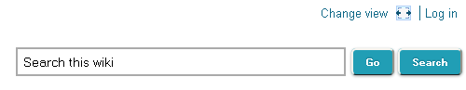
Figure 1: Log in area
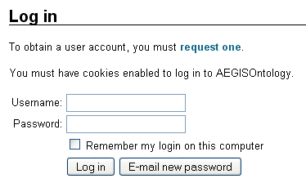
Figure 2: Request account
The wiki administrator will confirm the request and then you will be able to log in.

Logging in
Creating a user account means that you supply a username (your real name or a nickname) and a password. The system will reject a username that is already in use. A user account is created only once. You are then "logged in". Next time you log in you supply your username again and demonstrate with the password that you are the same person.
Edits you make are recorded under your username. If you are not logged in your edits are recorded under your IP address.

How to log in
First, make sure that your browser accepts cookies. Click on the Log in link at the top right of the page. You will then be prompted to enter your username and password.

AEGIS Mediawiki Help: Navigation/Search (see also video-part2)

AEGIS Semantic Wiki supports the following search mechanisms:

Simple search
The quickest way to find information in AEGIS Semantic Wiki is to look it up directly. For simple search a specific search box is required with two buttons next to it labelled "Go" and "Search" (Figure 3). These are provided by the semantic Media Wiki platform. “Go” (or Enter on keyboard) will take the user automatically to the page, if it exists. “Search” will search the text of all pages on the wiki. If a user clicks “Search”, or clicks “Go” and the page he is looking for does not exist, he will be presented a list of pages that matched his search criteria (or a message that no matches were found- Figure 4).
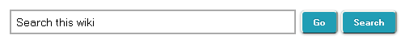
Figure 3: Simple Search box

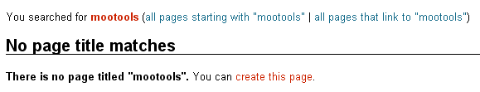
Figure 4: Message for no matches

Advanced Search
Advanced Search provides extra searching options and it can be accessed via Special:Search page. A user may restrict a search to pages within a particular namespace. By default only the namespaces specified in user’s preferences will be searched (Figure 5)

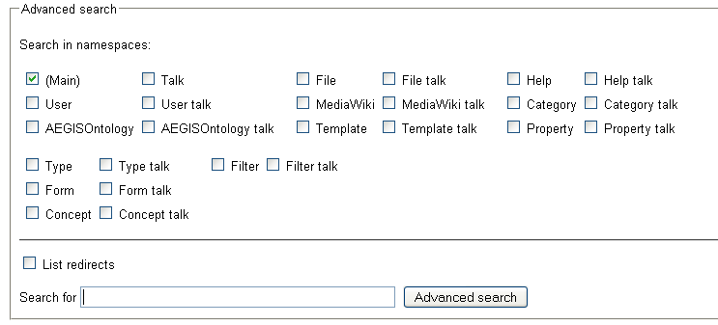
Figure 5: Advanced search

Semantic search
Semantic search in AEGIS Semantic Wiki is based on an easy-to-use query language (wikiQL) which enables users to obtain knowledge from information included in Wiki by the submission of the appropriate queries. If a user enters an inline query, a list of pages that match the submitted search will be presented (or a message about no matches found in case the results of the search query is empty). It can be accessed via Special:Ask page or at the Quicklinks menu- “Semantic Search”.

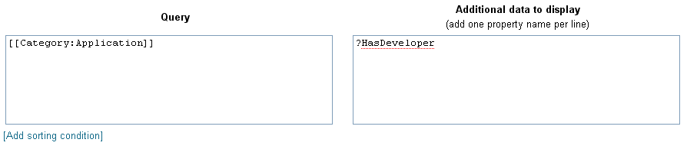
Figure 6: Inline query in semantic search

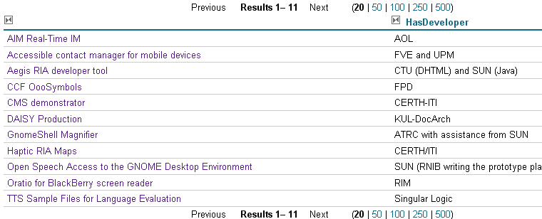
Figure 7: Results for inline query in Semantic search

Search by property
A user is able to search for a specific value of a property. When he enters the property and the value, a list of pages that matched his search is presented to him. In case the query returns empty information a “no matches found” messages appears. It can be accessed via Special:SearchByProperty page or at the Quicklinks menu- “SearchByProperty”.

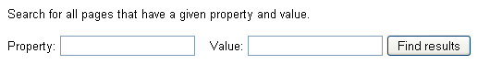
Figure 8: Search by property

AEGIS Mediawiki Help: Ontology Browsing (see also video-part3)
The Ontology Browser gives a fast and comprehensive overview of the wiki's ontology (i.e. its semantic knowledge model). It allows users to navigate through the category and property hierarchy and to inspect instances and their characteristics. Wiki administrators can use the Ontology Browser for changing the ontology quickly, e.g. by adding and renaming categories or deleting instances. Furthermore the displayed ontology can be searched and filtered. It can be accessed via Special:OntologyBrowser page or at the Quicklinks menu- “OntologyBrowser”.
The OntologyBrowser has 3 basic views:
- CategoryView: Shows category hierarchy. One may use the buttons above it to switch views and show the attribute and relation hierarchy.
- InstanceView: This view will always show the instances
- PropertyView: This view will either show the annotated properties or the schema properties.
Below every view is a filter input box. It filters the entities that are currently available in the view above it i.e. those entities that are currently in the memory. It is filtered dynamically whenever the filter text changes. The actual filtering is case-insensitive and uses substring matching. All entities are in alphabetical order with one exception: The instance view shows a category’s direct instances first.
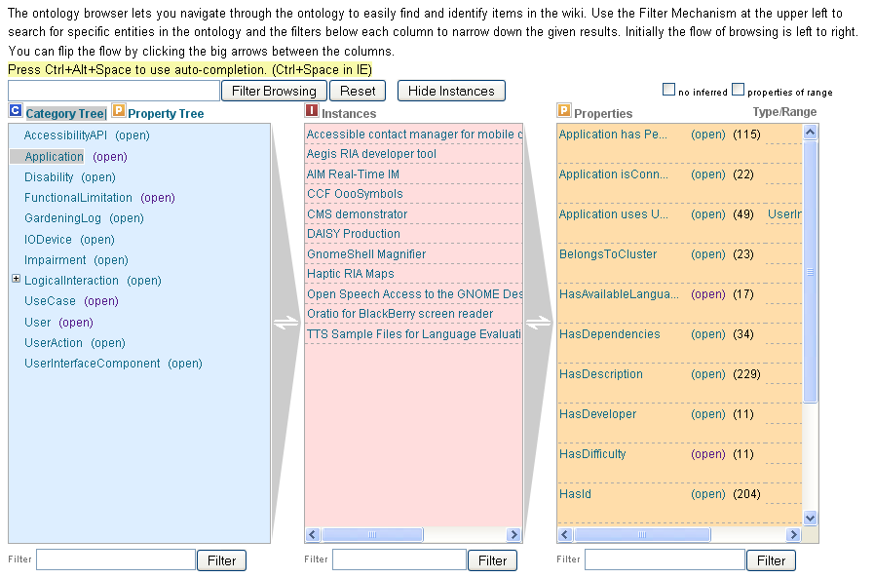
Figure 9: The OntologyBrowser displaying the three basic views

The Category View
The CategoryView will initially show the root categories. The user may expand the category tree by clicking the small plus icons that are in front of every category name or by selecting the category directly. These crosses will appear even if there no subcategory. In such cases, the icon will disappear when the user tries to expand it, otherwise the subcategories display.

Category Selection
The user may select a category. Selected categories get a gray background. In this case, the instance view shows all its instances. The direct categories will be displayed first while the inherited categories are displayed afterwards. It additionally shows the inherited instances actual category in angle brackets. The property view shows the schema attributes and relations which have the category as their domain. Only the direct ones and not the inherited one are displayed. Some additional information about properties is also shown:
The attributes will have this additional information:
- type e.g. string, integer, boolean. The relation that defines this value has type
- cardinality e.g. 1..2, 0..* (the last value is set by default). The Attribute which defines this value has min cardinality or has max cardinality.
The relations will have this additional information:
- range category. The relation which defines this value has a range hint
- cardinality e.g. 1..2, 0..* (the last value is set by default) the attribute which defines this: has min cardinality or has max cardinality
- symmetrical / transitive : These ones determine if a relations is symmetrical and/or transitive.

Instance Selection
If the user selects an instance, the property view will switch to the annotations of this instance. It's a two-column table showing attribute/relation name and its value.

The Attribute View
The user may select the AttributeView which shows the attribute hierarchy. It initially displays the root level. The user may expand it, just like the categories. If the user selects an attribute here, all instances annotating this attribute will be shown. The property view content does not change.

The Relation View
The user may select the RelationView which shows the relation hierarchy. It initially displays the level. The user may expand it, just like in the categories. If the user selects a relation at this point, all instances annotating this relation will be shown. The property view content does not change.

AEGIS Mediawiki Help: Querying Data (see also video-part4)
The Query interface is a special page. It may therefore be accessed from the page Special:QueryInterface or from the Quicklinks – “Query Interface” at the bottom of the wiki.
The Query interface is divided into two sections:
- Query definition section where you may define queries
- Results section where you can format and preview your query results.
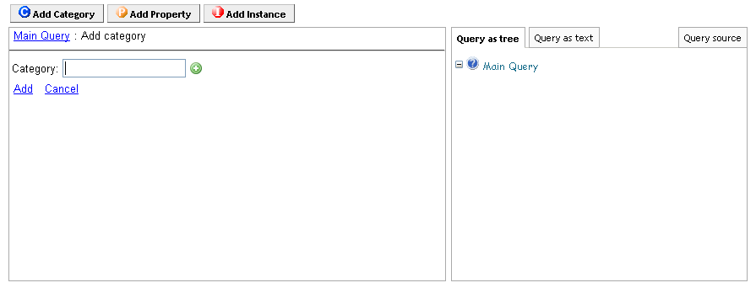
Figure 10: Overview of Query interface

The Query definition section
This section has three menu-bars. Namely, Add Category, Add Category and Add Instance. The functionality of these buttons is described below.

The Add Category menu
Clicking this menu lets you specify a category. In specifying this, you display the instances of this category.
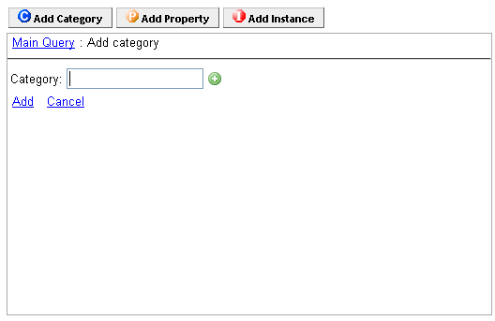
Figure 11: Add category

The Add Property menu
Clicking this menu lets you specify a certain property that the results ought to fulfil. You may either list all results or define specific values.
Figure 12:Add property

The Add Instance menu
Clicking this menu lets you specify an instance such that only one page is included.
Figure 13:Add instance

Semantic autocomplete feature
The Query interface supports the semantic autocomplete feature as shown in the picture below:
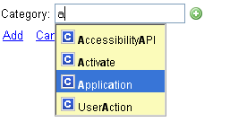
Figure 14: Autocomplete feature
The semantic autocomplete feature is triggered by pressing the Ctrl + Alt + Space key combination as you add a category constraint, a property or an instance to your query.

The Result section
The second section of the Query interface is the Result section which divided into two subsections, namely:
- The Layout Manager subsection where you can define the layout of the query results
- The Result Preview subsection where the results of the query are displayed
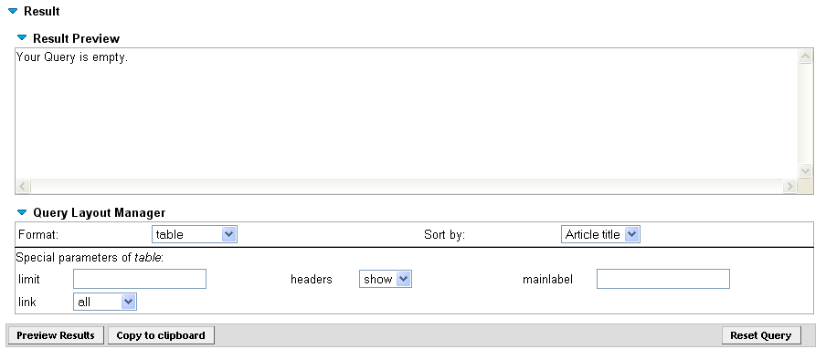
Figure 15: Format the query results as you wish

Sparql queries

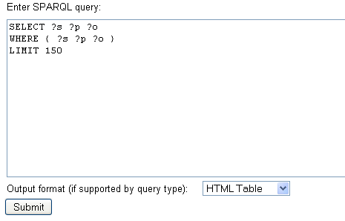
Figure 16: Sparql query endpoint

AEGIS Mediawiki Help: Gardening
The Gardening extension provides a compilation of bots to support the maintenance of a semantic wiki. Some bots are intended to find inconsistencies or anomalies, other are used to do long-running jobs. The Gardening bots are accessible via the SpecialPage of the bot framework which manages the bot execution- special:Gardening or at the Quicklinks menu – “Gardening”.
The gardening extension helps to find inconsistencies in the ontology. It can
- check the wiki consistency
- materialize template content
- find undefined entities
- find pages without annotations
- find anomalies and
- check referential integrity
- export the wiki as OWL ontology
- import an OWL file into the wiki
The findings are logged and displayed in the gardening log.
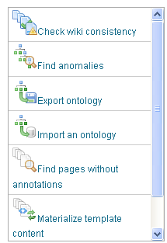
Figure 17: Gardening bots

