apt install python-opencv

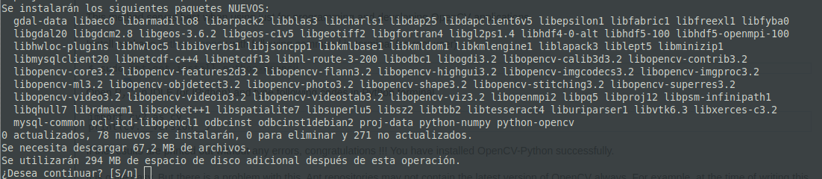

Dependencias opcionales

sudo apt install libpng-dev
sudo apt install libjpeg-dev
sudo apt install libopenexr-dev
sudo apt install libtiff-dev
sudo apt install libwebp-dev

