The title

author name

xxxx

This is an abstract

Table of Contents

# Introduction

Some review of the subject and the list of hypotheses discussed at meetings.

# Table 1

diamonds %>%  
 tableone::CreateTableOne(  
 data = .,  
 includeNA = T,  
 # strata = "visit",  
 addOverall = T  
 ) %>%  
 tableone::kableone()

|  | Overall |
| --- | --- |
| n | 53940 |
| carat (mean (SD)) | 0.80 (0.47) |
| cut (%) |  |
| Fair | 1610 ( 3.0) |
| Good | 4906 ( 9.1) |
| Very Good | 12082 (22.4) |
| Premium | 13791 (25.6) |
| Ideal | 21551 (40.0) |
| color (%) |  |
| D | 6775 (12.6) |
| E | 9797 (18.2) |
| F | 9542 (17.7) |
| G | 11292 (20.9) |
| H | 8304 (15.4) |
| I | 5422 (10.1) |
| J | 2808 ( 5.2) |
| clarity (%) |  |
| I1 | 741 ( 1.4) |
| SI2 | 9194 (17.0) |
| SI1 | 13065 (24.2) |
| VS2 | 12258 (22.7) |
| VS1 | 8171 (15.1) |
| VVS2 | 5066 ( 9.4) |
| VVS1 | 3655 ( 6.8) |
| IF | 1790 ( 3.3) |
| depth (mean (SD)) | 61.75 (1.43) |
| table (mean (SD)) | 57.46 (2.23) |
| price (mean (SD)) | 3932.80 (3989.44) |
| x (mean (SD)) | 5.73 (1.12) |
| y (mean (SD)) | 5.73 (1.14) |
| z (mean (SD)) | 3.54 (0.71) |

# Basic descriptive characteristics

## Distribution of age by sex

diamonds %>%  
 ggplot(aes(price, fill = color)) +  
 geom_density(alpha = .3) +  
 labs(  
 title = "Age Male x Female", x = "Age",  
 y = "Density"  
 ) +  
 theme_linedraw()

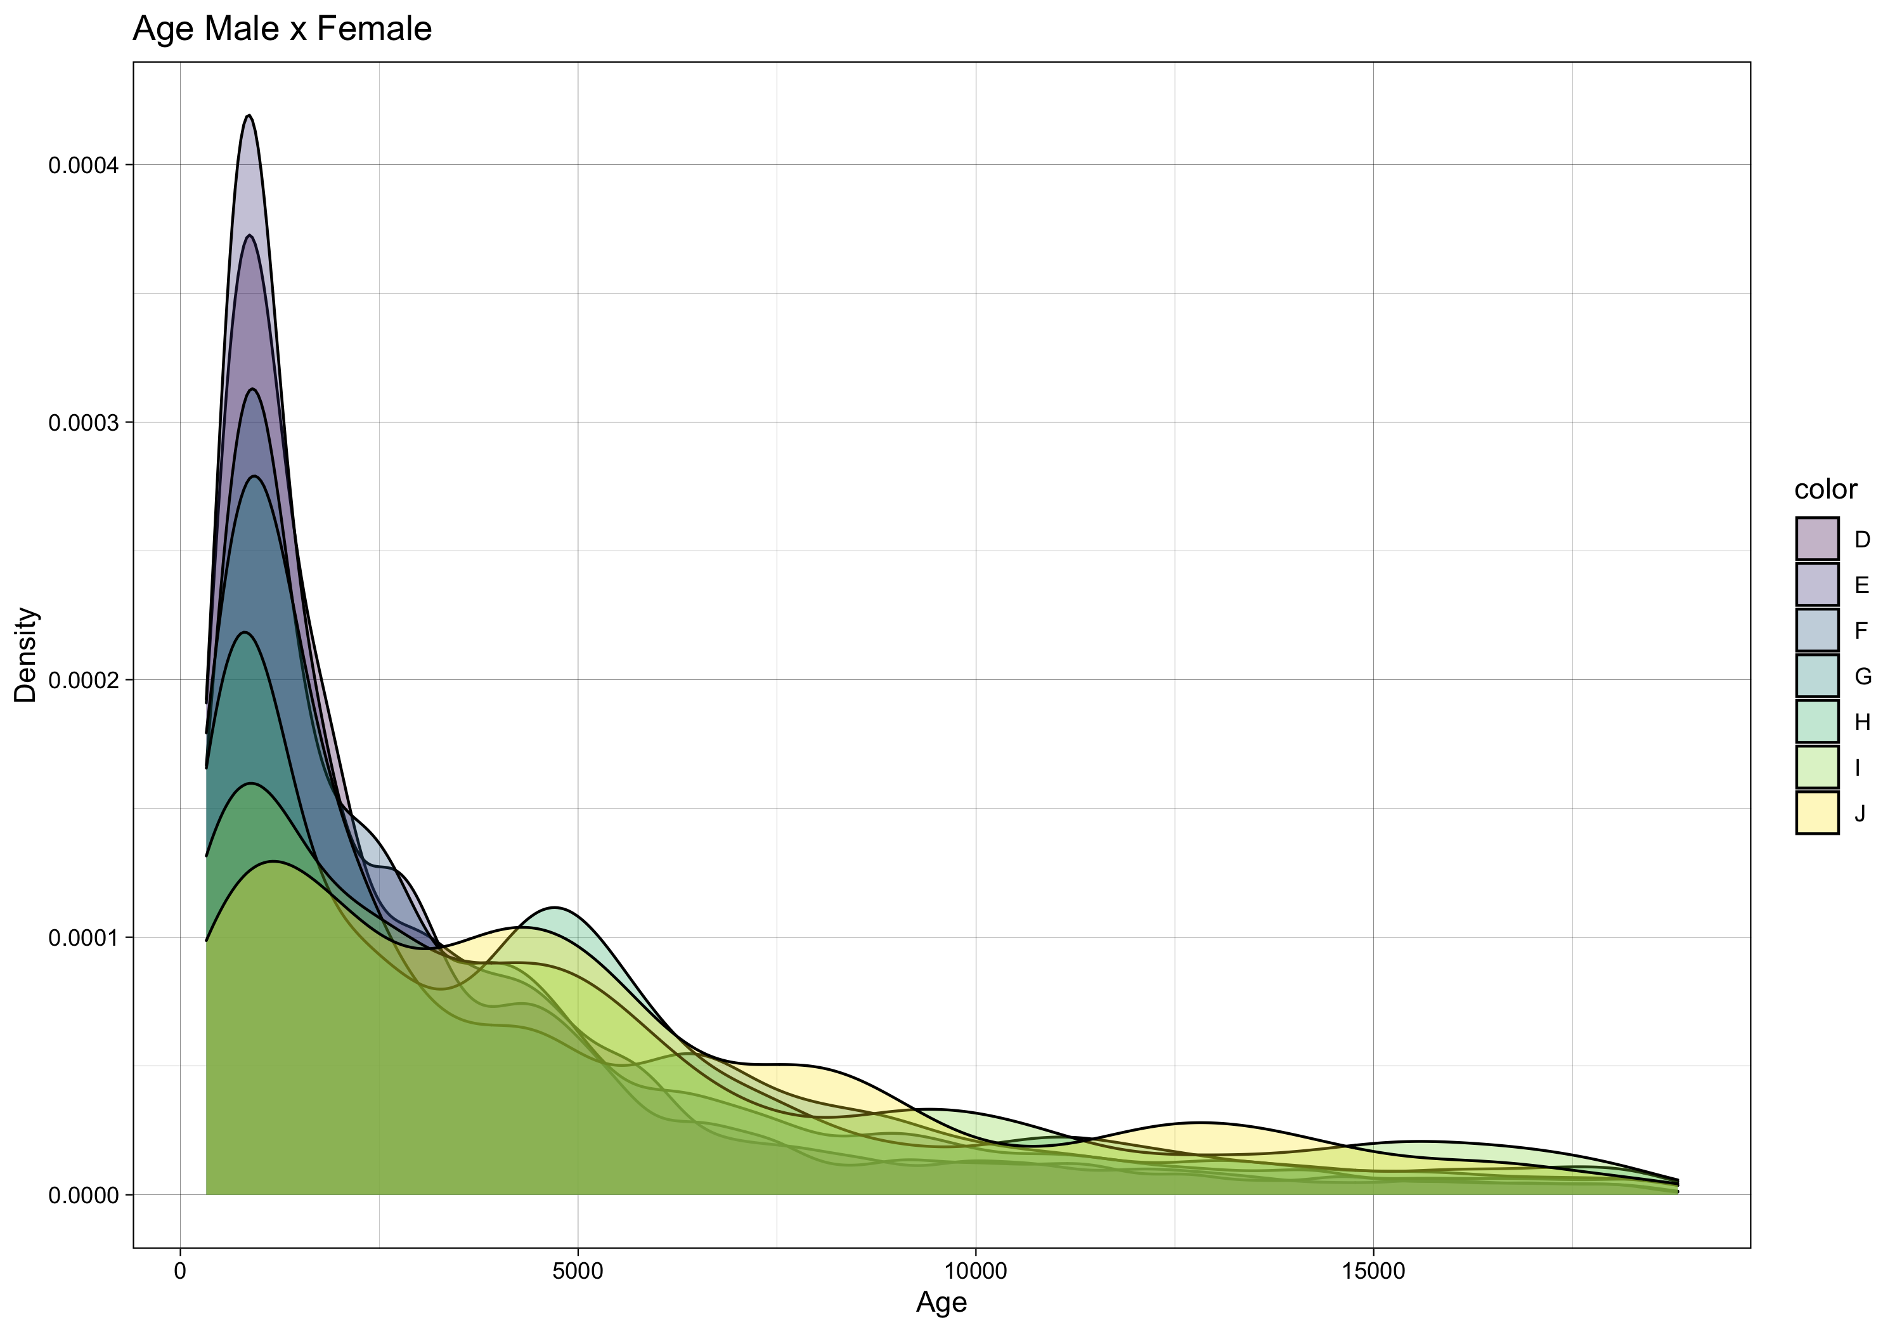

## Missing and categories and distribution in one picture

tabplot::tableplot(diamonds)

Registered S3 methods overwritten by 'ffbase':  
 method from  
 [.ff ff   
 [.ffdf ff   
 [<-.ff ff   
 [<-.ffdf ff

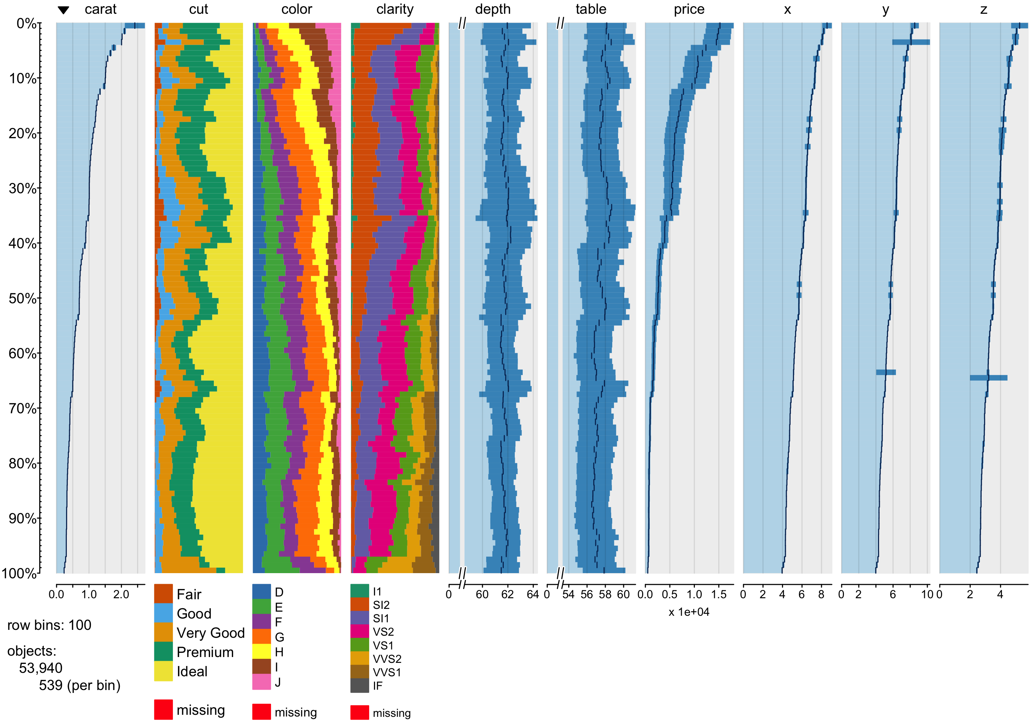

Missings, categories and distributions

## Any correlated?

diamonds %>%  
 select_if(is_numeric) %>%  
 psych::pairs.panels(.,  
 method = "pearson", # correlation method  
 hist.col = "#00AFBB",  
 density = TRUE, # show density plots  
 ellipses = TRUE # show correlation ellipses  
 )

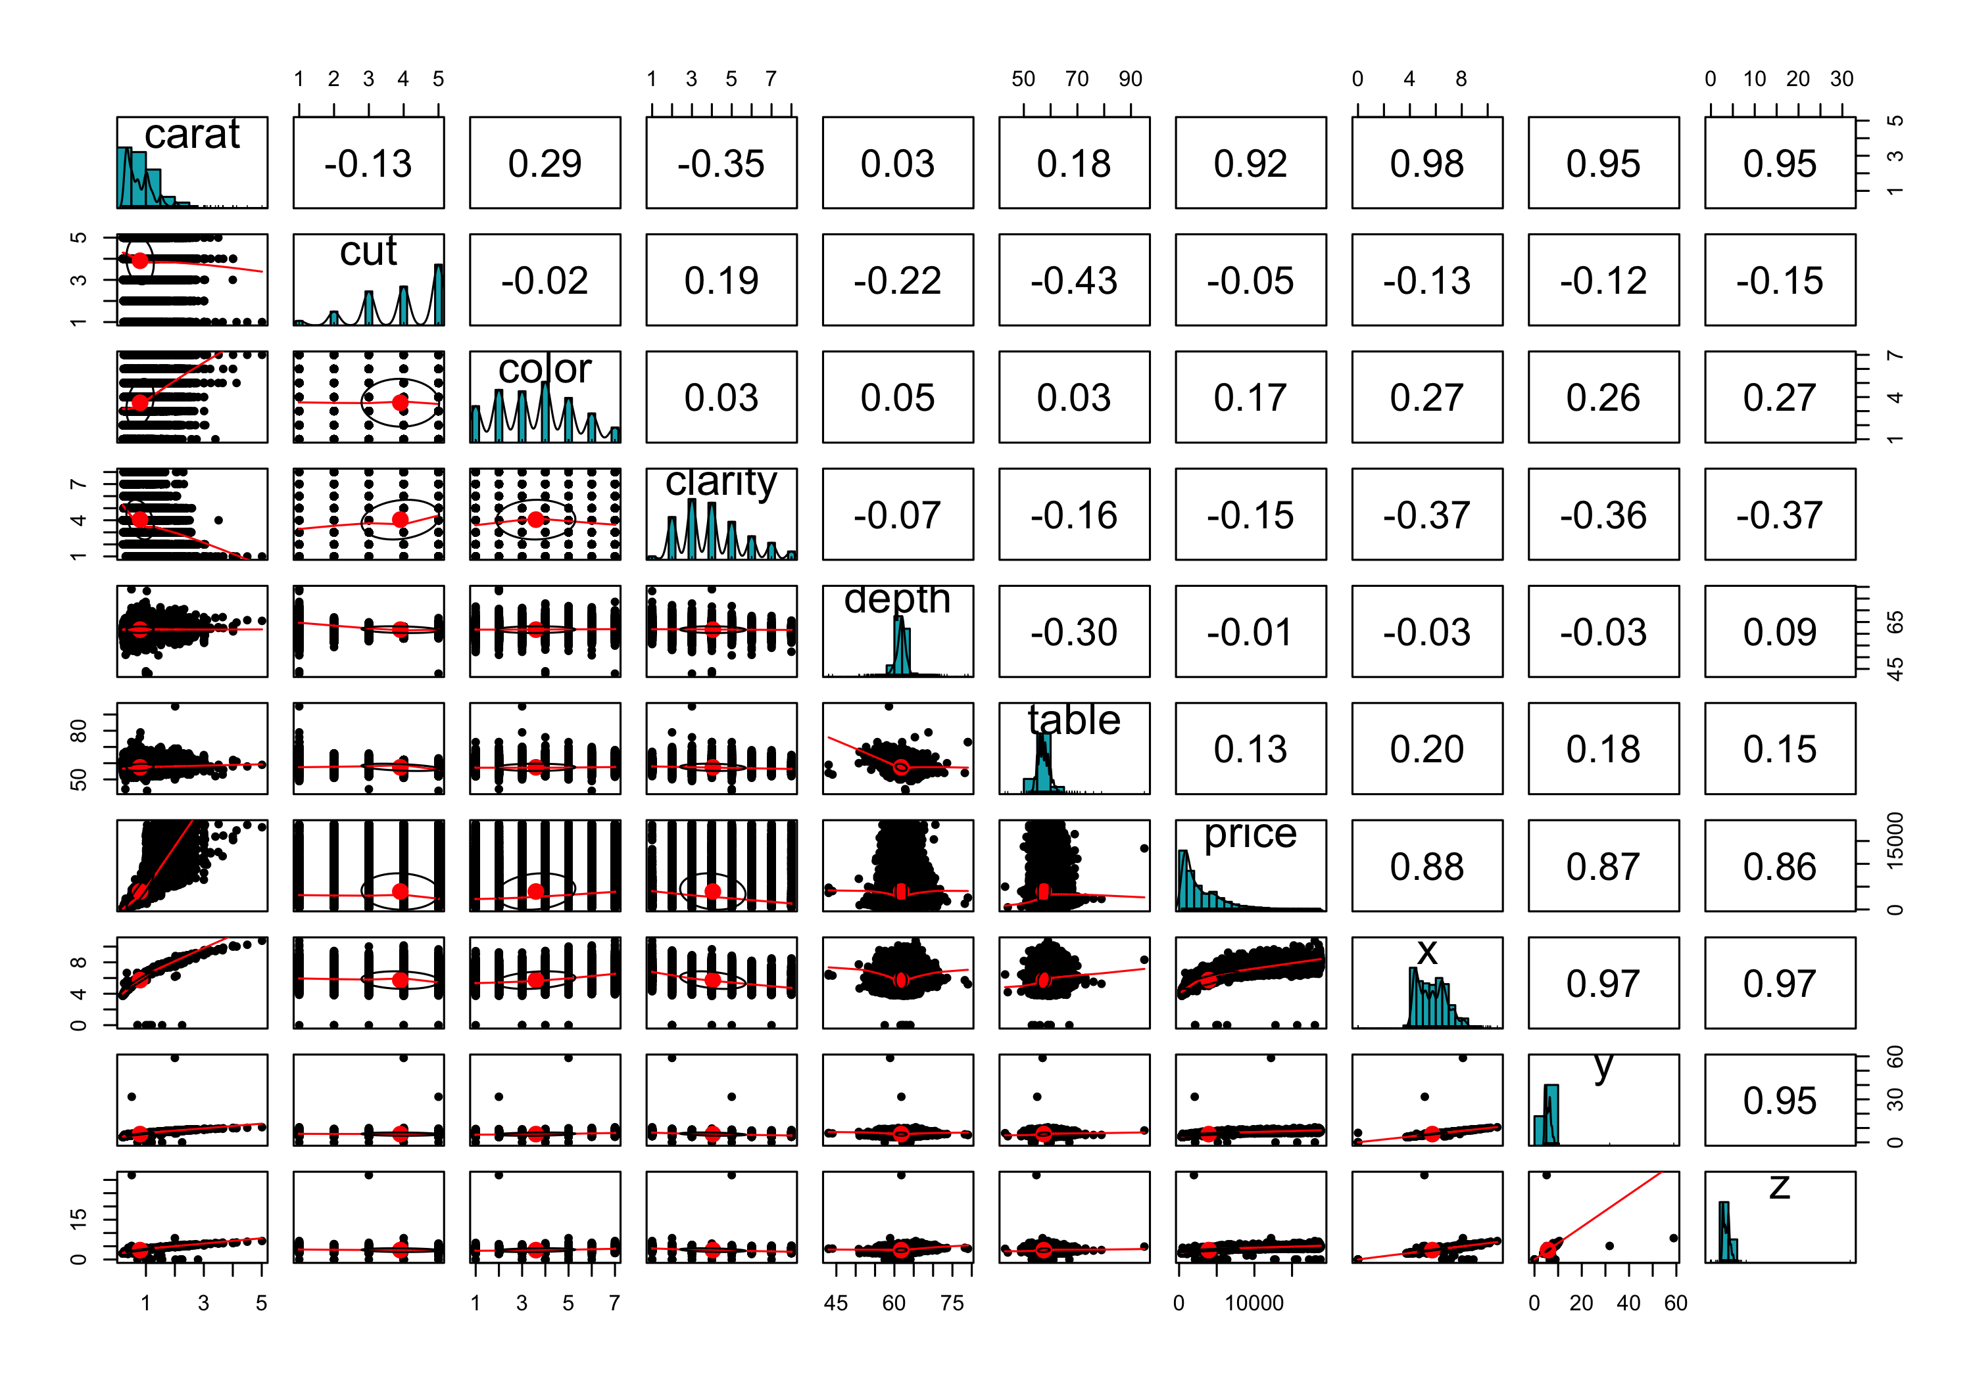

## More info on distribution with boxplots

diamonds %>%  
 select_if(is.numeric) %>%  
 gather(key = "ind", value = "values") %>%  
 ggplot(aes(x = ind, y = values)) +  
 geom_boxplot() +  
 coord_flip() +  
 theme_minimal() +  
 scale_fill_grey()

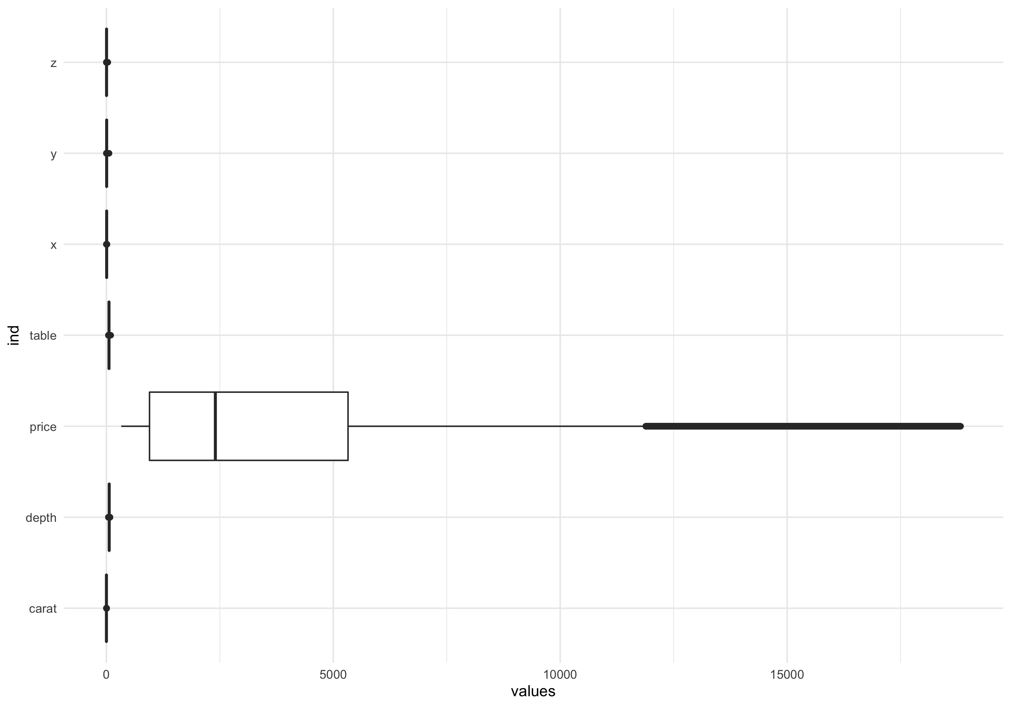

# System information

project.info

$config  
$config$version  
[1] "0.10.2"  
  
$config$data_loading  
[1] TRUE  
  
$config$data_loading_header  
[1] TRUE  
  
$config$data_ignore  
[1] ""  
  
$config$cache_loading  
[1] TRUE  
  
$config$recursive_loading  
[1] FALSE  
  
$config$munging  
[1] TRUE  
  
$config$logging  
[1] FALSE  
  
$config$logging_level  
[1] "INFO"  
  
$config$load_libraries  
[1] TRUE  
  
$config$libraries  
[1] "dtplyr"  
  
$config$as_factors  
[1] FALSE  
  
$config$tables_type  
[1] "data.table"  
  
$config$attach_internal_libraries  
[1] FALSE  
  
$config$cache_loaded_data  
[1] TRUE  
  
$config$sticky_variables  
[1] "NONE"  
  
$config$underscore_variables  
[1] TRUE  
  
$config$cache_file_format  
[1] "RData"  
  
  
$packages  
[1] "dtplyr"  
  
$helpers  
[1] "pclean.R"

sessionInfo()

R version 4.1.2 (2021-11-01)  
Platform: aarch64-apple-darwin20 (64-bit)  
Running under: macOS Monterey 12.1  
  
Matrix products: default  
BLAS: /Library/Frameworks/R.framework/Versions/4.1-arm64/Resources/lib/libRblas.0.dylib  
LAPACK: /Library/Frameworks/R.framework/Versions/4.1-arm64/Resources/lib/libRlapack.dylib  
  
locale:  
[1] en_US.UTF-8/en_US.UTF-8/en_US.UTF-8/C/en_US.UTF-8/en_US.UTF-8  
  
attached base packages:  
[1] stats graphics grDevices utils datasets methods base   
  
other attached packages:  
 [1] dtplyr_1.2.0 forcats_0.5.1 stringr_1.4.0 dplyr_1.0.7   
 [5] purrr_0.3.4 readr_2.1.1 tidyr_1.1.4 tibble_3.1.6   
 [9] ggplot2_3.3.5 tidyverse_1.3.1  
  
loaded via a namespace (and not attached):  
 [1] httr_1.4.2 jsonlite_1.7.2 viridisLite_0.4.0   
 [4] splines_4.1.2 tmvnsim_1.0-2 ffbase_0.13.3   
 [7] here_1.0.1 modelr_0.1.8 assertthat_0.2.1   
[10] highr_0.9 cellranger_1.1.0 yaml_2.2.1   
[13] pillar_1.6.4 backports_1.4.1 lattice_0.20-45   
[16] glue_1.6.0 digest_0.6.29 rvest_1.0.2   
[19] colorspace_2.0-2 psych_2.1.9 htmltools_0.5.2   
[22] Matrix_1.3-4 survey_4.1-1 pkgconfig_2.0.3   
[25] broom_0.7.11 labelled_2.9.0 haven_2.4.3   
[28] scales_1.1.1 tabplot_1.4.1 ff_4.0.5   
[31] tzdb_0.2.0 proxy_0.4-26 generics_0.1.1   
[34] farver_2.1.0 ellipsis_0.3.2 withr_2.4.3   
[37] mnormt_2.0.2 cli_3.1.0 survival_3.2-13   
[40] magrittr_2.0.1 crayon_1.4.2 readxl_1.3.1   
[43] evaluate_0.14 fs_1.5.2 fansi_0.5.0   
[46] nlme_3.1-153 xml2_1.3.3 class_7.3-19   
[49] tableone_0.13.0 tools_4.1.2 data.table_1.14.2   
[52] hms_1.1.1 mitools_2.4 lifecycle_1.0.1   
[55] ProjectTemplate_0.10.2 munsell_0.5.0 reprex_2.0.1   
[58] compiler_4.1.2 e1071_1.7-9 rlang_0.4.12   
[61] grid_4.1.2 rstudioapi_0.13 labeling_0.4.2   
[64] rmarkdown_2.11 gtable_0.3.0 DBI_1.1.2   
[67] R6_2.5.1 zoo_1.8-9 lubridate_1.8.0   
[70] knitr_1.37 bit_4.0.4 fastmap_1.1.0   
[73] utf8_1.2.2 fastmatch_1.1-3 rprojroot_2.0.2   
[76] stringi_1.7.6 parallel_4.1.2 Rcpp_1.0.7   
[79] vctrs_0.3.8 dbplyr_2.1.1 tidyselect_1.1.1   
[82] xfun_0.29

# References