An exhaustive search approach to solving the max clique problem
Rodrigo Ferreira

Resumo – Este artigo começa por contextualizar conceitos essenciais ao tema do problema, como o conceito de grafo, nós, arestas, subgrafo e clique. Passa então descrever o problema em questão. Depois de estabelecidas tais bases, explica o conceito de algoritmos de pesquisa de força bruta e em particular, pesquisa exaustiva. As suas características, vantagens, desvantagens, e como se encaixa no problema em questão, assim como uma avaliação dos resultados obtidos.

Abstract – This paper starts out by contextualizing important concepts essential to the understanding of its theme, like graphs, nodes, edges, subgraphs and cliques. Afterwards, the problem at hand is described. When the basic concepts and the problem are explained, we move on to the topic of brute force search, and exhaustive search in particular. Its characteristics, advantages, disadvantages, how it fits into this theme, as well as an evaluation of its results.

I. Introduction
We can’t discuss the max clique problem without first establishing some key concepts.
Graphs are structures composed of 2 sets, a set V, of nodes, and a set E of edges (we are always talking about undirected graphs in this paper).
Nodes, vertices, or points are the fundamental unit of which graphs are formed, in a graph diagram they are objects usually represented by a circle with a label.
Edges are pairs of nodes, representing a relation between them, in the case at hand (undirected graphs), (i,j) implies (j,i), this isn’t the case for arcs in directed graphs but we’re not using that structure here. In a graph diagram, edges are usually represented by a line uniting two nodes.
Subgraph…

II. Another heading (The 1ª letter is caps)
When you want to create a figure, you must align it to the center, insert a Frame in the selection figure+legend and select Format-Frame (top or bottom) in order to avoid figures in the middle of the page. Finally remove the Border.
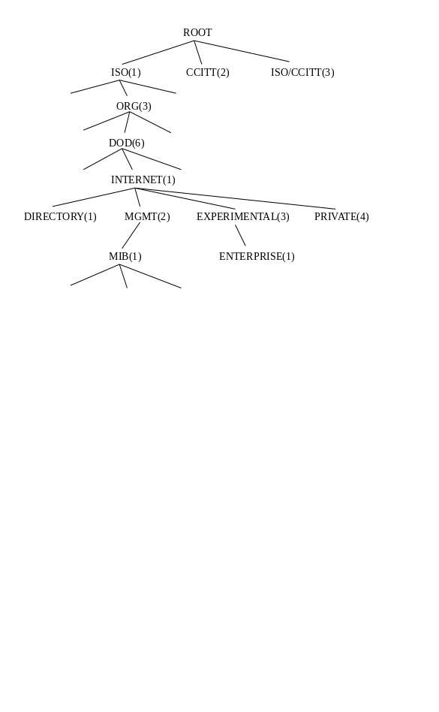

Fig. 1 - This is Style “legenda”.A. This sub-title is of Style Heading 2
To construct a item enumeration use the format “pontos”.
• bla-bla-bla;

To insert programs code or similar text just use the format “código” :

OBJECT-TYPE MACRO::=
BEGIN
TYPE NOTATION ::=
ReferPart
IndexPart
DefValPart
VALUE NOTATION ::= value (VALUE ObjectName)

References
Use the Style “referencia” to the references. Example:
[1] M. T. Rose and K. McCloghrie, "Structure and Identification of Management Information for TCP/IP-based Internets", RFC 1155, DDN Network Information Center, SRI International, May 1990.

This file is available by anonymous FTP in:
greco.inesca.pt: ~/pub/docs/dos/revdetua.doc
$ftp greco.inesca.pt
user: anonymous
passwd: <none>
cd pub/docs/dos
bin
get revdetua.doc
bye
$

Any comments to enhance this format can be send to jlo@inesca.pt.
This document was written in Word for Windows 2.0.

94.6.13 JLO

