**Rodrigo Valdes Ortiz**

MACS 30200

Problem Set 1

**Data Section**

***General Description***

The data come from the Current Population Survey (CPS), sponsored jointly by the U.S. Census Bureau and the U.S. Bureau of Labor Statistics. It is the primary data source for labor statistics in the United States. The survey is monthly, the response rate is about 90 percent, and it provides reliable estimates at the state level. For this paper, I will use the observations for January 2016.

The survey comprises data from a probability selected sample of about 60,000 occupied households. The households are in the survey for four consecutive months, then out for eight, and finally again in the survey for four months. Each month, one-eighth of the sample is new. Typically, one adult of the household provides information of all the habitants.

The CPS is based on a computerized questionary used by field representatives, which interview personally and by phone. Generally, the week which contains the 19th of the month is the interview period while the reference week is one week before, which includes the 12th of the month. Due to the structure of the survey, it is used to collect other information valuable for the sponsors, such as tobacco use, computer use, expectations of family size, among others. The data is available through the main website of the United States Census Bureau, as well as the National Bureau of Economic Research. Moreover, other distributors of this data are IPUMS and ICPSR.

This CPS has been used to study labor economics and other issues since the forties. For instance, Burkhauser, Couch, and Wittenburg (2000) utilized it to estimate the effects of changes in the federal minimum wage from 1979 to 1997. Also, Funkhouser and Trejo (1995) used it to track the labor market skills of male immigrants. In the same vein, Oaxaca and Ransom (2002) used it to test a model about discrimination and wage differentials. Finally, Louis-Philippe (2015) utilized it to estimate the causal impact of US governors party on labor market outcomes.

***Description of the data***

There are 151,010 observations at the individual level. The summary statistics are in Table 1. The mean age of the sample is 39 years, while the average family income is 67,052 USD per year. Also, the average number of own children bellow 18 years old is 0.38, and the mean of years in college is only about 1.85, for those who attended college (28,850).

**Table 1. Summary Statistics**

|  |  |  |  |  |  |  |  |  |
| --- | --- | --- | --- | --- | --- | --- | --- | --- |
|  | **Age** | **Gender** | **Income** | **Marital status** | **Spanish only** | **Children** | **Years at college** | **Hours work weekly** |
| **count** | 130198 | 130198 | 130198 | 105420 | 151010 | 130198 | 28850 | 57932 |
| **mean** | 39.19 | 1.52 | 67052.49 | Married (mode) | 0.02 | 0.38 | 1.85 | 37.26 |
| **std** | 23.03 | 0.50 | 45575.89 | NA | 0.14 | 0.87 | 0.92 | 10.64 |
| **min** | 0 | 1 | 2500 | NA | 0.0 | 0.0 | 0.5 | 10 |
| **max** | 85 | 2 | 150000 | NA | 1 | 13 | 4 | 50 |

The summary statistics by sex are in Table 2. There are differences between males and females regarding age, family income, the number of children and usual hours worked weekly. For instance, the mean yearly salary of a man is about 68,600, while the average for a female is 65,600. In the same vein, the mean usual hours worked weekly are 39.18, and 35.22, respectively. Also, women are on the average, older than males, with a mean age of 40.16 versus 38.16 for men.

**Table 2. Statistics by Gender**

|  |  |  |  |  |  |  |  |
| --- | --- | --- | --- | --- | --- | --- | --- |
| **Gender** | **Age** | **Income** | **Marital status** | **Spanish only** | **Children** | **Years at college** | **Hours work weekly** |
| **Male** | 38.16 | 68647.91 | Married(mode) | 0.023 | 0.348 | 1.86 | 39.18 |
| **Female** | 40.16 | 65558.85 | Married(mode) | 0.022 | 0.407 | 1.84 | 35.22 |

As depicted in the Graph 1, the higher incomes occur when persons are in a mature professional career, between forty and fifty years old. Meanwhile, people tend to have more children below eighteen when they are about forty years old. Furthermore, higher income is related to two kids (see Appendix).

**Graph 1**

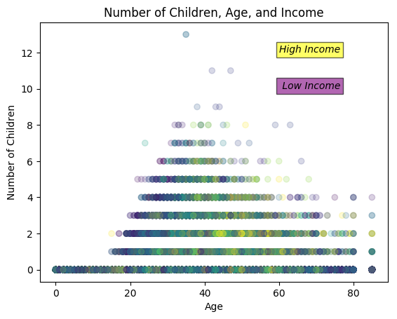

**BIBLIOGRAPHY**

Beland, L. P. (2015). Political parties and labor-market outcomes: Evidence from us states. *American Economic Journal: Applied Economics*, *7*(4), 198-220.

Burkhauser, R. V., Couch, K. A., & Wittenburg, D. C. (2000). A reassessment of the new economics of the minimum wage literature with monthly data from the Current Population Survey. *Journal of Labor Economics*, *18*(4), 653-680.

Funkhouser, E., & Trejo, S. J. (1995). The labor market skills of recent male immigrants: Evidence from the Current Population Survey. *ILR Review*, *48*(4), 792-811.

National Bureau of Economic Reseach. Current Population Survey (CPS) Basic Monthly Data at the NBER. Accessed on April 17th, 2017. http://nber.org/data/cps_basic.html

Oaxaca, R. L., & Ransom, M. R. (1994). On discrimination and the decomposition of wage differentials. *Journal of econometrics*, *61*(1), 5-21.

United States Census Bureau (2017). About the Current Population Survey. Accessed on April 19th, 2017. https://www.census.gov/programs-surveys/cps/about.html

**APPENDIX**

**Table 3. Statistics by Number of Children**

|  |  |  |
| --- | --- | --- |
| **Children** | **Income** | **Age** |
| 1 | 65179.0 | 39.1 |
| 2 | 72680.2 | 40.6 |
| 3 | 79067.3 | 39.1 |
| 4 | 71796.4 | 38.2 |
| 5 | 66205.8 | 37.9 |
| 6 | 61841.9 | 37.4 |
| 7 | 57954.1 | 38.9 |
| 8 | 55113.2 | 36.9 |
| 9 | 72249.6 | 42.1 |
| 11 | 36666.2 | 41.7 |
| 12 | 32499.5 | 44.5 |
| 13 | 54999.5 | 35.0 |