# Ink Tutorial– Installation Guide

1. First you must have Eclipse IDE installed. To do that, follow these steps:
   1. Download the Eclipse IDE latest version for Java developers from this URL <http://www.eclipse.org/downloads/>
   2. Unpack and install the Eclipse IDE.
2. Install the Ink-Framework Eclipse plugin:
   1. Go to ‘Help’🡪’Install New Software…’
   2. Type in the Ink-Framework update site URL : <http://aop.cslab.openu.ac.il/research/ink.eclipse.site/> :

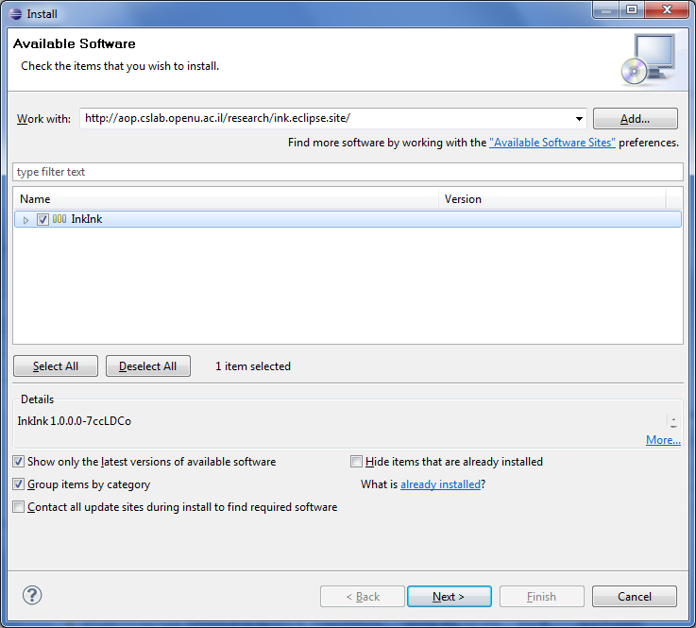Mark the ‘InkInk’ flag and then click the ‘Next’ button.

* 1. Complete the installation process and restart the Eclipse.

1. Install Eclipse SVN plugin :
   1. Follow these instructions : <http://subclipse.tigris.org/servlets/ProjectProcess?pageID=p4wYuA>
   2. Or simply go to ‘Help’🡪’Install New Software’ 🡪 type in the update site URL <http://subclipse.tigris.org/update_1.6.x> 🡪 ‘Next’…
2. Download the ‘ink-tutorial’ Eclipse project:
   1. Go to ‘File’🡪’Import’ and choose ‘Checkout Projects from SVN’.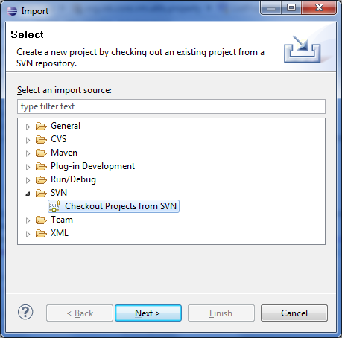
   2. Choose ‘Create a new repository location’ 🡪 ‘Next’.
   3. Paste the following URL: <http://svn.codespot.com/a/eclipselabs.org/ink/trunk/ink.tutorials> and press ‘Next’.

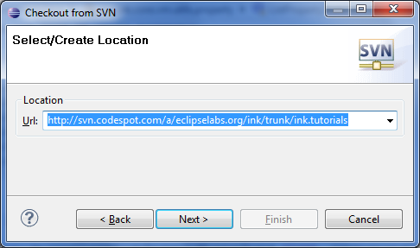

* 1. Choose the root element and press ‘Finish’.

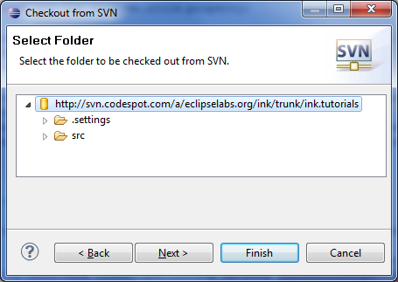

* 1. Restart the Eclipse IDE.
  2. Launch Clean-Build : Go to ‘Project’🡪’Clean’ (make sure ‘Clean all projects’ is marked)🡪Press ‘OK’.