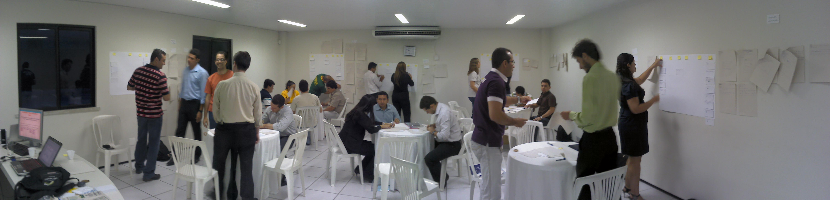
Kanban
Running The Flow Hour
Rodrigo Yoshima
@rodrigoy
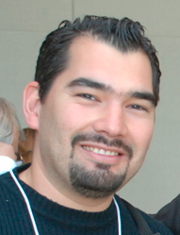
Good: Trainers talk less.
Better: Participants talk more.
Best: Participants DO more.

Dr. Sivasailam "Thiagi" Thiagarajan
”

A trainer who doesn't create his/her own
exercices and lessons is not a good trainer
but a copy/paste trainer.
Gendy Brown
“

About the Author:

Rodrigo Yoshima is a brazillian IT expert developing
computer systems since he was 12 years old.

For the last 16 years he is actively working with
complex systems for many companies and industries.

In 2005 he started to train and coach many teams
on good management and technical practices specially
with Agile Methods.

He owns Aspercom, a first-class company on IT
Training and consulting in Brazil.

Message for the Brazilian Software Industry:

Hope you shine on the worldwide market, find your own style, be creative and stop doing the same thing expecting different results. We can create software that changes the world.

Special thanks to Alisson Vale, our local world famous Kanban/Lean guru, for his knowledge and patience.

Pati, Lana and Paola. You girls rock!

The Flow Hour

1. Short Introduction

When I was 18 I said: “I won't be a teacher. Never!”. Seriously. I simply hated to explain things and make people understand my points. I also hated school. School was a tedious place. Long-winded teachers, deeply bored students. Unfortunately most schools I know today follow the same pattern. I wished something different for my daughters.

Teaching people for real can be a hard experience. If you take it serious, teaching is one of the most challenging activities you will ever face. A classroom can be frightening like sharks on the prowl.

For the last 6 years I've been working as a trainer and coach here in Brazil, and since then I've been trying to promote a better learning experience to my apprentices by hands-on activities as close as possible to real business situations. This is one of Aspercom's values.

“The Flow Hour” is one of these activities that I'm glad to share with you. It's a dynamic and fun class activity that helps your apprentices to understand and feel some complex concepts around Lean and Kanban applied to computer software environments. “The Flow Hour” is quite new and truly can be expanded and improved. I really believe that the best way to do this is sharing it with you and many other Kanban and Lean trainers around the world.

2. History

The easiest way I've found to explain software development to my apprentices is to tell a story, create a situation and put them inside it. Every training program I develop has a problem, a customer and a target. My OOAD course has a hotel and a billing problem. My Scrum Workshop has a Yatching/Sailing Portal to become profitable. The Extreme Programming course, my favorite, we develop a microblog site like a corporate Twitter. This strategy is all about putting things on context and emulating real conditions with strong metaphors.

Do you know the Head First Series of books? They did an incredible job designing the visuals elements as part of the content to lightweight the reading. But they use some poor and unreal examples. In the Head First Design Patterns they put something like Pizza.java or Car.java. It may sound clear to some people, but I find it harmful because it's unreal.

Many other trainers around the world run activities using tennis balls, cards, dices, coins and origami. I never liked these activities as good metaphors for software development. Being fun is not enough.

In 2009, influenced by Alisson Vale, I've started to study and experiment Kanban and Lean science applied for software development, specially because the problems I was experiencing with some dysfunctional teams running Scrum. I was looking for alternatives. By that time I've already trained more than 100 teams on Scrum and had deep experience coaching Agile transitions on several companies.

In 2010 people started to ask more about Lean in Brazil and I was figuring out how to design a course program and its classroom activities that would explain Kanban. Something similar to the Yatching Portal activities I run on the Scrum course.

My initial vision for “The Flow Hour” had some requirements:

  - It should convince that we survive without iterations
  - To create some race, it should be a groups activity
  - People's work must be a design activity (no dices please)
  - The knowledge should grow incrementally
  - It should not take too long

Using the experience I had creating other courses, “The Flow Hour” born as an intense hands-on activity targeted to immerse participants on a fictional project requiring swarming teamwork. I summary it as “from chaos to a more visible and predictable state using Kanban”.

In February 2010 I received a call from an IT manager in trouble, striving hard to run time-boxed sprints. His IT department was a small group of around 20 developers responsible to deliver and maintain computer systems for several business units of Cvale, a big farmers' co-op with US$ 1.2 billion revenue.

Many IT managers ask me what is wrong with their Scrum. I met Cvale's guys in Palotina for a meeting and after 3 hours chat and some process design sketches we realized that due to the nature of their concurrent demand (remember, they were serving several business units) it was impossible to run time-boxed iterations efficiently. I suggested them to move to a pull system with a more flexible decoupled release cadence using Kanban, promoting a more sustainable pace.

In that first visit to Palotina I had the opportunity to train more than 40 people on Kanban, including IT, operations, managers and business analysts. That was the first time I ran “The Flow Hour” for real, and it ran smoothly. Cool experience.

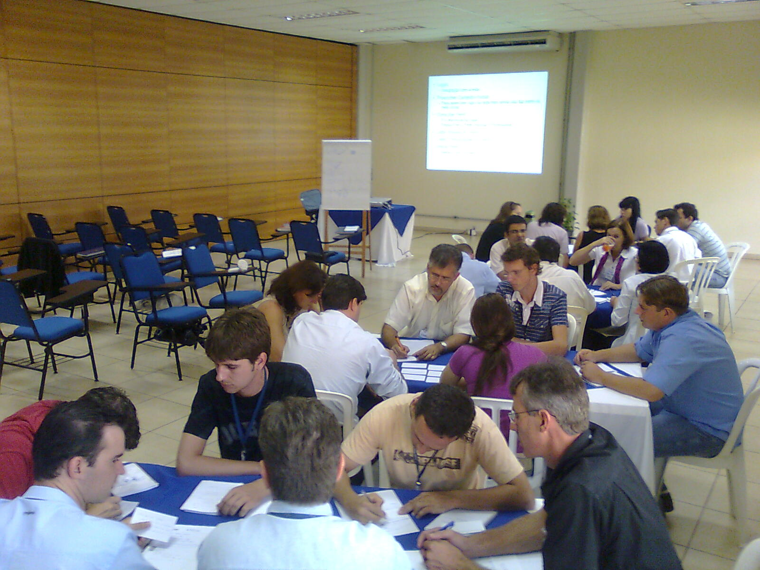
The Flow Hour at Cvale

Events and friends meetings gave me other opportunities to run and test some variations of “The Flow Hour” in 2010. Since January 2010 I was training and coaching about 100 people on Scrum and Kanban on a big insurance company in São Paulo (SulAmerica) and then some other customers asked for Kanban training. In August I decided to put a Kanban Workshop in our course list, but first, I asked Alisson Vale to evaluate it.

In November 2010 the “Maré de Agilidade”, a nice local event, was held in Fortaleza. This event gave me confidence to spread “The Flow Hour” nationwide. I invited Alisson to co-author an introductory Kanban course for the event. About 25 people attended and we run the activity together with a nice feedback.

That was the first open Kanban for Software training run here in Brazil by brazilians. I'm glad that Alisson endorsed “The Flow Hour” activity. He had hundreds of fresh ideas for variations and improvements.
The Flow Hour at Maré de Agilidade

After the event I successfully run the activity with some minor updates. It's quite enlightening for those developers used to time-boxed iterative paradigm.

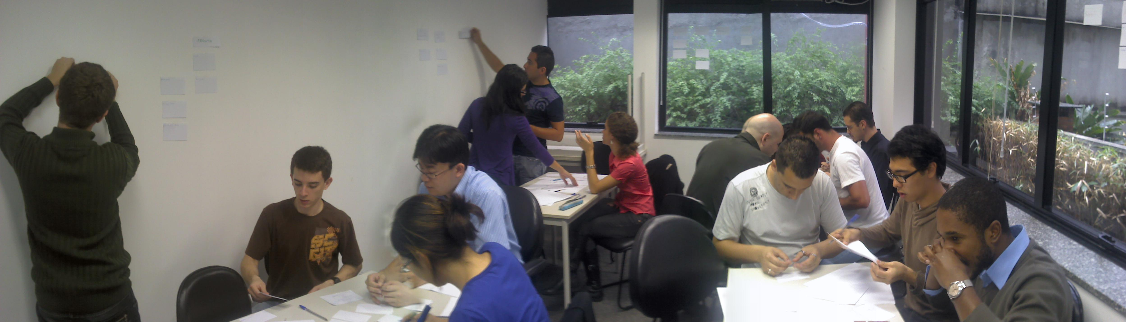
The Hour at Aurum Software – Help Desk, Services and Devs

The activity dynamic is easy, but in my experience some details are important. This document demonstrates how to run “The Flow Hour” and its rounds with no surprises. I hope you enjoy it. For document sources, slides, issues and other important information follow the links below

Github: http://github.com/rodrigoy/The-Flow-Hour
Discussion forum: http://groups.google.com/group/the-flow-hour

3. Preparing for Action
To successfully run “The Flow Hour” all you need as a trainer is courage. The first time you run it you'll feel like the things are going out of control, but stay confident and trust your participants. They might feel confused at the beginning, specially on round 1 (also called the chaos). Sometimes the best way to promote some kind of self-organization is doing nothing. The message is: trust your apprentices. They will find the way by their-selves.

Before running the activity be warned that it takes more than 1 hour. Retrospective lengths varies a lot. The number of participants also take count. Usually our classes has 12-14 people. If your class is much bigger than that maybe you should call a friend to help you. As I mentioned before, Alisson and I run with 25 people, 5 groups. I don't think it would work without his help. With 15 people expect that it will take between 1:30h to 2:00h.

The room must have table and chairs for each group. Groups can be 4-7 people. Each group also must have a good wall space to put the Kanban board. The space will be quite noisy and people will need to walk around a lot. You must use the slides, so a projector is needed.
Other materials are listed below:

  - Sheets
  - Index Cards (small size)
  - Pens / Pencils
  - Post-its
  - Adhesive Tape

4. Explaining the Activity
First of all, read all the slides and try to run the activity by yourself. Simulate what will happen and create a script adapted to your style and course program. I usually start my Kanban course with “The Flow Hour”. It helps breaking the ice and gives me feedback of people's level. It also builds up a nice knowledge base for the rest of the course.

Note that the first slides explains barely enough to run the first round. Here is an important detail on the initial explaining to the groups: do not give participants too much information! Don't say we will break stories later, don't say we will design a Kanban board, don't say anything! Just read the vision and make they feel free to try whatever each group decides. It can be messy. That's the spirit.

See that I use “round” for the activity periods. Note that it's not an iteration or sprint. Rounds just coordinate the activity to promote retrospectives and process improvements. It's mandatory that you don't put timers and don't say to the groups how long the round will take throughout the activity. If you say “this round will be 5 minutes long” it will create an instant mind association with “time-boxed” to the participants. Rounds don't have equal duration.

The prime objective of the activity is to create “iteration-less” coordination and flow. Like I said before, these details are important for the incremental knowledge construction “The Flow Hour” is based.

Round 1 | Chaos with the big batch
Round 2 | Better visualization with Stories
Round 3 | First Kanban design
Round 4 | The user bottleneck
Round 5 | Limit Work in Progress
Round ... | Deliver / Flow

The first slides also explains the deliverables giving examples. It's quite simple to build them. Solve all doubts about it before you begin. Some companies I run putting developers, testers and web-designers on each group.

4. In the beginning the chaos
The first round summary is: spread the chaos by making teams deal with a gigantic batch. Check the project vision slide. That's all the information you will give. Just ask for the deliverables. Remember the participants that the policy is “Production ASAP”. This round takes 8-12 minutes. Usually they will loose all this time discussing or doing Big-Design-Up-Front. Nothing is delivered. Some smart teams will break stories, but this is rare.

Remember, don't say how much it will last and don't put any timers ticking. When it finishes promote a retrospective. Listen carefully what they say. It will give you an important big picture of the participants.

Ask them if all project features deliver the same business value. Ask if the user needs everything to go to production. Ask how they prioritized. Ask them how they would deal with it on their companies. Finally, ask if it would be a good idea to break this big batch on smaller ones if they don't come to this conclusion by their-selves. They realize that batch size is important.

5. Round 2 – Smaller batches
The second round gives them a better coordination. Breaking the project on smaller parts and view it as incrementally deliverable is a skill that only few teams master. So this round 2 is a kind of a-ha moment for many of them.

Probably you will see that many groups started the project doing some terrible choices and really bad prioritization. If it happens let them suffer the consequences. Remember that the policy is “Production ASAP”. If they fail on prioritization they will learn a lesson and never forget it. Some groups finish stories on round 2. Unfortunately some stupid stories like “Display Friends” or “Create Community”. Definitely not valuable ones and not deployable to production.

The second retrospective makes them feel much better and less chaotic. Ask them if they do break stories or do something similar on their companies. Give focus asking if it improved the project visibility and predictability.

Some of you trainers might note that are too many stories on the slides. It's on purpose. By the round 4 or 5 you can say that many of the stories written are waste. Keep that in mind.

6. Round 3 – Visibility!
This round starts with teams designing a Kanban board. Give them 5 minutes for that and don't explain anything about how to do the design. See the process emergence! This is one of the coolest things on this activity. Observe the participants and listen to them talking about their boards. You trainer will learn a lot!

You will demand “As a customer/user I wan't to see the project on the board. I want to see the work status”. The suggested board on the slide won't give them much information. Make them think.

One thing Alisson Vale observed when we run the activity together is that each board has a unique design. You will see some of them quite waterfall. Other boards are more Scrum like. Some of them don't make any sense. This freedom is important because many people today just copy board designs from books and articles. Don't impose your board style. Let the group/team take their own decisions. They can refactor it on the next rounds.

This retrospective also asks about visibility. Ask them if the board represents the actual work. Ask if it helps the visibility and teamwork.

The explicit process policy is another Kanban concept “The Flow Hour” uses as guidance for the activity. Check the slides that every round has it own policies which are incremental and used to govern teams behavior and rules.

- Round 4 – User takes part

The round 4 starts with a question: “Do you remember the Production ASAP policy? What is the objective? Big Bang delivery?” This round we change the policy to include the user. You trainer will play this role. Your job is to prioritize, solve any doubts and accept the stories checking deliverables quality.

As the slides mention you are responsible to queue 2 stories at a time when teams have empty slots on the “Selected” stage. Someone in the team should go to your desk and ask “We have empty slots” or “We've got something for you to check”. Then you go to the team, just prioritize or accept the story and go back to your desk. One job at a time.

When you prioritize the focus is to get a set of stories that would be valuable on production. The first MMF would be “Create Profile, Login, Show Profile, Update Profile and Search Worker”. Deploy only things that make sense. You can create your own MMFs before the activity starts. The Corporate Social Network example gives a lot of room to adapt things on the fly when the teams go faster. You can suggest them to abandon stories if they prioritized badly on previous rounds.

The detail for this round is: be the bottleneck! Sit comfortably on your desk, do one job at a time and make participants wait in line by the side of your desk while you are prioritizing or validating a team's job. It will drive them mad and some groups will start to somehow “cheat”. Commonly they will see the restriction and try to fight it increasing the work in progress. Some of them just stop working. They will understand pull and bottlenecks just like they might experience on their companies. The board will show it clearly.

The retrospective starts sarcastically asking how did it go. They scream “The customer is the bottleneck!”. If some team trickily increased the work in progress ask them if it delivered any value. Ask what quality risks they would face if the user rejects everything. You can ask them how does it happen on their companies and how pull systems can help them. Some concepts of pull system can be exposed by this time to improve understanding.

On round 4 some teams could have some story set already accepted and good to go to production. Check it every time you validate a story. After the first go live they start to deliver things valuable more often. Ask the team to separate the deliverables already on production. If you got a good big wall for each team, put them next to the Kanban with sticky tape.

- Round 5 – Limiting WIP
This round will give the teams a clearer vision of Kanban and pull systems by limiting the work in progress to restore the flow and raise the system value. The limit will be set on the efforts of the development (see slide).

You need to suggest a limit for the teams or run more rounds to make them experiment what happens when a limit is changed. If you are short of time put a limit based on the number of people. Smaller limits will make them swarm on the same story. Bigger limits will not affect the work at all but less value will be delivered. If you got a group of 5, 3 is a good limit. It will make them swarm. Remember that the bottleneck (you, the user) will still be increasing the cost of delay and people's waste waiting in line.

The most important thing when you retrospect a round is to check their understanding. Apprentices in general all have the old styled “big requirements – big estimate – big bang delivery” background, and changing the vision for the Lean flow is not clearly intuitive.

On round 5 ask them what the limit imposes and what it protects. Focus explanations on value delivery and TOC. Feel free to run a bigger last round until every team deliver about 7-10 stories on production.

- Closing thoughts
“The Flow Hour” is the best way I found to people understand the Kanban process dynamic inside the classroom. Being a paper prototyping design activity, it simulates the job with a direct association of apprentice's everyday work. The hour is really helping me on my consulting job and training nationwide.

The last retrospective is good to move people around and check other teams board design. The key concepts you can discuss with the class are:

- Compare Iteration Time-boxes to Continuous Flow
- Kanban and Teamwork/Swarming
- Pull system and Sustainable Pace
- Clear and Explicit Process Policies
- Limiting the Work In Progress
- Continuous Improvement

Finish it solving any doubts, ask them what was good and what can be improved to “The Flow Hour”. I'm waiting for your report on our discussion group. Make it flow!

