# End-of-course portfolio project introduction

Each course in the Google Advanced Data Analytics Certificate concludes with a project that provides hands-on opportunities to practice your knowledge. These end-of-course portfolio projects build across courses to simulate the full lifecycle of a data project, just like job tasks that you will encounter as a data professional.

After completing all of the courses in this certificate program, you are encouraged to compile the projects in a portfolio that highlights your data analytics skills. You will learn how to create a portfolio in the final course of this certificate program: Google Advanced Data Analytics Capstone. In addition, the end-of-course projects can also be used to help you prepare for job applications and interviews since they showcase the valuable skills that you bring to the world of data analytics.

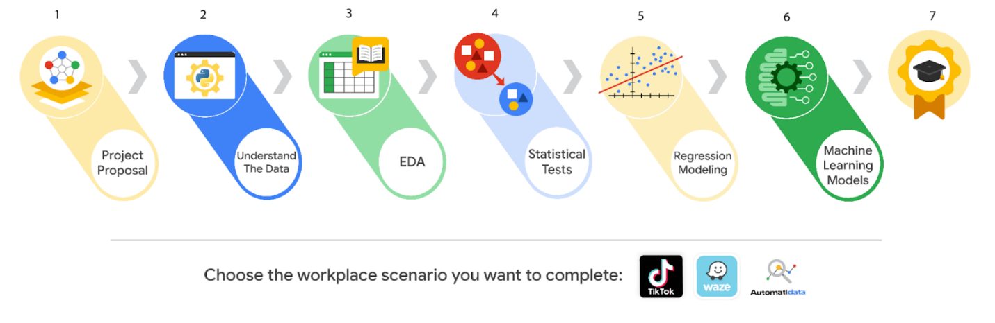

**Importance of communication in the data career space**

End-of-course projects emphasize technical and professional workplace skills, as well as the importance of communication in data analytics. The success of your workflow management, data analysis, data visualizations, statistics, regression analysis, and building machine learning models relies on your ability to communicate with cross-functional team members. So, each project is designed to help you develop critical communication skills that you’ll need to use on the job in order to effectively:

* Ask questions
* Share project needs
* Communicate with stakeholders
* Give and receive feedback
* Stay in contact with team members on the project

**Expectations**

As previously mentioned, you will encounter an end-of-course project in the final module of each course. The end-of-course projects were designed around a workplace scenario that will guide you through tasks that align with the concepts and skills you learned in each course. The workplace scenario extends across all of the certificate’s end-of-course projects.

You will be given the tools, resources, and instructions needed to apply your new skills and complete each individual end-of-course project. Additionally, you’ll also have access to helpful resources designed to guide and inspire your data analysis workflow. In the end, your effort will be rewarded with work examples that demonstrate the effectiveness of your data analysis. If you get stuck at any point, there are links to review relevant information within each course.

To help you complete each end-of-course project, you will receive a PACE (Plan, Analyze, Construct, and Execute) strategy document to guide your workflow. As you answer the questions, you will gain a deeper understanding of the data analysis process, document your growth as a data professional, and prepare the observations and reflections needed to complete each project.

**Start your project**

To complete the end-of-course portfolio project, you will first need to:

* Gather information about the business problem or question to be answered.
* Respond to key questions posed in the PACE strategy document.
* Create a project proposal for cross-functional team members.

In the next reading, you will learn about the workplace scenarios and how to get started on your end-of-course project. Good luck!