# http://imgur.com/1ZcRyrc.pngGA27 Project Key Points

## Research topic

**Topic #1:** The effect of FDI on the changing patterns of global trade

## Executive summary

Foreign Direct investment (FDI) is investment made to effective control over an enterprise operating outside of the economy of the investor.

There are two type of FDIs namely:

**Net inflows**: value of inward direct investment made by non-resident investors in the reporting economy, including reinvested earnings and intra-company loans, net of repatriation of capital and repayment of loans.

**Net outflows**: value of outward direct investment made by the residents of the reporting economy to external economies, including reinvested earnings and intra-company loans, net of receipts from the repatriation of capital and repayment of loans.

These series are expressed as shares of GDP and views as an important economic indicator. The effects of FDI on exports and imports have not been extensively explored. This project seeks to provide a tool to visualize the relationship. Specifically, project examines the effect of FDIs and its effect on the changing patterns of global trade between advanced nations in Asia and the emerging markets in Africa.

Datasets

The primary datasets will be obtained from the IMF and the OECD’s websites at:

http://data.imf.org/?sk=9D6028D4-F14A-464C-A2F2-59B2CD424B85

https://data.worldbank.org/indicator/BX.KLT.DINV.CD.WD

https://data.oecd.org/fdi/fdi-flows.htm

### Data dictionary

1) ***DirectionOfTrade.txt*** – text file of worldwide trade data from January 2013 to May 2016

V1 – Reporter Name (Country Name)

V2 – Reporter Code (Country ISO 2 Code)

V3 – Trade Flow (Type of trade:

Goods, Value of Exports, Free on board (FOB), US Dollars,

Goods, Value of Imports, Cost, Insurance, Freight (CIF), US Dollars,

Goods, Value of Imports, Free on board (FOB), US Dollars)

V4 – Partner Name

V5 – Partner Code

V6 – Period

V7 – Trade Value

### Data Structure

The data is stored in *semi-colon-separated (txt)*, *comma-separated (csv)*, and *tab-separated (csv)* formats respectively. The first few rows of data files look like this:

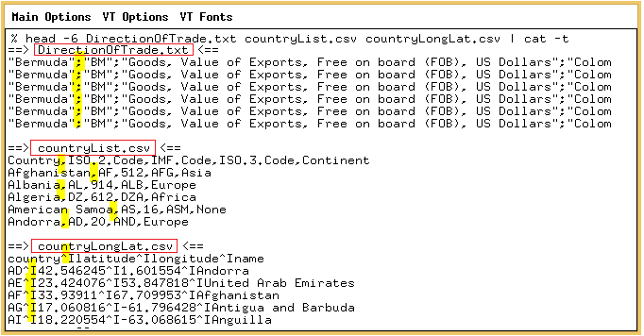

The following additional geographical data will be used to enhance the visualization tool.

2) ***countryList.csv*** – list of country names, ISO codes and their respective IMF Codes

Country – country name

ISO.2.Code – country ISO 2-digit code

IMF.Code – country IMF 3-digit code (numeric)

ISO.3.Code – country ISO 3-digit code

Continent – name of Continent (Africa, Asia, Europe, None, North America, Oceana & South America)

3) ***countryLongLat.csv*** – list of ISO codes and their respective coordinates

country – country ISO 2-digit code

longitude – country longitude

latitude -- country latitude

name – country name

### Workflow

The following data exploration workflow will be adapted:

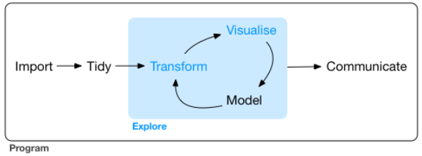

Source: http://r4ds.had.co.nz/explore-intro.html

## Project Goals

Use Python programming software to:

1. load that data into memory,
2. tidy up and transform certain column of the data,
3. arrange the data to calculate the average import/export per year and across all specified countries,
4. provide charts and tables to address some “economic literacy-related” questions, and
5. communicate the results.

## Economic literacy questions to be addressed

1. The effect of FDIs on the trade patterns between top x% export/import countries and their neighboring countries.
2. The Effect of Great Recession (Dec 2007 to June 2009) and FDIs on global trade patterns.

### Additional Questions

1. What are the top 10% of the worlds export/import regions?
2. What are trade balances of the countries in (1) from January 2013 to December 2015?
3. What are the exports of the key countries in (1) relative to their respective GDP.

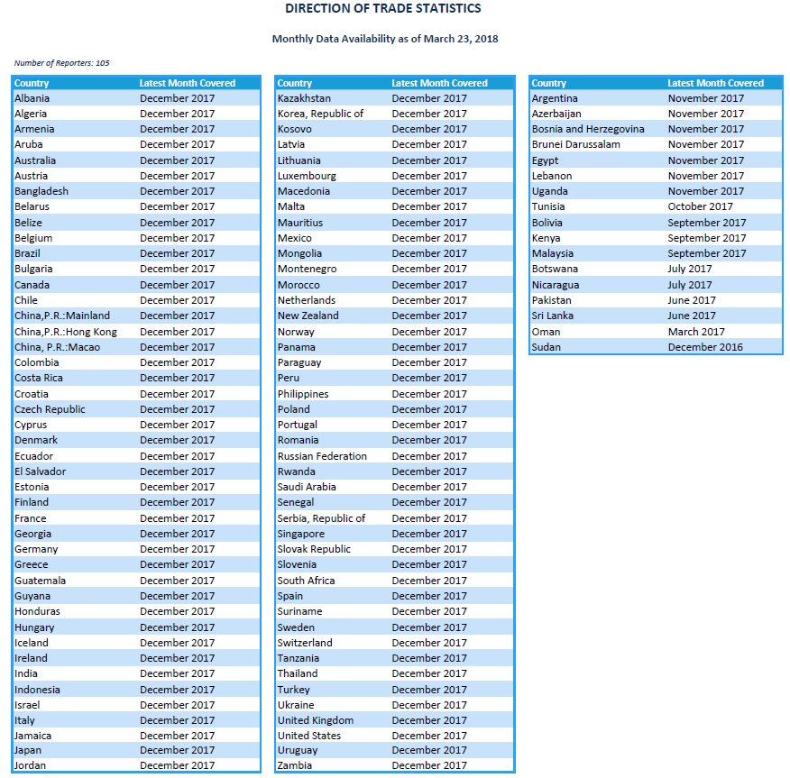

**Topic #2:** Mining timeseries shapelets for kNN prediction**.**

**Use** the Google trace data to analysis and compare results with selected machine learning prediction algorithms.

<https://cloud.google.com/storage/docs/access-public-data>

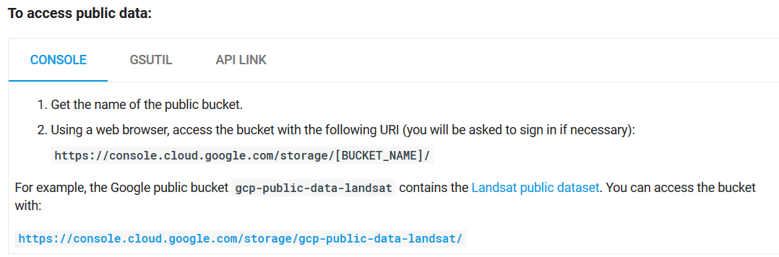

<https://console.cloud.google.com/storage/browser/clusterdata-2011-2?pli=1>

