1. Pipeline is located at example-voting-app\.github\workflows

2. gitleaks for secret-scan, trivy for sca-analysis, semgrep for sast-analysis, nikto for dast analysis  
  
3. Install Docker first to run pipeline on local, for example on my local using windows run command “act” (install act .exe)  
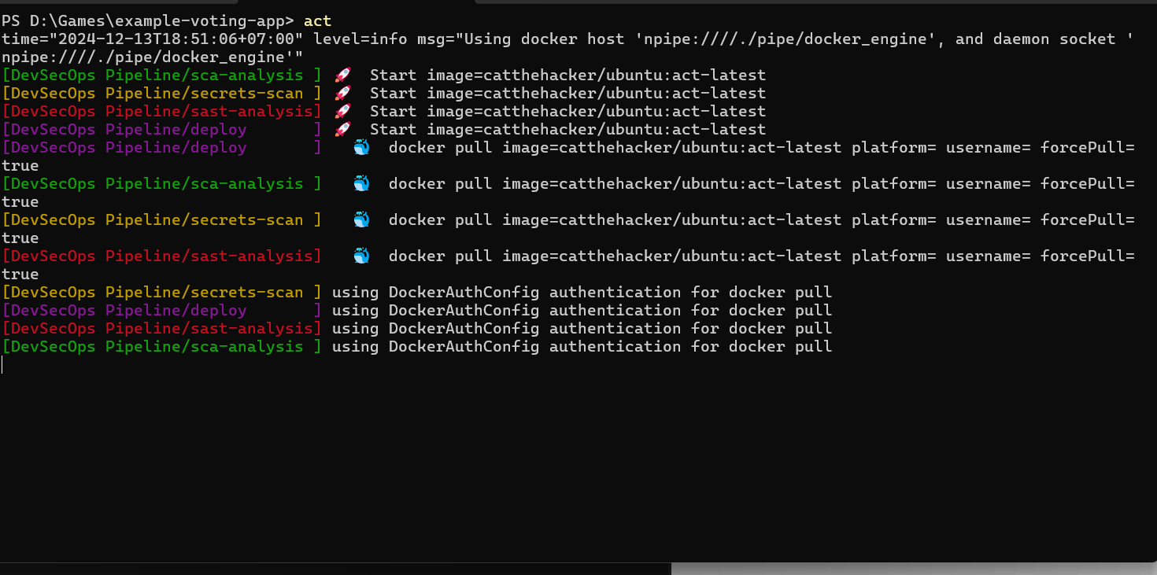  
  
4. report files is located on folder ./report