House History Evidence Report
1623 NE 73rd Ave
Portland, Oregon 97213
Evidence assembled through August 16, 2026

Purpose. This report separates documented facts, strong inferences, oral-history evidence, and unresolved hypotheses. It is intentionally conservative: where the evidence does not prove a point, the report says so.
Most important correction from the current evidence set: the earliest plumbing card is dated September 1912, not 1913. It describes a “1 story frame new” dwelling and names the owner as “Mr. J. Deveny.” This is the strongest evidence yet that the DeVeny connection began at or essentially at original construction.

Prepared as a working historical record; not a title report or legal ownership opinion.

Certainty Scale
Level | Meaning
5/5 — Confirmed | Direct primary record or authoritative public record explicitly supports the fact.
4/5 — Very strong | Multiple sources or a primary record plus a small, reasonable identity inference.
3/5 — Probable | Evidence fits well, but a direct record linking the person/event/property is still missing.
2/5 — Possible | Plausible working hypothesis; significant documentary gap remains.
1/5 — Unverified lead | Recollection, secondary genealogy, or research lead not yet independently established.
Evidence-type note. A high-confidence oral-history fact can still lack a documentary record. For example, the current owner is certain the house was tenant-occupied when Christine bought it in 1992; that is treated as strong firsthand evidence but is separately labeled as oral history until a lease, directory, ad, or deed-related record is found.

Executive Summary
- 5/5: The property is Lots 27 and 28, Block 33, Jonesmore. This legal description appears on the historic city records.
- 5/5: A plumbing inspection began September 2, 1912 and was finalized September 13, 1912. The card describes a “1 story frame new” dwelling and names the owner as “Mr. J. Deveny.”
- 4/5: The 1912 “Mr. J. Deveny” is likely a member of the same DeVeny family later associated with the house; identifying him specifically as James Benjamin DeVeny remains probable rather than proven.
- 5/5: In 1939 the house was converted from a cesspool to the city sewer under sewer permit 41973.
- 5/5: A 1947 plumbing record names “Mrs. Deveny” as owner and documents replacement of one water service.
- 5/5: A 1966 City of Portland oil-burner permit at 1623 NE 73rd was installed for “E. A. DeVeny” and shows a 275-gallon basement fuel tank.
- 5/5: Edgar A. DeVeny died April 24, 1969; an Oregon obituary index gives 1623 NE 73rd Ave as his death place.
- 3/5: Fern A. DeVeny may be the older woman a neighbor remembers living alone in the house after Edgar’s death and possibly until Fern died in 1986. This fits the evidence, but we do not yet have a 1980s directory, obituary, death certificate, or deed proving Fern’s residence at 1623 immediately before her death.
- 4/5 oral history: The house was tenant-occupied when Christine M. Irvin bought it in 1992, based on the current owner’s firsthand knowledge. The start date of the rental period is not yet documented.
- 5/5 sale event; 4/5 buyer identity: A public-record aggregation reports a sale on December 1, 1992 for $64,950. The current owner identifies Christine M. Irvin as the buyer; the deed itself has not yet been added to this evidence set.
- 5/5 sale event: A public-record aggregation reports a sale on May 27, 1999 for $127,000. The current owner recalls buying from Christine in summer 1999; the exact closing/recording date should ultimately be reconciled against the deed.

Chronological Evidence Ledger
1907 | Jonesmore was actively marketed for residential development.  Evidence: A September 1907 Oregonian advertisement by George D. Schalk offered buyers a Jonesmore lot and said his organization would build them a home. This is neighborhood context, not proof Schalk built this house.  Certainty: 5/5 for context; 1/5 as a builder attribution  Sources: W6  Qualification: No property-specific builder record has been found.

1912 | The house was a new one-story frame dwelling and a DeVeny was named as owner.  Evidence: Historic City of Portland plumbing inspection: first inspection 9/2/1912; final inspection 9/13/1912; “1 story frame new”; “Dwelling”; owner line reads “Mr. J. Deveny.” The card also identifies Lots 27 & 28, Block 33, Jonesmore.  Certainty: 5/5 for date, building status, legal description, and DeVeny owner name; 4/5 that the first initial is J  Sources: P1  Qualification: The handwritten first initial is somewhat stylized but reads most plausibly as J. Identifying this person specifically as James Benjamin DeVeny remains unproven.

1912 | Public property data also gives 1912 as the year built.  Evidence: Realtor.com’s public-record property history lists “Built 1912,” along with 1,102 square feet and a 5,724-square-foot lot.  Certainty: 4/5  Sources: W1  Qualification: Useful corroboration, but the 1912 city plumbing card is the stronger primary source for original construction timing.

1912 context | North Jonesmore was in an active building boom.  Evidence: The April 7, 1912 Sunday Oregonian reported that a large number of attractive homes had been built in North Jonesmore and that street grading and cement sidewalk work were underway.  Certainty: 5/5 for neighborhood context  Sources: W7  Qualification: This does not identify the builder or owner of 1623 specifically.

Pre-1933 address | The 1912 plumbing card appears to preserve an earlier street number, “369,” beneath/alongside the modern address.  Evidence: The scan carries both the modern “1623 N.E.” notation and a handwritten “369.” Portland comprehensively renumbered addresses in the early 1930s, finishing in 1933.  Certainty: 3/5  Sources: P1, W10  Qualification: The exact pre-1933 address format should be verified in the official street/name change directory before it is stated as definitive.

1939 | The property was connected to the city sewer and changed from a cesspool system.  Evidence: Historic plumbing permit dated 9/26/1939 states “Change from cesspool to sewer,” lists sewer permit 41973, and describes the building as a “1 story old frame res.”  Certainty: 5/5  Sources: P2

1939 | The sewer record independently matches the legal description and permit number.  Evidence: City of Portland Department of Public Works record for permit 41973 identifies 1623 NE 73rd Ave, Jonesmore, Lots 27–28, Block 33, between Halsey Street and Broadway, with Geo. L. Melvine as applicant.  Certainty: 5/5  Sources: P4  Qualification: The form’s handwritten dates are difficult in places; the linked 1939 plumbing record provides the clearest event date.

1939 | A city sketch documents the sewer/service geometry around the property.  Evidence: A companion historic drawing shows NE 73rd with Broadway and Halsey and a service line/location sketch.  Certainty: 4/5  Sources: P5  Qualification: The sketch is clearly associated with the address set, but it does not by itself identify an owner.

1947 | A woman recorded as “Mrs. Deveny” was the owner when a water service was replaced.  Evidence: City plumbing inspection dated 2/7/1947, permit 185319, names “Mrs. Deveny” as owner, calls the building an “Old dwelling,” and records “Water Service 1 repl.” Final inspection appears 2/14/1947.  Certainty: 5/5  Sources: P3  Qualification: Which Mrs. DeVeny this was is not yet proven. It should not be assigned to Sophia or Fern without a directory/deed link.

1966 | “E. A. DeVeny” was directly associated with the house and oil heat.  Evidence: City of Portland Fire Prevention Division oil-burner permit at 1623 NE 73rd, dated in July 1966, states “Install for E. A. DeVeny,” marks warm-air heat, and shows a 275-gallon tank located in the basement.  Certainty: 5/5 for the permit facts; 4/5 that E.A. is Edgar A. DeVeny  Sources: P6  Qualification: The reviewed permit documents a basement tank, not an underground tank. The user recalls additional underground-storage-tank material, which should be added when available.

1969 | Edgar A. DeVeny died while directly tied to 1623 NE 73rd Ave.  Evidence: VA-derived cemetery data gives Edgar A. DeVeny’s death as 4/24/1969; the Oregon obituary index gives his death place as 1623 NE 73rd Ave.  Certainty: 5/5  Sources: W2, W3

1986 | Fern A. Farmer DeVeny died July 18, 1986.  Evidence: Find a Grave lists Fern A. DeVeny, spouse of Edgar Arthur DeVeny, born 1/29/1906 and died 7/18/1986.  Certainty: 4/5  Sources: W4  Qualification: This establishes Fern’s death date and spouse relationship in a secondary genealogical source, but does not establish her residence at 1623 in 1986.

1969–1986? | Fern may have remained in the house alone after Edgar’s death.  Evidence: A neighbor remembers an “old lady” who lived in the house alone for as long as the neighbor knew her. Fern was Edgar’s widow and lived until 1986, which makes the identification plausible.  Certainty: 3/5  Sources: O2, W4  Qualification: The neighbor memory is strong evidence that an older woman lived alone there; identifying that woman as Fern and extending her residence all the way to 1986 remain inferences.

Nola — later life | Nola DeVeny later used the surnames Fick and Dowty; Nola Diane Dowty died October 9, 2000.  Evidence: A genealogical index associates the names Nola Diane DeVeny, Nola D. Fick, and Nola Diane Dowty. VA-derived Willamette National Cemetery data lists Nola Diane Dowty, wife of Lloyd W. Dowty, died 10/9/2000.  Certainty: 4/5 for name continuity/death date  Sources: W5, W11  Qualification: Her birth year conflicts between sources (1930 in one index, 1933 in the VA-derived cemetery database). The report does not resolve that discrepancy.

Before 1992 | Nola had moved away from the house before her death; exact move-out date is unknown.  Evidence: This is the current owner’s recollection from prior family/house history research, and Nola’s later married-name records are consistent with her living elsewhere.  Certainty: 2/5  Sources: O1, W5, W11  Qualification: No city directory, voter record, deed, or obituary has yet established the year she stopped residing at 1623.

1986–1992? | The house may have become a rental after Fern’s death and remained a rental until the 1992 sale.  Evidence: This hypothesis fits Fern’s 1986 death, the neighbor’s memory of an older woman living alone, and the current owner’s certainty that the property was tenant-occupied when Christine bought it.  Certainty: 3/5  Sources: O1, O2, W4  Qualification: Only the rental status at the time of Christine’s purchase is treated as strong firsthand evidence. The rental start date is not yet proven; “1986–1992” is a working hypothesis.

Dec. 1, 1992 | A public record reports a $64,950 sale; Christine M. Irvin is identified by the current owner as the buyer.  Evidence: Realtor.com public-record history lists a sale on 12/1/1992 for $64,950. The current owner states Christine purchased the house at approximately this time and did not subsequently operate it as a rental.  Certainty: 5/5 for sale event/price; 4/5 for Christine as buyer until deed is obtained  Sources: W1, O1  Qualification: The 1992 deed is a high-priority missing primary source. It should identify the grantor and resolve whether Nola or another DeVeny family member conveyed title.

1992 | The house was tenant-occupied when Christine bought it.  Evidence: Current owner is 100% certain of this point based on firsthand knowledge of the property’s history at purchase from Christine.  Certainty: 4/5 oral history  Sources: O1  Qualification: This does not establish when the rental period began or who the tenant was.

1992 onward | Christine did not use the property as a rental after she bought it.  Evidence: Current owner clarified that Christine herself did not operate the property as a rental.  Certainty: 4/5 oral history  Sources: O1  Qualification: A directory or deed-address record could later provide documentary corroboration of occupancy.

May 27, 1999 | Public records report a $127,000 sale.  Evidence: Realtor.com public-record history lists the sale on 5/27/1999 for $127,000. The current owner states he bought the property from Christine in summer 1999.  Certainty: 5/5 for recorded sale event; 4/5 for seller identity until deed is in evidence set  Sources: W1, O1  Qualification: The owner recalls July 1999, while the public-record aggregator reports May 27. The deed/closing statement should be used to reconcile closing versus recording timing.

Ownership and Occupancy: What We Can and Cannot Yet Say
Proposition | Current status | Why
DeVeny connection begins with original construction | Strongly supported | The September 1912 new-dwelling plumbing card names “Mr. J. Deveny” as owner.
1912 owner was specifically James Benjamin DeVeny | Probable, not proven | The first initial appears to be J and James Benjamin DeVeny is a known DeVeny family figure, but no deed/directory/census link to this parcel has yet been produced.
DeVeny family retained the property continuously from 1912 to 1992 | Plausible but not yet deed-proven | DeVeny-name city records recur in 1912, 1939, 1947, 1966 and 1969, but there are large gaps and no complete title chain yet.
Fern was the “old lady” the neighbor remembers | Probable | Fits Edgar’s 1969 death, Fern’s widow status and 1986 death, plus neighbor recollection; no late directory/death-address record yet.
Fern lived at 1623 until her death in 1986 | Possible to probable | The scenario fits all known evidence but remains undocumented at the endpoint.
The rental period began in 1986 | Possible | A logical consequence if Fern occupied through death, but neither the rental start date nor first tenant has been found.
The house was a rental when Christine bought it | Very strong firsthand evidence | Current owner states this with certainty.
Nola was the person who sold to Christine | Working recollection | Current owner recalls Nola held the property before the sale, but the 1992 deed is still missing.

Physical History of the House
Feature | What the evidence says | Certainty | Source
Original form | One-story frame dwelling; the 1912 card explicitly calls it “new.” | 5/5 | P1
Original plumbing | The 1912 record documents five plumbing fixtures and a 4-inch stack/drain notation; exact fixture interpretation is partly handwritten. | 4/5 | P1
Waste disposal before 1939 | The house used a cesspool before connection to Portland’s sanitary sewer. | 5/5 | P2
Sewer connection | Converted from cesspool to sewer in 1939 under sewer permit 41973. | 5/5 | P2, P4, P5
Water service | One water service was replaced in 1947. | 5/5 | P3
Oil heat | A 1966 permit documents warm-air oil heat and a 275-gallon basement tank. | 5/5 | P6
Underground fuel tank | Not established by the currently reviewed permit. User recalls additional UST-related records. | 1/5 pending record | O1 / additional record needed
Current public-record size | 1,102 sq ft; 2 bed; 1 bath; lot 5,724 sq ft. | 4/5 | W1

Highest-Priority Unresolved Questions
- Who exactly was the “Mr. J. Deveny” on the September 1912 plumbing card? A 1912 city directory, 1910/1920 census address match, or the original deed would be decisive.
- Who held legal title between 1912 and 1992? A complete Multnomah County deed-index chain can establish whether ownership was truly continuous in the DeVeny family.
- Who was “Mrs. Deveny” on the 1947 permit? It should not be assigned to a particular family member without a contemporaneous directory or deed.
- Did Fern live at 1623 continuously after Edgar’s 1969 death and until her own death in 1986? A 1969–1986 reverse directory run or Fern’s death certificate/obituary could answer this.
- When did the house become a rental, and who rented it? Reverse address directories and classified ads from 1986–1992 are the best path.
- Who conveyed the house to Christine M. Irvin in 1992? The deed is the single highest-value missing document for the late ownership chain.
- What is the exact original/pre-1933 address? The 1912 plumbing card appears to show “369,” but the official 1933 address-change directory should be checked.
- Was there an underground storage tank in addition to the documented 275-gallon basement tank? The additional tank records recalled by the owner should be located and added.
- Who built the house? George D. Schalk is a neighborhood development lead, but there is no property-specific builder attribution yet.
Record-access path. Multnomah County’s public research area provides recorded documents from 1955 to current and a deed index from 1855 to current. This should make the 1992 deed and earlier title chain research feasible. Portland also directs researchers to Historic Plumbing records through PortlandMaps. [W8, W9]

Source Register
Primary property records supplied by the owner
P1 — City of Portland historic plumbing inspection — September 1912 (785317.pdf, page 5)
Type: Primary municipal record
Use in this report: New dwelling; “Mr. J. Deveny”; Lots 27–28, Block 33, Jonesmore; first/final inspections 9/2/1912 and 9/13/1912.
P2 — City of Portland historic plumbing inspection — 1939 (785317.pdf, page 3)
Type: Primary municipal record
Use in this report: Cesspool-to-sewer conversion; permit 137936; sewer permit 41973; “Mr. De Verney.”
P3 — City of Portland historic plumbing inspection — 1947 (785317.pdf, page 1)
Type: Primary municipal record
Use in this report: “Mrs. Deveny”; old dwelling; one water service replacement; permit 185319.
P4 — City of Portland Department of Public Works sewer record — permit 41973 (441402.pdf, page 1)
Type: Primary municipal record
Use in this report: 1623 NE 73rd; Jonesmore; Lots 27–28; Block 33; between Halsey and Broadway.
P5 — Historic sewer/service sketch (529994.pdf, page 1)
Type: Primary municipal record / field sketch
Use in this report: Shows street context and service geometry associated with NE 73rd, Broadway, and Halsey.
P6 — City of Portland Fire Prevention Division oil-burner permit, July 1966 (owner-supplied scan)
Type: Primary municipal record
Use in this report: Installed for E. A. DeVeny; warm-air heat; 275-gallon basement tank.
Firsthand and oral-history sources
O1 — Current owner’s firsthand account
Type: Oral history / firsthand property history
Use in this report: Bought from Christine in 1999; Christine did not use it as a rental; property was tenant-occupied when Christine bought it; working recollection that Nola held the property before Christine and had moved out earlier.
O2 — Neighbor recollection of an older woman living alone at the house
Type: Oral history
Use in this report: Supports, but does not prove, the hypothesis that Fern remained at the house after Edgar’s death.
Web and reference sources
W1 — Realtor.com public-record property history — 1623 NE 73rd Ave
Type: Secondary public-record aggregation
Use in this report: 1912 build year; 1,102 sq ft; 5,724 sq ft lot; 1992 and 1999 recorded sale events/prices.
https://www.realtor.com/realestateandhomes-detail/1623-NE-73rd-Ave_Portland_OR_97213_M11432-78291
W2 — Oregon obituary index — Edgar A. DeVeny
Type: Newspaper index / secondary index
Use in this report: Lists death place as 1623 NE 73rd Ave.
https://oregonlive.newspapers.com/articles/obituary/1092756795/83066f5e-fc17-4fb3-91f2-e515d785ac0d
W3 — Willamette National Cemetery / VA-derived database — Edgar A. DeVeny
Type: Government-derived cemetery transcription
Use in this report: Birth 9/16/1895; death 4/24/1969; U.S. Army.
https://www.interment.net/united-states/oregon/multnomah-county/portland/willamette-national-cemetery/transcription/411.php?page=1482&sort=za
W4 — Find a Grave — Fern A. Farmer DeVeny
Type: Secondary genealogical memorial
Use in this report: Birth 1/29/1906; death 7/18/1986; spouse listed as Edgar Arthur DeVeny.
https://fi.findagrave.com/memorial/567125/fern_a-deveny
W5 — Willamette National Cemetery / VA-derived database — Nola Diane Dowty and Lloyd Wallace Dowty
Type: Government-derived cemetery transcription
Use in this report: Nola Diane Dowty died 10/9/2000; wife of Lloyd W. Dowty. Source gives birth year 1933.
https://www.interment.net/united-states/oregon/multnomah-county/portland/willamette-national-cemetery/transcription/411.php?page=1458&sort=za
W6 — The Sunday Oregonian, Sept. 29, 1907 — George D. Schalk Jonesmore advertisement
Type: Digitized historic newspaper / primary period source
Use in this report: Jonesmore lot buyers were offered a home-building arrangement; development context only.
https://oregonnews.uoregon.edu/lccn/sn83045782/1907-09-29/ed-1/seq-16/
W7 — The Sunday Oregonian, April 7, 1912 — Montavilla / North Jonesmore building activity
Type: Digitized historic newspaper / primary period source
Use in this report: Reports many attractive homes built in North Jonesmore and active street improvements.
https://oregonnews.uoregon.edu/lccn/sn83045782/1912-04-07/ed-1/seq-61/
W8 — City of Portland — Find public records with Permitting & Development
Type: Official government guidance
Use in this report: Confirms historic plumbing/sewer connection records are available through PortlandMaps.
https://www.portland.gov/ppd/public-records
W9 — Multnomah County — Tax, Property, Marriage and Military Discharge Records
Type: Official government guidance
Use in this report: Public research terminals include recorded documents 1955–current and deed index 1855–current.
https://multco.us/services/tax-property-marriage-and-military-discharge-records
W10 — Multnomah County Library — Who lived in my house? Getting started
Type: Library research guide
Use in this report: Explains Portland’s comprehensive early-1930s address renumbering and completion in July 1933.
https://multcolib.org/who-lived-my-house-getting-started
W11 — SortedByName — Nola Diane Dowty / DeVeny name variants
Type: Secondary genealogical index
Use in this report: Associates Nola Diane Dowty with the DeVeny and Fick surnames; reports a 1930 birth year, conflicting with VA-derived 1933.
https://sortedbyname.com/letter_d/dowty/index_10.html
W12 — Find a Grave — James Benjamin DeVeny
Type: Secondary genealogical memorial
Use in this report: Supports James Benjamin DeVeny (1871–1945) as a relevant DeVeny-family research lead; not proof he owned this parcel.
https://www.findagrave.com/memorial/189773929/james-benjamin-deveny

Appendix: Key Historic Records
Figure 1. September 1912 plumbing inspection — the strongest original-construction evidence.
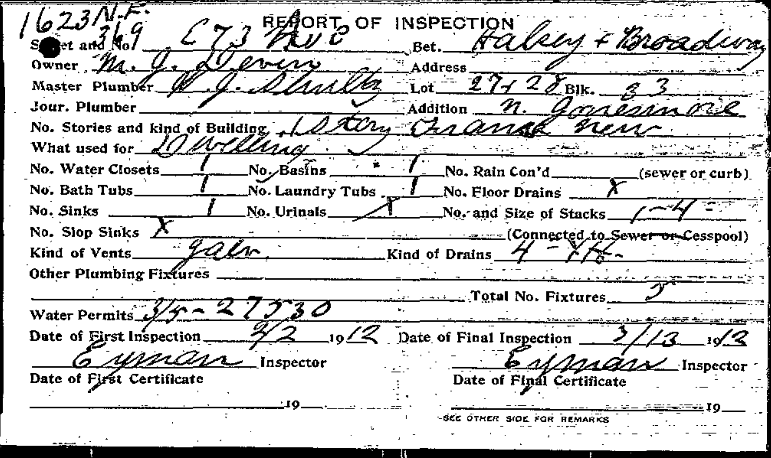
Source P1

Figure 2. 1939 plumbing inspection documenting the change from cesspool to sewer.
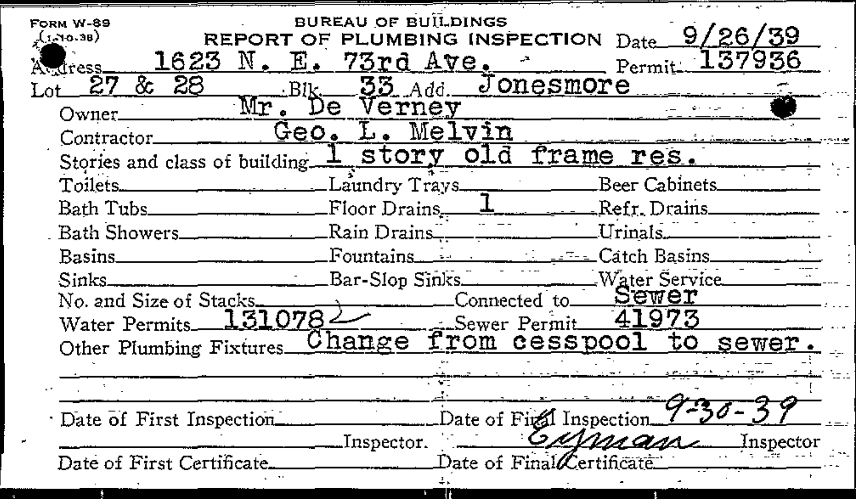
Source P2

Figure 3. 1947 plumbing inspection naming “Mrs. Deveny” as owner.
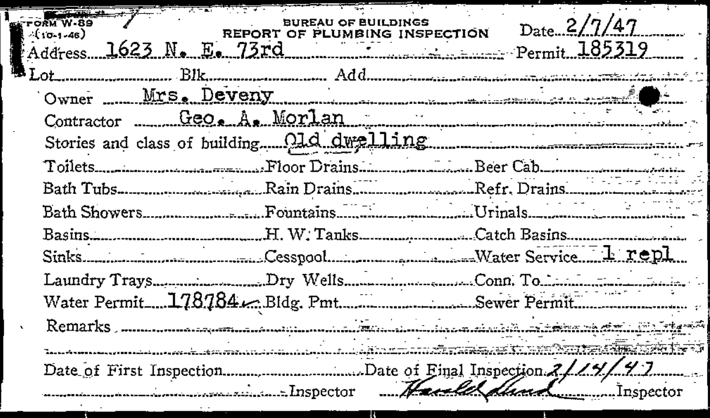
Source P3

Figure 4. 1939 Public Works sewer permit 41973.
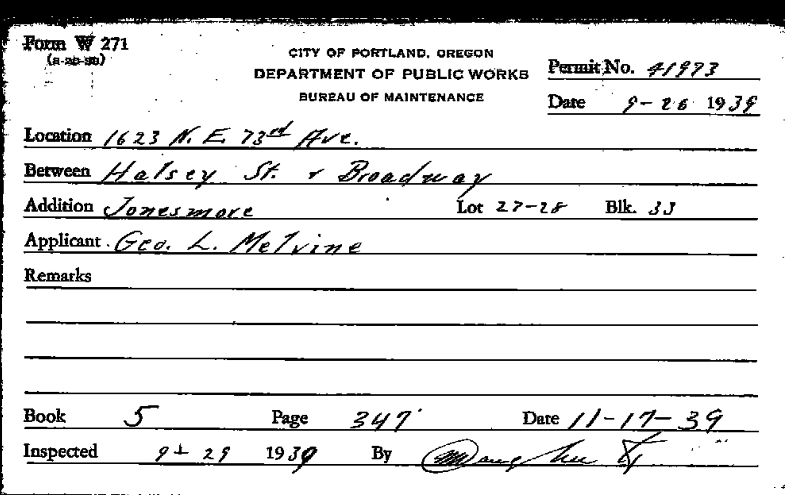
Source P4

Figure 5. 1966 oil-burner permit installed for E. A. DeVeny; 275-gallon basement tank.
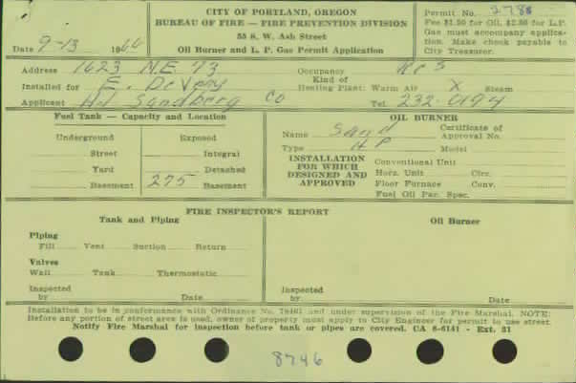
Source P6
Research status at this edition. The earliest house-specific primary record now dates the new dwelling to September 1912 and names a DeVeny owner. The late-20th-century occupancy/title chain remains the principal unresolved area, especially Fern’s residence after 1969, the start of the rental period, and the grantor on the 1992 deed.

