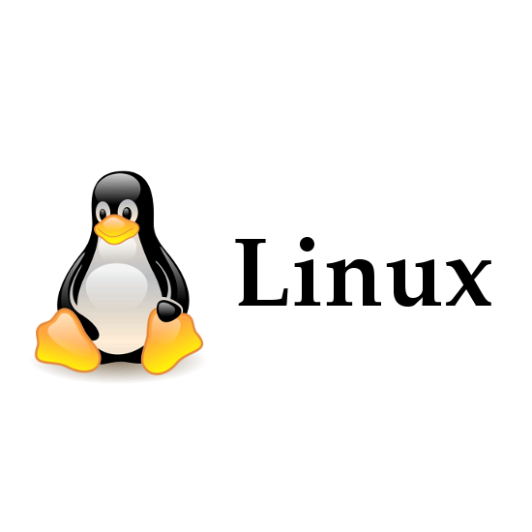

In 2003, he was honored with the Millennium Technology Prize, one of the world's largest technology prizes, for his work on Linux.

Linux is one of the most widely used operating systems in the world, powering everything from servers to smartphones.

He is also the creator of Git.

Git is the most widely used version controlled software in the world.

**Linus Torvalds**

He was born on December 28, 1969, in Helsinki, Finland.

He is the creator of linux operating system.

He made the source code for the operating system freely available online, and it quickly gained popularity among other programmers who contributed to its development.