EDA - F1 Clustering Project
Roee Amsalem, Oren Yehezkel, Ido Brener

1 Basic information about the dataset:

An important comment before we start:
In this document we would refrence to two different datasets:
- Raw data – in this dataset, each row is a sample, taken from a F1 car during a certain race using the sensors that are installed on the car. This data is directly imported from the API of the OpenF1 project, and it is the base of the second dataset, on which we plan to do the clustering.
- Processed data – in this dataset, each row is a turn a driver made during the race, the columns of this dataset are made using feature engineering. This dataset is the one we would do the clustering on.

- Dataset name: F1 Driver Cornering Telemetry (Custom Built Dataset)
- Data origin: Live telemetry of F1 cars from 4 official events that happened during 2023: Monza, Singapore, Spa, Suzuka. The information was extracted using OpenF1 project’s API.
- Number of samples: Raw data – 28086, Processed data - 1109
- Number of identifiers: Raw data – 2, Processed data - 3
- Number of features: Raw data – 10, Processed data - 12
- The Domain: The data comes from sensor measurments installed on each F1 car, that measure the telemetry data of the car at 3.7Hz (almost 4 times a second).

2 Feature Understanding:

Raw data:
The rows of the dataset: Each row is a sample taken in a certain time during the fastest lap of each driver in a qualifying round during one of the 4 races.
Indentifiers:
- track – the name of the track
  - Units: irrelevant.
  - Possible value range: {Monza, Singapore, Spa, Suzuka}.
- driver_number – a unique identifier given to every F1 driver.
  - Units: ireelevant.
  - Possible value range: {1, 2, 3, 4, 10, 11, 14, 16, 18, 20, 22, 23, 24, 27, 31, 40, 44, 55, 63, 77, 81}.
Features:
- lap_duration – the time needed to do the lap
  - Units: seconds
  - Possible value range: 0-130 seconds
- x – the drivers position in the x axis.
  - Units: irrelevant.
  - Possible value range: -15000 - 15000
- y – the drivers position in the y axis.
  - Units: irrelevant.
  - Possible value range: -20000 - 20000
- speed – the speed of the car.
  - Units: km/h
  - Possible value range: 0-400 km/h.
- brake – wether the brake pedal is pressed or not.
  - Units: irrelevant.
  - Possible value range: {0,100}
- throttle – the throttle position precentage.
  - Units: irrelevant.
  - Possible value range: 0-100
- n_gear – the current gear of the car
  - Units: irrelevant
  - Possible value range: 0-8.
- rpm – the amount of rounds per minute the car engine is doing.
  - Units: number of rounds.
  - Possible value range: 0-14000 rounds.

Processed data:
The rows of the dataset: Each row in the dataset represents a turn that a certain driver made during his fastest lap in a certain event.
The dataset columns:
Indentifiers:
- track – the name of the track
  - Units: irrelevant.
  - Possible value range: {Monza, Singapore, Spa, Suzuka}.
- global_corner_id – a unique identifier given to every corner during the corner detection process.
  - Units: ireelevant.
  - Possible value range: {101-110, 201-216, 301-316, 401-416}.
- driver_number – a unique identifier given to every F1 driver.
  - Units: ireelevant.
  - Possible value range: {1, 2, 3, 4, 10, 11, 14, 16, 18, 20, 22, 23, 24, 27, 31, 40, 44, 55, 63, 77, 81}.
Features:
- entry_speed – the speed of the car in the start of the turn.
  - Units: km/h
  - Possible value range: 0-400 km/h
- apex_speed – the minimal speed of the car during the turn.
  - Units: km/h
  - Possible value range: 0-400 km/h
- exit_speed – the speed of the car in the end of the turn.
  - Units: km/h
  - Possible value range: 0-400 km/h
- speed_drop – the difference between “entry_speed” to “apex_speed”.
  - Units: km/h
  - Possible value range: 0-400 km/h.
- braking_pct_before_apex – the precentage of the segment of the turn that is before the apex in which the driver presses on the brake pedal
  - Units: precentage.
  - Possible value range: 0-1.
- trail_braking_pct – the precentage of the turn in which the driver performed “trail breaking” (a slow release of the brake pedal).
  - Units: precentage.
  - Possible value range: 0-1.
- throttle_app_pct_after_apex – the precentage of the segment of the turn that is after the apex in which the driver presses on the throttle.
  - Units: precentage.
  - Possible value range: 0-1.
- coasting_pct – the precentage of the turn in which the driver didn’t press on the brake nor the throttle.
  - Units: precentage.
  - Possible value range: 0-1.
- breaking_time_pct – the precentage of the turn in which the driver pressed the brake pedal.
  - Units: precentage.
  - Possible value range: 0-1.
- min_gear – the minimal gear that the car was on during the turn.
  - Units: irrelevant
  - Possible value range: 0-8.
- avg_throttle – The average percentage the throttle pedal is pressed during the turn.
  - Units: precentage.
  - Possible value range: 0-100.
- avg_speed – The average speed of the car during the turn.
  - Units: km/h
  - Possible value range – 0-400 km/h.

Difference in feature scale:
We must notice there is a big difference in scale between the features that are speed-based, which are measured in km/h and are between 0-400, and the features that are braking/throttle-based, which are measured in precentages between 0-1. There will be a process of normalization of the features to the 0-1 range, in order to make sure that no feature has dramatic influence over the outcome of the clustering process.

3 Missing Values:

Our data is imported through the API of the project “OpenF1”, that aims to make official data from races accecible to the public for research purposes. In addition to making the data accesible, the project already filters any missing value caused by technical issues like damaged sensors. Therfore, we cannot calculate the precentage of missing values from the entire dataset.

Although the data was already “cleaned” from technical missing values, it has obvious theoretical missing values that may impact how well the data reflects the reality of an actual F1 race:
- There are approximatly 0.25 seconds between samples (the sample rate is 3.7Hz), in which, assuming the driver drives at an average of 200 km/h, the driver covers around 15 meters, that can be vital to learning his behavior during a turn.
- In the start and end point of each lap there is a gap of a few seconds in which the sensors of the cars stop producing new data. This gap can register as a turn when using our calculations, that relay on the change in location of the driver, thus generating noise that can affect the clustering.

These missing values may make it harder for us to understand the real-life implications of our clustering results on the drivers’ driving style, but it is unlikely because of the huge amount of data that is gathered.

4 Outliers and Data Quality:

Raw data:
Statistics:
Feature_Name | Minimum | Maximum | Mean | Median | Standard_Deviation
speed | 50 | 350 | 223.9458 | 234 | 74.5259
n_gear | 2 | 8 | 5.7148 | 6 | 1.9139
throttle | 0 | 100 | 71.7619 | 99 | 40.0555
brake | 0 | 100 | 16.3874 | 0 | 37.0168
x | -13708 | 11068 | -1043.9124 | -416 | 5947.2782
y | -15771 | 15883 | -1005.0467 | -616 | 7179.7117

Analysis:
After using box plots to analyze the data, we have reached a few conclusions:
- There are no impossible values in our data, simply because they are bounded by physics, for example, we didn’t see any negtive speed or gear number, simply because they don’t exist.
- There are a lot of measurement errors and redundent,
- There are almost no extreme outliers, and

Processed data:
Statistics:
Feature_Name | Minimum | Maximum | Mean | Median | Standard_Deviation
entry_speed | 64 | 335 | 199.7502 | 203 | 4348.4204
apex_speed | 50 | 320 | 162.8539 | 152 | 4779.5581
exit_speed | 52 | 320 | 179.7773 | 179 | 4883.9458
speed_drop | 0 | 178 | 36.8963 | 27 | 1467.3439
braking_pct_before_apex | 0 | 1 | 0.3717 | 0.4245 | 0.1122
trail_braking_pct | 0 | 1 | 0.3303 | 0.3062 | 0.108
throttle_app_pct_after_apex | 0 | 1 | 0.7615 | 1 | 0.1244
coasting_pct | 0 | 0.815 | 0.096 | 0 | 0.0184
braking_time_pct | 0 | 1 | 0.2614 | 0.25 | 0.0662
average_throttle | 0 | 100 | 47.3506 | 40.6154 | 1198.2503
min_gear | 2 | 8 | 4.3607 | 4 | 2.7687
average_speed | 60.3077 | 321.5714 | 178.9551 | 176 | 4389.51

Analysis:
After using box plots to analyze the data, we have reached fascinating conclusions:
- There are no impossible values in our data, simply because they are bounded by physics, for example, we didn’t see any negtive speed or gear number, simply because they don’t exist.
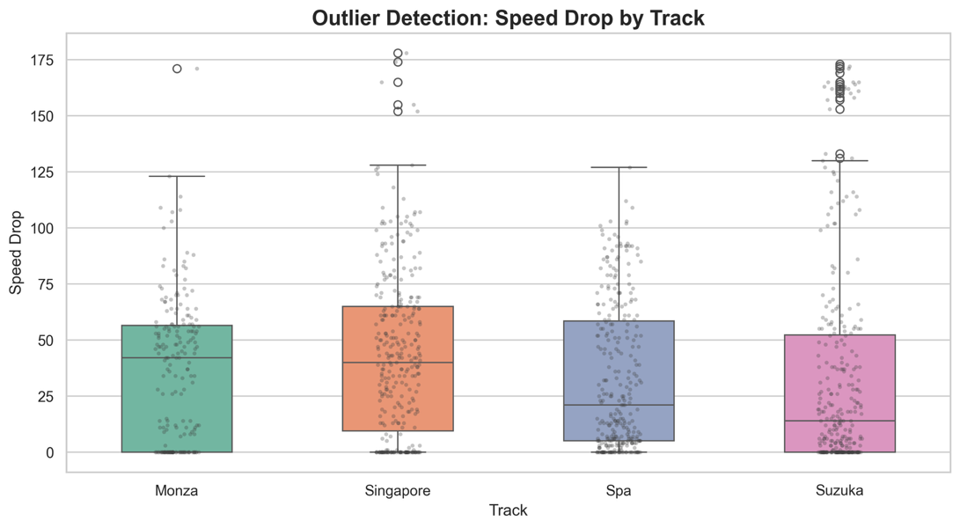
- There are many extreme outliers in almost every parameter, for example, let’s look at the box plot for the speed drop:
We can see that in almost every race, there are extreme oultiers.
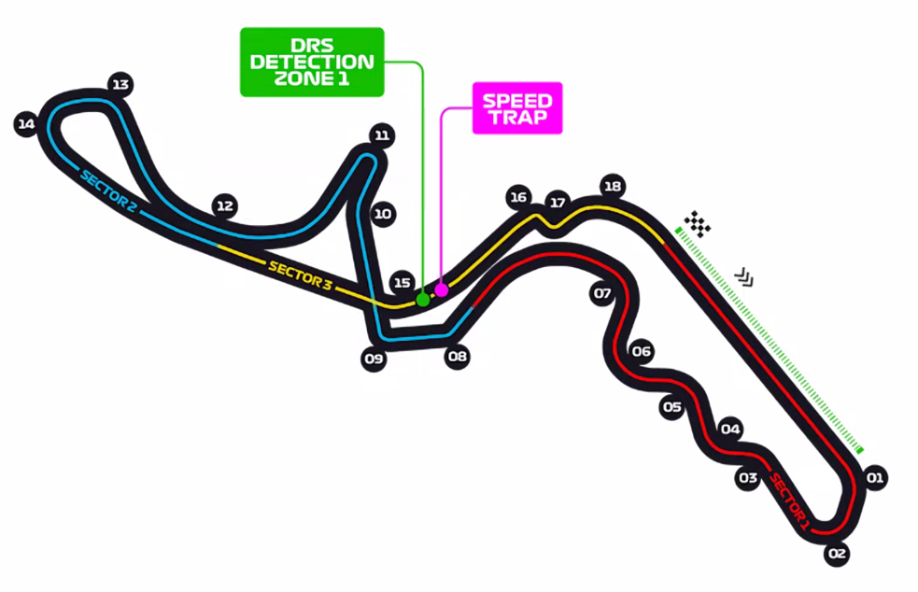
This reason for this massive amount of outliers and extreme outliers, is the difference between the turns themselves. For example, in Suzuka, there is one specific turn, marked 11 on the following map, that forces driver to decelerate extremely in order to succeed it.
This turn explains the massive amount of outliers in terms of speed drop, there are only 20 samples, one from each driver in this racetrack, that require such a massive speed drop.

Those extreme outliers would draw the center of the clusters towards them and by that affect the clustering process. We may need to normalize the data differently.

5 Data Visualization:

6 Feature Engineering:

7 Unbalanced Data:

8 Final Documentation:

